

Radiation Safety Unit

Direcrorate of Compliance & Risk

Ionising Radiation Safety Signs v 1.0 (11/2016)

* A range of door and furniture signs and symbols for use in radiation laboratories.
* RGB colours and design compliant with
  + BS ISO 3864-3: 2012 Graphical symbols - safety colours and safety signs: Part 3 Design principles for graphical symbols for use in safety signs.
  + BS EN ISO 7010: 2012 Graphical symbols – safety colours and safety signs – registered safety signs (ISO 7010: 2011).
  + The Health and Safety (Safety Signs and Signals) Regulations 1996 SI 1996 (341)
* Wording in blue boxes can be changed, but leave red and yellow boxes unchanged.
* If variants are required please contact Radiation Safety Unit (56982).
* QR codes are optional but provide access to further advice, guidance or information.
* Signs are designed to be used as A4 or A5.
* Temporary area signs will fit into an A5 counter top holder such as shown here:
  + <https://www.slatwallaccessories.co.uk/counter-top-acrylic-leaflet-holder>
* Or A4 / A5 signs slipped into door / wall mounted sign holders such as shown here:
  + <http://www.southernimperial.com/5-x-7-wall-mount-acrylic-sign-holders-p-3313.html>
* The UoM Recommended Supplier has sign holders in the catalogue…not suggesting the above links be used.

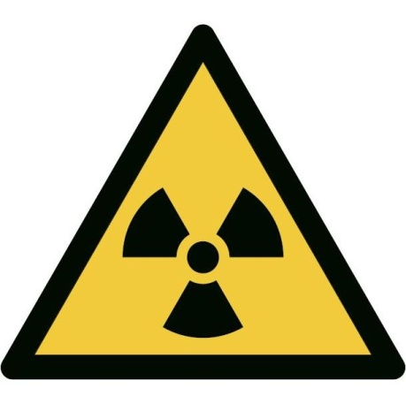

**No unauthorised access**

**Security Services and emergency staff may enter**

**More room**

**information**

**Warning; radioactive materials**

**Supervised Area**

**Moderate risk**

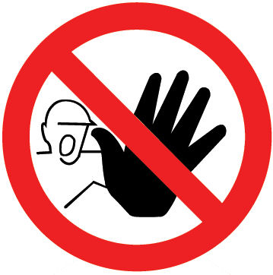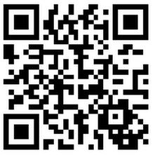

**Lab: School / Institute G.XX**

**Access: Name (0161 27) xxxxx**

**Out of hours contact:**



**More room**

**information**

**Warning; radioactive materials**

**Supervised Area**

**Moderate risk**



**No unauthorised access**

**Security Services and emergency staff may enter**



**Lab: School / Institute G.XX**

**Access: Name (0161 27) xxxxx**

**Out of hours contact:**



**No unauthorised access**

**Security Services and emergency staff may enter**

**More room**

**information**

**Warning; radioactive materials**

**Supervised Area**

**Moderate risk**



**Personal dosimetry (finger stalls / body badges) must be worn**

**Lab: School / Institute G.XX**

**Access: Name (0161 27) xxxxx**

**Out of hours contact:**



**Guidance on storage**

**Warning; radioactive materials**

**Refrigerated storage**

**Low risk**

**Typical contents C-14, H-3, I-125, P-32, P-33, S-35**

**iodine as RIA kits (etc) only**

**Maximum activity typically 740 MBq (20 mCi)**

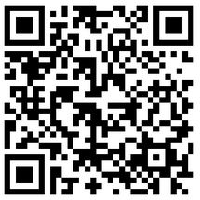

**Guidance on storage**

**Warning; radioactive materials**

**Store cupboard**

**Low risk**

**Typical contents C-14, H-3, I-125, P-32, P-33, S-35**

**iodine as RIA kits (etc) only**

**Maximum activity typically 740 MBq (20 mCi)**



**Lab: School / Institute G.XX**

**Access: Name (0161 27) xxxxx**

**Out of hours contact:**

**Lab: School / Institute G.XX**

**Access: Name (0161 27) xxxxx**

**Out of hours contact:**



**More room**

**information**

**Warning; radioactive materials**

**Low risk**

**Authorised access**

**Security Services and emergency staff may enter**



**More room**

**information**

**Warning; radioactive materials**

**Low risk**

**Authorised access**

**Security Services and emergency staff may enter**



**Lab: School / Institute G.XX**

**Access: Name (0161 27) xxxxx**

**Out of hours contact:**

**Lab: School / Institute G.XX**

**Access: Name (0161 27) xxxxx**

**Out of hours contact:**



**Warning; radioactive materials in use**

**Temporary area**

**Low risk**

**Small quantities of materials in use for a short time**

**Area monitored constantly, also at end of the working day**

**Radioisotope in use**

**………………………………**

**Maximum activity**

**………………………………**



**Lab: School / Institute**

**Radiation worker: XXX**

**Phone T: M:**

**A5 upright / portrait version, cut to fit**



**Contact the**

**Radiation Safety Unit**

**before breaking into this pipe**

**More room**

**information**

**Warning**

**Radioactive waste drain pipe**

**Low risk**

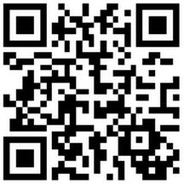

**This pipe drains labs .............................................**

**Radiation Safety Unit:**

**(0161 27) 56982 Date sign fixed:**



**Contact the**

**Radiation Safety Unit**

**before breaking into this pipe**

**More room**

**information**

**Warning**

**Radioactive waste drain pipe**

**Low risk**



**This pipe drains labs .............................................**

**Radiation Safety Unit:**

**(0161 27) 56982 Date sign fixed:**



**Warning**

**Radioactive waste drain pipe**

**Contact numbers**

**This pipe drains .........................................**

**Radiation Safety Unit (0161 27) 56982**

**Date sign placed .........................................**



*fold*



**Warning**

**Radioactive waste drain pipe**

**Contact numbers**

**This pipe drains .........................................**

**Radiation Safety Unit (0161 27) 56982**

**Date sign placed .........................................**



*fold*



**Warning**

**Radioactive waste drain pipe**

**Contact numbers**

**This pipe drains .........................................**

**Radiation Safety Unit (0161 27) 56982**

**Date sign placed .........................................**



*fold*

**Warning; radioactive materials**

**Low risk**

**Radioactive sources and samples**



**More room**

**information**



**Warning; radioactive waste**

**Low risk**

**SCINTILLANT WASTE**

**Warning; radioactive waste**

**Low risk**

**SOLID WASTE**



**Lab: School / Institute G.XX**

**Access: Name (0161 27) xxxxx**

**Out of hours contact:**



**DO NOT**

**Dispose of radioactive waste in this sink**



**DO NOT**

**Dispose of radioactive waste in this sink**



**Designated sink**

**To be used for the disposal of radioactive waste**



**Designated sink**

**To be used for the disposal of radioactive waste**



**Designated sink**

**To be used for the disposal of radioactive waste**



**Designated sink**

**To be used for the disposal of radioactive waste**



**Designated sink**

**To be used for the disposal of radioactive waste**



**Designated sink**

**To be used for the disposal of radioactive waste**