Initial signals of impact from the urgent and emergency care 10 high-impact initiatives

30 April 2024

Summary

- The January 2023 recovery plan for urgent and emergency care was generally well received. In response, NHS Regions, Systems, and Providers prioritised areas of focus, allocated resources and started implementing plans by the summer 2023.
- Respondents report that initiatives were often already in place before the ‘high-impact’ announcement in July 2023.
- Same day emergency care, acute frailty services, urgent community response and inpatient flow and length of stay are perceived to be making a positive impact on 4 hour A&E wait standards.
- Activity around urgent community response and single point of access is perceived to be contributing to improvements in Category 2 ambulance response times.
- Virtual wards were not anticipated to have a major impact on patient flow and discharge but are perceived to have potential value for defined patient groups.
- Respondents believe that they have selected right initiatives but there is also a sense that for improvements to be fully realised, there is a need to ‘stick with the plan’ into the medium term.
- NHS England’s universal support offer faced criticism for its execution, including issues with intended audience, timing, content relevance and operational challenges for those attending the webinars.
- Interviewees expressed a desire for peer-to-peer learning and exchange of successful high-impact initiatives implementation experiences across systems and providers.
- Consistently mentioned issues included a lack of focus on people with complex mental and physical health needs, insufficient attention to ambulance interventions and alignment with other national programmes.

- Evaluation context
Hospital occupancy rates in the NHS are consistently high, exacerbated by an aging population with complex health needs and seasonal increases in COVID and flu cases. This places significant strain on bed capacity and affects the delivery of timely care in urgent and emergency care (UEC) settings. Long wait times are common for those for those in A&E, including for those arriving via ambulance.
Complex interconnections within hospital systems mean that challenges in UEC departments and ambulance services are often linked to broader issues, such as capacity constraints in wards. Timely discharge of patients who no longer require in-patient care is a significant bottleneck.
The NHS Delivery Plan for Recovering Urgent and Emergency Care Services is a substantial two-year initiative aimed at enhancing care delivery for both service users and staff. Its primary goals include achieving at least 76% of people coming to A&E being admitted, transferred, or discharged within four hours by March 2024, with further improvements anticipated in 2024/25. Additionally, it aims to improve ambulance response times for Category 2 incidents, targeting an average of 30 minutes over 2023/24 and aiming for pre-pandemic levels by 2024/25.
The recovery programme encompasses various focuses, including streamlining discharge processes, expanding community-based care options, and enhancing communication and coordination across the health and care system to optimize patient flow and resource utilisation.
In July 2023, NHS England sent the letter Delivering operational resilience across the NHS this winter to all Systems and Providers on the approach to winter planning for the upcoming 2023/24 winter season. This was accompanied by a ‘system roles and responsibilities’ document which sets out the responsibilities of each part of the system and what actions should be undertaken to prepare well for winter. The letter built on the commitments and key ambitions laid out in the January plan and set out four areas of focus for Systems and Providers:
- Ensuring high-impact initiatives are in place
- Completing operational and surge planning
- ICBs should ensure effective system working across all parts of the system
- Supporting the workforce
Ten ‘high-impact’ initiatives were highlighted (see Table1). These focused on reducing waiting times for patients and crowding in A&E departments, admission avoidance, improving flow and reducing length of stay in hospital settings. NHS Systems and Providers were expected to prioritise the delivery of at least four of these initiatives to drive improvement efforts locally.
Table 1: Summary of high-impact initiatives options as part of the UEC recovery plan
Initiative | Focus | Anticipated changes and process impacts
Same day emergency care | Same day care (assessment, diagnosis, treatment, and discharge) for people with an emergency health issue to avoid a hospital admission. | Reducing variation in SDEC provision by providing guidance about operating a variety of SDEC services for at least 12 hours per day, 7 days per week
Acute frailty services | Service that identifies and assess frail patients soon after their arrival to hospital. | Reducing variation in acute frailty service provision Improving recognition of cases that could benefit from specific frailty services and ensuring referrals to avoid admission
Virtual wards | Virtual wards aim to deliver acute hospital level in-patient care in people’s homes. Use of technology is likely to play a role in these models. | Standardising and improving care across all virtual ward services to improve the level of care to prevent admission to hospital and improve discharge
Urgent Community Response | Delivery of urgent care to people in their homes, with referrals from multiple sources | Increasing volume and consistency of referrals to improve patient care and ease pressure on ambulance services and avoid unnecessary admissions
Acute Respiratory Infection Hubs | Service provision for the rapid assessment of people with acute respiratory infections, aiming to provide same day assessment to people referred from multiple sources. | Support consistent roll out of services, prioritising acute respiratory infection, to provide same day urgent assessment with the benefit of releasing capacity in ED and general practice to support system pressures
Inpatient flow and length of stay (acute) | Implementing in hospital efficiencies to support patient flow and timely, efficient discharge. | Reducing variation in inpatient care and length of stay for key UEC pathways/conditions/cohorts by implementing in-hospital efficiencies and bringing forward discharge process for pathway 0 patients
Community bed productivity and flow | Implementing community bed focused efficiencies to support patient flow and timely and efficient discharge. | Reducing length of stay and variation in inpatient care by implementing in-hospital efficiencies and bringing forward discharge processes
Care Transfer Hubs | A system level service that links relevant care services (e.g., acute, primary, community, local authority and third sector) to co-ordinate care for people. Key focus on safe hospital discharge | Implementing a standard operating procedure and minimum standards for care transfer hubs to reduce variation and maximise access to community rehabilitation and prevent re-admission to a hospital bed
Intermediate care demand and capacity | Supporting the operationalisation of ongoing demand and capacity planning, including through improved use of data to improve access to and quality of intermediate care including community rehab. | Supporting the operationalisation of ongoing demand and capacity planning, including through improved use of data to improve access to and quality of intermediate care including community rehab
Single point of access | Single point of referral for urgent care requirements. Aims to maximised care co-ordination which will facilitate whole system management of patients into the right care setting, with the right clinician/team, at the right time | Driving standardisation of urgent integrated care co-ordination which will facilitate whole system management of patients into the right care setting, with the right clinician/team, at the right time

- Gathering insights
This was a very rapid formative evaluation designed to inform ongoing learning and to serve as a basis for future policies and evaluations. We generated rapid insights on the practical implications of the July 2023 communication, focusing on the delivery of 10 specific high-impact initiatives, from a range of stakeholder perspectives.
The evaluation timeframe precluded in-depth engagement with individual Systems and Providers. Instead, we conducted a high-level online survey, developed in Qualtrics, a University of Manchester IGO-approved secure web platform. This survey sought to capture information on:

- What high-impact initiatives are being delivered locally
- Whether initiatives were new or existed prior to the recovery plan
- What sources of support were offered and or accessed
- Any barriers and enablers to delivery
- Whether there were any spillover effects or unintended consequences from delivery
- Which of the initiatives were perceived to have been most impactful
- Whether respondents were willing to participate in a follow up interview

The survey invite was circulated by email by the National UEC Team to Regional Chief Operating Officers, NHS Systems and Providers via existing NHS England channels on the 8th March 2024. A reminder email was sent on the 15th March 2024. The National Clinical Director for UEC also circulated a survey invite to Royal Colleges and other Clinical Leads via the Clinical Reference Group on 4th April 2024. A summary of the evaluation timelines is presented in Figure 1. The survey was open between 11th March and 19th of April 2024, and there were 127 respondents. Table 2 presents response rates by NHS Region. We summarised data from the survey with descriptive statistics.
Table 2: Survey responses by NHS Region
Survey responses by NHS Region | n (%)
East of England | 17 (13.4)
London | 21 (16.5)
Midlands | 22 (17.3)
North East and Yorkshire | 16 (12.6)
North West | 27 (21.3)
South East | 16 (12.6)
South West | 8 (6.3)
Total | 127 (100)

Follow-up interviews were conducted with people in Systems and Providers. Potential informants were assured of data protection and confidentiality ahead of interview. Participation was voluntary, and the anonymity of both individuals and the organisations they represent was assured as published findings would be anonymised and aggregated.
Interviews focused on how and why the selected high-impact initiatives were chosen; what, if any, implementation challenges were encountered; and whether there had been any perceived signs of impact, particularly around the 4-hour waiting time standard and Category 2 response times. We aimed for geographical representation from all regions in NHS England. We also conducted interviews with regional UEC leads.
Interviews were conducted between 8th March and 19th of April 2024. In total, we spoke to 21 people. Interviews were audio-recorded with consent. Recordings were not transcribed and were deleted upon coding of data. Interviews were analysed with a rapid approach to analysis, using a modified framework approach (Gale 2013). A coding framework was developed iteratively through discussion and REVAL analysis meetings, as well as through discussions with the NHS England team.
Figure 1: Evaluation timeline
 | February |  | March |  |  |  | April
Survey development
Survey distribution
Survey open
Survey Reminders
Key informant Interviews
Synthesis of insights

- Insights
The following insights provide early signals of the perceived impact of the ‘high-impact’ initiatives and of the value of the support offer in this process.

3.1 Prioritisation of high-impact initiatives

Interview data suggests that the January 2023 plan for recovery of UEC services was well received. In response to the announcement, and in the months following, NHS Regions, Systems and Providers worked together to identify the most pressing UEC issues and develop their operational responses to these. Regions and Systems reported that they focused on where the biggest gains in UEC recovery could be made – this often meant doing existing things better rather than starting new initiatives from scratch. Decisions were data driven and most influenced by what was deemed achievable given timeframes, estate, and resource constraints. This meant resources were committed and local UEC recovery plans were being implemented ahead of the summer 2023 letter announcing the high-impact initiatives focus. Survey responses (Table 3) support this, suggesting that initiatives were often available prior to the prioritisation request
A commitment to existing initiatives as part of the high-impact initiative work was also apparent from survey responses on the self-assessed maturity assessment exercise. Whilst this exercise was undertaken to support initiative selection, of the 69 respondents for this question, only 38% agreed that it had usefully informed initiative selection. Despite this, some interviewees stated that they liked the guidance provided by the maturity assessment, that was useful to get an overview of what was happening in their site, and that they planned to use it to determine focus for the 24/25 financial year.

Table 3: Initiatives recorded as prioritised in the survey (total n across the survey = 127)
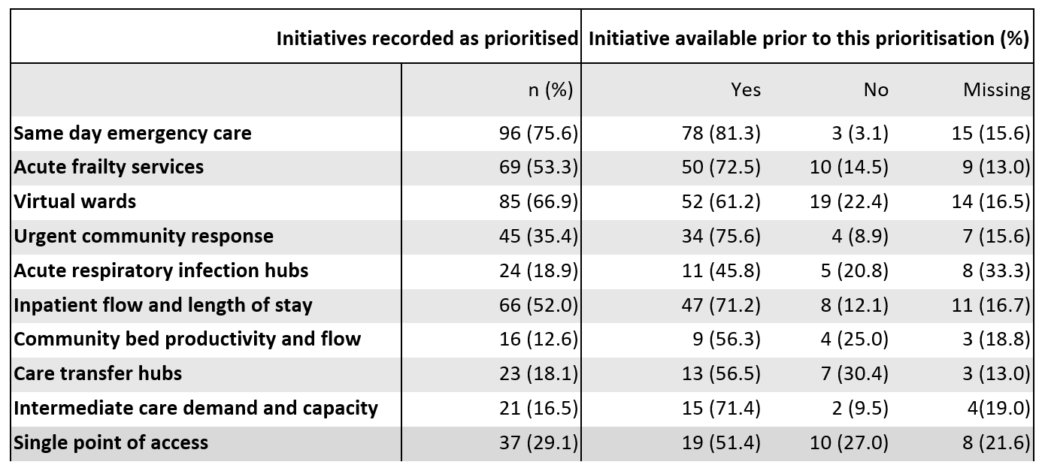

3.2 Universal Support Offer

When surveyed about their experience of the offer to support improvement and implementation of high priority initiatives, only 10% of respondents felt this has been adequate (Table 4).

Table 4 Overview of responses to survey question on people’s experiences to date with the improvement support offer by NHS England (n=80)
Response | n (%)
Extremely adequate | 0 (0)
Adequate | 8 (10.0)
Neither adequate nor inadequate | 28 (35.0)
Inadequate | 23 (28.7)
Extremely inadequate | 21 (26.3)

When explored in interviews, many interviewees indicated that support offer was not well received locally. It was perceived to have repeated the mistakes of an earlier support offer that targeted senior executive rather than operational staff. Whilst the webinars were viewed as being of good quality, overall, they were not necessarily the best format for the senior audience being targeted. Some interviewees also expressed frustration that the operational staff most likely to benefit; and indeed, the ones most likely to enact rapid improvement activity on the ground (Bands 4 to 7), were the ones excluded from participating in the support offer. The time commitment required for participation and the perceived need to complete mandatory homework (even though it actually wasn’t mandatory) were deemed too unrealistic in the months leading up to winter. Additional operational challenges, including last-minute invites, the inability to forward invites (leading to very senior staff trying to deal with these requests) and clashing sessions led to further drop-off in engagement at both System and Provider levels.
Despite this, many informants have highlighted that there is a strong appetite for peer-to-peer learning within UEC and that there are already many formal and informal learning networks around urgent and emergency care across regions; Emergency Medicine Leads have a national WhatsApp advice group for example.
Interviewees indicated that peer-to-peer learning was perceived to be very helpful and something that could be usefully expanded. Whilst time consuming, people could also see value in practical exposure to peer activities as opposed to seeing a showcase on a webinar. Suggested practical activities included operational site visits to other organisations with similar settings or populations or having in-person meetings with peers to discuss delivery experience and challenges in detail. Regional leads are well placed to coordinate or facilitate this learning as they well networked into ongoing activities across the region, allowing them to match people from similar settings/ facing similar challenges.

3.3 Initiatives and signals of impact

Selection of initiatives
From the survey, same day emergency care (SDEC), virtual wards, acute frailty services and inpatient flow and management were the most commonly selected initiatives (see Table 3 above). It was clear from interviews that initiative selection was informed by regional 23/24 planning priorities, as well as contextual factors that facilitated or inhibited specific activities. For example, physical estate and resource constraints in some settings meant that some initiatives were not possible to implement some services (SDEC for example). In some settings, regional planning deprioritised initiatives that were either too seasonal or perceived to lack an evidence base for impact – acute respiratory infection hubs for example.
Regions and Systems aimed to balance what activities were needed with those that would be achievable and provide the biggest gains in improvement. Survey respondents largely perceived they made the right decisions in their initiative selection; there is a commitment to choice. This was supported in interviews, with further insights that for improvements to be fully realised, there is a need to ‘stick with the plan’ into the medium term.
Whilst sticking with the plan was important, there was a strong sense that on-going issues of resourcing across the wider health and social care system would continue to put pressure on UEC. The interconnectivity between primary and community care, UEC, wider acute care and social care was, unsurprisingly, a common theme. Diversification of UEC services was recognised as vital, but these activities remain part of a complex system in which there are competing national priorities and where large-scale change is challenging.
Signals of impact: Category 2 ambulance response times
Over 60% of survey respondents reported that urgent community response, community bed productivity and flow, and single point of access had, or are likely to, contribute to improvement in Category 2 ambulance response time over the next 12 months (see Table 5). The regions where agreement was highest for the impact of these initiatives were East of England, London, Midlands and the North-West. These regional signals are tentative as they are based on small response numbers.
Signals of impact: A&E 4-hour waiting times
Over 60% of respondents recorded that SDEC, acute frailty services and urgent community response had, or are likely to, contribute to A&E 4-hour waiting times over the next 12 months (see Table 5). The regions where agreement was highest for the impact of these initiatives were East of England, and the Midlands. Again, these signals are tentative as they are based on small response numbers.

Table 5: Survey responses to positive statements on improved ambulance response and A&E waiting times
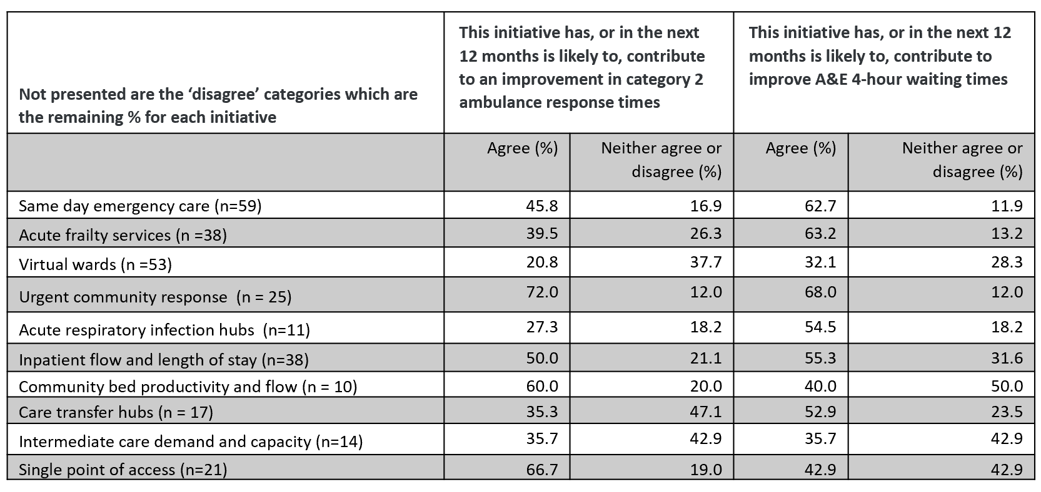

Signals of impact: reductions in hospital admissions and timely discharge
When asked about perceived impact of initiatives on a reduction in hospital admissions, 60% or more of survey respondents reported that acute frailty services, urgent community response, intermediate care demand and capacity and single point of access had, or are likely to, lead to a reduction in inpatient hospital admissions in the next 12 months (see Table 5). Some of these initiatives, however, had small response numbers so these results are fragile and susceptible to change.
Two thirds or more of survey respondents reported that acute frailty services, community bed productivity and flow, care transfer hubs, inpatient flow and length of stay and intermediate care demand and capacity had, or were likely to, improve timely hospital discharge in the next 12 months (see Table 6). Again, numbers for community bed productivity and flow, and for intermediate care demand and capacity were small. Additionally, inpatient flow and length of stay was noted by respondents as being the most challenging of the high-impact initiatives to implement.

Table 6: Survey responses to positive statements on reductions in hospital admission and improved timely discharge
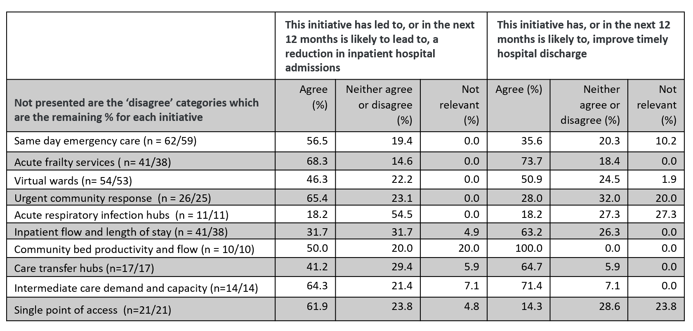

Signals of impact summary
From the survey data, several initiatives were perceived to have had, or the potential to have, impacts across key metrics. Acute frailty services and urgent community response were had 60% or higher agreement with positive statements about current or future impact for three of the four key metrics measured by the survey (Table 7). Whilst selected by a relatively high number of respondents, virtual wards did not score highly on any metric. Interview data suggests that virtual wards are not anticipated to have a major impact on patient flow and discharge but do have potential value for very defined patient groups.
Table 7: Summary of initiatives with 60% or more agreement with positive statements relating to key metrics (*based on very low number of responses)
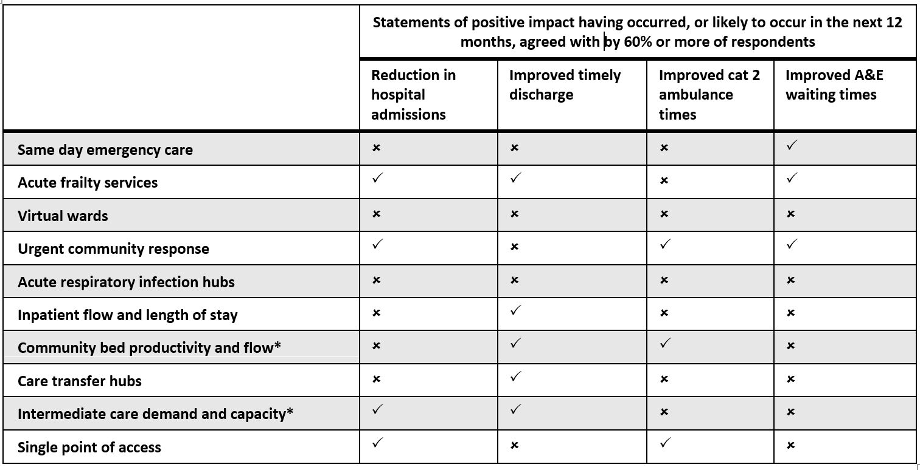
As the survey results are based on small numbers, it was important to link signals to interview information. However, people regularly noted that, due to the complexity of UEC delivery, the many players involved, and ongoing challenges like industrial action and a post pandemic workforce less familiar with working to performance standards, it was difficult to tease out signals of impact due to a particular initiative.
Interviewees again reinforced that the high-impact initiatives are, broadly, the right UEC services of focus and that was largely recognised by systems prior to the July 2023 support offer. People we spoke to emphasised the potential value of single points of access and the high use of SDECs. However, there were often caveats such as whether initiatives were targeting the right population groups, whether patient experience and care was actually enhanced by use of these ‘off clock’ initiatives or whether some, like virtual wards, may be acting as a safety net for people who could or would previously have been discharged home, without follow-up. Other people noted again that the work is difficult to quantify yet, but that regular monitoring via dashboards was giving a sense that improvements are coming but more time is needed for these to be confirmed.

3.4 Spillover effects and potential gaps in initiative focus
In interviews we explored any unintended consequences and or spillover effects arising from the focus on the high-impact initiatives. It is worth highlighting that interviewees do not view the high-impact initiatives as discrete interventions in their own right but as elements of wider plans to divert patients, avoid admissions, and enhance flow. In this context, it is mainly existing UEC staff that are deployed to deliver these services, and sometimes this displacement can result in fewer staff members available in A&E to manage presenting patients. All against a backdrop of prolonged industrial action.
Some interviewees mentioned that stopping or diverting people from arriving at the ‘front door’ was not being rewarded or recognised in the recovery plan. Interviewees mentioned that patients who would have previously been seen, treated, and discharged within four hours, were now being diverted or managed elsewhere. This in turn has led to a concentration of presenting patients with more complex needs, which take more time to manage, making it more difficult to achieve 4-hour waiting time standards. In particular, people with complex mental health and physical health needs were mentioned as a group that were challenging to manage in A&E. Whilst there is a focus on improving access to and capacity in mental health crisis services there is a lack of focus on admission and transfer options for those with physical health needs. Many patients become stuck in A&E as a result.
Many interview participants mentioned that in the post-pandemic period, the UEC workforce has not experienced working to performance targets. The pandemic ways of working and the turnover of the UEC workforce has led to a loss of organisational memory, particularly in relation to the 4-hour standard. The March 2024 focus on 4-hour standards has helped refocus but normalising the 76% target will be challenging. Opportunities to share learning on delivering sustained operational management and productivity would be welcome.
Finally, many interviewees mentioned that unscheduled care is not just tackled in UEC, but also across the system as a whole. Many systems are facing significant financial and workforce challenges and as such have finite capacity to respond to and address the requirements of the various national programmes and sector recovery plans – this can be can be ‘a job in itself’. Prioritisation and coordination of announcements by national teams would alleviate some of this burden.

- Next steps
This briefing report aims to provide actionable insights on the initial impact of the high-impact initiative to inform the ongoing UEC recovery plan. Results have been presented in a feedback session with the national team. A discussion with the national team will be held to inform the development of the 12-month evaluation to follow on from this work.

Authors
Maartje Kletter, Elaine Harkness, Jo Dumville and Paul Wilson.
NIHR Rapid Service Evaluation Team (REVAL)
School of Health Sciences
University of Manchester

Address for correspondence; paul.wilson@manchester.ac.uk

Disclaimer
This research is an independent evaluation undertaken by the NIHR Rapid Service Evaluation Team (REVAL). REVAL is funded via a competitive review process by the NIHR Health Services and Care Delivery Research Programme (NIHR151666).
The views expressed in this briefing are those of the author(s) and not necessarily those of the NIHR, NHS England or the Department of Health and Social Care.

All the authors are in receipt of funding from the NIHR.

