Children’s Menu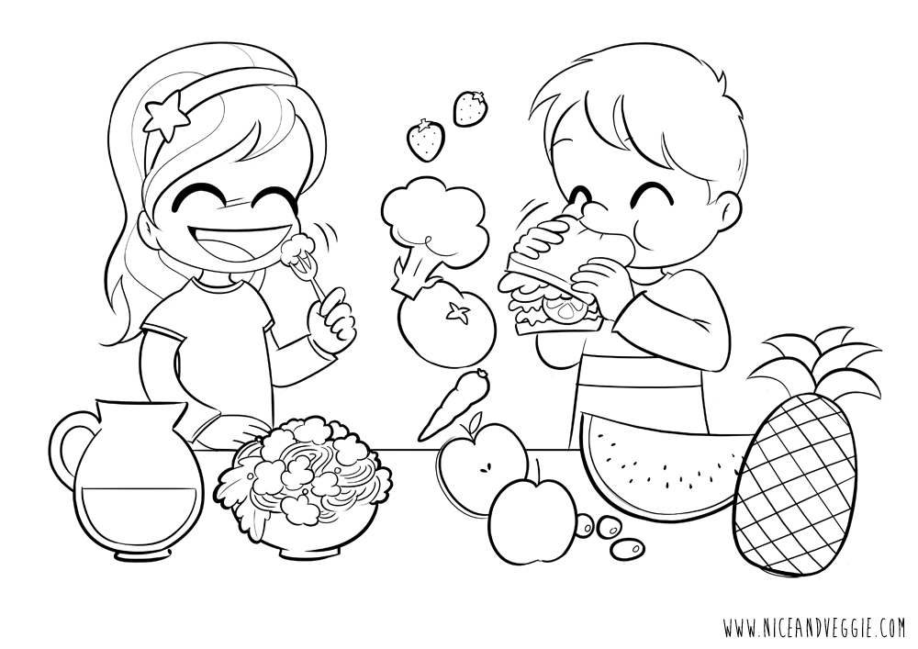

Roast ham sandwich, hummus, carrot sticks £4.00

Cheese sandwich, hummus, carrot sticks *(v)*  £4.00

Spaghetti, tomato sauce, parmesan *(v)* £5.00

Homemade fish fingers, French fries, beans £5.50

Pork sausage, French fries, beans £5.50

‘Little mezze’  
*hummus, olives, cottage cheese, carrot sticks, flat bread (v)* £5.50