The Martin Lawlor Research Bursary Award
Winner’s post-activity report detailing how the award money was spent to benefit professional and career development, by Somto Chike-Obuekwe

Report on the 32nd International Association for Suicide Prevention (IASP) Congress in Piran, Slovenia

I would like to start by expressing my gratitude to the Martin Lawlor Bursary Award for awarding me this grant that allowed me to attend and present my research work in an international congress at the International Association Suicide Prevention (IASP) Congress held in Piran, Slovenia, from the 19th to the 23rd of September 2023. The congress was held in the Grand Hotel Bernardin located by the sea, which is an awesome view to pass while walking to the congress.
The main objective of the IASP congress is to increase regional and worldwide awareness on the issue of suicide while highlighting the necessity of prompt local action. This congress provided a crucial forum for sharing information among a diverse community of academics,
researchers, clinicians, crisis responders, and people with lived experiences. It facilitated the sharing of viewpoints and novel research on suicide prevention methods across local, national, and worldwide contexts.
Activities
The congress featured a range of activities designed to achieve the stated objectives:
- Plenary Sessions: Renowned experts in the field of mental health and suicide prevention delivered keynote speeches addressing the latest research findings and innovative approaches.
- Workshops: Concurrent workshops covered various aspects of suicide prevention, including risk assessment, crisis intervention, postvention support, and community-based initiatives. Workshops included Self Talk, Partnerships for Life, Early Career Researchers and Special Interest Group for Primary Care.
- Panel Discussions: Panels of experts, individuals with lived experience, and representatives from diverse organisations engaged in insightful discussions on topics such as destigmatisation, access to mental health care, and community resilience.
- Networking Opportunities: Attendees had opportunities to connect with one another, fostering collaboration and the exchange of ideas during coffee and lunch periods.
- Resource Fair: A resource fair featured organisations and resources related to suicide prevention, providing valuable information to attendees such as LivingWorks, the American Association of Suicidology (AAS) and the Slovene Centre for Suicide Research.
The congress was a resounding success. It was a wonderful experience that I will continue to cherish, I not only learnt and acquired knowledge but also developed personally as a
researcher. I also got the opportunity to meet and talk to researchers and policymakers whom I highly admire. The Congress had fantastic talks, posters, symposiums, and workshops. One of the presentations that stood out to me was presented by Professor Joseph Osafo and Dr Emmanuel Nii Boye Quarshie on the decriminalisation of suicide in Ghana. The presentation highlighted the challenges such as the cultural and religious stigma associated with suicide. Furthermore, the presentation highlighted the action that led to decriminalising suicide in Ghana. This was a very interesting presentation because Nigeria (my home country and setting for my research) is a country with similar histories and beliefs. Therefore, the action taken could easily be implemented in Nigeria. Also of great interest to me were presentations by Delesha Carpenter on the Development of the Pharm-SAVES educational module for gatekeeper suicide prevention training for community pharmacy staff.
I was also privileged to attend presentations on suicide prevention guidelines, where I learnt about the key criteria for developing and implementing guidelines. Additionally, it was interesting to see similar methods as my research being applied, which gave me the opportunity to share the challenges and strengths of my research. This also informed me of possible future work and collaborations from this research.
Away from the main sessions, I attended workshops such as SafeTalk, organised by LivingWorks Australia, where I learned to have an effective and comforting conversation about suicide. I find it interesting to implement within my country because part of the suicide prevention barrier we face is talking about suicide without shame. The Congress also organised a Pecha Kucha presentation where presenters present their work in the form of imagery storytelling in under 4 minutes. I was excited to be there to witness the advancement of research, especially for presenters who have associated suicide prevention with social media and internet use.
I was excited to present my work to a room of game changers in the field. I presented my PhD work on the Contribution of Community Pharmacists in Suicide Prevention Efforts in Nigeria. I did two presentations - a qualitative study involving global key informants was presented on Wednesday under Implementing Suicide Prevention at the Community level. The second part of the research work is a Delphi study focusing on the community pharmacists in Nigeria, which was presented as part of a symposium, “Dispensing Support- How Pharmacists and their Teams Contribute to Suicide Prevention Efforts”.
Being a shy, nervous speaker, I was proud of my accomplishments during this congress. I received accolades from experts in the field. The interest people had in my work highlighted the importance and the future impact of the research. However, I also felt the lonely part of my research of being the first and trying to build on non-existing literature, especially in a country where you are uncertain about the expectations of your change, but I hold on to the words of Abraham Maslow, “In any given moment we have two options: to step forward to growth or step back into safety.”
This experience was extremely beneficial for my professional development as a researcher, as well as learning about other techniques and areas employed by researchers in this important field. I would again like to show my sincere appreciation to the Martin Lawlor Bursary Team for this invaluable opportunity to showcase my work and create awareness of suicide prevention efforts in Nigeria. The networking connection I made from this congress will forever be of great value to my research work.

Picture 1: During my first presentation
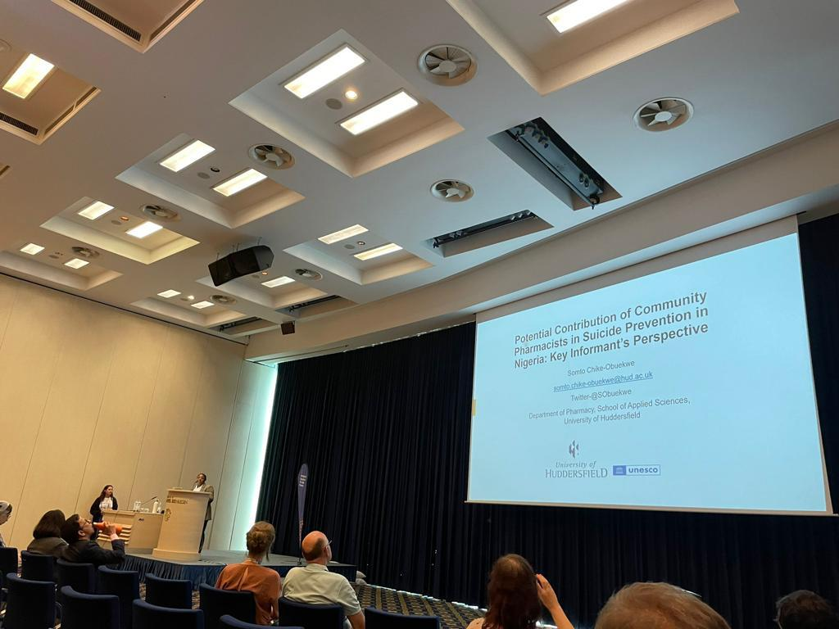
Picture 2: During my first presentation
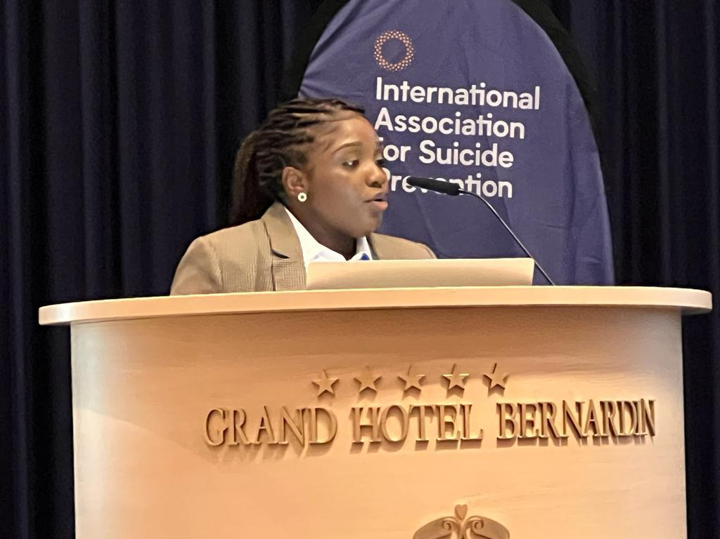
Picture 3: Picture with the Pharmacy group (L-R Prof Josie Solomon, Dr Ana Maria Barcelos, Somto Chike-Obuekwe, Dr Hayley Gorton, Pauline Stas and Dr Delesha Carpenter)
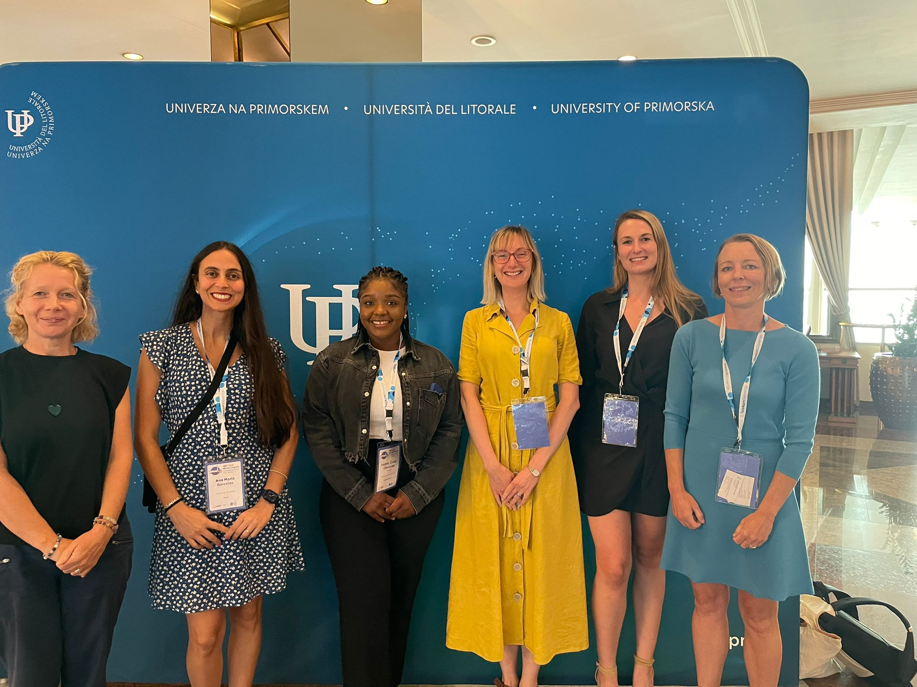

Picture 4: Picture with African region researchers on suicide prevention. (L-R:Prof Joseph Osafo, Somto Chike-Obuekwe and Dr Nii-Boye Quarshie Emmanuel)
