Working with colleagues across the University, we've enabled:

# TEACHING SUPPORT AND POLICY

* 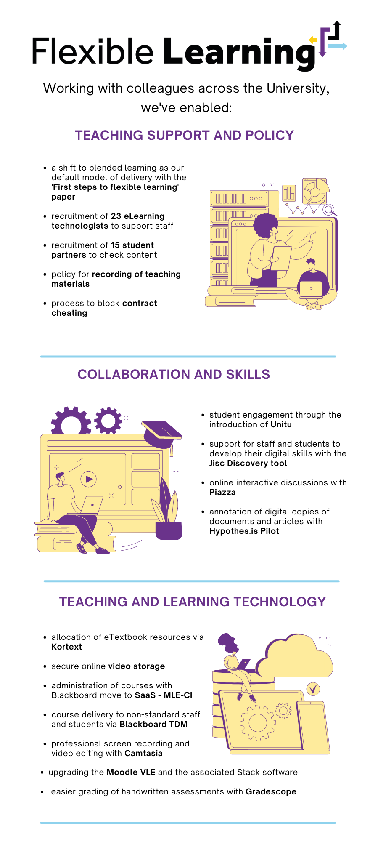A shift to blended learning as our default model of delivery with the **'First steps to flexible learning' paper**
* Recruitment of **23 eLearning technologists** to support staff
* Recruitment of **15 student partners** to check content
* Policy for **recording of teaching materials**
* Process to block **contract cheating**

# Collaboration and Skills

* Student engagement through the introduction of **Unitu**
* Support for staff and students to develop their digital skills with the **Jisc Discovery tool**
* Online interactive discussions with **Piazza**
* Annotation of digital copies of documents and articles with **Hypothes.is Pilot**

# Teaching and Learning Technology

* Allocation of eTextbook resources via **Kortext**
* Secure online **video storage**
* Administration of courses with Blackboard move to **SaaS - MLE-CI**
* Course delivery to non-standard staff and students via **Blackboard TDM**
* Professional screen recording and video editing with **Camtasia**
* Upgrading to **Moodle VLE** and the associated **Stack software**
* Easier grading of handwritten assessments with **Gradescope**