Welcome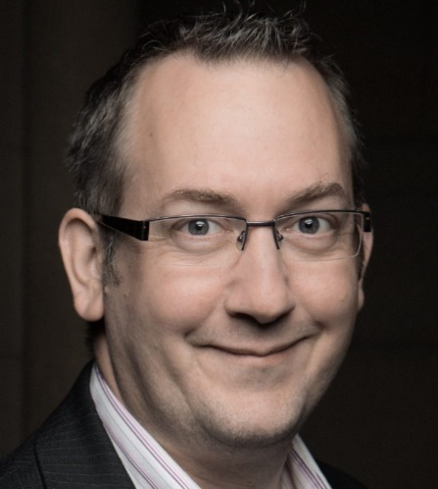 to Engineering the Future 2023

# Professor Ian Cotton

Welcome to the Engineering the Future conference which is being held in the new home of Engineering and Materials at The University of Manchester. During this two-day event we hope you will have the chance to learn more about the ways we are shaping the future through our research and our education of the next generation of engineers.

The connection between our engineering expertise and our region takes us back to the 1800s. The University originated in Victorian times in response to the engineering challenges of the industrial revolution then centred in the North West of England. The 1824 that you see on the University logo was the date of the formation of the Manchester Mechanics’ Institution and the University soon followed in 1851.

Manchester was the birthplace of the industrial revolution, but we now know that this initiated one of today’s biggest global challenges – climate change. A significant proportion of our activity is now focused on addressing this through major research projects in engineering and by ensuring our knowledge is used to inform the decarbonisation plans of the Greater Manchester region.

Our work focused on climate change takes place alongside a much wider portfolio of research and teaching that supports many of the United Nations Sustainable Development Goals (SDGs). We make major contributions that benefit people across the world in areas including health, clean water and resilient infrastructure. The quality and scale of our impact against these goals was ranked among the top ten in the world in the Times Higher Education University Impact Rankings in 2022. The University of Manchester has contributed 21,571 research publications across all 17 SDGs over the past five years – representing 4% of the UK’s research on the goals. This event will tell you about some of the research and teaching that has contributed to this success.

We’re delighted to be joined by so many people over the two days of the event. We have over 300 attendees in person each day with more joining sessions virtually. As such we hope you have a chance to make new connections with colleagues from both inside and outside of the University. You have the chance to visit stands hosted by our Research Institutes, Business Engagement Team and the Innovation Factory. Businesses can access a range of funding that supports industrially focused research. Our colleagues would be delighted to provide more details of this.

Our venue is Engineering Building A, this is a place like no other and one of the largest higher education construction projects completed in the UK. This new part of the campus is made up of five buildings, Engineering Buildings A and B, Oddfellows Hall, James Chadwick Building and York Street Building. Within these buildings are housed a wide range of experimental facilities ranging from a large wave tank that is being used to accelerate the deployment of offshore renewables to laboratories focused on electromagnetic techniques being used for a range of purposes from de-mining to airport security. All of our experimental facilities can be used by colleagues across the University and can be accessed by business.

Finally, can I thank all of my colleagues who have contributed to the delivery of this event, both those who are delivering the sessions and the teams who have worked behind the scenes to make it a success. We all hope you enjoy the event and make new connections that will benefit you in the future.

# Engineering the Future

The Engineering the Future conference is hosted by the School of Engineering and the Department of Materials. The conference is showcasing recent and future research and the contributions we are making in educating the next generation of engineers. The event highlights the way our work is impacting the world around us (including contributing to the UN Sustainable Development Goals) and provides an opportunity to learn more about what we do.

The conference is your opportunity to:

* Attend talks and interactive workshops focused on specific technical areas.
* Meet our researchers and students.
* Visit our facilities and understand how you can access them.
* Speak with our business engagement teams to find out more about how to work with us.

The venue

## A photo of Engineering Building A with the University of Manchester logo on it.

The event is being held in the new home of Engineering and Materials at The University of Manchester. This is where engineers and material scientists collaborate, innovate, and make their mark on the world. These new buildings add to our existing presence in Kilburn Building and a range of other locations across campus. Unrivalled in scale in the UK as a hub of engineering and materials expertise, it combines Manchester’s heritage as the birthplace of the industrial revolution with new purpose-built facilities that are enabling a change in our approach to solving some of the world’s most pressing issues.

Find your conference room by using the home of Engineering and Materials [interactive map](https://clients.mapsindoors.com/uniofmanchester/f02513f6650e4646ae55c607/search)

Learn more about our new home of [Engineering and Materials at The University of Manchester.](https://www.mecd.manchester.ac.uk/)

## Maker Space

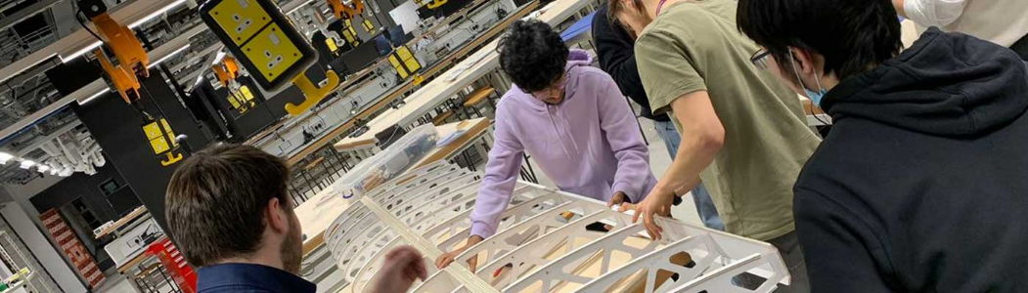

Manchester is synonymous with the Worker Bee and our Makerspace is the hive of activity. It is led by students, for students, as a self-sustainable best-in-class ecosystem of creativity, innovation, and entrepreneurship. So, a chemical engineer could be sat alongside a materials scientist working on clean water, or bump into a fashion student developing their own sustainable brand, or an aerospace engineer sending a rocket into space.

It is a place like no other for interactions and one of the biggest communities of engineers and materials scientists in any University in the world.

Located in the heart of Engineering Building A, next the Ground Floor event space, the Makerspace is an environment like no other – a place which rips up the rule book on traditional disciplinary boundaries and provides the space and tools for staff, students and visitors to bring their ideas to life as part of an inclusive ecosystem of innovation.

Learn more about our [Makerspace](https://www.mecd.manchester.ac.uk/makerspace/).

On both days of the conference, we’ll be open between 9:00am – 10:00am during morning registration sessions and 1:00 – 2:00pm over lunchtime– whether you’re staff or a visitor, why not drop in and speak with our team to find out more about how to get involved.

Video link - <https://www.youtube.com/watch?v=DS5q8EyLXRA>

## Institutes and Centres

The collaborative nature of our research means we are able to push the boundaries of our research discoveries, as well as providing key expertise to the businesses we work with.

Much of our research is concentrated around key Institutes and Centres, many of which include industry partners.

Learn more about our [Institutes and Centres.](https://www.se.manchester.ac.uk/research/institutes-and-centres/)

Our institutes will be available to talk to you at lunch time on both days in Engineering A 2A.011-.14.

# Conference programme

# Sessions Day 1 – Tuesday 28 March

Our team will be on hand to direct you to your sessions, this [digital interactive map](https://clients.mapsindoors.com/uniofmanchester/f02513f6650e4646ae55c607/search) Engineering Building A & B can also be used.

|  |  |
| --- | --- |
| Room/Time | Tuesday 28 March 2023 |
| Engineering A  9:00 – 10:00am | **Registration**  **Tea/Coffee & pastries in the main exhibition area** |
| Lecture Theatre A  10:00 – 10:45 | **Welcome from Professor Chris Hardacre**  **Keynote Speaker**  **Azhar Quaiyoom**  **Delivering Sustainable Projects and calling ALL to action!** |
| Engineering A 3A.052  11:00 – 13:00 | **Engineering for Health**  **Alex Casson and Amir Keshmiri** |
| Engineering B – 2B.002  11:00-13:00 | **Robotics & AI**  **Angelo Cangelosi** |
| Engineering B – 2B.026  11:00-13:00 | **Delivering Net Zero – a showcase and reflection on working with stakeholders and collaborating to drive change**  **Prof Carly McLachlan** |
| Engineering B – 2B.003  11:00-13:00 | **Chemical Engineering Pilot Plant**  **Dr Vincenzo Spallina** |
| Bridge joining Engineering Build A and B  11:30 – 12:30 | **Facility and capability tours**  **John Warren** |
| Engineering A – 2A.011-14  1:00 – 2:00 | **Lunch**  **Meet our representatives from our institutes and centres** |
| Engineering B – 2B.003  2:00-4:00pm | **TRANSIT – Transition to a Sustainable Future through Training and Education**  **Eduardo Martinez-Cesena** |
| Engineering B – 2B.025  2:00-4:00pm | **Virtual and Augmented reality in Engineering**  **Lee Margetts** |
| Engineering B – 2B.026  2:00-4:00pm | **Artificial Intelligence in Engineering**  **Hujin Yin** |
| Engineering B – 2B.002  2:00-4:00pm | **Subsurface Engineering in the context of Energy Transition and Security**  **Prof Vahid Niasar** |
| Engineering A 3A.052  2:00-4:00pm | **Engineering for Quantum**  **Dr Jessica Boland** |
| Bridge joining Engineering Build A and B  2:30 – 3:30pm | **Facility & capability tours**  **John Warren** |

# Session Day 2 – Wednesday 29 March

Our team will be on hand to direct you to your sessions, this [digital interactive map](https://clients.mapsindoors.com/uniofmanchester/f02513f6650e4646ae55c607/search) Engineering Building A & B can also be used.

|  |  |
| --- | --- |
| Room/Time | Tuesday 28 March 2023 |
| Engineering A  9:00 – 10:00am | **Registration**  **Tea/Coffee & pastries in the main exhibition area** |
| Lecture Theatre A  10:00 – 10:45 | **Welcome from Professor Alice Larkin**  **Keynote Speaker**  **Professor Danielle George**  **Engineering education and inspiring the next generation** |
| Engineering B – 2B.003  11:00-13:00 | **Engineering coating for corrosion control**  **Beatriz Mingo** |
| Engineering B – 2B.002  11:00-13:00 | **FutureMODSIM (1)**  **Prof Alistair Revell and Prof Benedict Rogers** |
| Engineering B – Blended Theatre G.056  11:00-13:00 | **Sustainable Futures**  **Steve Lowe** |
| Engineering A 3A.052  11:00-13:00 | **Advanced in Mechanics of Materials**  **Andrey Jivkov** |
| Bridge joining Engineering Build A and B  11:30 – 12:30 | **Facility and capability tours**  **John Warren** |
| Engineering A – 2A.011-14  1:00 – 2:00 | **Lunch**  **Meet our representatives from our institutes and centres** |
| Engineering B – 2B.003  2:00-4:00pm | **Advanced Engineering Materials**  **Tim Burnett** |
| Engineering B – 2B.002  2:00-4:00pm | **FutureMODSIM (2)**  **Prof Alistair Revell and Prof Benedict Rogers** |
| Engineering B – Blended Theatre G.056  2:00-4:00pm | **Sustainable Future – Decarbonising Construction**  **Dr Mithila Achintha and Prof Yong Wang** |
| Engineering A 3A.052  2:00-4:00pm | **Electronic transport systems – design test and monitoring**  **Prof Ian Cotton** |
| Engineering B 2B.026  2:00-4:00pm | **The use of ChatGPT in assessments**  **Prof Andrew Stewart** |
| Bridge joining Engineering Build A and B  2:30 – 3:30pm | **Facility and capability tours**  **John Warren** |

# Keynote Speakers



[Professor Danielle George](https://research.manchester.ac.uk/en/persons/danielle.george)

Danielle is the University’s Vice President for Teaching, Learning and Students and Professor of Radio Frequency Engineering. She completed her BSc in Astrophysics at the University of Liverpool, MSc in Radio Astronomy at The Victoria University of Manchester based at Jodrell Bank Observatory, and her PhD in Electrical and Electronic Engineering at The University of Manchester Institute of Science and Technology.

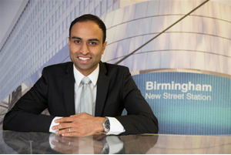

Azhar Quaiyoom

Azhar is a highly motivated and charismatic entrepreneur and Chartered Engineering professional with 20 years’ experience within sustainable design and delivery across different sectors such as buildings and Infrastructure, in particular, rail, creating first of its kind achievements across complex projects. This is coupled with invaluable experience in practical major programmes with extensive knowledge of the feasibility, design, and implementation stages. With this experience, Azhar runs a successful consultancy at [Q Sustain](https://www.qsustain.co.uk/) that is well placed to expand and diversify with a key emphasis on creating a diverse and inclusive workforce and engaging all communities to consider careers and activities related to climate action.

Azhar has a rare and exclusive combination of Engineering design, sustainability, and practical project management experience with knowledge of how to implement low carbon and sustainable developments from concept, design, and procurement to construction and operation.

# Day 1 Session Leads – Tuesday 28 March.

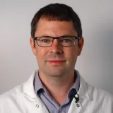 [Dr Alex Casson](https://research.manchester.ac.uk/en/persons/alex.casson) 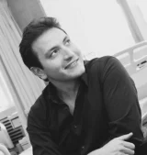 [Dr Amir Keshmiri](https://research.manchester.ac.uk/en/persons/a.keshmiri)

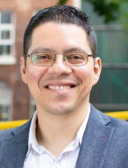 [Dr Eduardo Martinez-Cesena](https://research.manchester.ac.uk/en/persons/alex.martinezcesena) 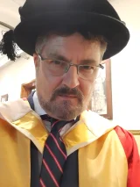 [Professor Lee Margetts](https://research.manchester.ac.uk/en/persons/lee.margetts)

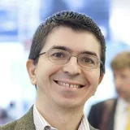 [Professor Angelo Cangelosi](https://research.manchester.ac.uk/en/persons/angelo.cangelosi) 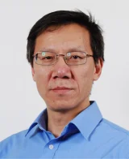 [Professor Hujun Yin](https://research.manchester.ac.uk/en/persons/hujun.yin)

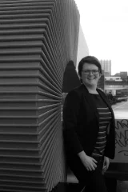 [Professor Carly McLachlan](https://research.manchester.ac.uk/en/persons/c.mclachlan) 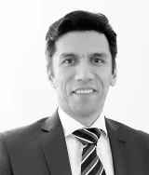 [Professor Vahid Niasar](https://research.manchester.ac.uk/en/persons/vahid.niasar)

 [Dr Vincenzo Spallina](https://research.manchester.ac.uk/en/persons/vincenzo.spallina) 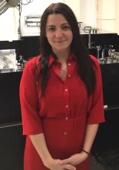 [Dr Jess Boland](https://research.manchester.ac.uk/en/persons/jessica.boland)

# Day 2 Session Leads – Wednesday 29 March.

 [Dr Beatriz Mingo](https://research.manchester.ac.uk/en/persons/beatriz.mingo)  [Professor Tim Burnett](https://research.manchester.ac.uk/en/persons/timothy.burnett)

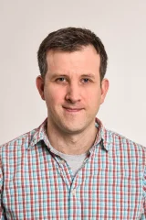 [Professor Alistair Revell](https://research.manchester.ac.uk/en/persons/alistair.revell) 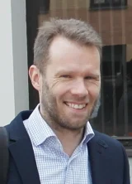 [Professor Benedict D. Rogers](https://research.manchester.ac.uk/en/persons/benedict.rogers)

[Stephen Lowe](https://research.manchester.ac.uk/en/persons/stephen.lowe-2) 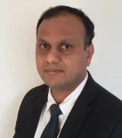[Dr Mithila Achintha](https://research.manchester.ac.uk/en/persons/mithila.achintha)

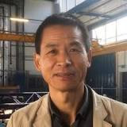 [Professor Yong Wang](https://research.manchester.ac.uk/en/persons/yong.wang) 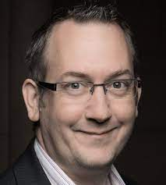 [Professor Ian Cotton](https://research.manchester.ac.uk/en/persons/ian.cotton)

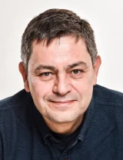 [Professor Andrey Jivkov](mailto:https://research.manchester.ac.uk/en/persons/andrey.jivkov)  [Professor Andrew Stewart](https://research.manchester.ac.uk/en/persons/andrew.j.stewart)

# Feedback

Thank you for attending the Engineering the Future Conference. We would love to hear about your experience with us; [can you please fill in this short form.](https://forms.office.com/e/8NCNgNCcUn)