**Call for papers**

***‘Byron and Italy’***

**The Byron Centre**

**University of Manchester**

**Thursday 4 - Friday 5 December 2014**

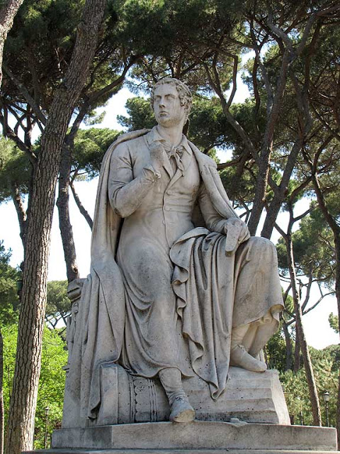

The Byron Centre at the University of Manchester, in collaboration with the Centro Interuniversitario per lo Studio del Romanticismo at the University of Parma, invites paper proposals for an interdisciplinary conference on the topic of ‘Byron and Italy’, to be held at the University of Manchester, 4-5 December 2014. Papers are welcome from any disciplinary perspective that opens up new approaches to, or offers new insights into, any aspect of the conference theme, including, for example:

* Byron and the Italian poets (Dante, Tasso, Ariosto, Pulci, Casti …);
* Byron and Alfieri;
* Byron and Rome / Venice / Ravenna / Pisa / Milan …;
* Byron and the idea of Italy;
* Byron and Italian landscapes/cityscapes;
* Byron’s (self-)Italianisation;
* Byron’s relationships with Italians;
* Byron and Catholicism;
* Byron and the Carbonari / the Risorgimento / Italy as a nation;
* Byron and the Austrians in Italy;
* Byron and Italian art;
* Byron and Italian history;
* Byron and the dialectics of Italian antiquity and modernity;
* Byron’s relation to other British/continental writers on Italy;
* Byron’s Italianised relations with Britain;
* Byron and the Italian language;
* Byron’s influence on Italian culture.

Please email abstracts of 250 words maximum to The Byron Centre’s Director, Dr Alan Rawes (alan.rawes@manchester.ac.uk), by 15 September 2014.