Coping with...

psychosis

**SECTION 1**

**Understanding psychosis**



Coping with...

psychosis

# What are distressing experiences?

You may have had experiences in the past that can be called ‘psychotic experiences’ or ‘symptoms’. Experiences of psychosis can be very different for each person. You may have discussed your personal experiences with a mental health professional. Some common experiences are in the table below. You can tick any that apply to you if you wish. Also, you can add any others that you have noticed.



|  |  |
| --- | --- |
| **Common experiences** | |
| **Please tick where appropriate:** | |
| Hearing voices of people talking that other people don’t hear |  |
| Paranoia  i.e. thinking that others may be planning to harm you or are talking about you |  |
| Thinking that you are being controlled by external forces |  |
| Believing that you have special powers or abilities |  |
| Thinking that people are reading your mind |  |
| **Please add any other experiences you have had below:** | |
|  |  |
|  |  |
|  |  |
|  |  |
|  |  |

**How common is it?**

Studies have looked at how often people with and without a psychiatric diagnosis have experienced the symptoms listed previously. They have shown that these symptoms are quite common. Also, they don’t just occur for people who have a psychiatric diagnosis.

Surveys of the general public suggest that:

Over 2 million people in the UK have a diagnosis of psychosis

Up to 1 in 4 people have had a hallucination at least once

Around 1 in 3 people experience paranoia regularly

Up to 1 in 5 people have regular delusional ideas

Most people have experienced things such as:

Thinking everyone is looking at them

Thinking that the plane will crash

Thinking they’ve been set up

Superstitions, e.g. thinking that the number 13 is unlucky

**What causes it?**

Research shows that things that seem to affect whether someone will develop psychosis include:

Upsetting past events /’Environmental factors’

physical, sexual or emotional abuse

poverty/hardship

difficult or unhappy upbringing

poor relationships with people

being bullied

severe illness in childhood

Biological factors

chemicals in the brain

genes

brain injury

Stressful events:

bereavement

losing job

not sleeping

having children

physical illness

exams

problems in relationships

money worries

using too much alcohol and drugs

# Are your experiences a problem for you?

Some people find that their experiences are unpleasant, distressing and disruptive in their lives. Other people find that some of their experiences are positive and helpful. The example below shows this.

|  |
| --- |
| **James’ experiences**  James started to hear voices when he was 15 years old. He heard one voice that was supportive. It said things that helped him to cope with unpleasant things that were happening in his life. After a couple of years, he started to hear other voices. He thought that these voices were his neighbours who said unpleasant, threatening things to him. He got very upset about these voices, but still welcomed and felt supported by his other voice. The unpleasant voices happened every day. He became very upset about what he thought his neighbours were saying to him. He stopped going out and started to avoid his family and friends, as he began to think that they were also saying bad things about him. |

James’ experiences show that some experiences can be helpful to people, while others can be upsetting and disruptive. The example also shows how these experiences can affect how we feel and what we do. You may have had these types of experiences in the past, or you may still be having them. If you like, you could list the experiences you find distressing and those that are more positive and helpful in the table below. This can help you to decide if there are experiences that you would like to change or get some extra help with.

|  |  |
| --- | --- |
| **My experiences** | |
| **My distressing experiences** | **My positive/helpful experiences** |
|  |  |
|  |  |
|  |  |
|  |  |
|  |  |
|  |  |

Coping with...

psychosis

**SECTION 2**

**Vicious cycles**



Coping with...

psychosis

Having distressing experiences of psychosis affects our thoughts, feelings and behaviours. There will be certain triggers to these experiences:

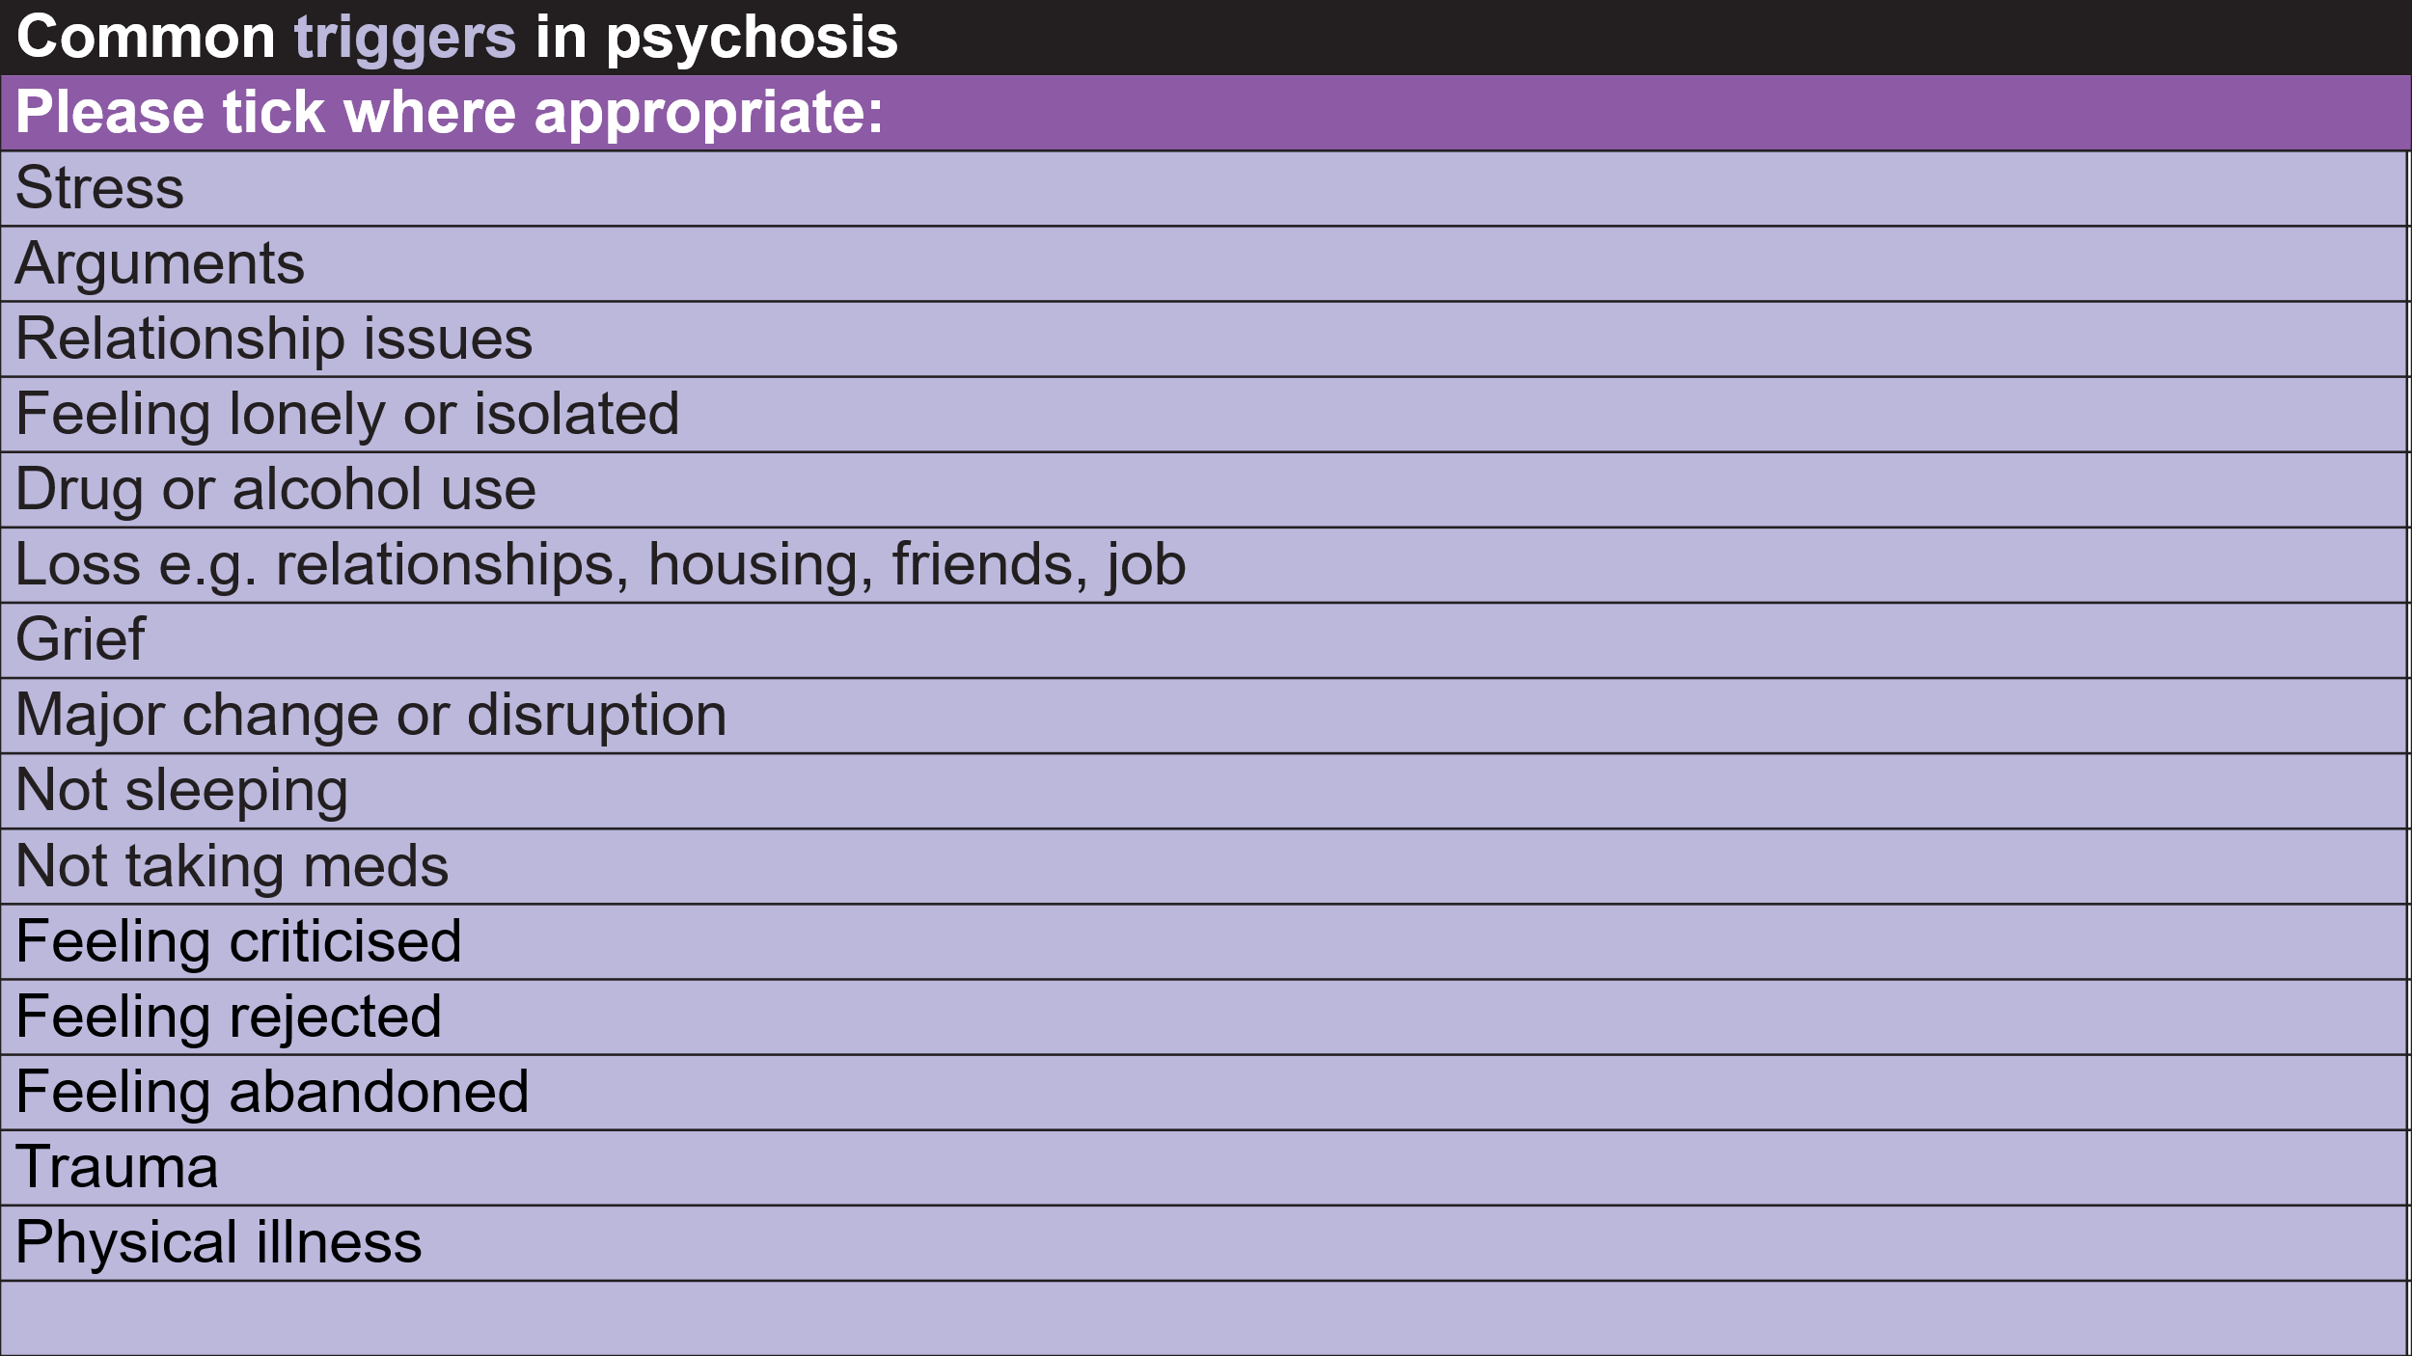

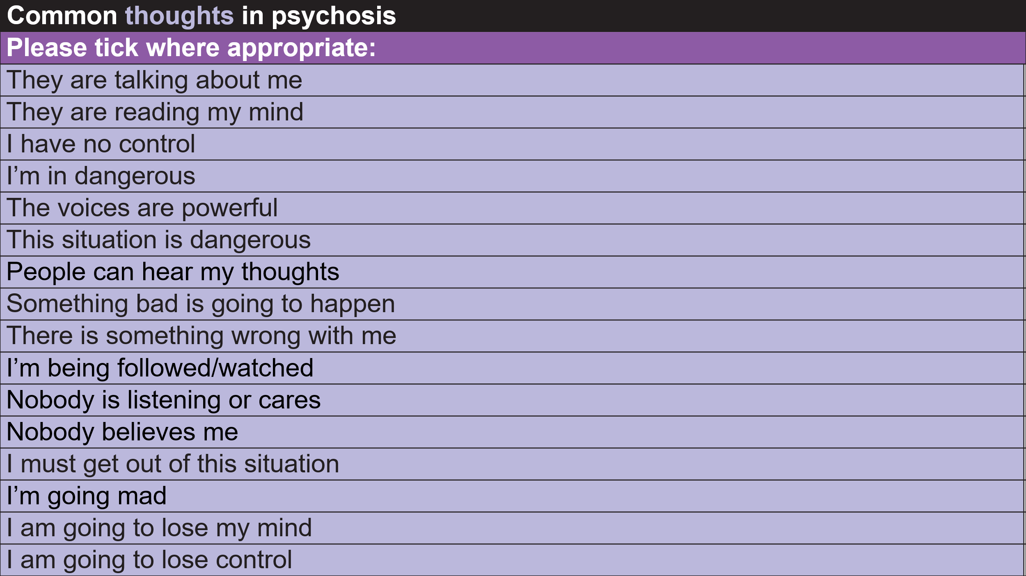

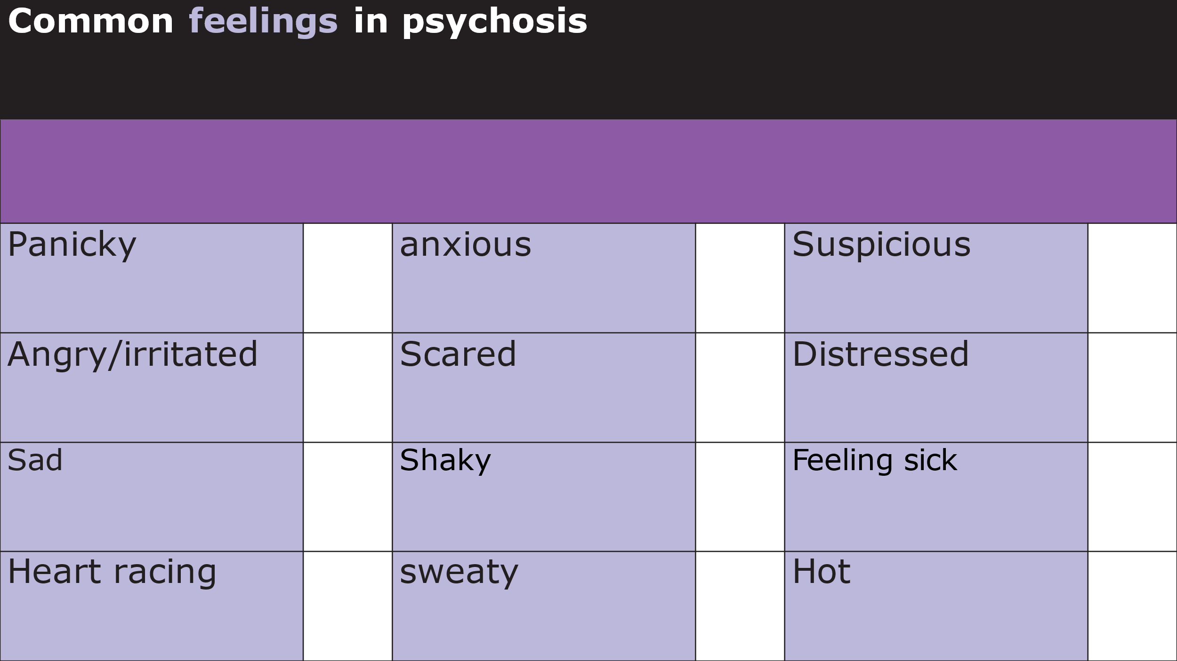

|  |
| --- |
| **Common behaviours in psychosis** |
| **Please tick where appropriate:** |
| Avoid people/isolate yourself |
| Smoke |
| Use drugs, alcohol |
| Leave the situation |
| Stay busy |
| Be around others (don’t be alone) |
| Ask for reassurance |
| Argue with others, confront |
| Fight |
| Distract yourself e.g. music |

Vicious cycles

* Sometimes it is useful to think about situations where we have been distressed and understand why they happened.
* Our thoughts, feelings and behaviours are all connected.
* When we are in fight-or-flight, it can be difficult to think rationally (thoughts), we feel anxious or fearful (feelings), and we feel like we want to run away or fight (behaviours).
* Often, something will happen that triggers this cycle and we can get stuck in it, which makes us feel worse.
* Below is a diagram of a vicious cycle:

Below is a blank vicious cycle diagram. Try to think about a recent time you felt anxious when having unusual (psychotic like) experiences and fill in the circles below.

* What happened just before? (triggers)
* What were you thinking? (thoughts)
* What were you feeling? Emotionally? In your body? (feelings)
* What did you do? How did you respond? (behaviours)

**Triggers  
*(What was happening? Where was I? Who was I with?)***

**Thoughts  
*(What was I thinking?)***

**Behaviours**

***(What did I do? How do I act? How did I cope?)***

**Feelings  
*(How did I feel?)***

Coping with...

psychosis

**SECTION 3**

**Coping**



Coping with...

psychosis

* Everyone will have their own way of coping with distressing experiences.
* We often learn these strategies when we are young and continue them into adulthood.
* Sometimes these strategies are helpful in the short-term (e.g. alcohol can make you feel more relaxed), but are unhelpful in the long-term (e.g. physical health problems from drinking too much).

My coping strategies

Have a go at writing some of the coping strategies you use when you are distressed, or ones you’d like to try:

On the next page you will find some lists of coping strategies you might like to try when you experience different feelings.

**Coping with upsetting thoughts**

One useful way of dealing with worrying thoughts is to learn to look at thoughts in a more balanced way. When we are upset, we tend to see things in a more threatening way.

**Thoughts** in anxiety tend to be:

* Automatic (involuntary, often ‘pop-up’)
* Believable (we take them as fact when they are not necessarily true)
* Habitual (we can have the same thoughts that keep coming back, like a bad habit)
* Unreasonable and unhelpful
* Self-perpetuating (lead to spiral of negative thoughts)

Ask yourself:

* What evidence do I have for these thoughts
* Are these thoughts helpful?
* What thoughts might be more helpful?
* Am I confusing thoughts with facts?
* Are my thoughts biased? If so in what ways e.g. am I jumping to conclusions or catastrophising (thinking that the very worst will happen)?
* Am I being too hard on myself?
* If a friend in the same situation told me this anxious thought, would I agree?
* How would someone else view this?
* How would I have viewed this situation in the past when I was not feeling so anxious?

|  |
| --- |
| **Upsetting thought (write here):** |
| **More balanced response after looking at the evidence and asking yourself the questions above:** |

**Coping with feelings and changing behaviours**

**Grounding to bringing arousal down (if really upset)**

Grounding exercises use mental distractions to help redirect your thoughts away from distressing feelings and back to the present. Examples:

* Use **5,4,3,2,1**:  Think about 5 things you can see, 4 things you can hear, 3 things you can touch (and touch them), 2 things  you can smell or like the smell of, and 1 slow, deep breath
* Grounding using senses - what can see, hear, feel (e.g. clothes on skin, feet on floor, back against the chair etc.. or walk and focus on those sensations, or hold a warm drink and notice the warmth on your hands)
* Focusing on a single object and describing it self - looks, feel and smells like.
* Grounding object or smell (e.g. aftershave)
* Focusing on feet to move attention from unpleasant sensations to more neutral one
* Focus on all the colours you can see and name them
* Counts/notice sounds around you
* Count objects e.g. any objects in the room
* Music, TV, Youtube
* Fidget spinners/tangle fidget
* Run your hands under cold water or put your face in a bowl of cold water, or hold a cold pack on your eyes and cheeks.  Hold for 30 seconds. Keep water above 10c (to calm down fast)

**Distraction Techniques**

• Watch TV/films – comedy or inspirational.

• Read comedy novels or joke books.

• Listen to music.

• Tidy the house.

• Shopping.

• Phone a friend.

• Gardening.

• Exercise e.g. walking, swimming.

• Wear ear-plugs.

• Reading aloud.

• Puzzles/crosswords/suduko.

• Arts and crafts.

• Watch TV.

• Cooking.

• Humming or singing.

• Playing board games/cards/computer.

**Self-Care and Comfort**

• Keep a list of achievements and strengths or a list of positive things other people have said about you.

• Positive self-talk and self-forgiveness.

• Look at comforting items e.g. e-mails, birthday cards, photos.

• Take a warm, scented bath.

• Get help with practical problems e.g. housing, finances.

• Remember that situations/feelings frequently change -“This too shall pass”.

• Do something nice for ‘me’ each day.

• Keep in frequent contact with support network

• Get a pet, or help care for someone else’s.

• Plan the day to ensure there aren’t long periods of time with nothing to do.

• Create a personalised crisis plan when you are feeling well.

• Having good support around you.

• Meditation.

• Massage/acupuncture/yoga.

• Focus on your breathing/breathe deeply – e.g. Counting the breath involves counting each in-breath and out-breath:  “Breathing in one, breathing out one, breathing in two, breathing out two” and so on up to five (or ten) for ten mins or longer

• Listen to guided relaxation or soothing music.

**Challenging the voices**

**Selective listening** – only listening to the positive/least negative voices.

**Refuse** to obey commands, or delay obeying them.

**‘Time sharing’** – schedule a time for them, and refuse to listen until that time e.g. I’m watching TV now I’ll listen in an hour

**Set boundaries** – refuse to speak with negative voices unless they are respectful.

**Reality testing** This involves checking the reality of what the voice is saying, for example, by asking a friend or member of staff what they think

**Don’t Believe What The Voices Tell You** This can be difficult and takes a lot of determination, but you don’t have to believe or do what the voices tell you.

**Ask the voices to justify their comments** e.g. you’re saying I’m bad person whats your evidence?

**How true are the things they say?** E.g. have they said the same things before? Do their predictions always come true? Is it possible to ignore them with no obvious consequences?

**Write a ‘mantra’** e.g. if the voices always tell you you’re mum hates you might have the mantra “My mum loves and cares about me and would never do anything to harm me”

**Talking back** If your voices say something that you wouldn’t usually accept from someone in your life – tell them that. Tell them, as calmly as possible, that you don’t agree with them and that they’re being nasty. If you’re not sure what to say back to the voices, it can help to talk it over with someone you trust.

**Use your imagination** Some people are good at imagining sounds, others at dreaming up images. If you have this skill, why not try using it to make the voices seem less scary. If you can image what the voices look like, how could you make them seem less frightening? You could think up a funny hat, change their face or give them a comedy walk. You can try changing their sound too.

**Express yourself** If your voices sound really angry, hurt or distressed you might have some feelings that you need to let out. These feelings can both trigger the voices and result from them. Creativity can really help here – especially if you’re not sure what you’re feeling. Why not try drawing, painting, writing or making something.

**Other ways of coping:**

Keep a record of what the voices are saying.

Talk about the voices to someone you trust.

Join a self-help group, or set one up.

Mentally visualize a barrier between yourself and the voices.

Using positive voices as allies.

**My coping plan:**

Have a go at writing some of the coping strategies you’d like to try: