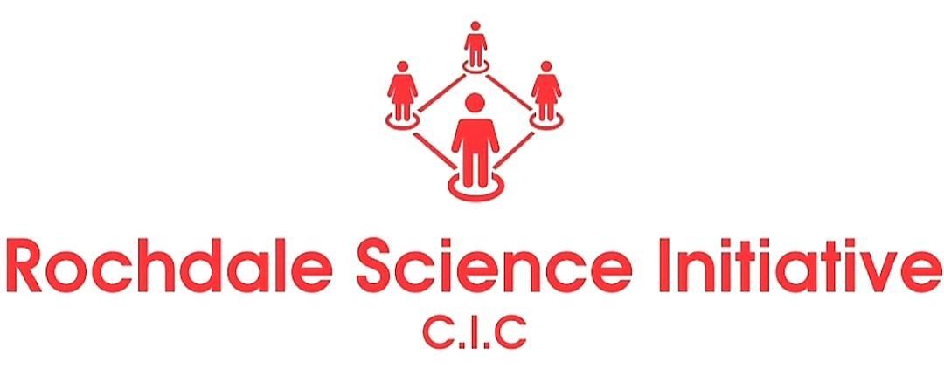

**Rochdale Eid Science Extravaganza 2023**

**Would you like to be part of an event that is created by the community for the communities of Rochdale and Greater Manchester?**

**The Muslim celebration of Eid is a joyous occasion. It is a time for families and friends to come together and rejoice. It is also an occasion for Muslims to be mindful of families within the wider community who may be struggling, so no one is left out. Eid celebration also aims to create a feeling of good will and communal unity.**

**Rochdale Science Initiative C.I.C, in partnership with Neeli Mosque Rochdale, is designing a belated Eid al-Adha celebration. The one day celebration will take place on Sunday 23 July 2023 at Neeli Mosque. The event aim is to promote inclusivity and diversity in STEM. We will create a safe and welcoming space for people of all genders and families of all ethnicities, including people with disabilities. It’ll be a free to attend event. RSI has a proven track record of developing and delivering community events that engage with in excess of one thousand people.**

**It’s imperative for RSI to design the event around fun and education. Therefore, the theme will focus on family, South Asian culture, STEM education, innovation, living well, and a sustainable future. It will be a fun ‘edutainment’ day; the audience will be encouraged to be inquisitive, explore, and learn from the multifaceted STEM exhibitors and the diversity of South Asian cultural traditions.**

**They’ll be a wide spectrum of stands and stalls focusing on fun and education:**

**Fun: They’ll be two circus rides and a humongous bouncy castle suitable for both young people and adults. We’ll also have a planetarium that can accommodate up to 70 people in one go; visitors to the planetarium will get the opportunity to view a video on climate change. In addition, they’ll be a variety of street food stalls, delicious sweet treats, Mehndi and face painting stalls, and art and craft workshops.**

**Education: We are aiming to fill 30 stands consisting of hands-on activities, drop-in workshops, exhibitions, and demonstrations. Broadly speaking, these stands will showcase ways to support mental wellbeing in science, how technology and innovations can improve the quality of our lives as well as the world we live in, how science can help solve environmental problems, how behavioural science can help to ease the cost of living, and specifically for young people, the pathway to many green STEM careers.**

**You would be required at Neeli Mosque, Hare Street, Rochdale, OL11 1JL on Sunday 23 July 2023; 10am – 5pm. The option to set-up the day before is available. We appreciate that this will be a big time commitment for those who wish to get involved, but it’s also a wonderful opportunity to create meaningful engagement with a truly multicultural audience in a town that is still yet to establish a STEM based discovery centre.**

|  |  |
| --- | --- |
| **Rochdale Eid Science Extravaganza 2023; Dates/Times** | |
| Saturday 22nd March | • (optional) you can choose to setup stands the day before from 1pm at Neeli Mosque, Hare Street, Rochdale, OL11 1JL. |
| Sunday 23rd March | * Setting up from 10am * Extravaganza event opens from 12pm-5pm * Set down stands from 5pm onward |

Travel costs will be reimbursed and meals will be provided with the options of halal and vegetarian. They will also be facilities for those who wish to perform their prayers.

**To confirm your involvement, please return the form to Mohammed Rahman; atta.ur.rahman@hotmail.com by 1st July 2023.**

***Expression of Interest to participate with a stand at the Rochdale Science Extravaganza***

|  |  |  |  |
| --- | --- | --- | --- |
| Full Name |  | |  |
| E-mail Address |  | |
| What organisation are you from? |  | |
| What is the title of your stand  for Rochdale Science Extravaganza ? |  | |
| Have you taken part in a Science festival before?  *If yes, please give details.* |  | |
| Please provide a brief outline of what your stand will cover; and what attendees will experience from visiting your stand? |  | |
| How many volunteers do you expect to bring? |  | |
| We have approximately 20 stands left. Each stand area will compromise of a table (4ft x 2ft 6ins), maximum 2 table and 2 chairs. Please specify how many tables needed (if any).    You will have to bring your own poster boards- please describe what else you will bring along |  | |
| Will you need access to power?    *If yes – you will need to bring your own extension cable* |  | |
| Is there anything else you would like to tell us about your stand? |  | |
|  |  |  |
|  | |  |

# Risk Assessment Information

|  |  |  |
| --- | --- | --- |
| Risk Assessment Information for: |  | Information Form completed by:  Name:  Signed:  Date of Assessment: |
| Activity Description: |  | |
| Does the Activity involve any specialist equipment?  Please give details. |  | |
| Will participants in your activity be working with any electrical equipment?  If so, has the equipment been PAT tested within the past 12 months. |  | |
| Does your activity require the use of any Personal Protection Equipment?  If so, will this be provided for all participants? |  | |
| Does your activity require the use of any chemicals or substances that may be harmful to health?    Please give details. |  | |
| Do you require access to or disposal facilities for water?    *Please note: we are not able to provide disposal facilities for chemical or hazardous waste.* |  | |
| I understand that company representatives are responsible for keeping their area tidy and free of trailing cables and other slip and trip hazards. |  | |
| Are there any other risks associated with your activity which have not been covered elsewhere in this form? |  | |
| Have you already completed a risk assessment for this activity?  If so, please send it to us along with this form. |  | |