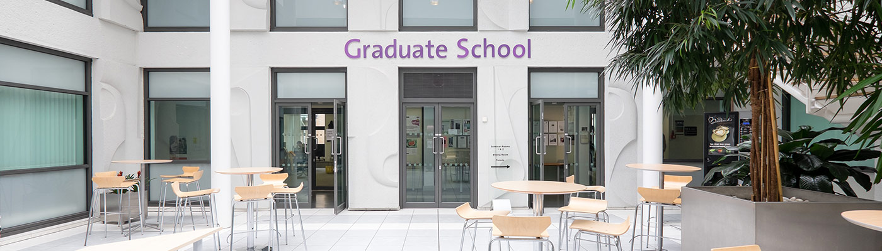

**School of Arts, Languages and Cultures**

**INDUCTION for**

**Postgraduate Research Students**

**Wednesday 21 September 2022**

**Venue: via Zoom. Meeting ID:** [**https://zoom.us/j/92991626474**](https://zoom.us/j/92991626474)**;**

**Passcode: 726654**

**10.45 – 11.00 Welcome and Login**

***Please arrive promptly.***

**11.00 – 11.30      Meet the Academic Leadership Team**

TBC, Associate Director for Postgraduate Research

**Meet your Graduate School Support Team**

Miss Rachel Corbishley, PGR Admissions/Funding Administrator

Mrs Julie Fiwka – PGR Administrator – Theses/Changes to Programmes

**11.30 – 12.00 What I wished I’d Known – Top tips from your peers**

TBC