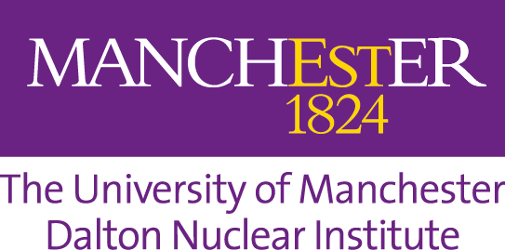

**Dalton Seminar Series:   
Future Reactor Design and Delivery**

Tuesday 11 August 2020

14:00-16:00

|  |  |  |
| --- | --- | --- |
| **Time** | **Speaker** | **Title** |
| **14:00** | **Welcome and Introduction** | |
| **14:10** | **Gregg Butler**  Head of Strategic Assessment, Dalton Nuclear Institute | Drivers for Nuclear Systems Choice |
| **14:25** | **Juan Matthews**  Visiting Professor, Dalton Nuclear Institute | Lead-cooled Fast Reactors: A Critical Overview |
| **14:40** | **David Lunt**  PDRA, Department of Materials | Using HRDIC to Investigate Irradiation Damage in MAX Phase Materials for Light Water & Gen-IV Reactors |
| **14:55** | **Edmund Ireland**  PhD Student, Tyndall Centre | Optimising Nuclear to Meet the Paris Climate Challenge |
| **15:10** | **Aneeqa Khan**  Research Fellow, The University of Manchester at Harwell | Nuclear Fusion |
| **15:25** | **All speakers** | Q&A Panel |
| **16:00** | **Finish** | |