**Incel Corpus**6,973,685 tokens

**Keywords**

Top 20 keywords of incel corpus (reference corpus – Sketch Engine’s Eng Web 2021: ~52.2bn words)

| **Item** | **Frequency** | **Frequency per million words** | **% of whole corpus** |
| --- | --- | --- | --- |
| incel | 20365 | 2920.26 | 0.29 |
| foid | 17494 | 2508.57 | 0.25 |
| stacy | 48451 | 6947.69 | 0.69 |
| truecel | 7936 | 1137.99 | 0.11 |
| normie | 8253 | 1183.45 | 0.12 |
| chad | 33247 | 4767.49 | 0.48 |
| jfl | 3283 | 470.77 | 0.047 |
| cuck | 3109 | 445.82 | 0.045 |
| gigastacy | 2652 | 380.29 | 0.038 |
| blackpill | 2654 | 380.57 | 0.039 |
| subhuman | 3211 | 460.45 | 0.046 |
| stacie | 3083 | 442.09 | 0.042 |
| stacys | 2072 | 297.12 | 0.030 |
| fakecel | 1995 | 286.08 | 0.029 |
| landwhale | 1767 | 253.38 | 0.025 |
| inceldom | 1622 | 232.59 | 0.023 |
| looksmatch | 1601 | 229.58 | 0.023 |
| cucked | 1600 | 229.43 | 0.023 |
| manlet | 1522 | 218.25 | 0.022 |
| chadlite | 1501 | 215.24 | 0.022 |

| In-group references | Out-group references | Both in/out-group | Other |
| --- | --- | --- | --- |
| incel | foid | subhuman | Jfl [just for laughs] |
| truecel | stacy | manlet |  |
| blackpill | normie | looksmatch |  |
| inceldom | chad |  |  |
|  | cuck |  |  |
|  | gigastacy |  |  |
|  | stacie |  |  |
|  | stacys |  |  |
|  | fakecel |  |  |
|  | landwhale |  |  |
|  | cucked |  |  |
|  | chadlite |  |  |

All keywords in in- and/or out-group references are arguably based around the incel naming strategy for groups of individuals/concepts - I.e. these are not words in the everyday English lexicon.

**Subhuman**

3,211 [460.45 per million words; 0.046%]  
Occurs 2,512 times as an adjective

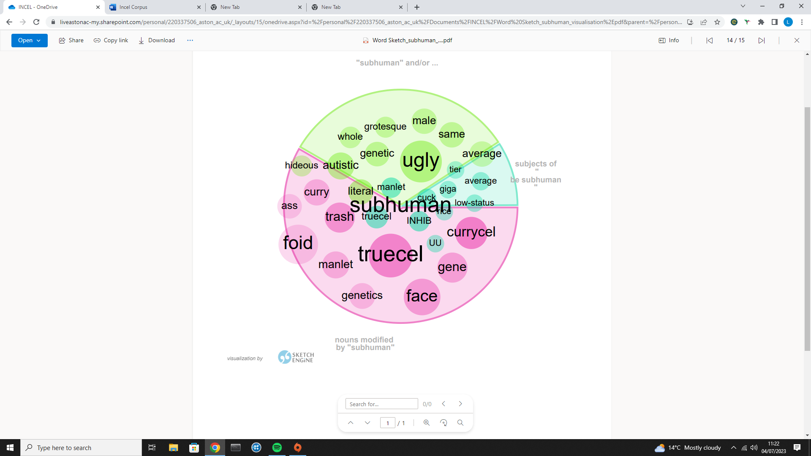

Themes of appearance/race/genetics. Key modifiers: truecel; foid; currycel; face.

In a random sample of 25 instances of ‘subhuman’ from the incel corpus:

| **Self-identifying** | **Dehumanising out-groups** | **Other/ambiguous** |
| --- | --- | --- |
| IT DOES NOT MEAN IM A FAKECEL NOR VOLCEL IM A 3/10 UNDERWEIGHT NON NT HIGH INHIB SUBHUMAN . | The times I've been to Germany I've always been astounded at how subhuman they are. Of course, their country is filled with immigrants so it's hard to even find a German. But you think they would | buying into their worldview and adopting their value system, QUESTION IT! DO NOT reinforce it by calling yourself " subhuman " or "manlet". WHY should you be considered unattractive? |
| i'd rather NEETmaxx+leechmaxx till i die, imagine putting all that effort and look like a literal subhuman next to the top 1% Jep, what even is the point? | Some research studies have indicated that relatively uglier women (like LTBs and subhuman bitches) have a higher bodycount or / and have sex more often than relatively prettier women | based tbh, foids getting humiliated by subhuman is always the most based thing you could possibly see. |
| lol people will probably call the cops on me when I walk around with my kid they'll think I kidnapped. I have never seen subhuman single fathers I will be the first and pave the way and endure the shame | its the subhuman becky tier foids that are more annoying than actual stacys. they think they are stacy and entitled to a chad. | No company wants some ugly subhuman in their presence. They will employ anyone over some ugly dude. |
| You can't make an incel/Chad distinction without making a subhuman /human one, and that's not objective. | He was one of the musicians at one of there shitty hostel jam sessions and he was an ugly tallfag, with subhuman face features and kinda fat. | Yeah because they know that when they associate with subhuman males their status gets lowered. Normies usually want to socially elevate themselves to be like Stacy and Chad. |
| half of his monthly salary on a ring is now a major problem, as they've never actually faced true suffering as the average subhuman | BUT I MADE A THREAD ABOUT MY EX-ONEITIS (SOLID 8.5/10 FACIALLY with a petite body which isn't my thing tbh) DATING A SUBHUMAN BEFORE AND ME SUSPECTING THAT HER CURRENT FWB IS ALSO A SUBHUMAN. Well, I was wrong about her having a FWB at all. | Then again how you treat people is what theyll become. Eliot became a killer because people treated him like subhuman . Yeah there was conflicts that was his fault but it was a fucked up society giving him the motive. |
| my only option is Hindumaxxing and getting a waifu in India (not in that order). Since I'm too subhuman for my own community. | He was never meant to be a cool kid, he was meant to be a king of subhumans. So he couldve gotten a Lot of subhuman girls, but he wanted stacy. |  |
| Even though I was drunk af I still remember the vile disgusting look she gave me for being a subhuman daring to touch her.. never began | Not completely over like it is for Indian and Asian men but still subhuman to most white foids (and the degenerate ethnic foids who emulate white foids). |  |
| Chad doesn't play the same game as us, we're playing "Completing life as a subhuman " and Chad is playing "Completing life as chad" | I can't wait for reality to catch up to them EG there is a 5'6 ethnic subhuman small frame weak ~100 IQ who has a stacy gf he belongs on this forum but associated with the popular crowd early |  |
| SHE SMIRKED WHILE SHE WAS MOANING LOUD , WHY DID SHE SMIRK YOU MAY ASK SHE SMIRKED BECAUSE OF MY SUBHUMAN FACE AND MY GIGANTIC COCK THAT WRECKED HER IM A FUCKING INSKLRE |  |  |
| I would kill the other guy if he was better looking than me. Then I would have the Stacy to myself. If he is a subhuman incel I would let him live so I have someone to talk to. |  |  |
| THE TWO FAGGOTS WERE MOGGING ME SO HARD AND I KNOW THEY WERE LOOKING AT ME AND THINKING "Look at that manelt subhuman haha". |  |  |
| if you are subhuman incel you are subhuman incel no matter if it is the 50s, the 90s, the 30s or even the fucking ice age we would STILL not be able to ascend |  |  |

**Foid**

*Female humanoid - i.e., an entity resembling a female human*

17,494 [2,508 per million words; 0.25%]  
Occurs as a noun 15,414 times.

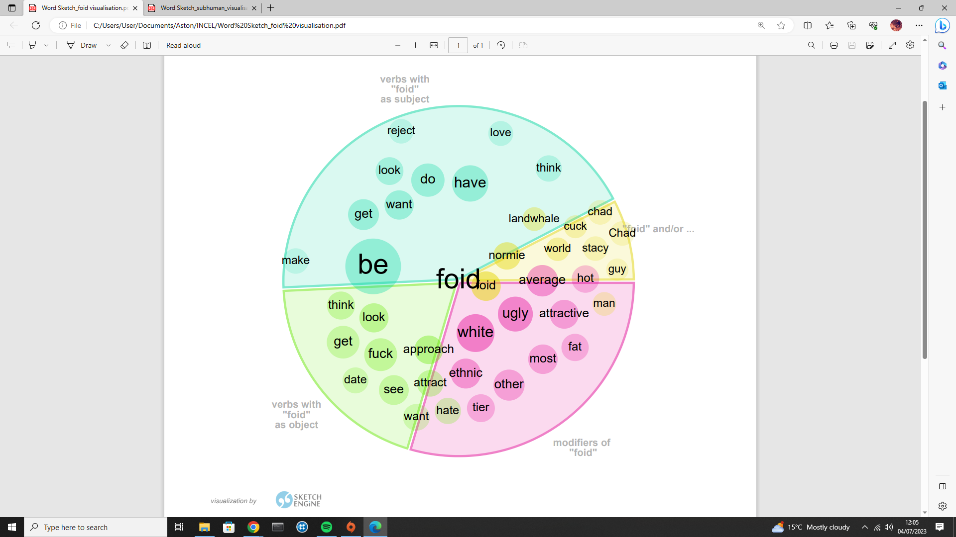

Themes of appearance/attraction/ethnicity. Key modifiers: white; ugly; average.

In a random sample of 25 instances of ‘foid’ in the incel corpus:

| **Objectifying/hateful** | **Anecdotes** | **In-group support/advice** |
| --- | --- | --- |
| Giga Stacy? More like Amazonian Becky. Albino ogre low tier becky tbh... I like tall foids , but this one looks like an ogrecel | walking across the commons area in the school, and in my direction was a foid who waved at me. I waved back but she had that look of disgust and said "ew no, not you" | The chadpreet gets curry stacy. I assume you're saying the chadpreet can't get a white foid , that may be true but that doesn't matter. |
| My personal philosophy is that foids are inherently disgusting but are made tolerable by their breasts. | I can easily hold eye contact with foids I'm not that attracted to but when it's Stacy I get nervous and brake the eye contact when talking | Freakshowmaxxing is a legitimate strategy. If your face or body is that deformed a foid may like you for the novelty |
| All the foids I've had sex with have had big tits. I don't plan on changing that. For me, I won't settle for anything less than the best. | the foid had all the gigastacy traits, she was hot, blonde, wore makeup, wears skimpy clothes, popular, parties | Agreed. 6'0 is average to foids in 2020. And with their hypergamous tendencies, in 6 months the new average will be 6'2 " |
| This life is not fair and not worth to live. If you don't have foids harem or 10/10 blonde gigastacy, life is meaningless. | -- I didn't expect him to be a failed American normie. He asks if I'm blonde and petite. See, I'm not sure why he thinks I'm a foid . This is the first time that anyone online, in a game or on a forum, has ever assumed that I'm a foid. | A loyal white foid? Very unlikely because any white foid that dates outside their race doesn't value loyalty. A loyal foid in general? Its possible, but not in the west where virgins cease to exist past AOC. |
| As most foids are really fucking medicore or ugly from an objective PSL analysis perspective. | This idiot gets laid a few times every month by going to clubs/parties or using tinder. He gets approached by two types of foids : hot gigasluts who want ONS and juggernauts who want LTRs. These girls usually have very obnoxious personalities | Ricecell: This is an asian incel. Currycell: This is an indian incel. Manlet: A short guy, any race. Foid : a woman Stacy: a pretty young girl, she can be any race. Becky: a fat middleaged women. Incel: involuntary celibate |
| to stay loyal with 1 looksmatch when theres endless hi tier normies, chadlite and chads out there thats willing to show foid a good time, and in return all she has to do is blow him and let him fuck. If it was me id rather have different stacies | i am 184cm ricecel and I am still incel Rice foids are picky when it comes to ricemen. Height + face + Money is required. | As a 4/10 richcel. The only foids who can give you absolute loyalty, will be 3-4/10 ethnics or slavs from 3rd world countries. |
| chadlites have to settle for sub5 or even sub4 foids these days. I've seen it many times at school. Also high school is the "easiest time to get laid". | I've seen posts seemingly to be bragging about having friends and going to parties . Being tall . Being hit on by a foid . Having normie tier looks . Blending in with normies . Being complimented by foids . Not being bullied . Making friends | Yup, first indication of a fakecel is believing in Sub 8 rule and on top of that NEVER approach a single foid in his life. Anyone who say, b...but Chad doesn't even approach b.b..but skinny prettyboy gets laid so Gym is Cope b..b |
| Noodle A foid is a foid, they're all equally trash. |  | ugly foids despise me this is one indication the black pill is real because the same foids that would torture you as a kid that now want to settle haven't really changed their opinions about you |
|  |  | yeah i know you've pedestaled your specific point on the content spiral as evidence of good character you've fallen for foid tricks and are bluepilled |
|  |  | = Abomination = KHHV for life 2/10 = Ogre Truecel = KHHV for life unless he moneymaxes, geomaxes and finds the ugliest foid 3/10 = Truecel = Can date 1-3 women with no problem, can moneymax to date most women 4-7 range |

**Truecel**

7,936 [1,137.99 per million words; 0.11%]  
Occurs 6,499 times as a noun.

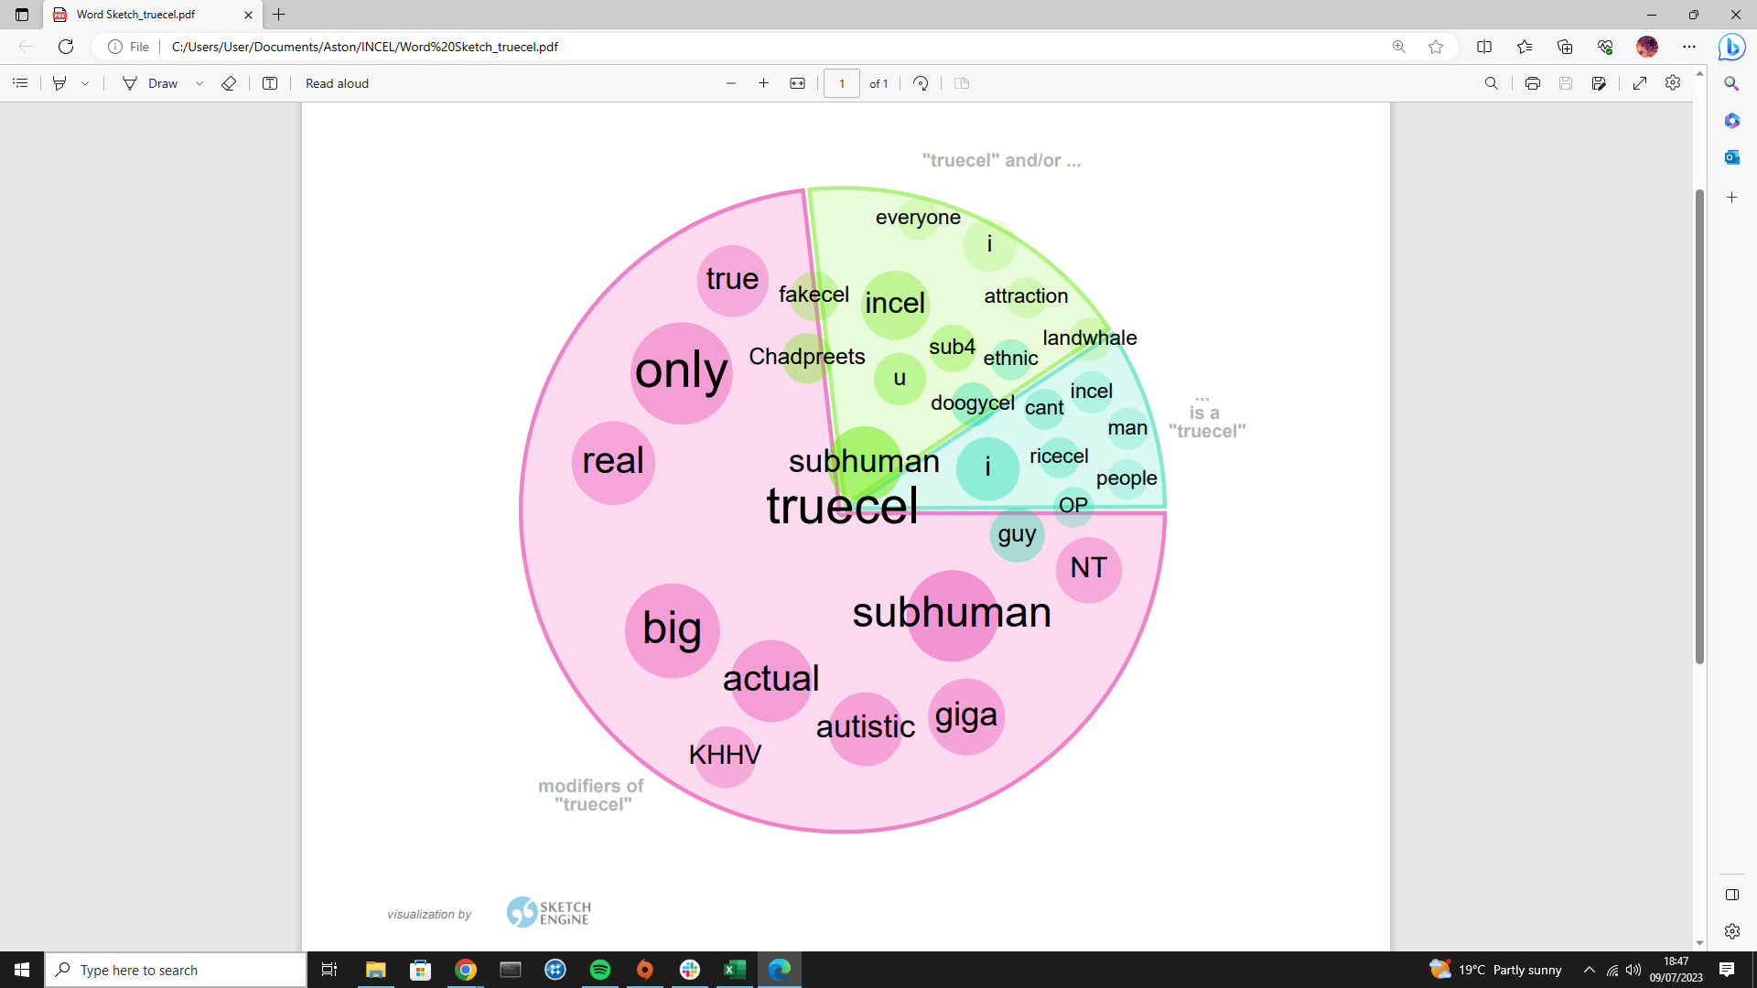

Themes of authenticity/ethnicity/other -cels. Key modifiers: only; subhuman; big.

In a random sample of 25 instances of ‘truecel’ in the incel corpus:

| **Self-pitying/identifying** | **Defining in-group** | **Excluding out-group** |
| --- | --- | --- |
| The reason why I say this is to tell you guys how unsocial I am and even the truest of truecels here are more social than I am. I am the ultimate example of a permacel. | Womb to tomb: To live as an incel for life. Used to describe a man so ugly and aspie that he will be a truecel for life. | Escortcels are not truecels in my opinion. I have a tiny dick and can't get deepthroat from escort, also truecels are rejected even by escorts. |
| I had my prom yesterday and it is SUIFUEL for truecels . One super low inhib incel brought a BODY PILLOW as a date and a bunch of chads and Stacie's recorded him and made fun of him | What about c-sections? Those are the most truest of truecels | “im only truecel everyone else is fakecel normie " this ex mod triggered whole bunch of retards with his retarded larp i love it lmao |
| Maybe you used to be the truest truecel before I joined in June of 2022. You aren't the truest truecel here any more because you are not me. I am 5'1" and weigh 230 with a 3.5" erect dick (on the rare occasions I can get a stiffy) | If some women say im handsome, good looking, or cute am i a fakecel? Or could it be a lie? Would a truecel ever get any compliments from women online or irl? Or would they never get that? | He prob a fakecel who ascended with a girl and is still coping thinking hes a truecel by saying that she was scared and intimidated by him |
| Height doesn't matter, Face is everything. I'm 6'3 confirmed truecel . | You may be the oldest KHHV and the biggest truecel on this forum yup maybe. i think there was at one point a guy in his 50s who was a virgin on here. dont know if hes still around | Don't get triggered by the 2022-retards and their moronic " truecel trait:" threads fellow OGcel |
| First thing I did after coming home was posting this. I had to get this off my chest, brocels. The truecel struggle is real. This life is fucking hell for us truecels. I just know I'm going to die alone. | Normie tier but very feminine and under-developed looking. You won't have real problems like the ugly truecels here where people don't want to interact with you or women treat you like garbage. | how can you get any pussy from that? your pretending to be chad when your actually truecel cause you say you are rich and famous and like... from another country or something dumb foid believes that |
| Rather be a truecel in peace than get mogged | invite this truecel onto the forum theyre made to either detroy truecels or make them overdose on bluepills |  |
| got bashed up in the middle of the streets and mugged for all I had. Also didn't get any pussy and remained a permavirgin truecel never again | Again, it's not unnatural for a 5'0 turbomanlet truecel to wish they were born different. |  |
| Trucels can never ascend I'm truecel and was close with my oneitis in 8th grade but now she doesn't want me anymore | he is a bigger truecel thanme. |  |
| Nobody has it worse than us, us Truecels live lives that are horrendous shit shows and people read our stories and about our shitty physical attributes to feel better about themselves | Truecels love winter, darkness, fog and rain Nothing better than observing wagie in morning cleaning his frosted car |  |
| Look at my face, I'm also a truecel, although I'm new | Truecels like me wouldn't get any reacts other than from myself. It will be like Facebook where it was only me who liked my posts |  |

**Fakecel**

1,995 [286.08 per million words; 0.029%]  
Occurs 1,739 times as a noun.

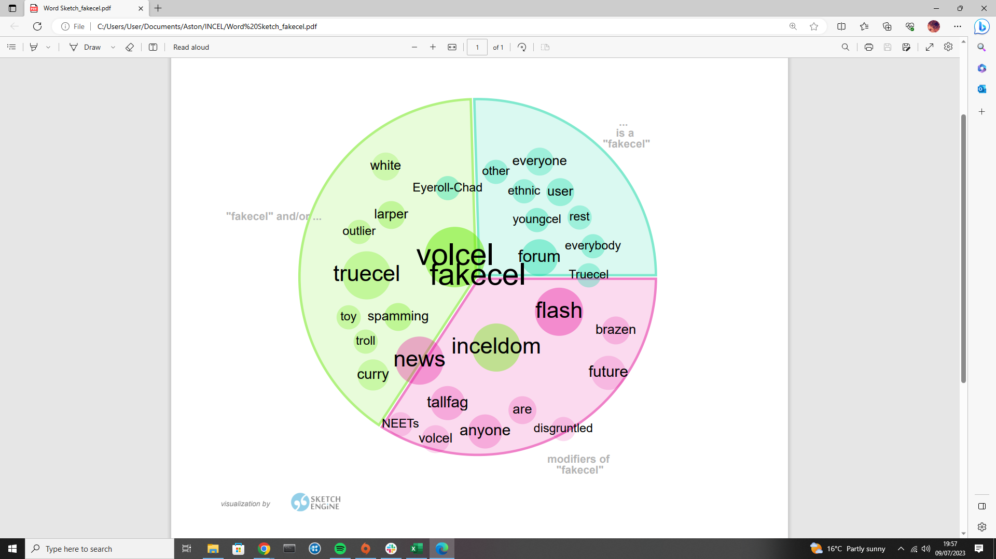

In a random sample of 25 instances of ‘fakecel’ in the incel corpus:

| **Accusatory to other users** | **Defending self or other users** | **Accusatory to non-users** |
| --- | --- | --- |
| FUCKING fakecel . Niggas like me have been incel for 3 decades. And will die trucel and you come here to flex the fact you got to fuck an art Stacy | Just because one mod stole stacy's flower doesn't mean everybody's a fakecel | Blackcel with a BBC = fakecel . I tend to agree. |
| We all know you're a fakecel if you're under 6'0, girls don't like tall guys. | Just because he stole a cute 19 year old's viriginity is he a fakecel ? I think this is gatekeeping, we should be more inclusive with Stacy impregnators | He was a fakecel , end of story. |
| Fakecel Didn't you send me a pm saying you banged a gigastacy? | Ugly nt guys at least have friends. And I'm bullied even in this forum because of muh I'm fakecel . | another fakecel who could easily get some random indian girl in india. |
| No, but this guy has average looks. If you mog him or have looks at the same as level as his, then GTFO fakecel | Being a standardscel is based I used to think that standardscels were fakecels that should be banned off this forum. | If an "ugly" guy manages to get with pretty much 1000 Stacy hookers in a row without one rejecting him, then he's a fakecel . |
| Although I've met girl #1 in high school (we first saw each other in art class in 10th grade no we didn't date you fakecel hunters), i never spoke a single word to girl #2 in my life despite seeing her from time to time in middle/high school. | Cuz I am not a LARPer fakecel autist who demands a Stacy gf. I am actually aware of my subhuman face | Anyone that HAS to have a white 'foid much less a white Stacey is fakecel though |
| you’re a fakecel ,you are so lookism that you're exactly like landwhales that demand chads don't be here to destroy incels' reputation |  |  |
| at 17, in brazil, with a stacylite japanese girl yeah you are a fucking fakecel for sure kek |  |  |
| Here's the ultimate way to prove you are fakecel or not. If you never did this, you are a FUCKING FAKECEL that should be banned. |  |  |
| News flash fakecels , inceldom can occur to anyone and that person doesn't need to be a big fan of Hitler and promote the white genocide meme. |  |  |
| ur massive fakecel, richcel = fakecel u can easily ascend in Malaysia with ur money volcel |  |  |
| Inactivity shows that the fakecels (chads) are busy with their stacys' |  |  |
| and to all fakecels ,i hope you all have a horrible fucking life,you fucking scumbags faggots |  |  |
| Is it a wonder that we have so many fakecels here? Just the other day we had a literal tallfag make a thread about how it feels to be considered short by a Stacy. |  |  |
| Only an absolute brainlet can think that's a valid counterpoint to those of us calling you a fakecel , which, you factually are one. |  |  |
| It's 100% low IQ, volcel behaviourand it's the reason there are so many fakecels on this site. |  |  |

**Exploring ideology: ‘foids should be’:**  
**[total occurrences]**

covered and forced to labour in concentration camps.

turned into national owned proprety and sold to the honest good proletariat at locked prices decided by the state according to the low-class max incomes for breeding purposes.

chopped up and used as fertilizing for plantations.

Sub 6 foids should be covered and forced to labour in concentration camps. Over 6 foids should be turned into national owned proprety and sold to the honest good proletariat at locked prices decided by the state

legally considered "livestock", not persons. and they should kill al women below stacylite

transformed into a public service reserved for incels' where taxpayers would pay them to perform the job of being an incel’s wife or girlfriend. They'd also be required to attend monthly STD testing, couldn't legally refuse sex and then once they 'expire'

Another day, another reason of why foids should be caged. Cut their tongues off OP.

these lesbian foids should be turning straight and sucking my cock. There is something wrong if a foid would rather lock another sluts disease ridden pussy than take a cock.

Cock carousel riding whore foids should be killed in Grand Theft Auto V

Teen foids should be mostly left for grown men.

should be raped by truecels.

**Exploring ideology: ‘foids are’:**  
**[randomised set of occurrences]**

gold digger whores

attracted effortlessly

sexual objects

the prize

naturally picky choosers

not impressed by your job

big boob foids are the best

feminist cunts

supposed to be thin stacys

incredible und a pervertion of nature

really fuckin mediocre or ugly

n't showing “love” but lust (attraction to superior genes)

ether very attractive or completly landwhales

fucking bigots

antipathic

forced to join Chad’s harem

equally as ugly as their male counterparts

delusional about their looks and think they’re beautiful

the most privileged group in our society

making up rape if it means having won the lottery

**‘rape’:  
[randomised set of occurrences]**

And if a man dares to say the wrong thing to her, or do anything that goes against her, she can just scream rape and ruin his life. I would think that being able to rape someone is proof that they can consent

eventually she accepts her fate and willingly become my sex slave and start to enjoy being dominated and virtually raped and violated by a subhuman.

you should just overpower and rape the stacy who is staying at yours, she will enjoy it too

i wish i were gigachad so i could commit maritial rape without any backlash. Spoiler the victim is blonde gigastacy ofc

Just because a foid is raped and says she didn't enjoy the rape , doesn't mean she didn't enjoy getting raped. (Foids should never be taken seriously)

Stacy got raped on campus at night in an elevator where there are no cameras. There is a witch hunt for the dude who did it.

" 'A Happy Marriage Begins by Crying': Kyrgyzstan's Tradition of Kidnapping and Raping Brides The future husband rapes the young woman shortly after having kidnapped her

i would take the stacy and just put her under house arrest and rape her if she doesn't want to have sex, boom all the issues solved.

When these women are outside of his reach, the only access the incel believes he has is through killing Chads or raping Stacys.

So rape will be normalized in the future. We will live just like we used to live in the stone age. Rape will be the only option for men in the future. Rapemaxing will be a real thing.

Instances of *cel  
[total 40,539 occurrences; 5813.14 per million words; 0.58%] - any specific linguistic patterns for these types of incels?

Examples from the first 50 pages of *cel.

truecel gymcel volcel christcel  
incel baldcel greycel fatcel  
employmentcel wristcel blackcel religiouscel  
brocel gymcel richcel hopecel  
femcel workcel poetcel cheerleadercel  
commercel ethnicel escortcel animecel  
fakecel framecel oldcel weaboocel  
currycel mentalcel zoomercel eurasiancel  
codecel slavecel standardcel blondecel  
ricecel slavcel ogrecel gingercel  
chinkcel tallcel wagecel nevereventriedcel  
virgincel inhibitioncel pinoycel stacyorbustcel  
skullcel stormfrontcel dickcel  
whitecel permacel marriedcel

**Discussion of Corpus Findings**

*‘Subhuman’ and ‘Truecel’ as in-group identifiers*

According to Lindsay (2022) “[t]he perception that incels are an oppressed group serves as the bedrock of the black pill philosophy” (p.213). This is supported by the self-referential use of the keywords ‘subhuman’ and ‘truecel’ identified in the corpus, both of which appear to serve as a badge of self-identification and in-group membership, yet also in statements of self-pity. Consider these examples from the incel corpus:

1. Even though I was drunk af I still remember the vile disgusting look she gave me for being a subhuman daring to touch her
2. Nobody has it worse than us, us Truecels live lives that are horrendous shit shows and people read our stories and about our shitty physical attributes to feel better about themselves

Extract a) uses ‘subhuman’from the perspective of the female character (F) in the anecdote being told. This acts as an accusatory term assumed by the incel (I) to be mentally assigned to him by F, therefore implying her superiority over him, typically based on factors of physical appearance (Hoffman et al. 2020) and supported by the phrase *daring to touch her,* as though he is of far lower societal status than her. While this statement appears to seek sympathy from other forum members due to the victim perspective of the original poster, the inference gleaned is that F is to blame for this interaction and that the poster has somehow been assaulted by the *vile disgusting look* given to him, rather than the female in the situation who appears to have been touched without consent by the admittedly drunken poster. Nevertheless, ‘subhuman’ appears in the corpus as both an in- and out-group reference for -cels of various characteristics, for example, some frequently occurring collocates of ‘subhuman’ are *currycel, truecel, autistic* and *manlet.* These collocates as modified by ‘subhuman’ are reflective of the “reductionist and biologically essentialist” (Yoder et al. 2023:2) views of genetics and race exemplified by the incel community as a subsection of the ‘manosphere’ and their interpretation of masculinity in terms of ‘alpha’ or ‘beta’ traits (Ging 2019; Lindsay 2022).

Extract b) also bears references to self-pity, physical appearance and being somehow oppressed or lesser than the out-group of mainstream society. There appears to be a sense of camaraderie-building for those who identify as ‘truecels’ on the part of the poster; the poster acts as a mouthpiece for truecels as a group, as suggested by first-person plural pronoun *us* and attributive adjective *our.* As a result, those who identify as a truecel may find comfort in the sense of having their experiences understood by another community member. Frequent modifiers of ‘truecel’ as a noun in the corpus include *real, actual,* and *true*, demonstrating the degree of authenticity and in-group status that comes from being awarded the truecel label. Interestingly, *subhuman* is also one of the most frequent modifiers of ‘truecel’, suggesting that the label of ‘subhuman’ can also be capable of elevating in-group status within the incel community, despite its conventionally negative connotation.

*Foid*

‘Foid’ as an item in the incel sociolect acts as a dehumanizing term for women, with dehumanizing language defined by Prazmo (2020:19) as that which is designed to “conceptually deprive people of their humanness and human rights and denigrate their moral status.” Short for ‘femoid’ or ‘female humanoid’, this label assigns robotic qualities to women, or suggests that they are similar to humans in physical resemblance only. In an analysis of metaphors occurring in incel fora, Bogetic et al. (2023) identify the category of ‘non-human being’ as prominent in their dataset. This includes the mapping of animal traits (e.g. *vermin, bitches, landwhales*), and also the use of the mechanical depiction of women as *foids.* By referring to women in this way, they are portrayed with a lack of feelings and emotions, morals, and humanity. As suggested by Wills (2009), when an enemy is ‘inhuman’, they are far easier to incite hate and violence towards. Further dehumanization of women is demonstrated through the collocates of ‘foid’, with women discussed as objects to be attained and used, or to *get, want, hate* or *fuck* (as also found in Yoder et al. 2023).

Following the simplistic search for collocations, deeper-engrained ideologies surrounding ‘foid’ are sought using declarative noun+aux verb structures ‘foids are’ and ‘foids should’. In doing so, the aim is to portray the incel view of an existing state (are) vs a proposed state (should).

*‘foids are’...*

In searching the corpus for “foids are”, the results returned can be segmented into the three potential (but not exhaustive) semantic categories demonstrated in table a) below: sexualisation and appearance, dehumanisation, and anti-incel/anti-men. These categories have been complied owing to the prevalence of women in these results as targets sexual desire, objects without agency, and enemies of the incel community, respectively.

*Table a): Semantic categories of concordances of the search term “foids are” in the incel corpus*

| **Sexualisation and appearance** | **Dehumanisation** | **Anti-incel/anti-men** |
| --- | --- | --- |
| gold digger whores | attracted effortlessly | naturally picky choosers |
| [ big boob foids are] the best | *sexual objects | not impressed by your job |
| *sexual objects | the prize | feminist cunts |
| supposed to be thin stacys | incredible and a pervertion of nature | n't showing “love” but lust (attraction  to superior genes) |
| equally as ugly as their male  counterparts | *ether very attractive or completly   landwhales | fucking bigots |
| delusional about their looks and  think they’re beautiful | forced to join Chad’s harem | antipathic |
| really fuckin mediocre or ugly |  | the most privileged group in our  society |
| *ether very attractive or completly  landwhales |  | making up rape if it means having won  the lottery |

Consistent with the incel fixation on physical appearance, the ‘sexualisation and appearance’ and ‘dehumanisation’ categories make repeated reference to physical traits, such as *big boob foids, thin, looks, beautiful, ugly* and *attractive*. The phrases *sexual objects* and *ether very attractive or completly landwhales* have been included in both categories (noted by an asterisk) due to the explicit reference to women as both *sexual* and *objects* in the first instance and considered either *attractive* or dehumanised by the animal metaphor *landwhales* (as in Bogetic et al. 2023)*.*

The anti-incel/anti-men category of concordances demonstrate accusatory declarative statements used to assign unanimously negative characteristics to women.

*‘foids should be’...*

The search term “foids should be” allows insight to the incel ideology of women’s place in an idealised world. The results are far beyond the sexist labelling, objectification and othering of the “foids are” search, and become further representative of hate speech, as shown in table X.

In example a), the term *forced* shows the incel desire to control and strip power from women. In the incel view that they are the oppressed group, this fantasy of the ability to exert power over women gives the impression of a victory for the incels as they are in control. The imagery of women forced into labour in concentration camps is purposefully reminiscent of the holocaust and suggests an extreme, genocidal attitude towards women. Elsewhere in the dataset, incels make reference to Hitler as an inspirational figure to their community based on his physical appearance and their view on his possible neurodivergence, viewing him as an example of what an incel can achieve through hard work (although it's not possible to deduce whether this is a long-running ‘joke’ or a serious affection). Nonetheless, idealizing and joking about Nazi ideologies and the holocaust suggests a lack of empathy for other social groups, further enforced by the desire to torture women.

Further dehumanisation of women is exemplified through the statement “foids should be owned property”, which imagines them as something to be possessed and traded. They are additionally viewed as something to be used solely for “breeding purposes”, likening women to cattle or livestock, while subtextually insinuating rape. In this example, women are used only for the purposes of sex and giving birth; they are awarded no emotion, agency, needs, will, or voice. What’s more, the incel corpus demonstrates homophobic discourse in the case of “lesbian foids”, through the use of further graphic rape-themed content in pairing with the ignorance displayed in the belief of someone being able to ‘turn straight’.

*Sexual Violence*

Owing to the repeated references to rape outlined above, a search for the token ‘rape’ was performed to glean in which other contexts it occurred. As a token, *rape* appears in the corpus 2,043 times (292.96 per million tokens; 0.029% of the corpus), meaning it appears more frequently than the accusatory item *fakecel* (i.e., not a truecel). In a randomised set of occurrences generated by Sketch Engine, instances of use range from recommending a forum user overpowers and rapes his lodger, the insistence that women enjoy being raped, rape fantasies, and the view that rape will be normalised in the future.

Much like the holocaust example above, the jocular way in which rape is mentioned and the frequency with which it occurs is alarming as the idea of violence towards women is being trivialised and even promoted. Perhaps in the incel ideology, rape and torture are viewed as means of ‘reclaiming power’ for this supposedly oppressed group; means of revenge for personal rejections they may have faced. Needless to say, the level of harm caused by refusing to date someone vs violent sexual assault is a highly asymmetrical one. Therefore, the incel attitude towards women has become much deeper engrained than resentment and jealousy, but extremely hateful. There is evidence to suggest this violent hatred has developed through the story-sharing practices of the forum and the female lore and myths that have spawned from this, while the seed may have been planted by minimal direct personal experiences. The forum community then forms an echo-chamber of hateful ideologies and opinions, with evidence of conformity to these ideologies rewarded with in-group status.

*‘Kill’*

Inceldom has been linked to real-world murder since the 2014 spree killings of self-professed incel Elliot Rodger in California. Roder is now heralded as a hero on incel fora, with users celebrating the masculinity of power and the actions of he who some refer to as ‘The Supreme Gentleman’ (Witt 2020:682). As demonstrated above, references to sexual violence and the forceful ‘acquisition’ of women are plentiful in the incel corpus, so the next step is to explore acts of killing. Table b) below demonstrates a random sample of occurrences of *kill*, showing the subject(s) and the object(s) of each statement – i.e., who is theoretically ‘doing’ the killing and who is ‘having the killing done to them’. The search for *kill* in the corpus returned 2,775 results (397.92 per million tokens; 0.04%), ranging from threats to other users, contemplations of suicide, and fantasising about the deaths of women. Conversely, the search term *murder* returned 469 results (67.25 per million tokens; 0.0067%), predominantly appearing in discussions of recent (non-incel-related) news events.

*Table b) A random sample of occurrences of ‘kill’ in the incel corpus*

| **Concordance Line** | **Subject** | **Object** |
| --- | --- | --- |
| i hate fashion stacys and chads  dont worry i dont kill them | I I | Stacys and Chads |
| I'd kill a million 4/10 beckies just   to cum once inside a 10/10  gigastacy | I I | Beckies |
| After these people are gone, you  might want to consider killing the  becky because her body would be  too weak at that point and she  likely is quite mediocrely  developed thus inefficient caloric  wise in her consumption | You | Becky |
| Every few minutes thug Chad or  Tyrone will killsomeone for drugs  and later get rewarded for his  psychopathy with getting to  spread his genes. | Chad or Tyrone | Someone |
| To you Chad's and Stacy's reading  this forum worried about us: you  are much more likely to be killedby stray gunfire in a gang or police  shootout, a car crash, or even  killed by a loved one/friend during  a heated argument or personal  dispute. | Us/stray gunfire, a car crash, a  loved one | Chads and Stacys |
| It's their greed for chad that gets  them killed lmao. | Them | Chad |
| ; baby died ;female ;future stacy  has been spawn killed ;good job  boys, we got em ;lifefuel tbh | Ambiguous, possibly natural cause | A baby/Stacy |
| Should've killed myself when I was  bullied in HS already. | I I | Myself |
| You'll be devastated and will kill  yourself (as you should). | You | Yourself |
| From zero dating prospects, to  zero career prospects, near zero  job prospects, and zero friendship  and social development  prospects, why wasn't I just mercy  killed as a toddler, when my  parents could tell there was  clearly something wrong with me? | I I | Parents |

From the examples above, it is apparent that in some cases, users appear to have the same jocular attitude towards death as they do towards sexual violence. This could be because they genuinely find these concepts funny and can easily ‘out-group’ anybody who doesn’t share that opinion, or perhaps because the topics are so far removed from their real lives that they have no personal emotion towards the subjects, such as the example celebrating the death of a baby. Additionally, the most common object or ‘victim’ of the killing in this (albeit limited) sample is female, i.e., *Becky* or *Stacy,* followed by *Chad*, who also appears as a subject or ‘killer’. This further fuels the portrayal of the out-group as worthy of hate; people capable of violence or those deserving of it.

Reference is made to the relationship between incels and murder of out-group members, in which the user suggests *you are much more likely to be killed**by stray gunfire in a gang or police shootout, a car crash, or even killed by a loved one/friend during a heated argument or personal dispute*, if we presuppose that *us* is a referent for the incel community. This example suggests that incels should not pose a direct threat to the wider public, although it does not attempt to mediate or deny any claims that they have the potential or desire to harm.

Further to the problem-sharing dimension of the forum, two references to suicide are made with the *kill* lemma, one of which represents the desire to already be dead, while the final excerpt from the table also demonstrates a wish to be dead, but at the hands of one’s parents (presumably to spare him the life he has led up until this point). Furthermore, the second suicide reference appears in the form of a prediction regarding the future response of another user to an event or action, through which, the poster criticises the reaction of the other user to the extent that he believes he should kill himself.

**References**

Bogetic, K., Heritage, F. Koller, V. and McGlashan, M. (2023). Landwhales, femoids and sub-humans: Dehumanising metaphors in incel discourse. *Metaphor and the Social World.*

Ging, D. (2019). Alphas, Betas, and Incels: Theorizing the Masculinities of the Manosphere. *Men and Masculinities.* 22(4): 638–657.

Hoffman B, Ware J and Shapiro E (2020). Assessing the threat of incel violence. *Studies in Conflict and Terrorism*. 43(7):565-587.

Lindsay A (2022). Swallowing the black pill: Involuntary celibates’ (Incels) anti-feminism within digital society. *International Journal for Crime, Justice and Social Democracy*. 11(1): 210-224.

Prazmo, E. (2020). Foids are worse than animals: A cognitive linguistics analysis of dehumainzing metaphors in online discourse. *Topics in Linguistics.* 21(2):16-27.

Wills, D. (2009). *At war with metaphor: Media, propaganda, and racism in the war on terror*. Lanham, MD: Lexington Books.

Witt, T. (2020). ‘If I cannot have it, I will do everything I can to destroy it.’ The canonization of Elliot Rodger: ‘Incel’ masculinities, secular sainthood, and justifications of ideological violence. *Social Identities*. 26(5): 675-689.