# **Student Guidance on Open Book Exams off campus**

*This short guide provides guidance on completing* ***essay type*** *Open Book Exams.*

*For Student guidance on completing* ***fixed time*** *examinations such as multiple choice tests off campus see* <http://documents.manchester.ac.uk/DocuInfo.aspx?DocID=52184>

Contents

**Student Guidance on Open Book Exams off campus** 1

Exam timetable 2

Taking your exam (untimed exams) 2

Submission due date 2

Anonymity 2

Submitting your work (one submission) 3

Handwritten questions 3

Penalties for lateness 4

DASS students’ adjustments 4

Academic Malpractice 5

Appendix 1: Preparing for online assessment 6

Appendix 2: Unexpected technical issues during the exam window 7

Appendix 3: Unexpected technical issues impacting the upload of your submission 8

Appendix 4: IT Support 9

### Exam timetable

Your School will contact you with your exam dates. All dates and times use British local time: Greenwich Mean Time (GMT) or British Summer Time (BST) as appropriate for the time of year.

### Taking your exam (untimed exams)

* Your exam will be an open book exam. This means you can use your lecture notes, readings etc. during the exam.
* 7 day exams give you a full 7 days from the time the exam question(s) is released to submit your work. The equivalent applies for 48 or 24 hour exams.
* In the case of a 7 day or 48 hour exams you have various days to complete an exam. However, it is likely that you will have multiple exams to complete during the examination period (one per course unit). The total length of time available to complete the assignments accounts for possible overlaps in exams within a given week.
* You are not expected to spend more than three times as long completing an open book exam than the set duration of the examination. For example: you should spend no more than nine hours completing an open book version of a typical three hour exam.
* You will be given clear instructions as to word length for each exam. You must not exceed the specified word length. The word length is a maximum word limit (+10% does not apply). Markers will be instructed that they do not have to mark anything beyond the maximum word length.
* You will not be penalised for answers shorter than the limit: answers will be given credit for being comprehensive, rather than for being a certain length.
* To prepare for the exam, we recommend that you follow our guidance: Preparing for online assessment.
* Details of how to get in contact with the IT support team can be found here.
* If you have any technical issues during the exam, then refer to our guidance

Unexpected technical issues during the exam window

Unexpected technical issues impacting the upload of your submission

### Submission due date

* Final submission deadlines will always be stated in British local time (Greenwich Mean Time GMT or British Summer Time BST, depending on the time of year). If you live in a different time zone, it is your responsibility to convert your local time to British time.
* Time zone errors will not be accepted as mitigating circumstances for late submission.
* See also DASS students’ adjustments

### Anonymity

All work will be marked anonymously.

When submitting your work you should:

1. Enter your student ID number as the file name e.g. 5667890.docx.
2. 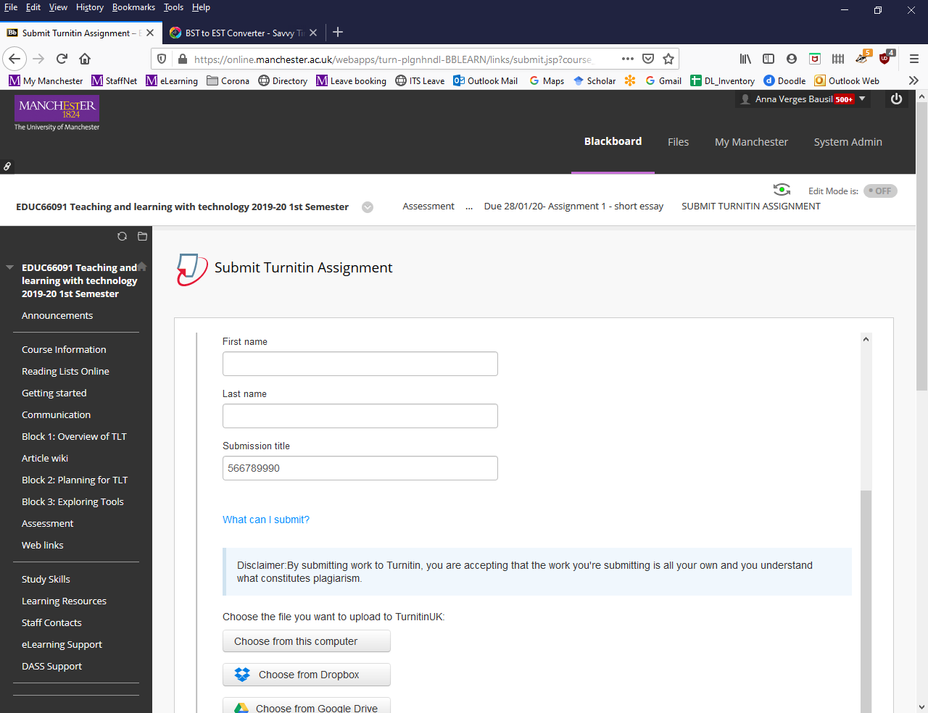Enter your student ID number at the top of your exam script. Do not add your name or surname anywhere.
3. When submitting through Turnitin, enter the file title (i.e. your ID number) in the ‘Submission title’ field.

### Submitting your work (one submission)

* Turnitin submission inboxes will only accept a single submission. If your exam includes different questions, make sure that you write the question numbers for each of your responses but then **submit one document containing all the answers to the questions you are required to answer**.
* If required, you can re-upload your work up until the submission deadline. The last submission received at the due date will be the submission that is marked.
* Use standard word-processing software (i.e., Microsoft Word) and submit your exam script as a Word Document. Do not submit a PDF unless you are given specific instructions to do this.

* Exceptionally you may be instructed to complete the exam in a prescribed format or template and submit more than one file. Where that is the case, your tutor will indicate whether you are expected to integrate multiple documents into one single document or submit different questions to different Turnitin inboxes.

* Make sure you upload your exam to the correct course and Turnitin inbox. Avoid having multiple Turnitin tabs simultaneously opened.
* Note that Turnitin no longer sends an email notification of submission. However you can download a digital receipt (see [Student Guide to submitting via Turnitin](http://documents.manchester.ac.uk/display.aspx?DocID=13010)).

### Handwritten questions

On some course units, course unit directors may ask you to submit all or part of your exam in your own handwriting. You should only do this if instructed by your course unit director:

* Handwritten answers should be completed using a black ball pen on white paper (to ensure good contrast).
* It is your responsibility to ensure that photographs of your answers are of high quality.
* Photographed answers must be integrated into a single file ready for submission to Turnitin/Blackboard. There are several ways to insert a photograph into your exam script ready for submission to Turnitin (see instructions in box below).

|  |
| --- |
| *Guidance for submission of Handwritten scripts*  1. Take a picture of your handwritten answer and transfer it to your Desktop/PC/Laptop using any of these methods:   1. Email it (as an attachment) to yourself. Open your email on your laptop/desktop and save it to your desktop. 2. Transfer it via Bluetooth to your desktop. 3. Transfer it to your laptop/desktop via a USB cable. 4. Take a picture with a digital camera and transfer it to your laptop/desktop by removing your memory card (SD card) in your camera and inserting it into your laptop card reader.   2. From your laptop/desktop, save your handwritten response to your desktop. Open Microsoft Word, go to the ‘Insert’ menu and select the picture. Ensure that the picture appears numbered within your script or add as an appendix at the end of the document. Save your Word file.  3. To reduce potential issues with the size of your submission to Turnitin[1], crop the unwanted edges of your image within Word. To crop the image simply place your cursor on top of your image, select ‘Crop’ and drag the edges towards the centre of the image. Press enter to confirm the changes and save.  Where only parts of the exam are to be handwritten, follow your course leader’s instructions as to whether to insert them within the text or add them at the end of your submission e.g. as an appendix.  If you do not have access to a photographic or scanning device (camera, mobile phone camera, scanning photocopier), you should alert your course unit director as soon as possible and at least two weeks before the submission date.  Your course director will provide a mock inbox for you to practice photographing and integrating your images into a single submission before the submission date. |

### Penalties for lateness

Turnitin submission inboxes will be open for 7 days, 48 hours or 24 hours depending on the type of exam. Do not wait until the final minute to submit your exam.

Failure to submit by the due date and time will be treated as **absence** from the examination, and your work will be given a mark of zero. There is no sliding scale for late submission for exams.

Submission deadlines are fixed for all students except where there are mitigating circumstances. The extended length of these exams allows for the possibility of personal technical difficulties during the examination period. As a result, such difficulties will not normally be accepted as mitigating circumstances for late submission. Make sure you are prepared technically and you submit your work well before the deadline.

### DASS students’ adjustments

The School has worked closely with DASS to ensure that the assessments which replace on-campus exams are as inclusive as possible.

#### Access to paper and submission of work online

If you have any disability-related concerns about accessing the assessment on Blackboard or submitting work via Turnitin, please contact your School to arrange appropriate support.

You should inform your School if you are unable to access exam papers and/or submit work via Turnitin.

#### Assessments open for either 7 days or 48 hours during the usual exam period:

* These assessments have been designed to be inclusive of extra time and rest breaks as needed. No additional time will be added to 7 days or 48 hours exams.
* If you are already registered with DASS and your support plan states that you have exam adjustments other than extra time and/or rest breaks, DASS will contact you so you have the opportunity to discuss any appropriate adjustments. If you need to discuss adjustments, you will need to reply to DASS by 26 April to ensure that your needs can be assessed before the exam period.

#### Assessments open for 24 hours or less during the usual exam period:

In line with the practice for on-campus exams, additional time will be provided for exams of a duration of 24 hours or less.

### Academic Malpractice

Like coursework, open book exam submissions will be reviewed and checked for plagiarism. All assessments will be checked for plagiarism and/or collusion using **Turnitin** and other existing methods to detect malpractice. Academic malpractice is a disciplinary offence and can lead to significant penalties.

During the examination (whether 7 days, 48 or 24 hours exams), you must work under examination conditions. In an open-book exam, this means that you can you can access readings or use your notes but:

* you must complete the assessment task on your own and without help or assistance from academic staff or other students.
* you must not impersonate another candidate or allow yourself to be impersonated.
* you must not pass off the work of someone else as your own and fully reference your sources.
* You must nor share your answers with anyone.
* You must reference your sources fully.

### Appendix 1: Preparing for online assessment

There are some potential issues that may affect completion of online exams. It is important that you are technically prepared.

1. *Access to hardware*

Ensure you have the necessary hardware, and software to complete your examinations. If you face difficulties, you can seek advice and support for online learning and assessment by contacting [helpmegetonline@manchester.ac.uk](mailto:helpmegetonline@manchester.ac.uk?subject=) or phoning +44 (0)161 306 6199.

1. *Connectivity issues*

Wi-Fi performance is the most likely issue that you may encounter but connectivity issues are generally temporary and can be resolved by:

* Using a wired (as opposed to wireless) connection.
* Avoiding peak times and seeking locations with a strong signal including coming on-campus if required.
* Limiting the number of applications open and running simultaneously.

1. *Seek IT advice ahead of the assessment period*

You should seek support via the IT Services Portal ahead of the exam period if you have concerns about:

* The performance of your PC or finding ways to improve it e.g., clearing cache, cookies, temporary files.
* your Wi-Fi performance
* the performance of your browser

1. *Individual IT Best practice*

The following points will help to ensure you can submit your work on time:

* Save your work frequently. Make regular backups of the work you are undertaking to minimise the impact of any IT failure.
* Use cloud-based storage to prevent issues such as a failed hard drive.
* Check that you are running the most recent version of your internet browsers.
* Check whether the applications you will use in your assessment have browser preferences and follow those preferences for best performance.[2]
* Make sure you know whom to contact in the case of technical issues both prior to and at the time of submission (see contact information below)

### Appendix 2: Unexpected technical issues during the exam window

If technical failures occur in University systems (e.g., Blackboard or Turnitin downtime), adjustments to submission deadlines will be made by your School and this will be communicated to you.

If you experience technical failures during the exam window that are individual to you do not worry. Excluding a very small minority of courses, all exams provide an ample window of availability (7 days, 48 or 24 hours) to allow you to work around any temporary technical issues.

* If you experience a short period of network failure, close the browser and try again using a different browser/computer, or try again later. Connectivity issues may impact your access to library or other resources but will not affect your ability to access word-processing tools.
* If you experience issues with Blackboard or Turnitin that prevent you from completing the exam submission outside of service hours (i.e. 9am-5pm local British time), you should re-attempt submission during office hours and, if issues persist, contact your eLearning Team as indicated below to get support to complete your exam
* If you experience connectivity issues frequently, consider submitting part of your completed work to Turnitin prior to the deadline so there is some record of achievement. This is not a requirement but is good practice and provides evidence of work completed.

Remember to not leave exam submission to the last minute.

### Appendix 3: Unexpected technical issues impacting the upload of your submission

If you experience network or hardware fault at the point of submission or experience technology issues that significantly affect your submission:

1. Take video footage, or a screenshot or photograph any error message.
2. Do not re-save your documents on your computer after the submission deadline has passed. Retain the document that you were trying to submit as it is, without editing it further.
3. Submit your assignment to Turnitin as soon as possible once the fault is resolved.
4. Send a copy of the captured error message to your School for consideration under mitigating circumstances.

If you suspect that your IT issues may be due to University systems, check the Service Availability information on the IT Services homepage: <http://www.itservices.manchester.ac.uk/> 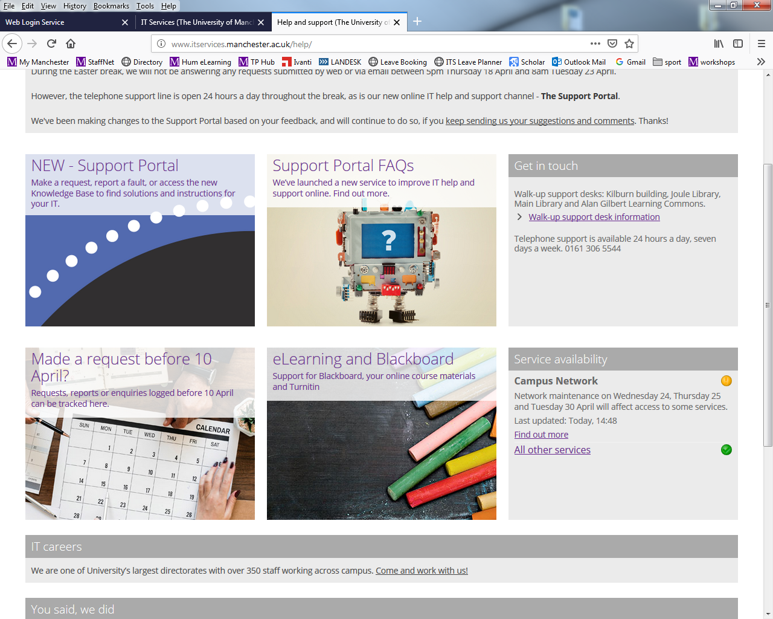The Service Availability portlet will show whether there is any unexpected or planned service disruption and flag any issues with a red or an orange circle, and the date and time the information was updated.

If the service disruption concerns Turnitin you can consult the Turnitin Service Status page: <https://turnitin.statuspage.io/>.

Should University-wide issues occur that prevent assessment processes going ahead, your School will contact all affected students.

### Appendix 4: IT Support

Support outside of office hours:

* Students experiencing IT issues outside office hours should contact IT Services via the Support Portal <https://www.itservices.manchester.ac.uk/help/>, who provide telephone support around the clock.
* Students experiencing Blackboard or Turnitin specific issues that prevent them from completing their exam submission outside of service hours, should re-attempt submission during office hours and contact the eLearning Team if issues persist <https://www.itservices.manchester.ac.uk/help/elearning/>

During office hours (9am-5pm GMT or BST as appropriate):

* Students experiencing IT issues during office hours should contact the IT Services via the Support Portal <https://www.itservices.manchester.ac.uk/help/>
* Students experiencing Blackboard or Turnitin specific issues that prevent them from completing their exam submission can contact the eLearning team via the Support Portal <https://www.itservices.manchester.ac.uk/help/elearning/>
* For urgent support during the exam period, the eLearning team will provide technical support to students Monday to Friday 9-5pm (GMT) via instant messaging (Live Chat). You can contact the eLearning Team via your School intranets:
* AMBS student intranet: [UG intranet](https://www.ambs.ughandbook.manchester.ac.uk/support/elearning/), [PGT intranet](https://www.ambs.pgthandbook.manchester.ac.uk/support/elearning/)
* [SALC student intranet](https://www.alc.manchester.ac.uk/student-intranet/support/elearning-support/)
* [SEED student intranet](https://www.seed.manchester.ac.uk/student-intranet/support/elearning-support/)
* [SoSS student intranet](https://www.socialsciences.manchester.ac.uk/student-intranet/undergraduate/elearning-support/)

|  |  |
| --- | --- |
| **Policy / Procedure Title:** | **COVID19: Student Guidance on Open Book Examination off-campus** |
| **Date Approved:** | 30 April 2021 |
| **Approving Body:** | Humanities Teaching and Learning Leadership (COVID 19 Group) |
| **Version:** | final |
| **Supersedes:** | Staff and Student Guidelines for implementation of Open Book Exams. May2020 final |
| **Previous Review Dates:** | September 2021 |
| **Next Review Date:** |  |
| **Related Statutes, Ordinances, General Regulations:** |  |
| **Related Policies / Procedures / Guidance:** | Faculty of Humanities: Changes to assessment in response to Covid-19  Staff and Student Guidelines for implementation of Alternative Examinations |
| **Code of Practice:** |  |
| **Document Owner:** | Fiona Smyth |
| **Lead Contact:** | Anna Verges |

**Amendment history**

|  |  |  |
| --- | --- | --- |
| **Version** | **Date:** | **Reason for change:** |
| Final of 5 May 2020 | 4 May 2020 | Addition of provision on bibliography and word count |
|  | 17 December 2020 | Increase clarity by splitting Staff and Student Guidance.  Updating guidance due to changes in Mitigating policy on the grounds of IT failure |
|  | 30 April 2021 | Minor changes such as advising students on capturing video footage of technical issues.  Clarification on purpose of 10 minute submission window |
|  | 10th January 2022 | Minor change relating to new version of Tii (LTI): no email notification of submission  Updated link to SoSS live chat support webpage |

1. Note that Turnitin has a file size limit of 100MB.
2. Internet Explorer (all versions) is no longer supported by Blackboard. You should use one of the supported browsers. See more information at <https://sites.manchester.ac.uk/humteachlearn/tools-we-support/browser-preferences/>