Palm Oil Workshop Activity Sheet
Complete the worksheet activities as you watch through the video. I’ll tell you when you need to pause for an activity!

Shopping Basket (3:35)
- Circle the items which you think DO contain palm oil
- Draw lines or numbers to match up the facts below with the correct shopping basket item
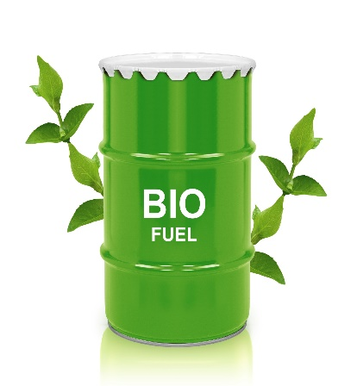
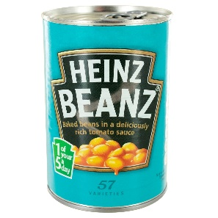
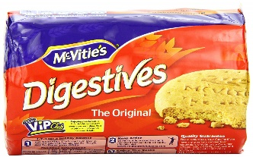
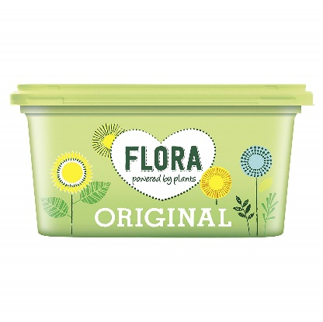
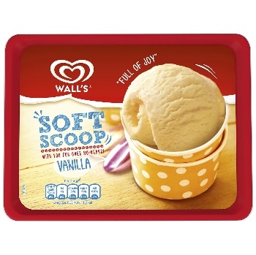
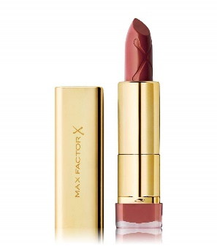
Palm oil is used in this because it has virtually no taste
Palm oil is semi-solid at room temperature
Palm oil is a healthier alternative to trans fats
Palm oil is a cheap raw ingredient
Palm oil might be listed in the ingredients of unexpected items as glycerin
Some items use other oils like rapeseed oil if they want a fried flavour

Consequences of forest loss (14:32)
Write down three ideas:
- ……………………………………………………………………………
- ……………………………………………………………………………
- ……………………………………………………………………………
Should we ban palm oil? (19:14)

YES!
NO!
Palm Oil Industry Events (skip to 28:43)
Choose your two characters:
- ……………………………………………………………………………
- ……………………………………………………………………………
Rate the events (TERRIBLE/BAD/FINE/GOOD/WONDERFUL) for each of your characters. How would this event affect them?
Event | RATING 1 | RATING 2
Biofuel use in Europe declines by 50%
The Sumatran Orangutan goes extinct
South American countries begin producing palm oil on a large scale
The GDP per capita of Indonesia doubles
Shoppers in Europe boycott palm oil
Wildfires destroy a third of the Indonesian palm oil crop
An economic crash causes the price of palm oil to double
The E.U. increases use of biofuel by 40%
Donations to orangutan conservation charities increase by 60%
Scientists engineer a new strain of palm which produces twice as much oil
A new disease completely wipes out the palm plant overnight
Any further deforestation in Indonesia is immediately outlawed
All the remaining orangutans are captured and moved to zoos
Thousands of farmers are kicked off their land to make way for a nature reserve

Extension (20:40)
Choose one of your events to FLIP by adding an extra chapter of the story:
Rating:
New rating:
BUT…
Event:

