There are two places that you need to reference MAP in your UCAS application:

1. When you add a choice at The University of Manchester to your UCAS application, you need to make sure ‘MAP’ is in the further details:

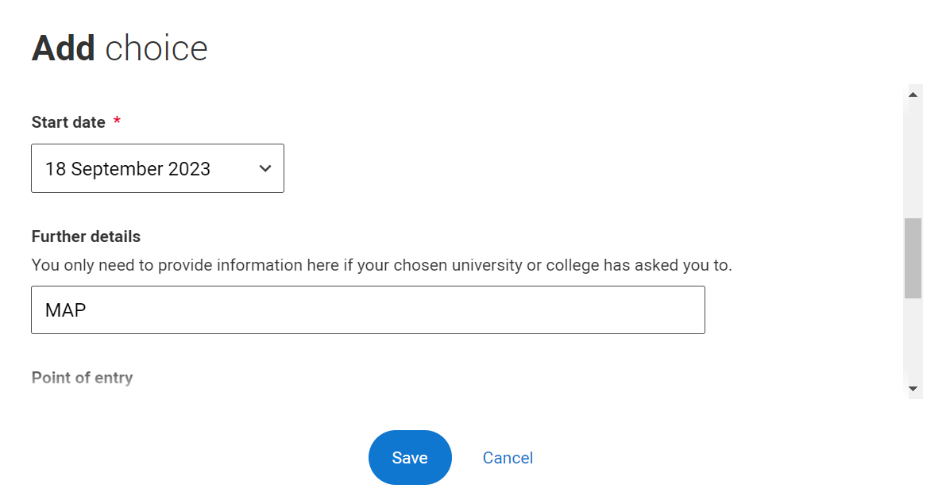

1. In the ‘extra activities’ section of your profile, you will need to add an activity in preparation for higher education:

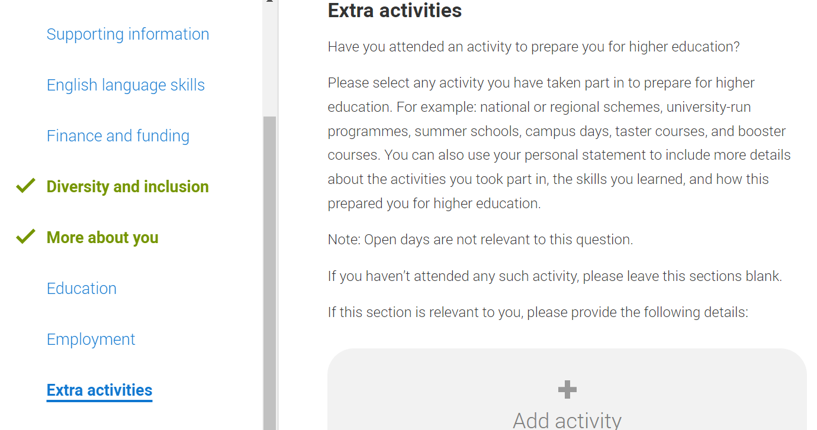

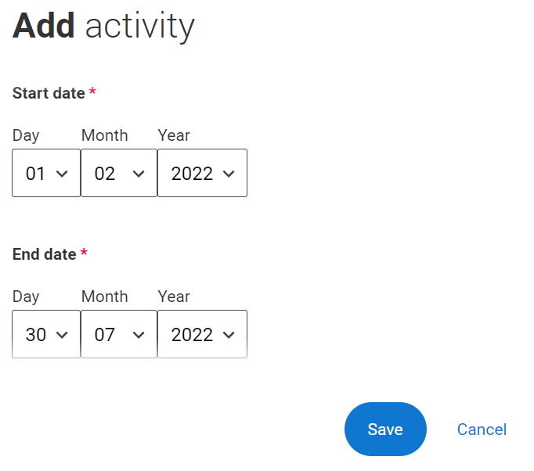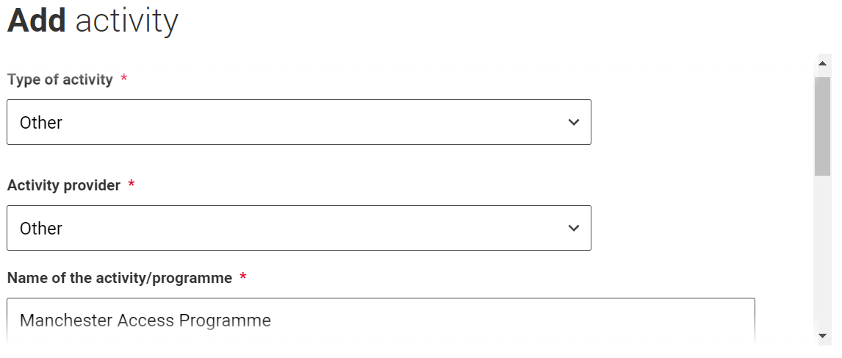

**Start date:** most of you are MAP 2022 students and therefore should put 02/2022 as the start date. If you are a previous student, please make sure you adjust the date accordingly.