An Introduction to Bacterial Infections
This Photo by Unknown Author is licensed under CC BY

What is the Purpose of this Tutorial ?
- What are bacterial infections?
- What are the signs and symptoms of an infection?
- How does someone get a bacterial infection?
- How is a bacteria different to a virus?

Starter activity

Statement | True or false?

Bacteria always cause disease

You can treat a virus with antibiotics

Bacteria are living cells

Bacteria can infect any part of the human body

Only humans get bacterial infections

Bacteria are larger than viruses

What is a bacteria?
Bacteria are all living single-celled microbes. The cells are all prokaryotic. This means bacterial cells do not have a nucleus or any other structures which are surrounded by membranes. Larger bacterial cells may be visible using a light microscope. However, an electron microscope would be needed to see the details of the cell organelles.
This Photo by Unknown Author is licensed under CC BY-SA

Not all bacteria are “bad”! This means they don’t all cause an infection. Some bacteria are very helpful in looking after the digestive system and your gut.
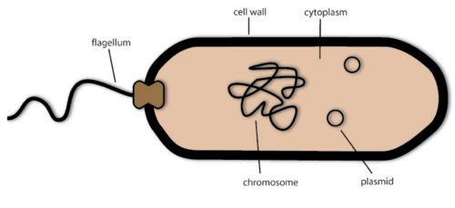
Figure 1 Not all bacteria cause diseases!

Question 1: What is a bacterial infection?

How would you know if you had a bacterial infection?

If you’re ill, how do you feel?

Symptoms are what a patient experiences or describes. This means you may not be able to see them. Examples are a headache or tiredness. Signs are things you or your doctor would be able to see or measure when they look at you. Examples are a rash, a high temperature or bruising.

Question 2: What are the signs and symptoms of a bacterial infection?

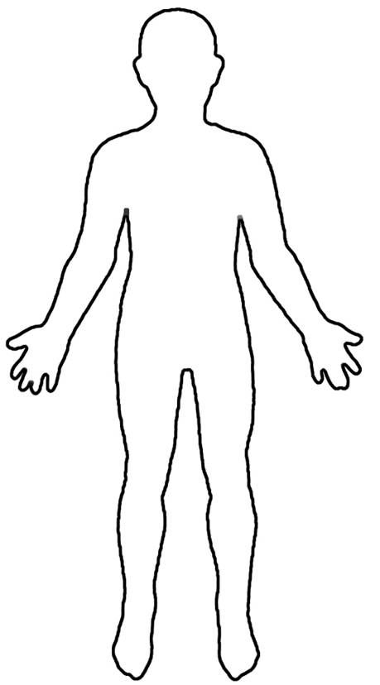
Cough

How does your doctor know if you have a bacterial infection?

In many cases, it’s difficult to know whether an infection is caused by a bacteria or a virus (or even fungi!). Your doctor will first look to see if you are unwell. This is by observing the signs, for example taking your blood pressure, temperature and respiratory rate (how fast someone is breathing). The doctor will ask you to describe your symptoms.

Generally, the doctor will then take a sample from you. This sample will depend on where you think you have the infection. For example, if you have a wound that you think is infected, the doctor will swab the wound. This sample will then be sent to a laboratory for further testing.
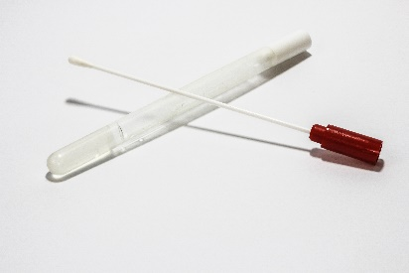

Viral infections

Viral infections are caused by viruses. Unlike bacteria, most viruses cause diseases.
Some examples include COVID-19 (Coronavirus) and Influenza (“The Flu”). Viral infections and bacterial infections may have similar symptoms, such as coughing, diarrhoea and vomiting.

Viruses are very small- the largest virus is smaller than the smallest bacteria.

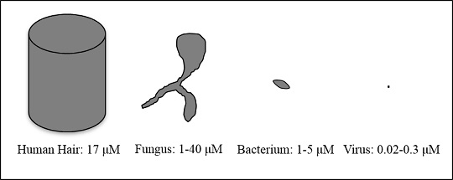

Viruses are not living cells. They can only survive by using a ‘host’, which is another living cell which they use to reproduce. In contrast to bacteria, viruses are very specific about where they can infect. For example, HIV only attacks very specific cells called Th lymphocytes in the immune system. Other viruses will only infect the blood, the liver or specific organs.

Antibiotics that are used to treat bacterial infections are NOT effective on viruses. This is because they aren’t the same structure as a bacteria. Viruses are made up of a protein coat with some DNA/RNA inside. Therefore, they can’t be targeted by antibiotics.

Question 4: How is a bacteria different to a virus?

Bacteria | Virus

