# **How to…do a stakeholder analysis**

Understanding the stakeholders in a change is important not only to ensuring buy-in but also to ensure that the change is properly considered for everyone who potentially may be impacted.

## **Step 1: Brainstorm the stakeholders**

Either in a team or individually sit down and brainstorm all likely stakeholders. If you do this alone, run this by someone else to check there isn’t anyone who has been forgotten.

## **Step 2: Influence & impacted**

Map the stakeholders into any easy grid to see which are the stakeholders you should focus on – any who are impacted are important to the change; any who have influence may need to be considered as important to be engaged even if they are not impacted.

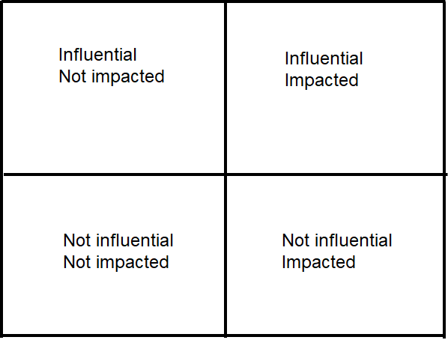

## **Step 3: How do our stakeholders currently feel and how do we need them to feel?**

Having a steer on whether the stakeholders are an advocate for the change or are hostile is important but you also need to understand what you need them to be for the change to be successful.

If they are hostile, you will need to consider how to win them over or get them to a neutral standpoint. It’s also important not to lose sight of the advocates – they need to be engaged throughout to ensure they remain advocates.

## **Step 4: Action Plan**

Document the analysis into a Stakeholder Log and detail the actions that are going to be taken. Actions may include:

* The Change Sponsor briefing an influential and impacted stakeholder
* The change manager engaging with an impacted team
* A quick update to an impacted stakeholder from a project team member

## **Top Tip**

Focus on the key stakeholders – those with influence and who are impacted. Don’t forget that stakeholder management takes time and resources when planning a change.