**SEED Geospatial Working Group Report: Meeting 1, 15th June, 2020**

Attendees: *Sarah Lindley (Geography), Richard Kingston (PEM), Billy Haworth (HCRI), Nuno Pinto (PEM), Gail Millin-Chalabi (SEED), Anna Hughes (Geography), Claire Goulsbra (Geography), Jonny Huck (Geography), Łukasz Stanek (Arch), Matt Dennis (Geography), Angela Harris (Geography), Jiawei Li (Geography PGR), Ransford Acheampong (PEM), Polyanna Bispo (Geography), Johan Oldekop (GDI), Andreas Schulze Bäing (PEM), Julian Williams (MIE), Jonny Crook (SEED)*

**Aims**:

* To ensure business critical geospatial activities are supported across SEED for SoY.
* To explore innovative solutions / resources for remote geospatial teaching and grow geospatial activities in SEED.

**Overall project objectives:**

* Schedule objective - To ensure that any specific SoY software/updates required for September is made known ASAP and to investigate whether these updates are possible with the current outsourcing of IT application requests.
* Technical objective - To provide remote robust access to geospatial software's to students no matter what hardware or operating system they are using so that they can conduct GIS and Remote Sensing practical's successfully.
* Cost objective - To assess the current GIS/RS software available in SEED’s portfolio and highlight any software that is no longer required or new software that is necessary for teaching going forward.
* Innovation in Teaching objective - To seek solutions for providing an introduction to geospatial resources and assets across SEED to support teaching remotely and thereafter once staff and students return to the campus.

**Summary of key points and recommendations**

* Geospatial teaching is a core part of SEED business. There are 20+ courses with some representation in each discipline. The courses are associated with upwards of 660 student registrations, excluding dissertations and independent projects.
* Student hardware and software was seen as the biggest difficulty faced in Semester 2, followed by student’s operating systems/other software restrictions and then internet/data access problems. Issues are therefore student-centred.
  + **Recommendation 1a:** Further student support materials should be considered (see Recommendation 5).
  + **Recommendation 1b:** Remote working recommendations to take account of these student centred issues (see later bullets)
  + **Recommendation 1c:** Students should be made aware of the transferable skills associated with working remotely and using discussion boards
  + **Recommendation 1d:** Students should be encouraged to phrase their technical questions in effective ways and which enable more efficient action. A draft template for all students to follow to submit technical questions in a consistent way has been developed (see Annex 1).
* Teaching staff would prefer students to work remotely with their own installations of required software. This would overcome internet problems, but has negative implications for equity and widening participation agendas. It might be reasonable to make recommendations for computing expectations for PGT students but likely not for UGT students. It was also noted that different solutions may be appropriate for different cohorts and levels, with beginners perhaps being directly to wholly online options, thus reducing the range of possible technical issues.
  + **Recommendation 2a:** Where appropriate (e.g. PGT students) course leaders/programme directors to develop and disseminate information for students regarding hardware and software computing requirements for particular courses and programmes.
  + **Recommendation 2b:** Information to be provided to students about widening participation funds available if they have inadequate machines to undertake specific courses/programmes.
  + **Recommendations 2c:** Where individual courses could be migrated to cloud platforms (e.g. ArcGIS Online) this is recommended, especially for beginners.
  + **Recommendation 2d:** There will still need to be some flexibility of in remote working options according to specific course requirements & remaining student issues – requires further action.
* Remote access to clusters (virtual lab classes) was the second preference. Here, restrictions are simply associated with the numbers of machines available for teaching.
  + **Recommendation 3:** Further consider remote access to clusters option for AY 2020/21, e.g. in terms of logistics, out-of-class working, support and how/if to manage on campus physical access.
* It was noted that blended learning for geospatial teaching would present particular challenges. While some practical challenges might be overcome with additional resource (e.g. TA support) social distancing would increase teaching demands on lecturing staff (e.g. repeating classes). Most critically, the inherent value of computer lab classes – which require proximity to lab machines to investigate problems and demonstrate solutions – would be lost under any form of social distancing, Remote classes would provide a better, and more equitable, teaching and learning environment.
  + **Recommendation 4a:** Do not prioritise computer classes for face-to-face small group teaching in Semester 1, instead invest in designing better remote working options based on the cluster machines.
  + **Recommendation 4b:** GM-C to seek a clear steer from IT Services on how remote access to cluster machines will operate for SoY.
* Several ‘quick win’ options were identified, including developing a shared resource space (e.g. in BB) and populating it with enhanced support materials (e.g. screen casts and how to documents). There was support to start to develop them collectively.
  + **Recommendation 5:** SL and GM-C to begin to organise the foundations for collective development of additional resource.
* Some issues remain to be discussed, for instance about TA support. Since there was general agreement to hold a further meeting in ~2 weeks, this can be covered then, along with an update on other activities.
  + **Recommendation 6:** SL to arrange a further follow-up meeting of the group.

**Notes from the meeting supporting the summary and recommendations**

Please refer to the **pdf for the slides and survey results**. The notes in this document provide further supplementary information based on the wider discussion and questions via chat.

Note for slide 4: SL will report to Director of T&L and make notes available to all via the T&L intranet.

1. ***Feedback from experience of remote geospatial teaching in Semester 2 & lessons learnt***

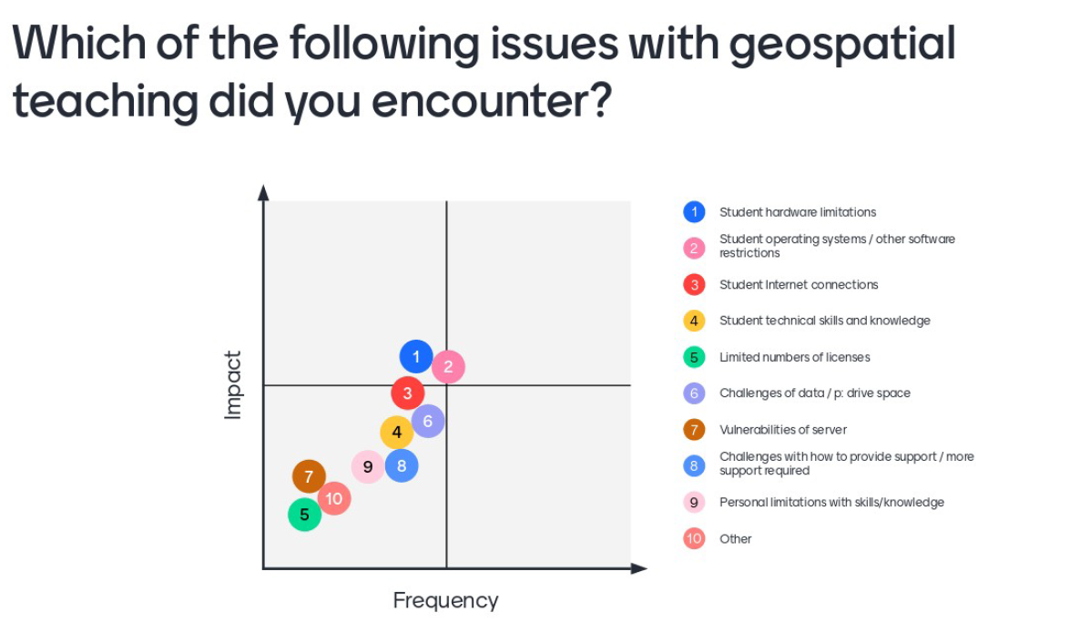

*Figure 1: Which of the following issues with geospatial teaching did you encounter? Rate the options according to the frequency of issues reported and their impact on course units.*

**Student hardware and software was seen as the biggest difficulty faced in Semester 2** (Figure 1). Many participants felt that this will be critical to address for the new semester.

Other reactions to this question included:

* Some participants (JW, LS, JO, ASB) had not had experience of teaching to date and/or had not taught in Semester 2.
* Some participants (Ahu) responded based on their experience of use by dissertation students.
* Student UEQs were not released prior to the meeting therefore the assessment is somewhat anecdotal
* MD Some noted that experiences in S2 were based on open software so experience may be different for S1 using proprietary software
* Detailed response data can be used to match issues with respondents - some experiences differed quite markedly between participants’ answers
* Other issues from Semester 2 were also raised:
  + BH raised the issue of how to meaningfully interact with students working online on geospatial topics. For instance, how can we effectively use discussion boards and also handle enquires outside timetabled sessions when there can be a considerable lag between an enquiry being made and then answered.
  + AHu raised the issue of the time it takes to respond via email to individual students and the difficulty of not being able to see their screen to resolve problems.
  + Others raised the issue of difficulties sharing screens one to one with students, e.g. as this requires also sharing with the rest of the class too. MD noted that if students are happy to share screens this can sometimes be useful as a wider learning exercise (since students frequently have similar problems). However, SL noted that some students may feel uncomfortable with sharing and it may discourage questions.
  + ASB asked whether it was possible to share screens within BB collaborate breakout sessions and whether these breakouts can be recorded.
  + RK raised the issue of sharing spatial data wasn’t that straightforward and if you wanted students to work together collaboratively on a GIS project.

Colleagues shared some of their positive experiences of what seemed to work for remote geospatial teaching and support in semester 2:

* Some in the group (e.g. AHa) used teaching slots only for practical support and recorded lecture-based sessions in advance. This gave more time for practical support.
* AHa noted that she also uses software (Google Earth Engine) which enables students to share a link to their work thus avoiding the need to share screens. However, this can be done more effectively in some forms of teaching than others. Another solution was to use zip files (QGIS) to recreate projects (JH) (similar can be done in ArcGIS Pro by producing a map package this packages the project file and associated datasets so that it can be shared via email).
* Another tip was that some colleagues (JH) have a rule not to respond to student questions which are poorly phrased and hard to understand. Students need to develop their skills in phrasing technical questions. The same is also true for students using discussion boards, downloading software and using technical workarounds. A key thing here is that communications with students about remote working could emphasise the additional skills to be learnt rather than the new difficulties with online working in geospatial areas (given that so much geospatial work relies on online working and problem solving).

Several practical questions came up:

* Screen-sharing. Although there are potential problems with students sharing their screen to all via software like BB and Zoom, one option that seemed to work well (AHa) is to use Zoom with the waiting room option alongside BB collaborate classes. Here students can have a one-to-one screen share without the need to let everyone see their screens.
* JC noted that on Bb Collaborate students can be given permission to share their screen and they should be able to do this within Breakout groups too. <https://help.blackboard.com/Collaborate/Ultra/Participant/Presenting>

1. **Schedule objective: Teaching Geospatial in SEED**

There are 20+ courses in SEED (and further courses in HCRI available to SEED students) using geospatial teaching. This represents upwards of 660 student registrations. Further course units were added to the existing list (e.g. PLAN40812/PLAN60812 Neighbourhood Planning and PLAN10062 Applied Project) and a few additional units where geospatial teaching features as smaller blocks (see pdf, p.14). In addition UGT and PGT students frequently access geospatial software for their independent dissertation[1]/project work, further adding to the student numbers involved. It was noted that a decision had been made to not run at least one of these courses in 2020/21(GEOG20381). GM-C highlighted that it is essential to request new software requirements ASAP for SoY. Software lists were reviewed to highlight changes to licensing; no additional essential software requirements not being handled separately were identified. See pdf for further information.

1. **Technical objective: Remote access options**

Six technical options were presented for remote working using geospatial software in Semester 2 (see pdf). GM-C highlighted both positives and negatives of remote access options and suggested that depending on the students individual circumstances one option may be more suitable than another option e.g. operating system used, internet access, students technical capabilities and therefore it is possible for some courses more that one of these options could be used and indeed that was the case for Semester 2.

JH asked for clarification around option 5. GM-C stated option 5 is online open source platform e.g. Sentinel Hub Playground, EFFIS or Google Earth Engine and that open source software e.g. QGIS & SNAP should go under option 1 as to use it students would need to install the software on their personal device. Participants were asked what they think *would work* for their teaching (top) and what their *actual preference* would be (bottom) (Figure 2).

1. ***What options would work for your requirements?***

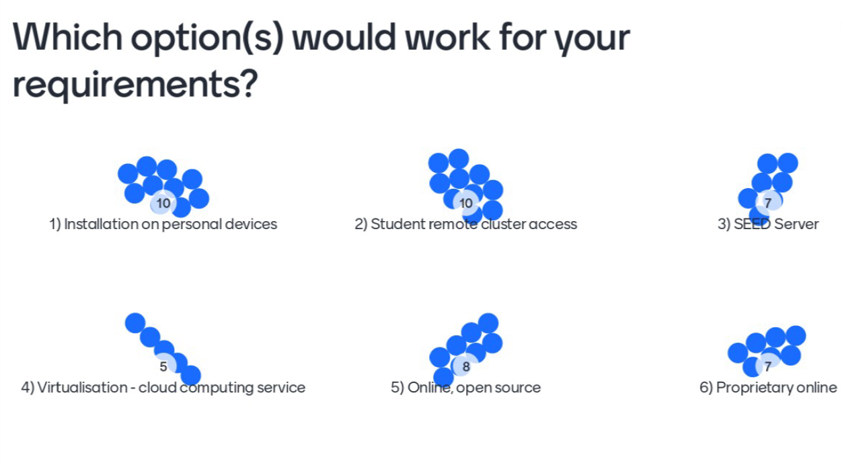

1. ***What options would you actively prefer?***

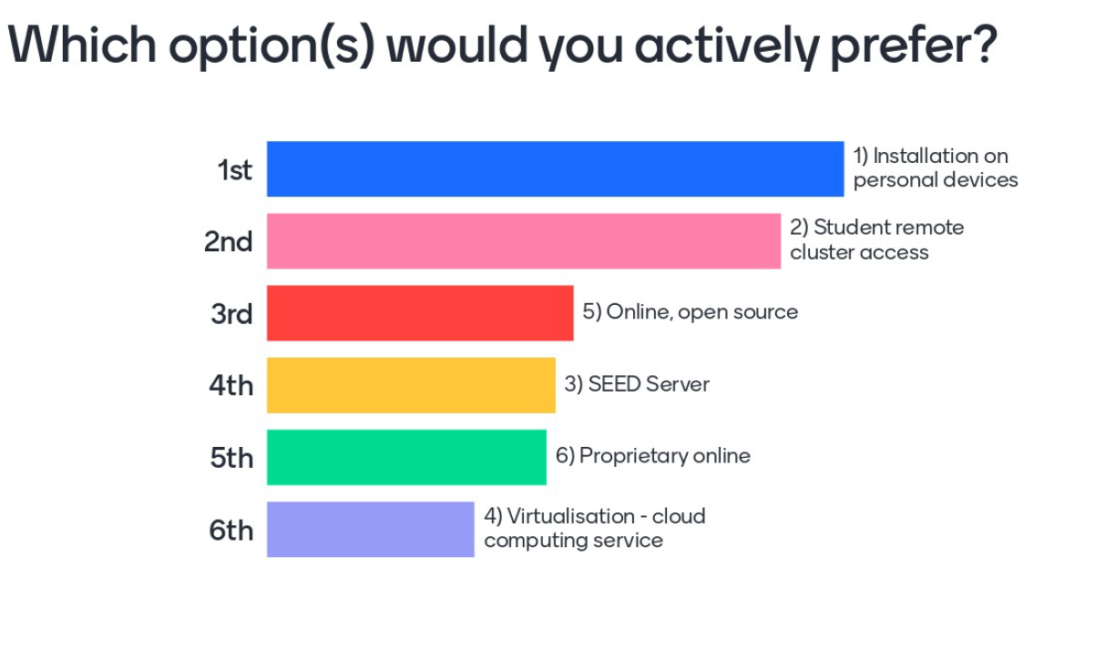

*Figure 2: Participant responses to the six presented options in terms of (a) what would work for their teaching (b) what is preferable for their teaching*

Of the options presented, there was **a clear preference for installation of required software on student devices, followed by the use of student remote access to clusters**. However, many participants agreed that a number of options would be workable, leaving some flexibility in remote working options.

Although ideally students would **install required geospatial software on personal devices, the experience of Semester 2 suggested that many students would not have sufficiently high specification computers to enable this to work as a single solution.**

Students could be informed of the specification requirements of courses prior to registration. For example, AHu asked if there should be an indication to incoming PGT or UGT students that they will need a minimum setup for personal computers, e.g. in terms of RAM. CG also agreed noting that installation on personal devices will only work if students have decent machines. This is currently not a requirement in terms of admissions[2]. JH noted that at the moment students are only told of these sorts of issues if they actively request that information in advance. RK and CG emphasised the issue of equality and widening participation objectives with concerns expressed about whether the requirement to have high specification machines to attend certain classes would disadvantage some students over others. Issues may be more acute for UGT than PGT, as PGT students (e.g. on Geography’s GIS or EMMR programmes) might reasonably expect that they would have a relatively high specification machine for homeworking. Here, a recommendation for computing requirements for incoming students may be useful.

It was noted that the **remote cluster option** would overcome these issues in that students would still have access to high spec machines, though not automatically on a 24 hour basis.

ABS asked about whether there was a class size limit for remote cluster access, for instance some Planning units (Neighbourhood Planning) have 80-90 students. GM-C reported that licenses are not an issue but there are restrictions in terms of physical computer numbers to support the remote logins. It is only possible to run for the number of the machines booked for those classes and machines cannot be accessed remotely and physically concurrently – it is one or the other.

ABS also reminded the group that internet access issues should also be considered here as that was an issue in Semester 2, especially as this sort of working may be demanding on data limits. Cost implications for students should also be considered.

JH noted that not all classes are 2 hours, some are 3 hours so this needs to be considered if timetabling for this option. It was noted that geospatial teaching staff cannot assume that computer cluster lab access will prioritise geospatial teaching needs and that there will be other demands on cluster space, including for other software with restricted availability in HBS2.1 and 2.2 (for SEED and non-SEED courses).

As JO & AHu noted, these options were not necessarily mutually exclusive; there may be different solutions for specific courses. Some of that can be drawn out of the detailed responses from participants (available from SL). GM-C also agreed that we might adopt a range of solutions for different use cases and wider situations. For instance CAL licenses and the SEED remote server might be best for small classes with specialist needs, PGRs or specialist UG dissertations (e.g. Agisoft Metashape, ENVI, STATA and Flood Modeller).

1. ***Innovation in geospatial teaching and learning***

The final part of the meeting touched on a range of other questions looking to what wider changes and innovations might be adopted for the new academic year (Figure 3). Initial preferences for what the geospatial working group should collectively develop to support geospatial teaching in 2020/21 (Figure 4)

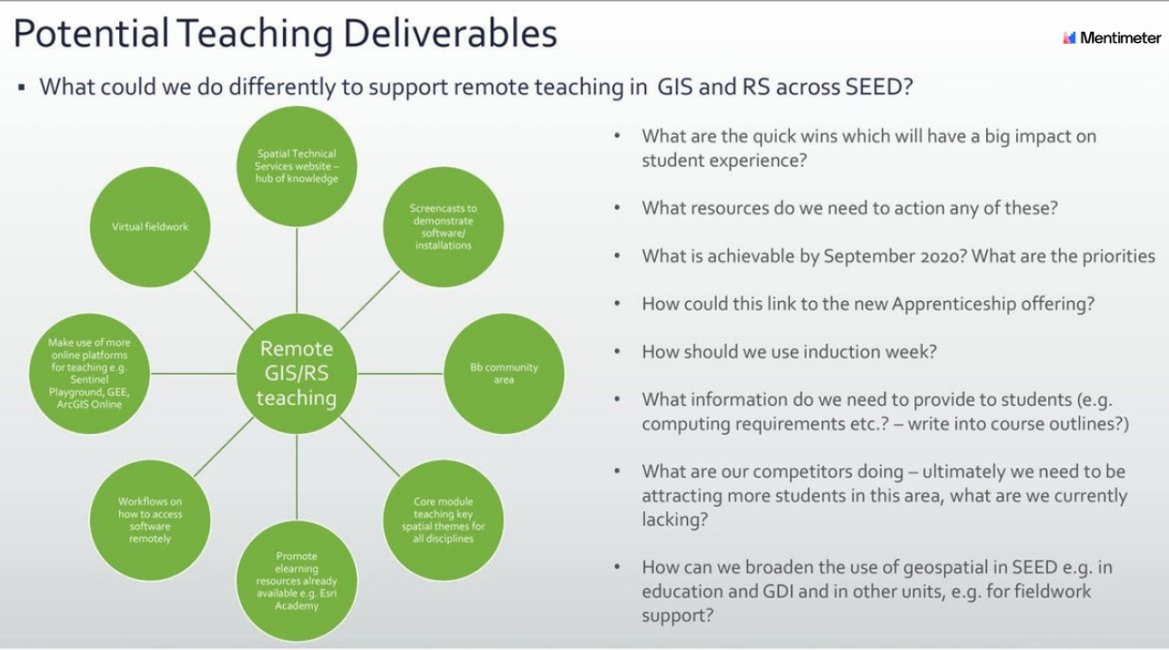

*Figure 3: Further questions and options for the geospatial working group.*

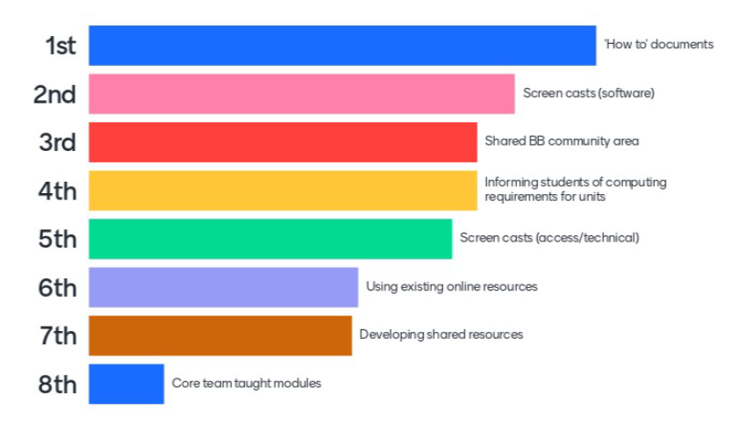

*Figure 4: Ranked responses to the question on what we should collectively develop to support geospatial teaching in 2020/21.*

There was support for the development of a wider set of support materials in the form of ‘how to’ documents (primarily aimed at students) and screencasts (ditto). These can be hosted as part of a shared community BB site and this was a strong preference over the idea of developing cross SEED/University team-taught modules. SL stressed that the development of these options would need a **collective effort** from all members of the group. Some of the content of the community area could also make use of existing online materials. It was recognised that there is scope for wider innovations, which might be explored in future meetings once business critical elements are tackled.

1. ***Other issues raised***

Participants were asked about any other issues which had not been covered, or not sufficiently covered. Some were reported through survey responses (Figure 5) and others verbally/via chat e.g. GM-C mentioned the issue of students not able to connect to Global Protect VPN which then prevents students from accessing the license server for software packages such as ENVI, ArcGIS Pro and Agisoft Metashape Professional, however there are potential workarounds such as Named User License for ArcGIS Pro or the SEED Server for ENVI/Agisoft Metashape Professional

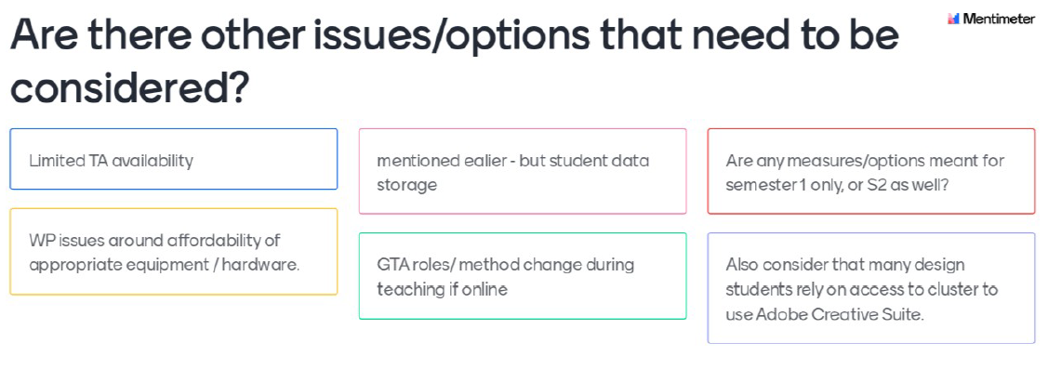

*Figure 5: Topics requiring further consideration reported by participants.*

An important discussion centred on views around **blended learning and geospatial teaching**. Practical classes are a core element of teaching and learning in geospatial topics and key to the student experience. However, there were concerns about the practicality and desirability of face-to-face teaching in computer clusters in 2020/21, especially in Semester 1. **There is a need to consider whether computer cluster access should be considered as ‘small group sessions’ and therefore a priority for early face-to-face classes**. CG noted that the University is keen to deliver some classes – which may be assumed to include computer cluster classes – and to encourage students to attend where they can. However, no one in the group made a case for prioritisation of this form of teaching and JH suggested that in fact physical face-to-face teaching in computer clusters should be one of the final forms of teaching to be resumed. Some of the reasons given include:

* In the context of very heavily used computer cluster laboratories, social distancing at 2m means that any face-to-face sessions would likely need to be run multiple times and/or teaching outside timetable hours in order to accommodate the same number of students. This may make running practical classes impractical.
* Keyboards, mice and monitors would need to be cleaned after each session/use with any social distancing regulations in force. This would likely rely on students being asked to perform this task before and after sessions.
* Having some students physically in the class and some remote would cause added complications in that it is not possible to use a single machine both in the class and remotely. Therefore machines would need to be identified as remote or class machines. NP suggested that if labs are available, social distancing could allow two remote workstations to be allocated between students physically attending. However, there are questions about how far lecturing staff can deliver a meaningful teaching and learning experience for remote and present students concurrently[3]. One option would be for classes to be duplicated (separate remote and face-to-face versions of the same classes). This increases staff teaching time and impacts the student experience and opportunities for peer-to-peer learning.
* Perhaps most critically, participants felt very strongly that the essential teaching and learning value of computer laboratory classes would be lost for those physically in class. As noted by AH, often it is the ability of the instructor to see a student at their workstation to discuss problems or demonstrate solutions, or for students to gather around machines which is most important. Any form of social distancing would preclude this normal practice. Under these circumstances remote working with the option for screen sharing is actually preferable.
* It was also noted there is a management issue of labs in the sense that students are used to following-up classes with their own work. It is unclear about how this can work, but further investigation is needed.

1. ***What should happen next?***

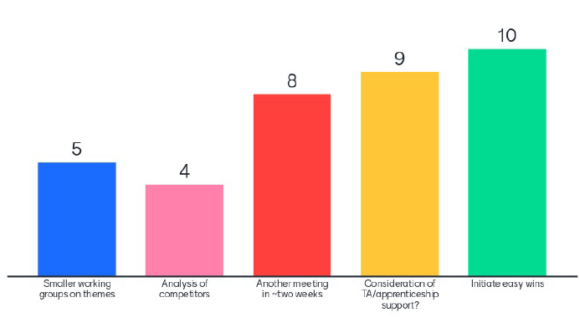

*Figure 6: Views on how to take things forward.*

The final question was about taking things forward (Figure 7). There was interest in initiating the easy wins immediately and holding another meeting in ~2 weeks. So far two people (JH & GM-C) have volunteered to take forward a smaller working group on particular themes. The final issue (also raised under 4) was about TA/apprenticeship support. This requires further discussion. CG noted that she will be having a TA meeting on 17th June and will bring information from that meeting to the group.

***Annex 1: Suggested template for all students to follow to submit technical questions. Guidance can be given by course leaders on course-specific information (e.g. software, version and platform).***

|  |  |
| --- | --- |
| Email |  |
| Computer username |  |
| Operating System |  |
| Software |  |
| Version |  |
| Platform |  |
| Specific Technical Query |  |
| Screen shot |  |

.

1. AHu – there are issues about how to support study-abroad students and other students having to change their dissertation topics to secondary data sources. This may also need to be considered in a future meeting.
2. SL note – Given that many students are new to geospatial topics, there is also the issue of students potentially becoming interested in courses and dissertation topics later in the academic year finding that they cannot take courses, or conduct independent research, due to their computer specifications.
3. TA support might help with this activity, if available.