2023/24 PDR Guidance for Library staff (Reviewers and Reviewees)

The Performance and Development Review (PDR) template is available to download from the Library intranet , alternatively you may wish to use this accessible PDR form. Guidance on how to use the University PDR system can be found here.

- PDR meetings
Managers may use their discretion in relation to the number and formality of the PDR meetings, but it is recommended to continue with the two-step PDR process (1st PDR meeting late Nov/Dec & 2nd PDR meeting Dec/Jan) to provide additional reflection time. The PDR conversation/s and agreed objectives are the most important part of the process and the PDR form can be used as a starting point for discussion with bullet pointed information in each section. It is also recommended that Team and Directorate-wide objectives are considered alongside this process to ensure individual objectives are appropriately aligned.

- Guidance on conducting PDR discussion.
The PDR conversation should consider how an individual is performing in their role, how they are delivering against their objectives, how they are demonstrating expected behaviours and ways of working and reflection on goals for the Personal Learning and Development plan.
Key areas to focus on before the review meeting:
- What would you like to get out of the review process?
- Review last year’s objectives and the learning plan.
- Key achievements
- Skills development and contribution to the team.
- What feedback should be gathered? Consider and plan how to do this.
- Potential objectives and development areas for the next year.
Reflection on the past year
PDRs start with a reflection on the previous year. Whilst the PDR is primarily future focused, it is important to reflect on the highlights and challenges the last year has presented. This reflection should focus on noting key learning points and any key goals that may need carrying over. This is where you may want to consider any specific feedback relating to the role, e.g. feedback from colleagues.

Future focused discussion
The discussion should focus on performance and development expectations and needs for the next 12 months. We suggest that your future focused discussions consider four key areas (See the Development framework in appendix 1) but should also consider more general topics which have an impact on the way we work, including:

- Equity, Diversity and Inclusion: we all need to consider how we contribute to a more diverse, equitable and inclusive library. Start with small, manageable actions such as attending training or undertaking learning, for example taking the new LAOD154 Disability Equity Training. Consider how to improve access to services you’re involved in and identify one barrier you would like to tackle with colleagues, for example including more diverse examples in training materials. Everyone should include at least one action to support EDI in their PDR
- Information Governance and data protection: have you experienced or witnessed any data protection issues recently or do you have any thoughts on how to make the Team's work more secure?
- Environment Sustainability

- Role expectations
Refer to the job description to reach a mutual understanding of the day-to-day tasks in role / activities and general measures of success. This needs to be clearly articulated and regularly reviewed as the day-to-day needs of the role change.
Some coaching questions to help you with setting expectations about roles are given in Appendix 2

- Objectives
Annual performance objectives and expectations in role link to our University strategy, Imagine2030, Directorate priorities and Team targets and should indicate clear measures of success. It is helpful if managers can share their own, or any overarching team objectives, as part of this discussion, so individuals can link their objectives to the teams’, where relevant.

Line Manager Objectives – All line managers should have a least one objective that reflects their management responsibility.
Examples of objectives that you can tailor/edit as appropriate:
- All direct reports to have a Personal Learning & Development plan that supports the achievements of their objectives by 31st January.
- Operational plans are in place for the team and reviewed on a quarterly basis.
- All direct reports to complete a wellbeing action plan by XX
- New team member fully recruited and completed induction by [date].

For more information about setting objectives, see the ‘Setting Direction’ pages on Managers’ Essentials.
A quick guide to setting SMART objectives is given in Appendix 3

- Behaviours, values, and ways of working
In addition to objectives, it is important to agree expectations of the behaviours, values and ways of working needed to be successful in the role and team. The Library’s working together charter, local team charters and University’s Values will all support this conversation.
Some coaching questions to help you discuss expectations around behaviours and ways of working are given in Appendix 2.

- Personal Development

Personal and professional development is one of the most important aspects of the PDR conversation for all staff to excel in their roles and contribute to the University's performance. There is a useful L&OD resource (Individual Learning needs analysis) for individuals and managers to help identify learning or development needs, plus resources for managers on the Managers’ Essentials site under ‘Developing your People’ . L&OD will be a key source of any general learning or development needs identified. It is important that we think creatively about other ways of providing development, through experiential learning, coaching, and mentoring etc. and should embrace the 70:20:10 model (Appendix 4)
Line Manager Development - All line managers should have a development objective focused on enhancing their line management capability.
The learning objective should also be captured in the Personal Learning and Development plan. For more information and support in developing yourself as a leader and manager, see the Developing yourself as a Manager and Leader on Managers’ Essentials.

The Personal Learning and Development plan
The Personal Learning & Development plan supports the achievement of the developmental and behavioural PDR objectives by articulating how the development goal will be accomplished. For example, to meet the PDR development objective ‘To run productive meetings’:
- Think about someone you work with who is very effective at leading collaborative and productive meetings. Notice their approach and what they do.
- Become a coach so you can practice the skills of guiding rather than advising.
- Attend the L&OD course TSLD16 Chairing Meetings that Deliver Results.

Record this information in the Personal Learning & Development plan which will also be used to inform the Staff Learning & Organisational Development plan for the Library. It is worth considering and noting shorter term (this year) and longer term (future years) learning & development goals as part of your conversations.
Please can all line managers ensure they send a copy of their direct reports completed Personal Learning and Development plan to the Staff Learning & Organisational Group representative for their Directorate / Team. This will help inform a Library-wide Staff Learning and Organisational development plan and ensure a consistent and transparent approach to staff development.

Library SL&OD reps
- Peter Wadsworth (Directorate of the University Librarian)
- Sarah Rayner (Faculty and Student Partnerships)
- Kathryn Sullivan (Collection Strategies)
- Lucinda May (Directorate of the University Librarian)
- Paul Ralphs (Faculty and Student Partnerships)
- Amin Hussein (Digital Development, Digital Services)
- Elizabeth Carr (Curatorial Practices)

Appendix 1: Development Framework

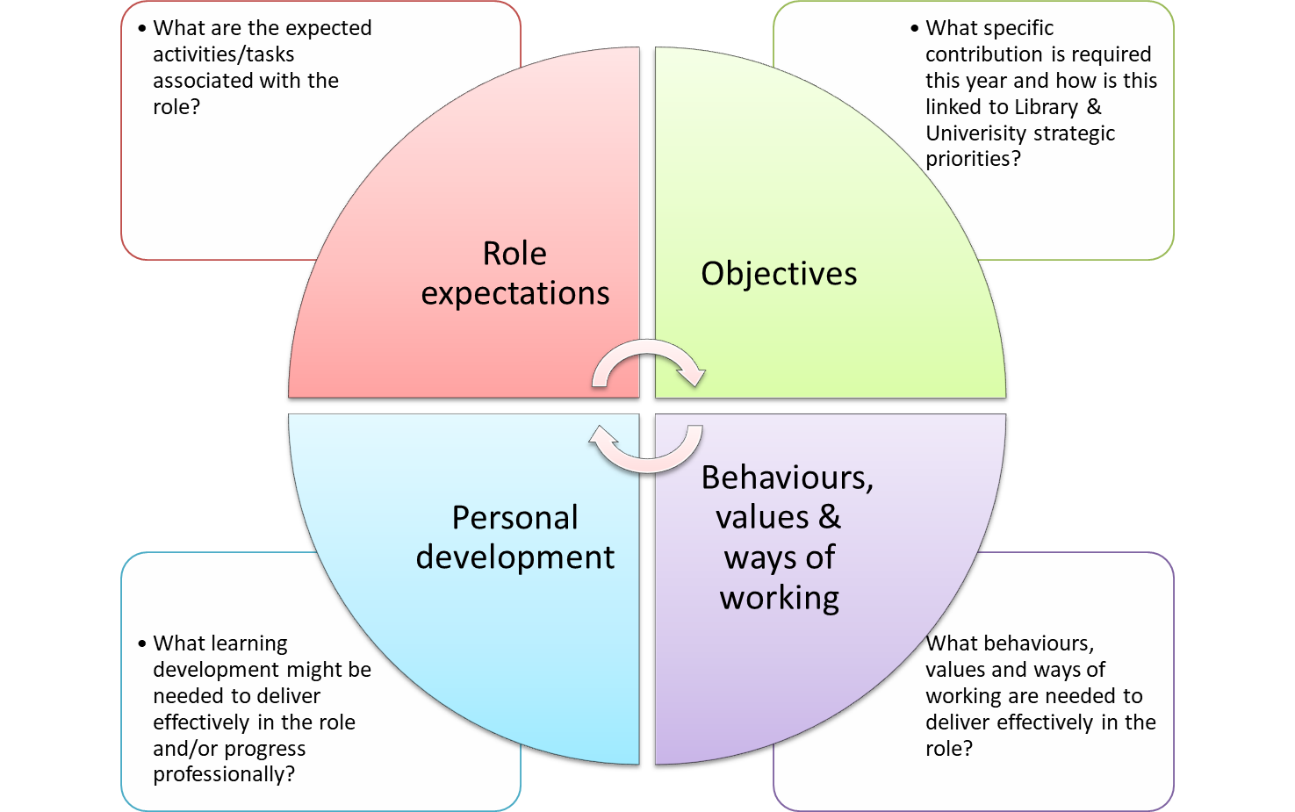

Appendix 2: Coaching questions
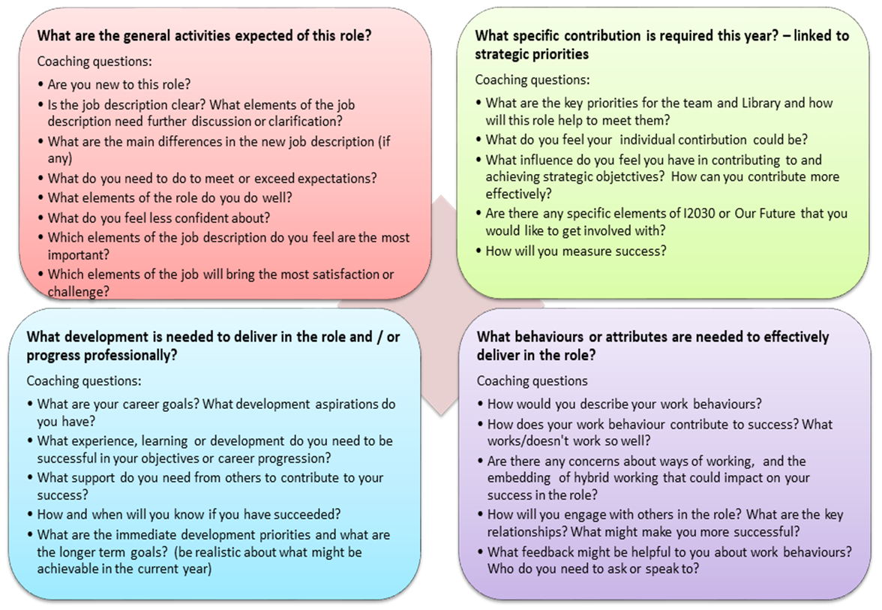

Appendix 3: Setting SMART objectives
Objectives link to our University strategy, Imagine2030, Directorate priorities and Team targets and indicate clear measures of success, outlining what each individual needs to prioritise and deliver over a 12-month period. Team and Directorate objectives should be shared so individuals can understand how their own objectives link to the wider strategy. When setting objectives, focus on identifying an appropriate challenge that is also supported by the Learning and Development plan: between three and six objectives is a good range, but this will depend on the nature of the role.
Objectives are simply statements of what you want to achieve. It is important to have clear objectives of what you are aiming to achieve. It can help to use the SMART approach to formulating objectives.
S | Specific & Stretching | Clear and unambiguous (is it exactly what needs doing?) who, what, where, when, which, why?
M | Measurable | Quantify and quality where possible (how close am I? how will I know when I have reached my goal?)
A | Achievable & Agreed | Must be agreed (by both) and achievable (allow for workload etc.)
R | Realistic & Relevant | Must be able to happen, must have resources, support, knowledge and must provide results, should be linked to team and organisation annual goals (does it need to be done?)
T | Timescale | With review dates and a final deadline (realistic timeframe adds focus - not too long!)

Examples:
- To collaborate with others from across the Library by contributing to the Imagine2030 lead priority area ‘Our Students’.
- To gain experience of recruitment (Development Objective).
- Contribute to a Library-wide group.
- To gather feedback on my communication skills from team members and my line manager; identify and document areas for change and ways that I can improve these skills. (Development Objective).
- Identify and attend relevant online conferences or training in inclusive recruitment.

Initial objectives should be agreed and captured in the PDR form. New or changed objectives can be captured at any time throughout the year on the form.
Appendix 4: 70:20:10 Learning Model
The 70:20:10 Learning Model suggests that individuals obtain 70% of their knowledge from job-related experiences, 20% from interactions with others, and 10% from formal educational events. Hands-on experience (the 70%) is the most beneficial for employees because it enables them to discover and refine their job-related skills, make decisions, address challenges and interact with influential people such as managers and mentors within work settings. They also learn from their mistakes and receive immediate feedback on their performance.
70% of learning is experiential.
It happens through learning on the job, including stretch assignments, practice and independent research.
20% of learning is social.
It happens with and through other people such as co-workers. It also includes mentoring, coaching and feedback.
10% of learning is formal.
It happens through structured training courses and programmes.
Examples of L&OD activities in this model:
70% – Learn & develop through experience  - Apply new learning in real situations  - Use feedback to try a new approach to an old problem  - New work and solving problems within role  - Increased decision making  - Champion and/or manage changes  - Take part in project or working group  - Exposure to other departments/roles  - Interaction with senior management, e.g. meetings | 20% Learn & develop through others  - Informal feedback  - Seeking advice, asking opinions, sounding out ideas  - Coaching from manager/others  - Learning through feedback  - Structured mentoring and coaching  - Learning through teams/networks and social learning  - External networks/contacts | 10% Learn & develop  through structured learning  - Courses, workshops, seminars  - eLearning  - Professional qualifications/ accreditation  - Certification  - Formal education, e.g. university courses

