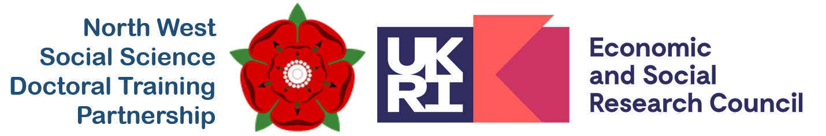

**Equal Opportunities Monitoring Form**

The NWSSDTP carries out equalities monitoring so that we can analyse applicant demographics and use the data gathered to inform our Equity, Diversity and Inclusion activities and encourage widening participation. **Studentship applicants are asked to help us do this by marking ALL appropriate boxes below.**

**Data protection statement**

The following section is mandatory, but will not be used as part of the assessment process. It will not be passed to assessment panels, will be anonymised at the earliest opportunity, and within the NWSSDTP will only be accessible to Professional Services staff. Data will only be kept until the Training Grant expires. For reporting purposes, anonymised data will be shared with the ESRC. For any questions you do not wish to provide information for, or where you would prefer your data not to be shared with the ESRC, please select ‘prefer not to say’.

|  |  |
| --- | --- |
| **Name:** |  |
| **University Student Number (if known):** |  |
| **Email address:** |  |
| **Nationality / Residential Status:** |  |

# Gender

Female  Male  Non-Binary  Other

Prefer not to disclose

# Is your Gender Identity the same as you were assigned at birth?

Yes  No

Prefer not to disclose

# Age

0 - 24  25 – 29  30 – 34  35 – 39  40 – 44

45 – 49  50 – 54  55 – 59  60 – 64  65 +

Prefer not to disclose

# Disability

The Equality Act (2010) defines a disability as a physical or mental impairment which has a substantial and long-term adverse effect on a person’s ability to carry out normal day-to-day activities.

No Known Disability

Blind or serious visual

Cognitive Impairment (e.g. ADHD, autism, or resulting from a head injury)

Deaf or serious hearing impairment

General Learning Disability (e.g. Down’s Syndrome)

Long-standing illness or health condition (e.g. cancer, HIV, diabetes, epilepsy)

Mental health condition (e.g. depression or schizophrenia)

Physical impairment of mobility issues

Specific Learning Disability (e.g. dyslexia or dyspraxia)

Other type of disability

Prefer not to disclose

# Ethnicity

Arabic

Asian British  Other Asian Background

Black British  Other Black background

White British  Other White Background

Mixed / Multiple Ethnic Groups

Other

Prefer not to disclose

# Sexuality

Bisexual / Pansexual

Gay man

Gay woman / Lesbian

Heterosexual

Other

Prefer not to disclose

# Socio-economic Background

Capturing socio-economic background information is a critical step in enabling us to consider what can to be done to improve socio-demographic diversity within the NWSSDTP. The questions here are based on the measures set out by the [Social Mobility Commission](https://socialmobilityworks.org/toolkit/measurement/?).

**What was the occupation of your main household earner when you were about aged 14?**

**Modern professional & traditional professional** occupations such as: teacher, nurse, physiotherapist, social worker, musician, police officer (sergeant or above), software designer, accountant, solicitor, medical practitioner, scientist, civil / mechanical engineer.

**Senior, middle or junior managers or administrators** such as: finance manager, chief executive, large business owner, office manager, retail manager, bank manager, restaurant manager, warehouse manager.

**Clerical and intermediate occupations** such as: secretary, personal assistant, call centre agent, clerical worker, nursery nurse.

**Technical and craft occupations** such as: motor mechanic, plumber, printer, electrician, gardener, train driver.

**Routine, semi-routine manual and service occupations** such as: postal worker, machine operative, security guard, caretaker, farm worker, catering assistant, sales assistant, HGV driver, cleaner, porter, packer, labourer, waiter/waitress, bar staff.

**Long-term unemployed** (claimed Jobseeker’s Allowance or earlier unemployment benefit for more than a year).

**Small business owners who employed less than 25 people** such as: corner shop owners, small plumbing companies, retail shop owner, single restaurant or cafe owner, taxi owner, garage owner.

**Other** such as: retired, this question does not apply to me, I don’t know.

Prefer not to disclose

**Which type of school did you attend for the most time between the ages of 11 and 16?**

A state-run or state-funded school

Independent or fee-paying school

Independent or fee-paying school, where I received a means tested bursary covering 90% or more of the total cost of attending throughout my time there

Attended school outside the UK

I don’t know

Prefer not to disclose

**If you finished school after 1980, were you eligible for free school meals at any point during your school years?**

Yes

No

Not applicable (finished school before 1980 or went to school overseas)

I don’t know

I prefer not to say

**Did either of your parents attend university and gain a degree (e.g. BA/BSc or equivalent) by the time you were 18?**

No, neither of my parents attended university

Yes, one or both of my parents attended university

Do not know / not sure

Prefer not to disclose

# Confirmation

I confirm that the information provided above is accurate and I agree to the NWSSDTP recording and using personal data contained in this form for the purpose of Equity, Diversity and Inclusion monitoring, and for statistical reporting.

|  |  |
| --- | --- |
| **Signature:** |  |
| **Date:** |  |