The University of Manchester - Daily Lesson Plan
Class | Yr 3-4 (but can be adapted to yr 2s or 5/6 | Date |  | Week no. |  | Lesson Context | Lesson …... of …….. lessons  (show where this fits in the teaching sequence)
Subject area |  | English linked to topic theme.
Lesson Objective |  | To identify features and structure of a formal letter  NC statutory requirements in Yr 3-4 section for reading and writing: (NB trainees look for dialogic teaching language in the NC like this – useful for your assignment 1)  - discuss writing similar to that which they are planning to write in order to understand and learn from its structure, vocabulary and grammar  - discuss a wide range of fiction, …non-fiction..  - plan their writing by discussing writing similar to that which they are planning to write in order to understand and learn from its structure, vocabulary and grammar
Success criteria: (differentiated where appropriate) |  | I can identify:  - The sender’s address on the top right hand side of the page; elsewhere?  - Where the date gets placed  - The greeting within the letter  - Paragraphs for new themes  - Signing off the letter
Are there any specific safety aspects to consider e.g. specific equipment, moving tables, outdoor space?  Resources to get ready |  | Children will be seated in mixed attainment groups.  Resources: Ahlberg Jolly Postman; Tolkien Letters from Christmas; (find a selection of different letters so each group has something different; note to self - find example with address on RHS); writing frame in shape of letter for Ben; Laila, Aisha and Tom  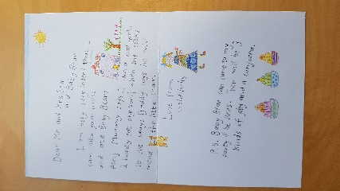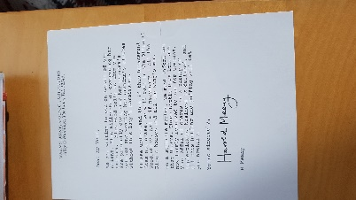

PLEASE ADD MORE SECTIONS BELOW, IF NEEDED
Lesson section and timings  e.g. introduction (whole class or specific groups), focus group teaching input, independent work, end of lesson | Lesson development  (use the planning bookmark to ensure that all aspects of an effective lesson are considered and planned)
10.45-10.55  3,2,1 minute minder  10.55-11.10 | Starter: Start with children sitting next to a buddy. Two example extracts on IWB 1 formal and 1 informal. Hard copies on tables for children to annotate as they discuss.  First prompt for discussion: Circle anything that is different between them?  Input:  What do you notice?  Why are they different?  Who is the writer writing to? Why is the writer using different ways of writing?  Draw up with children’s input two columns informal letters formal letters  When would we use formal language? Who might we be writing to? (discuss with partner; gather ideas for use on flipchart)  When would we use informal language? Who might we be writing to? (discuss with partner; gather ideas for use on flipchart)
11.10-11.20 | Introduce to children the purpose of writing a letter (reminder of Friday’s lesson content). With partner “What kind of language would we use for this letter? Why?  Model: Demonstrate to chn how to complete first element of SC in books: writing the address.  Give children the school address on slips of paper (separate one for each line of address) for them to re-arrange with their partner.  “Now write the address at the top of today’s page.”  “Can you and your partner suggest 2 things from Friday’s lesson that you want to say in your letter?” “Discuss with your partner the first sentence that you are going to write.”
11.20-11.40 | Task: chn then to complete the rest on the letter from comprehension activity on Friday (RAG cups)  Once completed chn to peer assess another classmates work using the ‘peer’ column – opportunity for them to give feedback to one another and to check each other have found all the features of the letter
11.40-11.45  11.45-11.50 | Plenary: “Here’s an example of a letter that I wrote when I got back from school on Friday. I was a bit tired so can you tell me where I can improve the letter writing style?”  “What features of a formal letter have I remembered? Which ones have I forgotten?”  Tidy up and get ready for lunch.

Assessment and evaluation of progress achieved (after lesson)
Assess children’s progress against your lesson SC, to inform you of their progress and achievement of the L.O
Success criteria  (cut and paste from S.C box above) | Names of those below (-) or exceeding (+) | Action required? (Now what?)  What do you need to do to respond to your assessment and children’s emerging needs? Changes to planning (show on weekly plan)? Targeted intervention? Change of group? Change of support?
- The home address on the top right hand side of the page; or on the top of the page  - Paragraphs for new themes | (-) Zayn, Phillip, Sarah  Adjectives group | Struggled with paragraphs start/end and meaning. Move Z, P, S into Adj group tomorrow and work with me.
 | (+)
- Where the date gets placed | (-)  Thomas | Reminder and ‘purple pen’ time – target him to reinforce this
 | (+)
- The greeting within the letter | (-) Louise, Sid, Fiona | Forgot this – target them (TA) during purple pen correction time.
 | (+) Ella, Maisie | Wrote effective greetings – share with class tomorrow
- Signing off the letter | (-)  Adjectives | Didn’t complete – reinforce this tomorrow during completion – T group.
 | (+)

