**My Placement – Improving Programme data quality for HESA data reporting**

As with Campus Solutions, data contained in My Placement is used in the annual return to HESA and so it is paramount that data is correct in the system. Due to the delivered configuration of My Placement, it is possible within the system to set-up programmes without completing the essential parameters required for HESA. There are only a handful of data fields within the programme parameters that require attention:

* Erasmus
* Mobility Scheme (HESA)
* Mobility Type (HESA)
* Mobility as Part of Programme

Erasmus

It is a HESA requirement that we report whether a student’s placement is part of an Erasmus scheme or not. This means that even if the programme is not part of the scheme, this must be flagged in the set-up. This is a simple process.

1. In My Placement navigate to the Programs menu, select Search and select the programme you are working on:

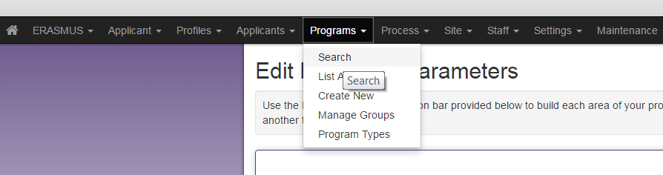

1. The programme can be found using the Program Name search or by using a combination of search criteria further down the page: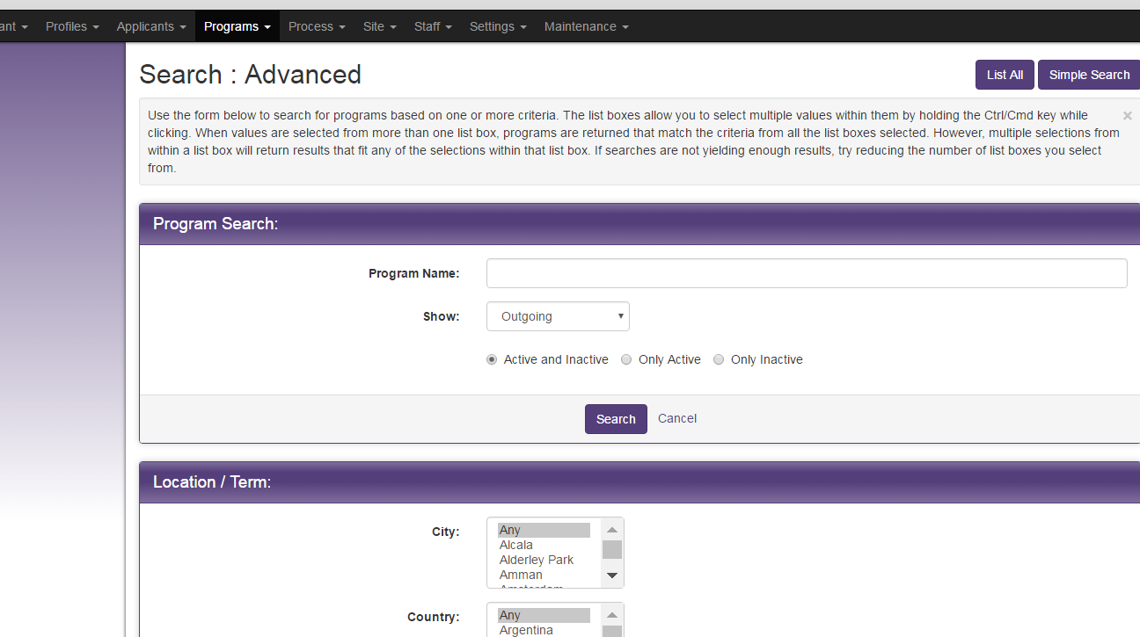
2. When you have located your programme, navigate to the programme’s Parameters menu:

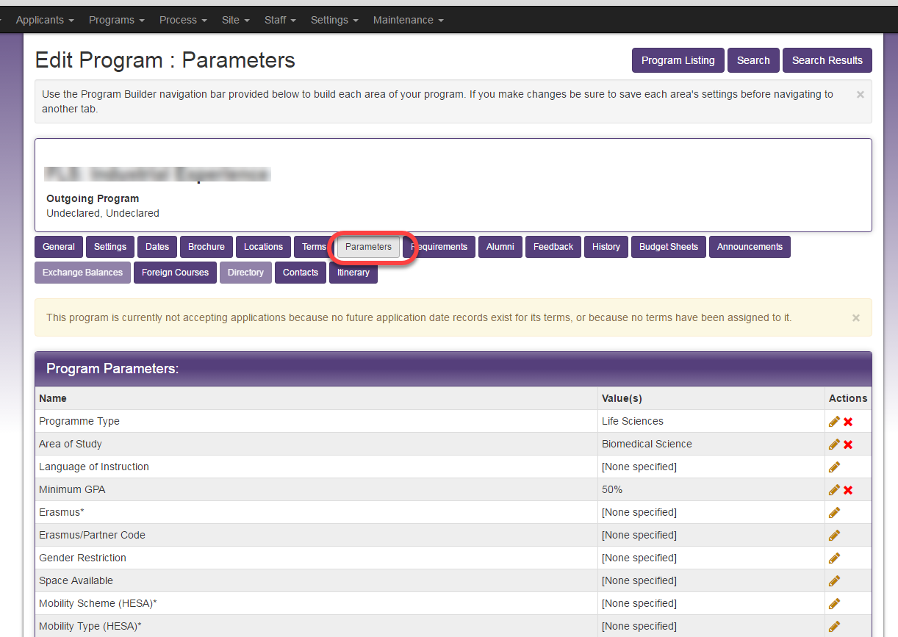

1. Click on the pencil icon to edit the Erasmus parameter:

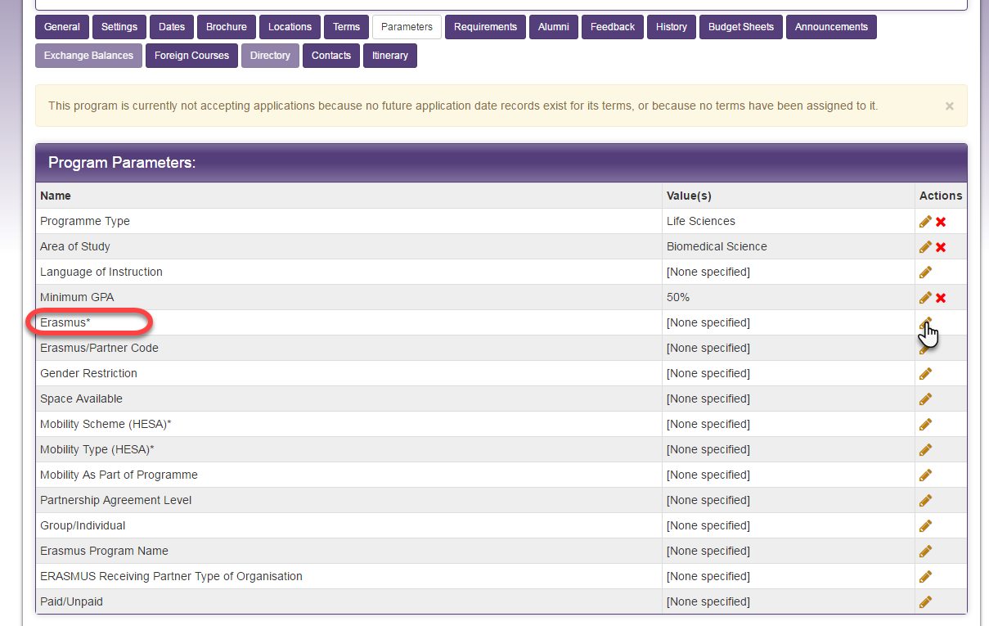

1. Select Yes or No appropriately then the Add button:

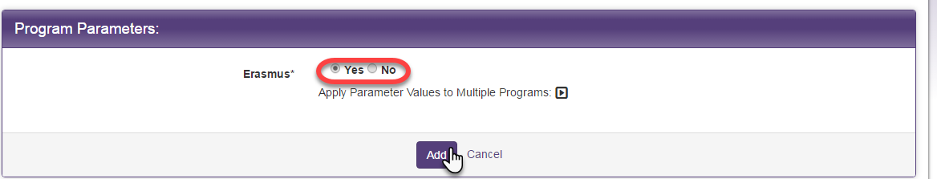

1. The parameter is now updated and saved. If you have indicated Yes then the Erasmus/Partner Code should also be added. Again this is via the parameter’s pencil/edit button:



1. Select from the list of codes and use the Add button below to move the value from Available into Selected. Once completed, save by clicking the Add button at the bottom of the page:

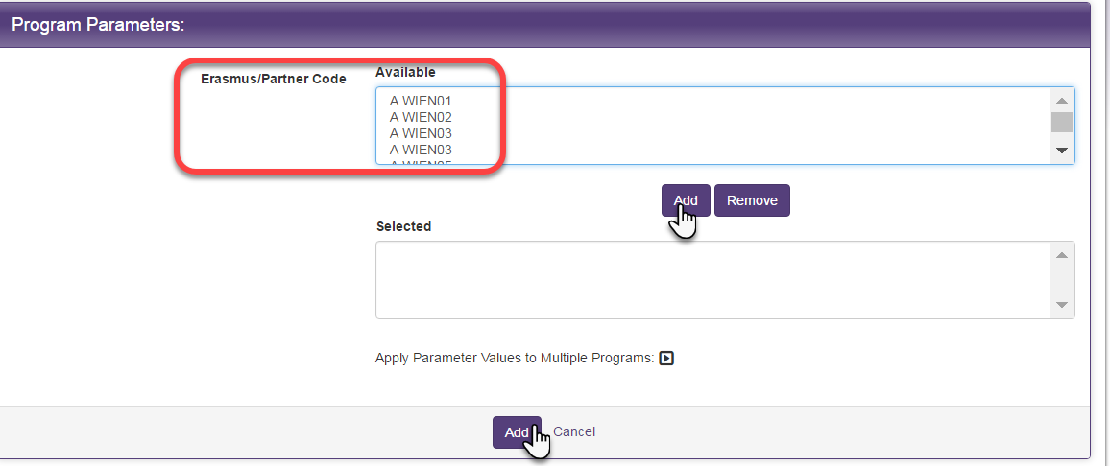

Mobility Scheme (HESA)

This is the classification that HESA use to tell them what type of placement scheme students on this programme are participating in.

1. In My Placement navigate to the Programs menu, select Search and select the programme you are working on:



1. The programme can be found using the Program Name search or by using a combination of search criteria further down the page:



1. When you have located your programme, navigate to the programme’s Parameters menu:



1. Click on the pencil icon to edit the Mobility Scheme (HESA) parameter:

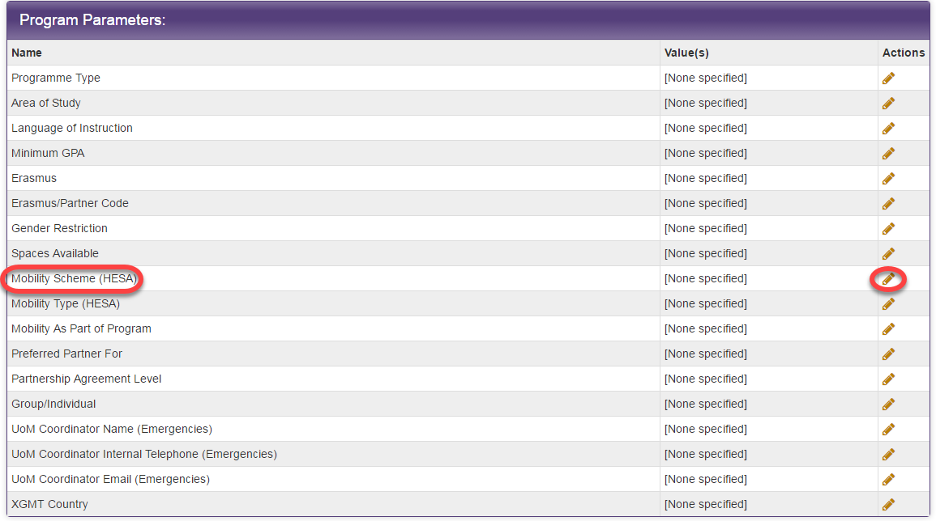

1. Select the option of either Institutional or ERASMUS then add to save the parameter:

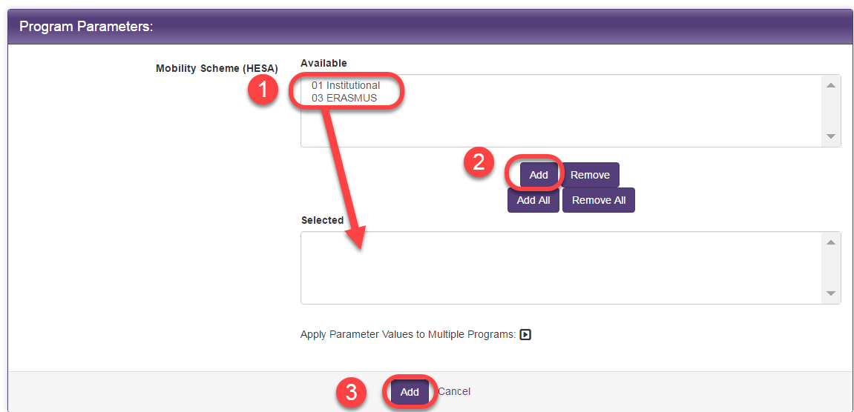

Mobility Type (HESA)

HESA require us to report the type of placement in which each student will participate and this is defined at programme level. This differs to the Mobility Scheme as it is seeking information on the nature of the placement rather than the hosting scheme. The types available to assign are:

01 Study Abroad

02 Work Abroad

03 Unpaid work/volunteering

99 UK Placement

As in the previous programme parameters, navigate to the Edit Parameters screen in the programme you are working on.

1. Click on the pencil icon to edit the Mobility Type (HESA) parameter:

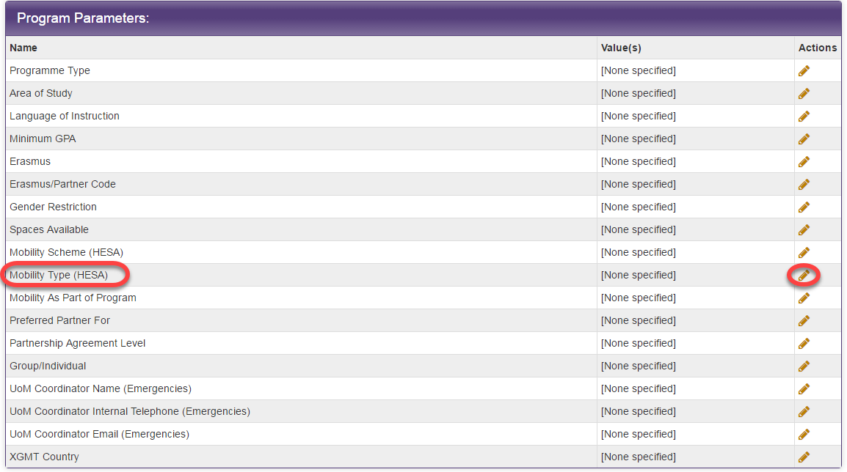

1. The appropriate option should then be chosen from the list and the parameter saved:

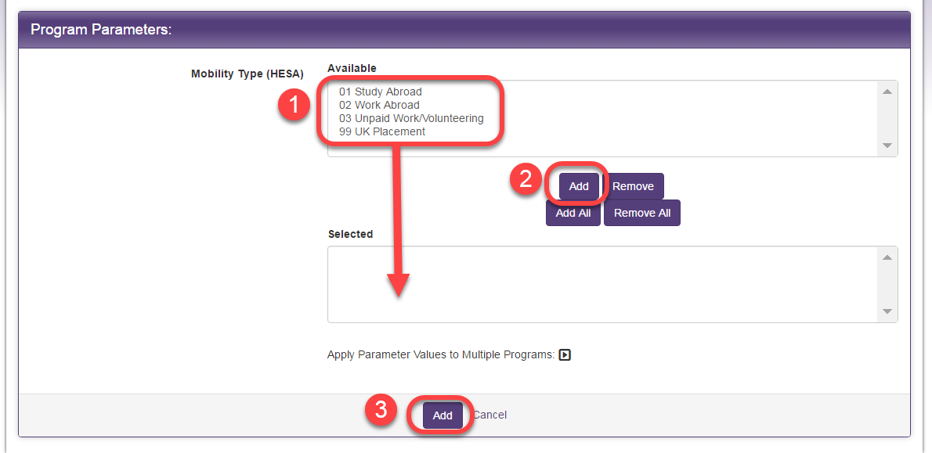

Mobility as Part of Programme

HESA defines this value:

***A 'mobility experience as part of their course outside of the UK' refers to any overseas experience organised or endorsed by the provider that takes place during the student's higher education. It does not need to be credit-bearing or linked to any learning outcomes.***

We interpret this as the University of Manchester participates and endorses the overseas placement. The fact that it is being managed on the university placement system suggests that the university supports and/or organises this activity for the student. Exceptions would be UK-based placements or placements lasting less than four weeks (unless multiple placements in the same reporting period added up to four weeks in total). However, placements less than four weeks in duration are not currently managed in My Placement.

Navigate once again to the Edit Parameters screen in the programme you are working on.

1. Click on the pencil icon to edit the Mobility Type (HESA) parameter:

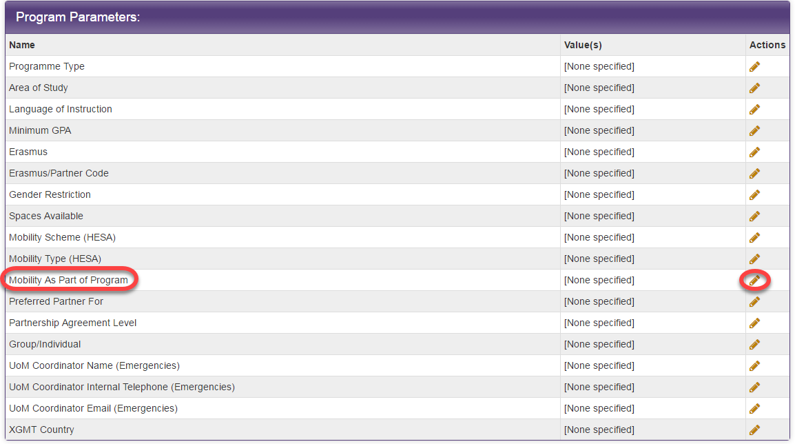

1. Yes or No, as defined in the criteria above should be selected and the record saved:

