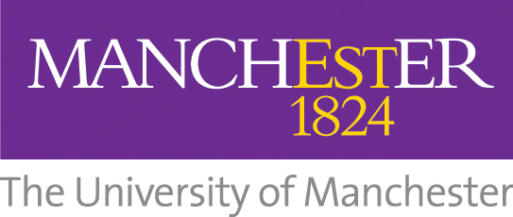
HALO Trust Bursary Application Form

Deadline to return form: 12pm (BST) on Friday 30 September 2022

Submit to: hcri@manchester.ac.uk

Please complete all sections:

PERSONAL DETAILS:

University of Manchester Application / Student ID number (if known):

Programme of study:

Title | Forename | Surname
Correspondence Address

Telephone
e-mail

Application (500-words maximum)

Please outline your motivation and interest in applying for the HALO Trust bursary.

