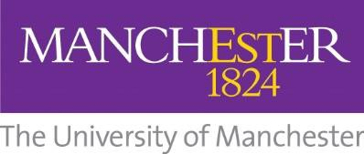

Bright Ideas 2023

Terms and Conditions
Last updated: 11/09/2023

Please read these terms and conditions carefully before submitting your entry. By submitting an entry into the Bright Ideas 2023 student ideas competition, you are agreeing to comply with the rules and regulations detailed below. Failure to comply will result in disqualification.

- This competition is managed by the Masood Entrepreneurship Centre.
- All entries must adhere to the following criteria:
  - All entrants must be registered students at The University of Manchester for the current academic year (2023-24).
  - First round entries must be no longer than 500 words accompanying a video of no more than 1 minute long.
  - All entries must apply via the online link:
https://forms.office.com/e/cYvK5wxMr5
- By submitting your video/reel application for the Bright Ideas competition, you are agreeing for the Masood Entrepreneurship Centre to publish your video on all our social media platforms (Instagram, TikTok, Facebook, X and Linkedin)
- Entries are welcomed from individuals and teams of up to six people.
- The deadline for receipt of entries is 23:59 pm. on Wednesday 8th November 2023
- Winners of the Bright Ideas competition will be announced on Friday 17th November 2023
- A prize of up to £200 will be awarded to the selected winners.
- Only one entry per team or individual is permitted.
- If an individual has submitted an entry, they may not also form part of a team.
- The Masood Entrepreneurship Centre will not take responsibility for any network malfunctions that may prevent individuals or teams submitting an entry in time.
- All correspondence will be with the lead entrant listed on the competition entry using the e-mail supplied on the entry form.
- The Masood Entrepreneurship Centre reserves the right to contact entrants to validate entry information.
- The Prizes will be awarded directly to the lead entrant listed on the competition entry.
- Winners will be encouraged to reference the competition in their own social media and publicity materials.
- All entries will be judged by the Masood Entrepreneurship Centre Team.
- There can be no appeal against the decision of the judges and these decisions must be accepted as final.
- The Terms and Conditions can be adjusted at any time prior to the deadline for receipt of entries.

The winners will be announced on the Masood Entrepreneurship Centre social media pages on the week commencing 20th November and will be published on the Masood Entrepreneurship Centre website: https://www.entrepreneurship.manchester.ac.uk/

