Dying to Live: Cancer, Cell Death and Chemotherapy
ANSWERS GIVEN IN THE VIDEO
Activity 1: Characteristics of Cancer
Can you unscramble the main characteristics of cancer cells?

Audible note

Molar time bulglaries

Exceeds vii visions

Our entwining cog

Obdurately stoned bee

Mit morality

Minimal fat on

Dehydrated baron soup

Judicable silk hop sop

Atom units

Activity 2: Components of an Animal Cell
Label the different parts of an animal cell on the diagram.
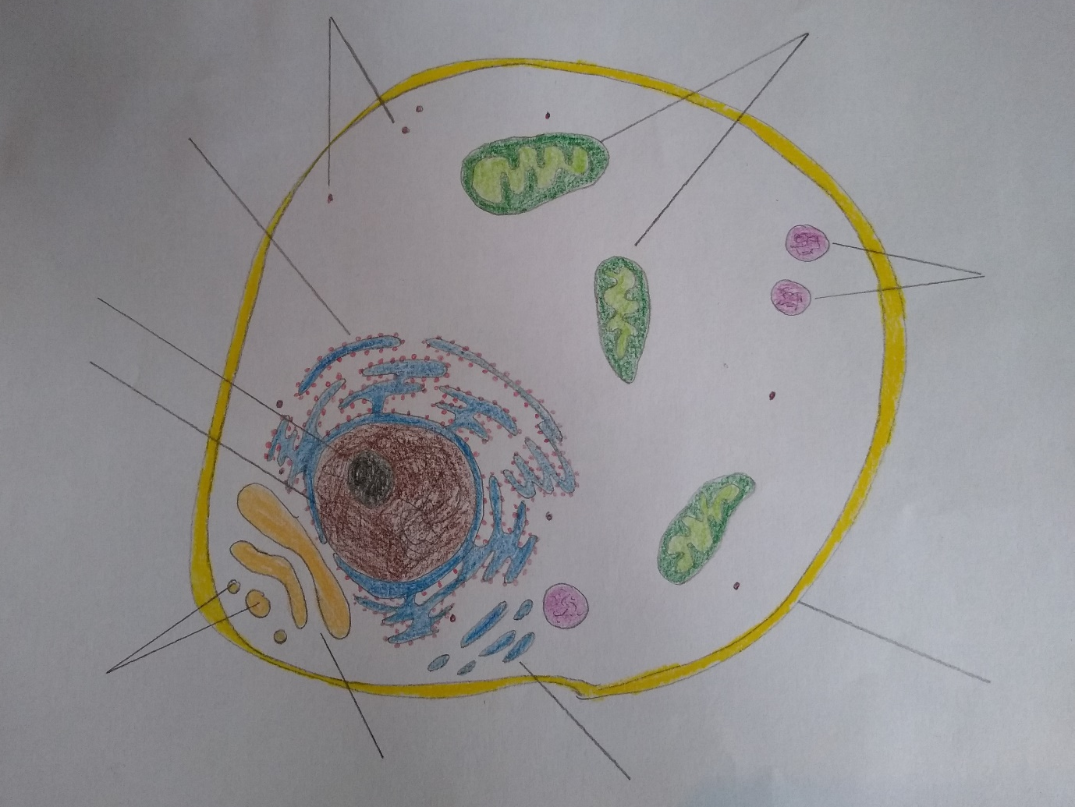

Activity 3: Chemotherapy Targets Match Up
Try to guess which drugs have which targets.

