# SEED / SoSS portable Dual Delivery equipment booking.

The equipment for Dual Delivery is shared across SEED and SoSS and can be requested using MS Outlook for use in school owned rooms.

* Please book with a minimum notice of 2 working days.
* Collect and return to one of the designated locations:

|  |  |
| --- | --- |
| Teaching location | Collection point |
| Ellen Wilkinson Building | room CG48 (Peter Leigh) |
| Humanities Bridgeford street, Arthur Lewis and Williamson building. | Arthur Lewis Building, Ground floor reception |

* Collect 15 minutes before your class starts and return directly after your teaching or as soon as possible.
* The person booking the equipment is responsible for the return of the equipment.
* Support is available by emailing [**DualDelivery.SEEDSoSS@manchester.ac.uk**](mailto:DualDelivery.SEEDSoSS@manchester.ac.uk)
* Training can be provided and GTAs and Interns will be able to provide assistance.
* Priority is given to teaching but the equipment can also be used for meetings.

## To book the portable Dual Delivery equipment.

From your Outlook calendar create a New Meeting or add an additional attendee to a teaching appointment already in your outlook calendar by Inviting Attendees from the menu.

|  |  |
| --- | --- |
| To | **DualDelivery.SEEDSoSS@manchester.ac.uk** |
| Subject: | equipment needed e.g. portable webcam, laptop |
| Location | Building code – Room number e.g. ALB G016  Building code = HBS - Humanities Bridgeford Street, EW - Ellen Wilkinson Building, ALB = Arthur Lewis Building, WB = Williamson Building. |
| Start Time: | Date and time the class starts |
| End time: | Date and time the class ends |
|  |  |

Please add any other instructions or questions to the Calendar invitation

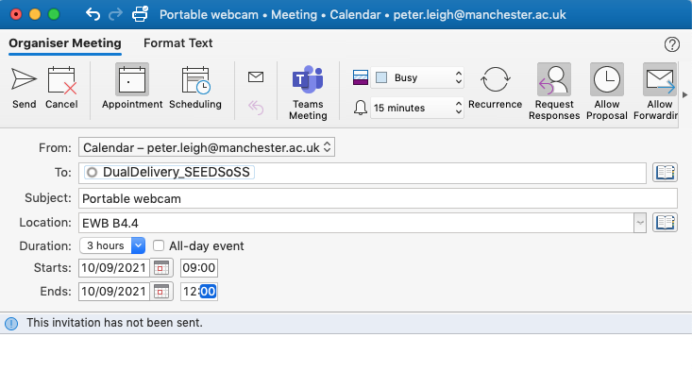

Once sent a request for the equipment is made but has not been confirmed. If you open the request you are informed that no response has yet been received then equipment has not yet been allocated to your booking request.

## Confirmation of your booking request

Once the booking is confirmed you will receive an email confirming your booking from email account DualDelivery_SEEDSoSS

If equipment is not available you will also be contacted.

## Returning borrowed equipment

Please return as soon as possible to the same collection location unless other arrangements have been agreed, remember the equipment that you have used may be booked that same day by a colleague.

If you have any questions then please email [**DualDelivery.SEEDSoSS@manchester.ac.uk**](mailto:DualDelivery.SEEDSoSS@manchester.ac.uk)