Match the Mucus Malady
Invasion of Trichuris trichiura parasite into colon wall by breaking down mucus. Affects over a billion people

Often caused by infection of Helicobacter pylori bacteria in stomach mucus

Autoimmune disease. Weakened mucus layers mean pathogens can penetrate large intestine cells, cause inflammation

Genetically inherited disease. Accumulation of thick, sticky mucus in lungs caused by ion imbalance

Genetic and Environmental. Airways become inflamed and mucus is over-produced

Irreversible damage to lungs often caused by smoking. Mucus can no longer be cleared and leads to hypersecretion
Asthma
Cystic Fibrosis
COPD
Gastric Ulcers
Ulcerative Colitis
Whipworm
Mucus Memory Challenge
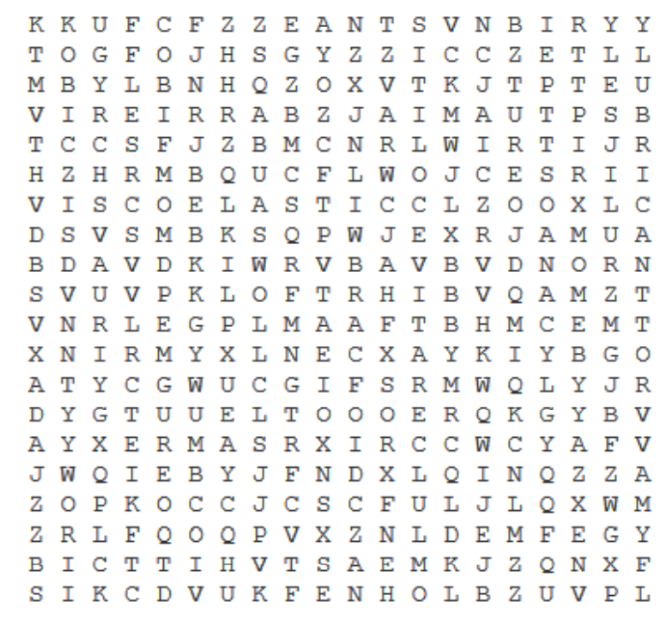
Fill in the gaps by finding the missing terms! (Brackets = number of letters)
Mucus is 90% W_______(5). The other 10% is mostly made of special proteins called M______(6). These have G_____(5) chains attached to the protein backbone, and this structure gives mucus its V_____________(11) properties. Mucus acts as a physical B_______(7) on cell surfaces exposed to the environment. Mucus allows hydration as well as acting as a L________(9), which helps traps particles and pathogens in the lungs during mucus (C_________9). Mucus also provides a place for your body to interact with the (M_________10), and is mainly found in the intestines, which hosts most of the body’s commensal bacteria. Mucus aberrations leads to a range of diseases. This can be solely inherited, like C_______(6) F_______(8) that causes thick, stick lung mucus, and U_______(10) C______(7) in the large intestine, which is a combination of genes and the environment.

