**From:** Climate Network [climatenetwork@manchester.ac.uk](mailto:climatenetwork@manchester.ac.uk)

**Sent:** 13 May 2024 22:58

**To:** [CLIMATE-NETWORK@listserv.manchester.ac.uk](mailto:CLIMATE-NETWORK@listserv.manchester.ac.uk)

**Subject:** [CLIMATE-NETWORK] Newsletter



**Hi everyone** J

UoM Climate Network

Our recorded talks are now available on our [YouTube channel](https://www.youtube.com/channel/UC2cRMptAl_0ou8F2TT8C0kg).

UoM Events

**Natural Cultural Health Service**

The Whitworth

A range of nature-based activities at varying times

<https://www.whitworth.manchester.ac.uk/getinvolved/nchs/>

**Climate Cafés**

Manchester Museum

In-person events running every 2 months from 3 Jul 2024 onwards – 17:30 - 19:00

<https://www.eventbrite.com/e/climate-cafes-tickets-520550379197>

**Community-centred approaches to active travel policy (GM Hub seminar)**

Policy@Manchester

15 May 2024 - 13:00 - 14:30

<https://www.manchesterfoe.org.uk/eventsevent/community-centred-approaches-to-active-travel-policy-gm-hub-seminar/>

**Social Metabolism and Valuation Languages in the Atlas of Environmental Justice**

Global Development Institute

15 May 2024 – 16:30 - 18:00

<https://events.manchester.ac.uk/event/event:t2b-lutnufdz-ma7pf>

**The City After Dark: Air Space Night Walk + Workshop**

Creative Manchester

16 May 2024 – 19:30 - 21:30

<https://events.manchester.ac.uk/event/event:g4s-lvcg9ei5-urxi01>

**Time is Running Out**

Jodrell Bank

16 May – 7 Jul 2024 – All day

<https://events.manchester.ac.uk/event/event:c89-lvzd9zkg-boa84j>

**Why natural dye? Unlocking the potential of natural dyes**

HATCH Projects - WOVEN Curators

20 May 2024 – 11:00 - 12:00

<https://www.eventbrite.co.uk/e/why-natural-dye-unlocking-the-potential-of-natural-dyes-tickets-883239100927>

**GDI Webinar and Documentary Screening - 'Migrants: Joy, Rest & Celebration'**

Global Development Institute

21 May 2024 – 12:00 - 13:00

<https://events.manchester.ac.uk/event/event:d4y-lvdwp61h-6wwmz>

**Navigating ESG Challenges: Business Skills for Transition**

Alliance Manchester Business School

23 May 2024 – 08:00 - 10:30

<https://www.alliancembs.manchester.ac.uk/events/navigating-esg-challenges/>

**Only open to those internal to UoM: Addressing Biodiversity Challenges Through Interdisciplinary Research**

Sustainable Futures

4 Jun 2024 – 09:00 - 14:00

<https://www.eventbrite.co.uk/e/addressing-biodiversity-challenges-through-interdisciplinary-research-tickets-881805613327>

·       [An episode](https://www.socialresponsibility.manchester.ac.uk/all-news/talk-200-new-podcast-on-energy-and-climate-change-now-available/) of UoM’s Talk 200 podcast series focuses upon energy and climate change, with talks from Prof. Alice Larkin, Dr. Aneeqa Khan, and Aidan Rhode.

·      UoM Library’s [Libby App](https://www.librarysearch.manchester.ac.uk/discovery/fulldisplay?docid=alma992985983962101631&context=L&vid=44MAN_INST:MU_NUI&lang=en&search_scope=MyInst_and_CI&adaptor=Local%20Search%20Engine&tab=Everything&query=any,contains,libby) can now be downloaded on a smartphone or accessed via a browser (UoM login required); there are a number of e-books that have been made available for Sustainability Action Month.

·       UoM Earth and Environmental Science PhD student Kaydee Barker and environmentalist Cody Sanford have co-created the [Livable Future Podcast](https://livablefuturepodcast.com/) focussed around current global challenges and how we can work together to create a more liveable future.

·       UoM’s Environmental Sustainability Team has launched a new environmental sustainability strategy (2023-2028); the update is provided [here](https://www.staffnet.manchester.ac.uk/news/display/?id=30043).

·       Harriet Bickley has created an [Easy Everyday Eco Actions booklet](http://documents.manchester.ac.uk/DocuInfo.aspx?DocID=44432) full of practical info to help UoM staff & students live, work & study in a more eco-friendly manner.

·       Pooja Kishinani and Marion Smith, students at The University of Manchester, have created a [Student Guide to the Climate Crisis](https://climateemergencymanchester.net/student-climate-handbook/) centred around three themes: the emotions, basic information, and activist advice of climate change.

·       [Want Not Waste](https://www.thezerowastenetwork.com/united-kingdom/manchester/zero-waste-shop/want-not-waste) have recorded their various environmental talks, which you can view on their [YouTube channel](https://www.youtube.com/channel/UCTpg3EG9LV9B14R1cXbHDig).

Greater Manchester Events

**Fossil Free Greater Manchester campaign meeting**

Fossil Free Greater Manchester

Online meeting on 2nd and 4th Monday of every month – 18:30 - 20:00

<https://www.manchesterfoe.org.uk/events/event/fossil-free-greater-manchester-campaign-meeting-39/>

**Manchester Extinction Rebellion Groups meeting**

XR Manchester

In-person meeting on 2nd Monday of every month – 19:00 - 20:30

<https://www.manchesterfoe.org.uk/events/event/manchester-extinction-rebellion-groups-meeting/>

**Olinda Community Garden volunteering morning**

Olinda Community Gardens

Every Tuesday (for the foreseeable future) – 10:00 - 12:30

<http://www.manchesterfoe.org.uk/events/event/olinda-community-garden-volunteering-morning/>

**Pond & Woodland Management in Salford**

City of Trees

Every Thursday (from 11 Jan 2024 onwards) – 10:00 - 15:00

<https://www.manchesterfoe.org.uk/events/event/pond-woodland-management-in-salford-city-of-trees/>

**EcoHome Lab: Monthly meetup and skill share**

EcoHome Lab

Online meeting on 2nd Thursday of every month – 18:00 - 19:30

<https://www.manchesterfoe.org.uk/events/event/ecohome-lab-monthly-meetup-and-skill-share-13/>

**Bike Friday**

Manchester Friends of the Earth

Last Friday of every month (for the foreseeable future) – 08:00 - 08:45

<https://www.manchesterfoe.org.uk/events/event/bike-friday-various-locations-2/>

**Levenshulme Repair Café**

Levenshulme Repair Café

Third Saturday of every month (for the foreseeable future) starting 20 Jan 2024 – 10:00 - 12:00

<https://www.manchesterfoe.org.uk/events/event/levenshulme-repair-cafe-6/>

**Plant Swaps @ Manchester Craft & Design Centre**

Manchester Craft & Design Centre

Third Saturday of every month (for the foreseeable future) starting 18 May 2024 – 12:00 - 13:00

<https://www.manchesterfoe.org.uk/events/event/plant-swaps-manchester-craft-design-centre-2/>

**Gardening and Clean Up**

Olinda Community Gardens

First Sunday of every month (for the foreseeable future) starting 1 Jan 2023 – 10:30 - 13:30

<https://www.manchesterfoe.org.uk/events/event/gardening-and-clean-up-2/>

**Peer Support Group**

Climate Conversations

In-person meeting every fortnight from 4 May 2023 onwards – 19:00 - 21:00

<https://www.manchesterfoe.org.uk/events/event/climate-conversations-peer-support-group/>

**Birchfield Park Forest Garden work session**

Birchfields Park Wildlife and Biodiversity Group

Various Days @ Various Times

<https://www.manchesterfoe.org.uk/events/event/birchfield-park-forest-garden-work-session/>

**SICK! FESTIVAL 2024**

SICK! Festival

3-31 May 2024 @ Various Times

<https://sickfestival.com/sick-festival-2024/>

**BIBA Insurance conference protest**

Greater Manchester Stop EACOP coalition

15 May 2024 - 08:00 - 18:00

<https://shorturl.at/jrvAH>

**Refill Action In Our Communities**

City to Sea / Manchester City Council / GMCA

15 May 2024 - 12:00 - 13:00

<https://www.manchesterfoe.org.uk/events/event/refill-action-in-our-communities-city-to-sea/>

**Spring Plant Swap @ Chorlton Makers Market**

Chorlton Plant Swap and Gardening Advice

18 May 2024 - 10:00 - 16:00

<https://www.manchesterfoe.org.uk/events/event/spring-plant-swap-chorlton-makers-market/>

**North West Summer Activist Gathering- Manchester**

Friends of the Earth

18 May 2024 - 12:30 - 19:00

<https://www.manchesterfoe.org.uk/events/event/north-west-summer-activist-gathering-manchester-friends-of-the-earth/>

**Horwich Repair Café – Happy 2nd Birthday!**

Horwich Repair Café

18 May 2024 - 13:30 - 15:30

<https://www.manchesterfoe.org.uk/events/event/horwich-repair-cafe-happy-2nd-birthday/>

**Walk Ride GM Social @ Station South**

Walk Ride GM

23 May 2024 - 18:30 - 21:30

<https://www.manchesterfoe.org.uk/events/event/walk-ride-gm-social-station-south/>

**Women of the World (WOW) Festival**

Factory International and The WOW Foundation

24-26 May 2024 @ Various Times

<https://factoryinternational.org/whats-on/wow-manchester/>

<https://invisibledust.com/projects/unnatural-history-at-wow-festival-manchester/>

**Repair Café**

Boilerhouse

25 May 2023 - 10:00 - 12:00

<https://www.manchesterfoe.org.uk/events/event/repair-cafe-boilerhouse/>

**Flashes Festival of Nature (Pennington Flash)**

Visit Wigan

25-26 May 2024 – 11:00 – 15:00

<https://www.manchesterfoe.org.uk/events/event/flashes-festival-of-nature-pennington-flash/>

**Manchester - People, Planet, Pint: Sustainability Meetup**

Small99

30 May 2023 - 18:00 - 20:00

<https://www.eventbrite.co.uk/e/manchester-people-planet-pint-sustainability-meetup-tickets-781652893847>

·       There are a number of ways that you can recycle single-use plastics both within Manchester and further afield:

(1)  [Co-op](https://www.coop.co.uk/) have been running a [soft plastics recycling scheme](https://packagingeurope.com/co-op-launches-collection-scheme-for-soft-plastics/) for plastic bags and product wrapping (plastics that can be scrunched and that ‘ping’ back) at their stores.  As an aside, yet still very much relevant to sustainability, Co-op are also [helping to expand Hubbub’s Community Fridge Network](https://www.co-operative.coop/media/news-releases/co-op-and-hubbub-partner-to-redistribute-6-8-million-meals-a-year-in-gbp500), a programme that can potentially tackle a number of societal ills, including: food waste, food poverty, and social isolation.

(2)  Stockport-based [Plastic Shed](https://www.plasticshed.org/) have reignited their collections of [specific types of plastic lids, soft stretchy plastic packaging, vinyl banners, straws, and plant pots](https://www.plasticshed.org/plastic-drop-off) to creatively recycle and repurpose them into useful items; they particularly need your plastic donations between Oct 2023 – Feb 2024 in order to [build a sculpture after receiving funding via UK SPF](https://www.instagram.com/p/CyIIHnOsjcD/?hl=en).  They also hold workshops and act as a community space; they share their [Merseyway Workshop](https://www.merseywayworkshop.com/) with a community-focussed design studio called [Easy Peel Studios](https://www.easypeelstudio.com/), who also run their own [events](https://www.merseywayworkshop.com/whatson) too.

(3)  An organisation called [ReFactory](https://myrefactory.com/) (previously ReWorked) have partnered with a number of organisations, including [Boots](https://www.reworked.com/2021/09/16/what-items-can-you-recycle-in-boots-stores-recycle-at-boots/), to promote better recycling practices in the UK.  A number of recycled household products can be purchased from their [online shop](https://shop.myrefactory.com/), as well as a wide range of recycling boxes for a variety of plastic waste, such as for lateral flow tests, face masks, disposable gloves, visors etc. (starting at £72 per box).

·       Manchester Climate Change Agency recommend [15 actions to take to become a zero carbon city](https://www.manchesterclimate.com/15-actions)

Other Events

**Heading for Extinction (and what to do about it)**

Extinction Rebellion

Online meeting on 2nd Wednesday of every month – 19:00 - 20:30

<https://www.manchesterfoe.org.uk/events/event/heading-for-extinction-and-what-to-do-about-it-extinction-rebellion-2/>

**How to: Make and Use Wheatpaste for Community Artivism**

Tipping Point

15 May 2024 – 12:00 - 13:15

<https://www.manchesterfoe.org.uk/events/event/how-to-make-and-use-wheatpaste-for-community-artivism-tipping-point/>

**Media training with the Local Storytelling Exchange for Great Big Green Week**

Local Storytelling Exchange

15 May 2024 - 18:00 - 19:30

<https://www.manchesterfoe.org.uk/events/event/media-training-with-the-local-storytelling-exchange-for-great-big-green-week/>

**Transport decarbonisation – making the necessary impacts**

Systra / Landor Links

16 May 2024 – 10:30 - 12:00

<https://www.manchesterfoe.org.uk/events/event/transport-decarbonisation-making-the-necessary-impacts-systra/>

**Hide on the Highway: Tracing Leather from Brazil to Europe under the EU Deforestation Regulation**

Rainforest Foundation Norway and AidEnvironment

16 May 2024 – 13:00 - 14:00

<https://www.manchesterfoe.org.uk/events/event/hide-on-the-highway-tracing-leather-from-brazil-to-europe-under-the-eu-deforestation-regulation-rainforest-foundation-norway/>

**Can the Green New Deal Fix the Cost of Living Crisis?**

Festival of Debate

16 May 2024 – 19:00 - 21:00

<https://www.manchesterfoe.org.uk/events/event/can-the-green-new-deal-fix-the-cost-of-living-crisis-festival-of-debate/>

**Learn how to have better conversations about climate change with people in your community**

Larger US

20 May 2024 – 18:00 - 20:00

<https://www.manchesterfoe.org.uk/events/event/learn-how-to-have-better-conversations-about-climate-change-with-people-in-your-community-larger-us/>

**Mapping suitable sites for onshore wind and solar**

Environmental Data Network & Friends of the Earth

22 May 2024 – 15:00 - 17:00

<https://www.manchesterfoe.org.uk/events/event/mapping-suitable-sites-for-onshore-wind-and-solar-environmental-data-network-friends-of-the-earth/>

**Mapping suitable sites for onshore wind and solar**

Environmental Data Network & Friends of the Earth

22 May 2024 – 15:00 - 17:00

<https://www.manchesterfoe.org.uk/events/event/mapping-suitable-sites-for-onshore-wind-and-solar-environmental-data-network-friends-of-the-earth/>

·       Dr. Emily Heath of [Scientists for Global Responsibility](https://www.sgr.org.uk/index.php/) has shared [9 tips](https://www.sgr.org.uk/resources/encouraging-culture-climate-activism-universities) to encourage a culture of climate activism in universities.

·       In Spring 2022, the Department for Education (DfE) released a [new policy paper](https://www.gov.uk/government/publications/sustainability-and-climate-change-strategy/sustainability-and-climate-change-a-strategy-for-the-education-and-childrens-services-systems) entitled ‘Sustainability and climate change: a strategy for the education and children’s services systems’, setting out key goals such as the introduction of a Natural History GCSE, a National Education Nature Park (NENP), a Climate Leaders Award (CLA), and a National Climate Education Action Plan (NCEAP).  MMU are [champions of the NENP and CLA](https://www.mmu.ac.uk/news-and-events/news/story/?id=15023), whereas The University of Reading will lead the [implementation of the NCEAP](https://www.reading.ac.uk/planet/climate-education/climate-education-plan).

·       UCL’s Generation One collective have created their own [Climate Podcast](https://www.ucl.ac.uk/climate-change/podcasts-videos/generation-one-climate-podcast).

·       The new [Sustainable Futures careers course](https://www.wwf.org.uk/get-involved/schools/sustainable-futures), aimed at providing teaching professionals with content suitable for a teenage audience (14-18y.o.), has been developed by [WWF-UK](https://www.wwf.org.uk/) in an attempt to bolster the next generation with a greater awareness of sustainability as they decide upon their future careers.

·       [Kudos](https://www.growkudos.com/), an online tool for improving research impact, created a [climate change knowledge cooperative](https://www.growkudos.com/showcase/collections/climate-change) to aid the sharing of the latest climate change research in a non-technical / comprehensible format.

·       A better future for our woodlands: [12 ideas to help British forests grow](https://www.youtube.com/watch?v=RX-LHyo_gJ4)

·       The [Lemu](https://le.mu/) app can be downloaded on smartphones.  The organisation’s mission relies on the idea of leveraging technology to learn, explore, and protect nature, as well as improving conservation measures and outputs.  They are looking to prove that financing conservation projects is not about charity but an investment into the future of our Planet

·       The [WeAre8](https://www.weare8.com/) app can be downloaded on smartphones – launched in 2020, it became the world's first B corp-certified social media ecosystem, built to transform the digital advertising sector and address the broken and divisive state of the social media industry.  The app’s purpose is to make a big impact through small daily actions; you can earn rewards for watching videos that support social and environmental causes.

·       [Skoot](https://skoot.eco/) is no longer the app it used to be (which allowed you to plant free trees for every car journey), its model changed after it succeeded in its ‘1 million free tree challenge’, it is now an award-winning climate change platform dedicated to helping its subscribers – both businesses and individuals – to reducing their carbon footprints through a variety of off-setting methods.

·       Downloading the [Treekly](https://www.treekly.org/) app on a smartphone allows you to plant 1 tree each week for free (seemingly in Madagascar); by tracking your footsteps, using either your phone’s built-in pedometer or a fitness tracker/smartwatch, you can convert your 25,000 steps per week [5,000 each day for 5 days] into the planting of a tree.

·       Downloading the [TreeApp](https://www.thetreeapp.org/) app on a smartphone allows you to plant a tree for free, in an area that it’s needed e.g. often in the Global South but now also in the UK, every single day (and now there’s [no daily limit](https://www.thetreeapp.org/blog/2023-08-14-from-seed-to-sapling-treeapps-new-growth-updates/)).  Also, if you own land (or know of potentially suitable land) for tree planting? Fill in [this form](https://docs.google.com/forms/d/e/1FAIpQLSfjHC3CW6UnvMQkRIUmRSr2Mc6jjuwYefmqRNufg-s6NCE3dw/viewform) and let the people behind TreeApp know.

·       [AllotMe](https://www.allotme.co.uk/) – originally marketed as the ‘Airbnb for your Garden’ sounds like a great concept –  whereby individuals can rent green spaces to grow food within major cities/urban environments, and garden owners can monetise their land (although many garden spaces appear to be free to use).

·       Spare 3 minutes to fill in [Currensea’s Sustainability survey](https://www.surveymonkey.co.uk/r/P2GFFCV) and each completed survey removes 100 plastic bottles from the oceans (thanks to their [Plastic Bank](https://plasticbank.com/) partnership).

·       A [CO2 widget](https://co2widget.com/) created to communicate daily levels of CO2 by Matthew Shribman, his colleagues, and University of Cambridge / Cambridge Zero.  There is also the [Climate Action Tracker (CAT)](https://climateactiontracker.org/) that can be used to keep track of global climate action.

·       Some [suggested climate actions](https://itstime.earth/climate-actions) have been listed by Ecologi on their It’s Time website.

·       Really useful links to organisations who are promoting [circular economy initiatives](https://eeb.org/circular-future); besides many organisations will now offer their own in-house recycling schemes, as is the case for [Google Devices](https://store.google.com/gb/magazine/recycling?hl=en-GB); yet there are many other organisations, like [Music Magpie](https://www.musicmagpie.co.uk/) and [Mazuma Mobile](https://www.mazumamobile.com/), that will pay you for items that you trade in.

·    Please take a look at the [Students Organising for Sustainability UK (SOS-UK) website](https://sustainability.nus.org.uk/) as well as two current campaigns they are running:

1. [Invest for Change](https://www.investforchange.uk/)

2. [Carbon Targets](https://www.carbontargets.uk/)

Social Media

You can now connect to the Climate Network on:

1. [Facebook](https://www.facebook.com/groups/235576384126425/)

2. [Yammer](https://www.yammer.com/live.manchester.ac.uk/)

How To Subscribe To Us

Feel free to forward this newsletter on, but also please pay a visit to our website below (where you can subscribe to our mailing list and see a sample of the environmental groups affiliated with UoM):

<https://climatenetwork.uk/universityofmanchester/>

-------------------------------------------------------------------------------------------------------

Help to improve Manchester and the climate crisis via a survey by Global Shapers Manchester

Born out of the World Economic Forum, the Global Shapers Community is a network of inspiring young people under the age of 30 working together to address local, regional, and global challenges.  The [Manchester Hub](https://www.globalshapers.org/hubs/manchester-hub-57f7919c6b-hub/) started in January 2020 with the aim to create a community that is focused on making a positive social impact and supporting one another.

The results of this survey will be used to design a climate action project that addresses the climate crisis and makes local people’s lives better.

The survey can be completed here: <https://www.surveymonkey.com/r/climateconversationsmcr>

-------------------------------------------------------------------------------------------------------

Can you help to shape/organise community events and would you like to help improve climate change education and upskilling?

[Envirolution](https://envirolution.org.uk/) are looking for volunteers to help their organisation and take their initiatives further over the coming years.  If interested, please contact Bob Walley at [bwalley1@uclan.ac.uk](mailto:bwalley1@uclan.ac.uk)

Envirolution Cooperative is a Manchester-based community benefit society that has been running annual large-scale, climate change education and community engagement festivals since 2010.  These are free to attend, positive, and solution-focused events, which aim to be as inclusive as possible by appealing to the wide and diverse demographic of communities who get involved.  Envirolution creates an atmosphere where attendees can learn new skills, meet new people, and explore pro-active responses to the climate emergency which are relevant and appropriate to them.

Everyone is welcome at Envirolution, though the target audience are people who do not currently engage with the challenges of climate change, or are not sure which actions are of the most value.  The event has a fun non-judgemental atmosphere, with world music playing from its solar-powered stages, vegan food stalls, games and creative activities for children, talks and interactive workshops, provided by organisations and groups making real and positive change in communities.  Attendees can then join groups, volunteer, receive training.  This increases employability for local people in the sustainability and green jobs sector and decreases social isolation and loneliness.  Around 5,000 people attend the event each year, creating a unique opportunity for workshop providers, speakers, and others to engage audiences they may otherwise find it difficult to access.  Envirolution is a colourful, vibrant, fun, inclusive, positive, and safe space for people to learn together how they can respond positively and proactively to the challenges faced by the climate and ecological emergency.  The value and impact of Envirolution and the groups events can be seen on their website.

-------------------------------------------------------------------------------------------------------

Would you, or a student you know of, like to help solve the climate issues of today and tomorrow?

The University Living Lab (ULL) provides opportunities for students to undertake sustainability-focussed projects that aim to provide tangible benefits to local and wider society by creating solutions for issues that businesses and other organisations may encounter.

With it being estimated that a quarter of all students at UoM (approx. 10,000) are already studying subjects that are directly related to sustainability, if each of those students dedicated half of their study hours (approx. 750 hours) to a ULL project it would equate to approx. 7,500,000 hours of research towards sustainable solutions to real-life problems.  Yet, there are many more areas of study that aren’t directly related to sustainability that could potentially also contribute!

Please take a look at the ULL website to see how you could get involved: <https://www.universitylivinglab.org/>

-------------------------------------------------------------------------------------------------------

Job Opportunities

* 4 x UoM-based environment/sustainability-focussed role:
* [Lecturer/Senior Lecturer in Environmental Economics](https://www.jobs.manchester.ac.uk/Job/JobDetail?JobId=28893) [Permanent, approx. £36k-£56k DOE], (**application deadline = 24 May 2024 @ 23:59**)
* [Lecturer in Environmental Planning](https://www.jobs.manchester.ac.uk/Job/JobDetail?JobId=28496) [Permanent, approx. £40k-£56k DOE], (**application deadline = 30 May 2024 @ 23:59**)
* [Research Associate in Public Perception of Climate Geoengineering](https://www.jobs.manchester.ac.uk/Job/JobDetail?JobId=28977) [Permanent, approx. £36k-£44k DOE], (**application deadline = 7 Jun 2024 @ 23:59**)
* [Reader/Professor in Climate Change Governance and Global Development](https://www.jobs.manchester.ac.uk/Job/JobDetail?JobId=28193) [Permanent, Professorial Scale], (**application deadline = 14 Jun 2024 @ 23:59**)

* 1 x [Undergraduate Appraisal and Forecasting Analyst](https://www.linkedin.com/jobs/view/3924209447) [12-month contract, £22k], Manchester-based (**application deadline = 16 May 2024 @ 23:00**) with Transport for Greater Manchester.

* 1 x [Sustainability Internship](https://www.linkedin.com/jobs/view/3918535655) [12-month contract, £23k], Manchester-based (**application deadline unknown**) with Siemens.

* 1 x [Sustainability Officer](https://www.linkedin.com/jobs/view/3917554185) [Permanent, £28k-£34k DOE], Manchester-based (**application deadline = 21 May 2024 @ 23:59**) with Manchester University NHS Foundation Trust.

* 1 x [Environmental Consultant - ETS](https://www.linkedin.com/jobs/view/3913294853) [Permanent, £26k-£30k DOE], can be Manchester-based [**application deadline unknown**] with Lucion.

-------------------------------------------------------------------------------------------------------

Volunteering Opportunities

Depending upon what you would like to get involved in, there’s plenty of choice when it comes to eco-volunteering:

·        [UoM People & Planet](https://manchesterstudentsunion.com/campaigns/peopleplanet) are looking for committed students to assist with its campaigning activities, a successful example of which has been its Fossil Free Campaign.  They can be contacted via email [peopleandplanetmcr@gmail.com](mailto:peopleandplanetmcr@gmail.com) and have a [Facebook community](https://www.facebook.com/groups/peopleandplanetmanc).

·        UoM’s [Students’ Union](https://manchesterstudentsunion.com/home) offers a range of options for students to support the local community, including via various sustainability projects (such as those listed by the ‘Student Action’ group): <https://manchesterstudentsunion.com/volunteering-and-fundraising>

·        [Plastic Shed](https://www.plasticshed.org/) in Stockport are looking for marketing assistants, graphic & website designers, photography & filmmaking content creators, business advisors, social & environmental impact analysts, fundraising advisors, volunteer coordinators, shop volunteers, workshop volunteers, and plastic recycling volunteers.  If interested, get in touch with Caitlin (Co-Director): [caitlin@plasticshed.org](mailto:caitlin@plasticshed.org).  One of their biggest projects to date has involved the creation of the [UK’s largest recycled plastic bottle cap mural in March 2024](https://www.manchestereveningnews.co.uk/whats-on/whats-on-news/amazing-mural-twist-appears-greater-28905805).

·        [Cracking Good Food](https://crackinggoodfood.org/), a not-for-profit social enterprise, are looking for [volunteers](https://crackinggoodfood.org/about-us/volunteering/), mainly around the Stockport area, to help them in their goal to encourage and support more people to cook affordable, seasonal, and nutritious homemade food from scratch.

·        [The Kindling Trust](https://kindling.org.uk/) offers regular hands-on agricultural volunteering at both its Woodbank Community Food Hub (Offerton) and Agroforestry Tree Nursery (Glazebury): <https://kindling.org.uk/Calendar?field_event_type_target_id=7>

·        [Manchester Friends of the Earth Manchester](http://www.manchesterfoe.org.uk/) can be supported in a number of ways, from campaigning to officer roles – you could join the Young FOE Manchester or help the communications team: <https://www.manchesterfoe.org.uk/current-volunteering-opportunities/>

·        [Manchester Greenpeace](https://greenwire.greenpeace.org.uk/s/group/0F94H000000CHhtSAG/manchester-greenpeace?language=en_US) support Greenpeace campaigns in the local area; there are wide range of activities that they get involved in as a local Greenpeace group.

·        [City of Trees](https://www.cityoftrees.org.uk/) want to hear from everyone – whether you’re a green guru, an eager novice, or just fancy helping out occasionally at some tree planting or orchard creation: <https://www.cityoftrees.org.uk/volunteer>

·        [Sow The City](https://www.sowthecity.org/) are in regular need of help in a variety of ways, including: constructing or maintaining community gardens and planting fruit and vegetables: <https://www.sowthecity.org/jobs%20and%20volunteering.htm>

-------------------------------------------------------------------------------------------------------

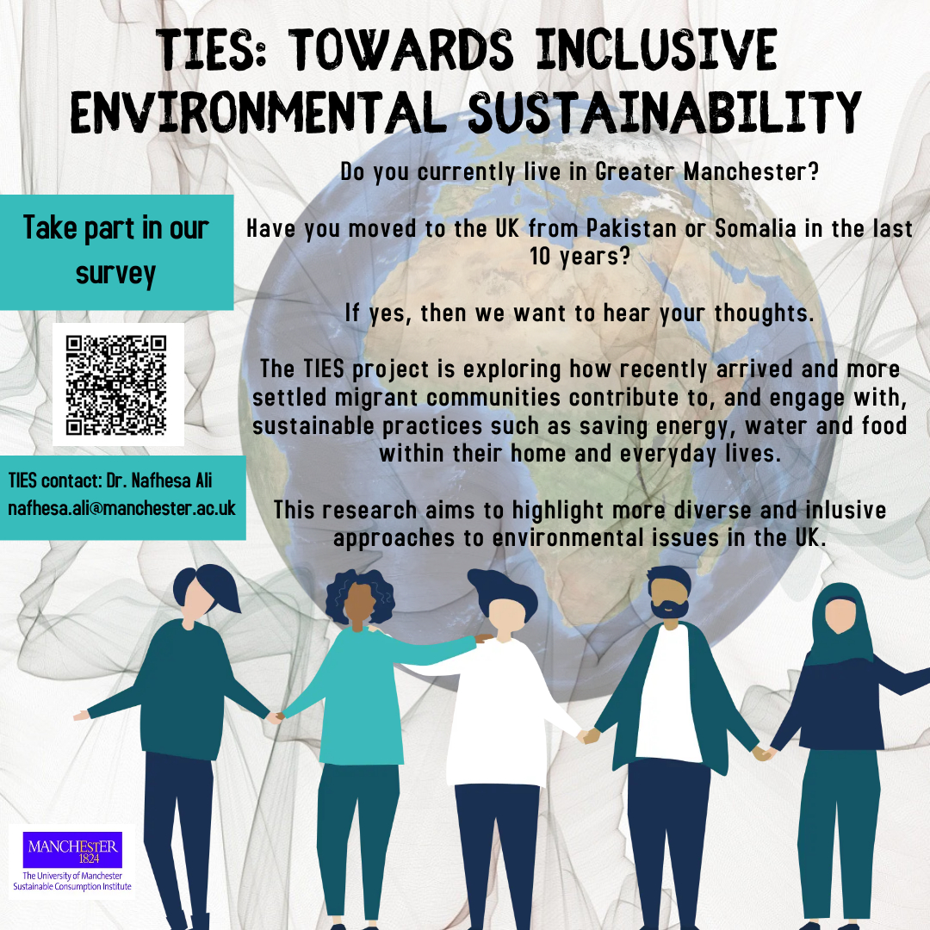

Here’s the [link](https://www.qualtrics.manchester.ac.uk/jfe/preview/SV_0dG0wKnlWCxKKeq?Q_CHL=preview&amp;Q_SurveyVersionID=current&Q_CloneSession=FS_38eP56BOKIimvDj) in case the QR doesn’t work (below).

-------------------------------------------------------------------------------------------------------

The Climate and Ecological Emergency (CEE) Bill

**118 MPs are now supporting the CEE Bill, tabled by Caroline Lucas MP, across all nations of the UK**

Parliament declared a Climate Emergency back in 2019 – but actions haven’t matched their words. An emergency requires strong, decisive action to reverse the climate and ecological crisis … Enter the [CEE Bill](https://www.ceebill.uk/).

The Bill requires the UK to take responsibility for its fair share of greenhouse gas emissions, to actively restore biodiverse habitats, and to stop damaging our natural world through the production, transportation and disposal of the goods we consume.

You can pledge your support for the CEE Bill as an individual here: <https://www.ceebill.uk/sign-up>

-------------------------------------------------------------------------------------------------------

The Co-operative Party’s Petition to Ban Bee-Killing Pesticides

**Close the loophole on bee-killing pesticides**

Earlier this year, when the Government announced it would use a loophole to temporarily allow the “emergency” use of banned bee-killing pesticides by sugar farmers, the Co-operative Party fought until the Government reversed its decision.

The Government has already said they “anticipate” that the emergency authorisations loophole – which allows bee-killing pesticides to be used – may be “needed” again in 2022 and 2023.

Please sign the [Co-operative Party](https://party.coop/)’s Petition here to protect our bees: <https://party.coop/bees>

-------------------------------------------------------------------------------------------------------

The 6R Sustainability Approach

* Follow the 6R protocol to manage plastics sustainably at [home and on campus](https://docs.google.com/document/d/16wjxe1q4OAjBTvzqIEfk9czKxUgdXbISYN78Dq2gmv0/edit?usp=sharing) or in the [labs](https://docs.google.com/document/d/1PBHZzpCqedexWnwd8WtCeYIxzVzCamUqrVRrmKg-iBo/edit?usp=sharing)

* These UoM [videos](https://www.youtube.com/channel/UCiONsNvprJGR4CSkPvAni0A/videos) and [texts](https://www.sustainability.manchester.ac.uk/waste/recycleweek2022/) can answer all your questions about recycling (plastics and other items)

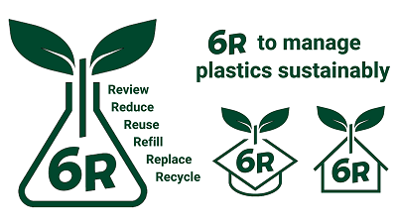

Best wishes

The UoM Climate Network

The CLIMATE-NETWORK list is archived at: <http://listserv.manchester.ac.uk/cgi-bin/wa?A0=CLIMATE-NETWORK>