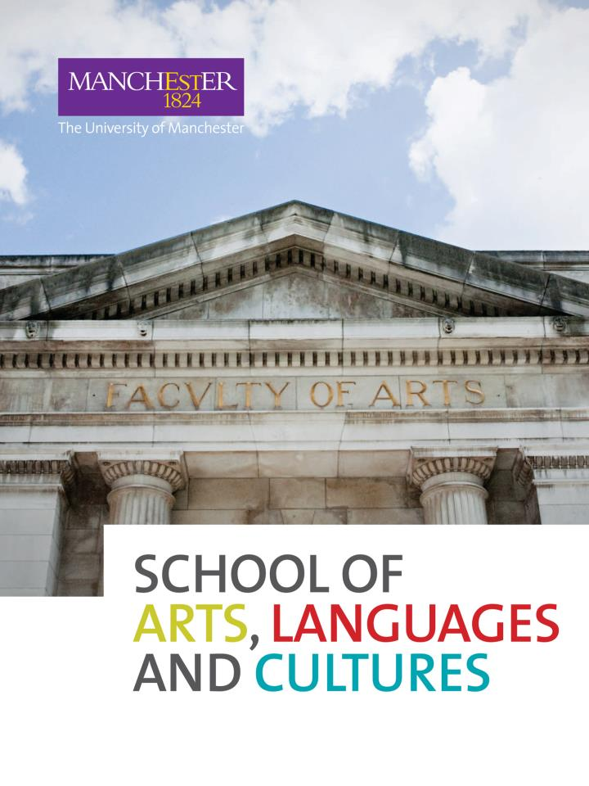

**Understanding a course code**

Courses within the School of Arts, Languages and Cultures include:

**AHVS** Art History and Visual Studies

**AMER** American Studies

**ARGY** Archaeology

**CLAH** Classics and Ancient History

**DRAM** Drama

**EALC** Chinese/Japanese

**ENGL** English Literature

**FREN** French

**GERM** German

**HIST** History

**ITAL**  Italian

**LALC**  School-wide Language Courses

**LELA** Linguistics and English Language

**MEST** Middle Eastern Studies

**MUSC** Music

**RELT**  Religions and Theology

**RUSS** Russian Studies

**SALC** School-wide courses

**SPLA** Spanish, Portuguese and Latin American Studies

**UL\*\*\*** University Language Centre (LEAP) For guidance on the enrolment process for these courses, please consult the University Language Centre website at http://www.ulc.manchester.ac.uk/languages/leap/

Each code is broken into four letters identifying the subject area and 5 numbers which identify both the Level (year of study) and the Semester the course unit is offered in.

The first numerical digit in the code shows the Level it is taught at:

* 1 = First year
* 2 = Second year
* 3 = Third year

You should usually take course units which correspond with your current year of study e.g. second years take 2**** numbered course units and third years take 3**** course units.

The semester a course is taught in is identified by the last digit in the course code

* 0 = Year Long course
* 1 = First semester
* 2 = Second semester

EXAMPLE

|  |  |  |  |  |  |
| --- | --- | --- | --- | --- | --- |
| **CLAH** | **3** | **0** | **2** | **2** | **1** |
| Subject Area (Classics and Ancient History) | Level – 3 (A course unit for final year students) | Unique numerical identifier | Unique numerical identifier | Unique numerical identifier | Semester 1 – A course running in semester 1 |