University Health & Safety Arrangements : Chapter 9

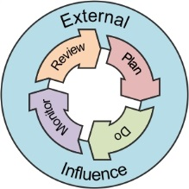
Risk Management & Risk Assessments – key principles

Key word(s) : | Risk management; risk assessment; hazard, risk control measure, risk profile
Target audience : | All managers with a duty to manage work and assess risk eg Senior Managers, PIs, research staff and students  Safety advisors

Contents
Introduction 2
Responsibilities 3
Hazard and Risk profiling 3
Assessment types 4
Justification of the assessment of risk 5
Protecting vulnerable people 5
Identifying hazards 6
Controlling the risk of harm 6
Hierarchy of control measures 7
Recording the assessment findings 8
University Guidance 8

Note.
“Senior Managers” are responsible for health and safety within their organisational unit, specified areas or as a consequence of their activities, and for any additional activities as agreed and delegated to them (e.g. where they accept responsibility for day-to-day safety arrangements for staff who have other line managers, for reasons of geographical or other convenience). They may be Deans, Heads of School, Directors of Institutes, Directors and Heads of Service in non-academic areas, the University Librarian, the Directors of the Manchester Museum and The Whitworth, and their equivalents.
Introduction
- The University promotes the use of sensible health & safety risk management for all its activities, through informed identification of hazards (anything that may cause harm), assessment of the risk of that harm occurring, and the use of proportionate mitigation and control methods to prevent or manage the residual risk of harm.
- In order to achieve the above, each School/ Directorate/Institute etc. is expected to reduce the risks present in their work area by identifying what might cause harm to people and taking all reasonable steps to prevent that harm occurring.
- Risk management is not about creating a totally risk free University, or generating paperwork for the sake of it. It should not be used to exaggerate trivial risks, or stop learning and research activities where the risks are managed.
- ‘Risk assessment’ or, ‘the assessment of risk’ is a thinking process which considers every step of the work, from design through execution to completion, ie the entire work ‘lifecycle’, so that sensible decisions can be made about whether there a risk of harm at any stage and what should be done to prevent or control it.
- A conclusion must be reached about the balance between weighing the risk of injury against the cost or sacrifice needed to control or reduce that risk. The assessment of risk must show that to do more to control a risk would be “grossly disproportionate” to the benefits. That judgement does not take into account whether a control measure is affordable – otherwise, poorer employers would be able to avoid the duty to protect their staff altogether.
- For example, it would be disproportionate to spend £1 million refurbishing teaching rooms to prevent a few people getting splinters from old desk tops. But it may be reasonable to spend £1000 of a £200,000 research grant to ensure the work could be done safely and without causing harm. These costs should be considered and planned in advance and included in funding applications.
- However, the judgement about what controls are used should not be based on cost alone, there may need to be a consideration of what it is actually possible to achieve.
- In the majority of instances a manager has flexibility to select and use control measures that are most suited to the circumstances – providing the controls give the same degree of protection from risk. There are very few instances where mandatory controls are specified in legislation, e.g. guarding of machinery.
- By following the principles of sensible risk management the University can:
- Ensure that employees, students and the public are properly protected
- Enable and support innovation and learning not stifle them
- Ensure that those who create risks manage them responsibly
- Ensure compliance with legal requirements
- Provide overall benefit to society by balancing benefits and risks, with a focus on reducing real risks – both those which give rise to less severe injury but occur more frequently, and those that are less likely to occur but if they do happen, could result in very serious consequences.
- Enable individuals to understand that as well as the right to protection, they also have to exercise responsibility.
Responsibilities
- At the University, the duty for ensuring the assessment of risk is undertaken is delegated through the line management structure.
- Senior managers should satisfy themselves that the arrangements for identifying and assessing risks in their area of responsibility are suitable and effective, and are being followed by those they line manage.
- Line managers/Supervisors must be competent in assessing risks and should ensure that the arrangements they put in place for controlling the risks associated with all aspects of their work are effective, and that those they manage and supervise work in accordance with these arrangements.
- The assessment of risk and identification of control may be delegated to a person with the necessary knowledge, skills and experience and who is familiar with the activity giving rise to the risk. However, the responsibility for ensuring this is done, is suitable for the activity, and people work in accordance with the findings, remains with the line manager/supervisor.
Hazard and Risk profiling
- Senior Managers will need to keep an up to date profile of the hazards and risks for their area of responsibility, which is used to inform the content of the local arrangements to manage these risks. The risk profile is a product of the findings of all the risk assessments carried out to manage the risks from identified hazards. This relationship is shown in the diagram below as part of the Plan, Do Monitor, Review cycle of safety management.

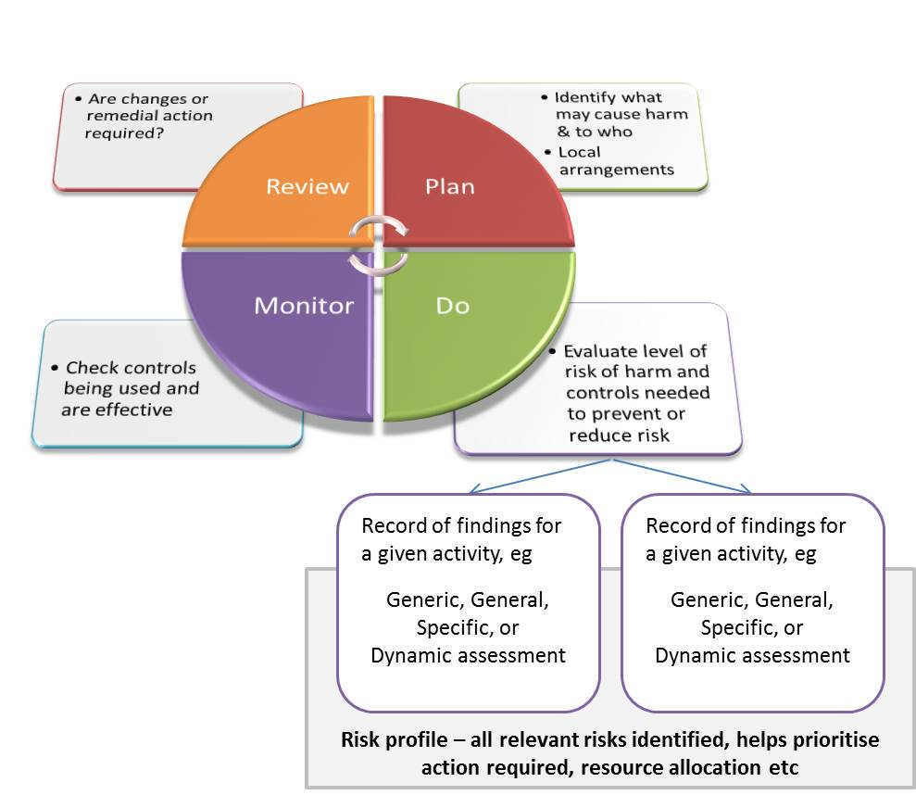
Diagram 1: Risk profiling

Assessment types
- An assessment of risk of the appropriate type must be carried out depending upon the nature of the activity and the level of risk, as shown in the diagram below. Only one assessment type is needed for any given activity i.e. specific assessments can be used to satisfy the need for a general one:
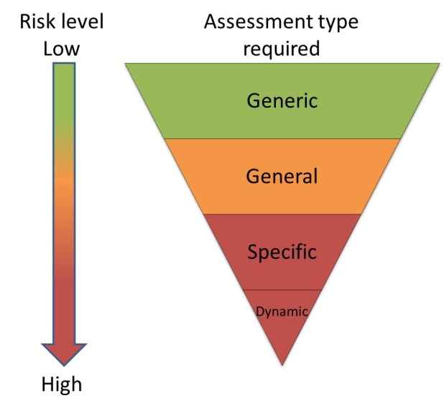
Diagram 2: Assessment types
- Generic assessment –an assessment of the risk posed by day-to-day activities often carried out by several people, and where the risks are very similar, e.g. where the same task is done regularly, or for a suite of rooms, or use of shared equipment, or attendance at a meeting in the UK. The scope and parameters of the activity covered by the assessment must be defined and taken into consideration when deciding the controls required.
- General assessment –an assessment of risk undertaken for any work activity, irrespective of scale or complexity, where there are no legislative requirements to assess specific risks.
- Specific assessment – for activities where there are legislative requirements for work with specific hazards e.g. COSHH, DSEAR, GM activity etc., or the activity is outside the parameters of a generic/general assessment and an aspect of control needs changing, e.g. when scaling up a chemical reaction, attending a conference in a country not covered by the generic assessment.
- Dynamic assessment – when circumstances dictate that the risks in a work activity must be addressed immediately and there is a need to work differently from the way identified in the existing assessment of risk. This is particularly applicable in emergency situations and the assessment should be undertaken from a place of safety. The dynamic assessment findings do not have to be recorded immediately but used to update the existing assessment or formalized in a new assessment as necessary. Dynamic assessment must not be used ‘on the job’ as a substitute for other assessment types.
Justification of the assessment of risk
- For the avoidance of doubt the assessment findings should state clearly the scope and range of activities included, and what is excluded.
Protecting vulnerable people
- There are a number of groups of people who require specific protection.
- New and expectant mothers – where the work activity involves a risk to a new or expectant mother or her baby, the assessment of risk for the workplace or activity must consider this. On receipt of a notification that someone is pregnant, has given birth or is breast-feeding the existing risk assessment should be reviewed. If it does not already cover risks to this group of people, it must be amended.
- Protection of young persons – risk assessments for young persons (under the age of 18) must take into account their relative lack of experience, and any lack of awareness of potential risks. If a young person is recruited or is on a work experience placement, existing risk assessments for the work they will undertake should be reviewed and amended as necessary.
- Those with disabilities – once it is known that an employee has a disability the risk assessment for their work should be reviewed to make sure it covers the risks that might be present for that employee.
- Those with long-term or temporary health issues – some people may be vulnerable due to health issues and risk assessments should be reviewed and amended accordingly to take account of their health status.
- Lone working – working alone can increase the risks to an individual. The University has particular arrangements for assessing the risks for lone workers (see Chapter 10).
Identifying hazards
- It is a requirement that all hazards are identified and the associated risk of harm determined and controlled from design and procurement, throughout use and disposal. This concept applies equally to all work activity, whether it is designing a new building or to individual tasks. However, the scale and scope of the assessment should be proportionate to the risks involved.
Controlling the risk of harm
- The University has to have appropriate and effective arrangements in place for the effective planning, organisation, control, monitoring and review of identified risks and their control.
- These arrangements form the health and safety management system identified in the continuous improvement cycle shown in Diagram 1 above. The four stages of the management cycle are described below.
- Plan – Adequate thought at the planning stage of any work e.g. building proposal, funding application etc. will serve as a preliminary assessment of risk and aid the identification of major requirements: eg suitable facilities, equipment needed, training etc
- Do – As work proceeds the controls and processes identified in the planning stages must be implemented. The assessment of risk for specific activities should be used to devise and define safe ways of working.
- Monitor – Once work commences checks are required to ensure people are working in the way specified, that controls are being used properly and are effective and if not, ensure corrective action is identified.
- Review – Where the monitoring activity highlights the need for change this should be incorporated by revising the current practice to implement the change.
Hierarchy of control measures
- It is University policy to use the control hierarchy from the Health and Safety Executive in the order they are shown below when planning to reduce the risks you identify. Elimination is the most effective control measure and PPE is the least effective, therefore do not simply jump to the easiest control measure to implement.
1 | Elimination | Redesign the job or substitute a substance so that the hazard is removed or eliminated.
2 | Substitution | Replace the material or process with a less hazardous one.
3 | Engineering controls | For example use work equipment or other measures to prevent falls where you cannot avoid working at height, install or use local exhaust ventilation to control risks from chemicals or fume or separate the hazard from operators by methods such as enclosing or guarding dangerous items of machinery/equipment. Give priority to measures which protect a number of people over individual measures.
4 | Administrative Controls | These are about identifying and implementing the procedures you need to work safely. For example: reducing the time workers are exposed to hazards (eg by job rotation); prohibiting use of mobile phones in hazardous areas; increasing safety signage, and performing risk assessments.
5 | Personal protective clothes and equipment (PPE) | Only after all the previous measures have been tried and found ineffective in controlling risks to a reasonably practicable level, must personal protective equipment (PPE) be used. For example, where you cannot eliminate the risk of a fall, use work equipment or other measures to minimise the distance and consequences of a fall (should one occur). If chosen, PPE should be selected and fitted by the person who uses it. Workers must be trained in the function and limitation of each item of PPE.

Recording the assessment findings
- Just as there are different types of risk assessment, so there are different ways of recording the findings from an assessment. For the majority of purposes, the University’s risk assessment template and associated guidance can be used to record the findings.
- This written record of the findings is often referred to as ‘the risk assessment’ however this actually refers to the thought process required to reach the conclusion of how to work safely.
- Documenting the findings should be functional and concise, with an emphasis on effectiveness rather than paperwork. The focus should be on actually controlling risks rather than implementing the recording system.
- Therefore alternative templates or recording methods, eg incorporation into a Standard Operating Procedure, may be used provided they address the same points.
- In some cases (e.g. for work with GMOs and biohazards) the findings of the risk assessment need to be reviewed and approved by committee before work can start.
University Guidance
Safety Services provides the following:

Risk assessment toolkit - www.healthandsafety.manchester.ac.uk/toolkits/ra/
General guidance in the form of FAQs
The role of generic and dynamic risk assessments

Additional Resources

http://www.hse.gov.uk/risk/index.htm - HSE information on risk management
http://www.legislation.gov.uk/uksi/1999/3242/pdfs/uksi_19993242_en.pdf

Document control box
Title | Chapter 9 Identifying hazards and controlling their risks :
Date approved: | OHSTAG, Sept 2018; SHE Committee, Dec 2018.
Approving body: | Safety, Health & Environment Committee
Implementation date: | V 2.0 Dec 2018
Version: | 1.2 May 2016 Updated illustration to reflect published source  1.1, Mar 2016, personnel change  1.0 Sept 2012
Next review date: | May 2021 (Upon significant change/3 years)
Owner of this chapter | Occupational Health, Safety & Training Advisory Group (OHSTAG)  Chair : Professor Nalin Thakker  Secretary: Dr Patrick Seechurn, Head of Safety Services

Managing for health and safety(HSG 65), 3rd Edition, 2013, HSE publication ISBN 978 0 7176 6456 6

