Process for the Management of Incidents in Practice (IP) Involving Learners Across Greater Manchester Provider Organisations
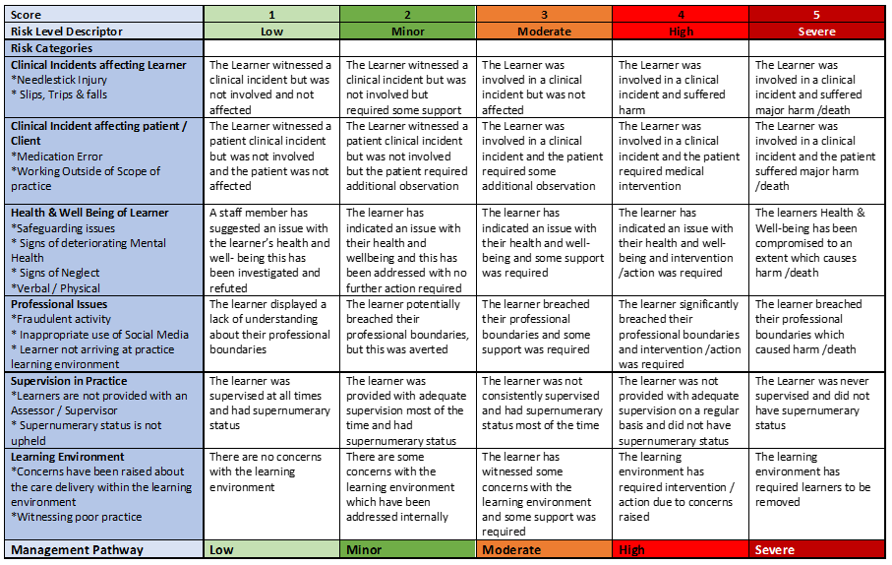

HIGH/SEVERE RISK

Brief summary of the incident

Date of incident

Location

Reported by
Lead contact
Assessment of risk level completed date | Assessment of risk level completed time | Assessment of risk level completed name

Learner name
Learner intake
HEI
Communication with & name/date
PEF
Service Manager
Head of service
Personal Tutor/Academic Assessor
Programme Lead/LME

Date and time of internal incident reporting

Recorded in provider organisation practice incident log date and time

Investigation lead name and title

Summary of Actions |  | Date Agreed | Date to be Achieved | Person Responsible
1
2
3
4
5

Action plan review date:
☐
☐
Action plan completed & approved by the Head of service/lead contact?
No
Yes

