Process for the Management of Incidents in Practice (IP) Involving Learners Across Greater Manchester Provider Organisations
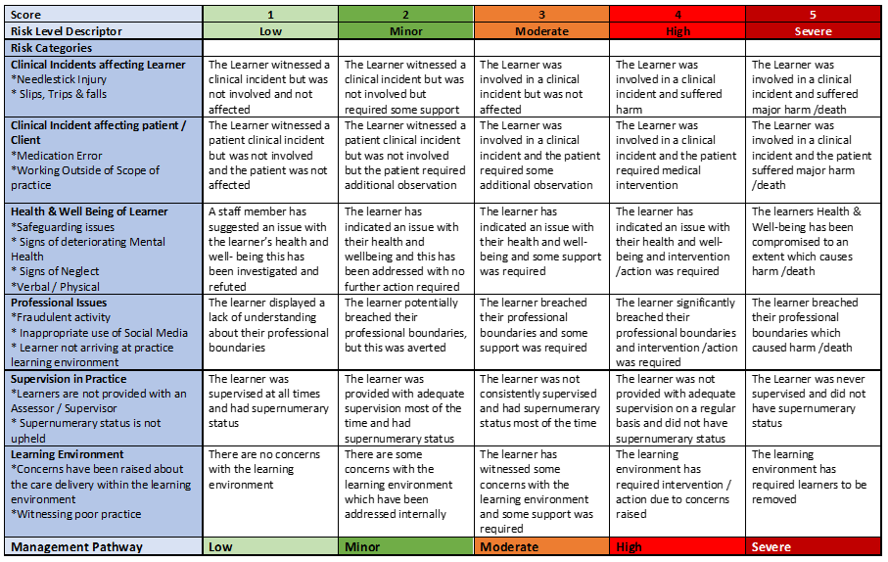

MODERATE RISK
Brief summary of the incident

Date of incident

Location

Reported by
Lead contact
Assessment of risk level completed date | Assessment of risk level completed time | Assessment of risk level completed name

Learner name
Learner intake
HEI
Communication with & name/date
PEF
Service Manager
Head of Service
Personal Tutor/Academic Assessor
Programme Lead/LME

Date and time of internal incident reporting

Recorded in provider organisation practice incident log date and time

Investigation lead name and title

Summary of Actions |  | Date Agreed | Date to be Achieved | Person Responsible
1
2
3
4
5

Action plan review date:
☐
☐
Action plan completed & approved by the Head of service/lead contact?
No
Yes

