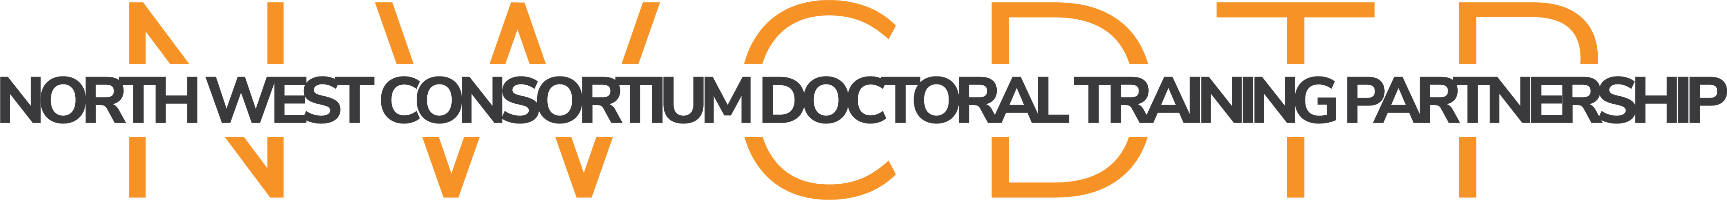

NORTH WEST CONSORTIUM DOCTORAL TRAINING PARTNERSHIP
CDA STUDENT NOMINATION FORM
OCTOBER 2023 ENTRY
This form must be submitted, along with supporting documents (two references and academic transcripts), for all students selected to undertake the AHRC NWCDTP CDA Studentship.
- Candidate’s Details

Name:
University Student Number (if known):
Address:
Town:
Postcode:
Country:
Telephone:
Email address:
Residency Status: | UK National  UK Settled status  EU National not resident in the UK  EU National resident in the UK for the past three years  Other

Studentship type:

+3 (PhD)

Award Type a. Home b. International

Mode of Attendance a. Full time b. Part time

NWCDTP Pathway:
Faculty/School/Institute:
University:
Primary Academic Supervisor:

- Qualifications

Please attach a copy of student transcript.

- Relevant Experience

Number of years:
Description of relevant experience:

- Proposed Training & Support

Please detail how the student's training needs will be identified, met and monitored throughout the period of the award. This should include reference to fieldwork, difficult language training and any other technical training that might be needed (750 words max).

- Candidate's Acknowledgement

I confirm that the information I have provided in this form is complete and accurate to the best of my knowledge at this date. I fully understand that it is my responsibility to ensure that the relevant forms are submitted to the relevant School in due time and that any missing information may render my application incomplete and ineligible. I authorise the North West Consortium Doctoral Training Partnership to disclose to the AHRC any information that is relevant to my application.

Signature:
Date:

- Primary Academic Supervisor Supporting Statement
Please give brief details of the recruitment process employed and why this particular candidate was selected.

- Pathway Lead Statement of Support

Please ensure that the Pathway Lead signs beneath to confirm that they support the choice of student for this CDA Project.

Signature:
Date:

Primary Academic Supervisors should submit this CDA Student Nomination Form, along with references and transcripts, to nwcdtp@manchester.ac.uk

