Right to Study Check
You need to have activated your IT Account in order to complete the Right to Study check. If you have not done so already, activate your account via https://iam.manchester.ac.uk/activates.
If you have already activated your account and do not know your password, you can reset this via https://iam.manchester.ac.uk/recover.
- Log in to Self Service via https://studentadmin.manchester.ac.uk/CSPROD/signon.html using the username name and password set when you activated your account.
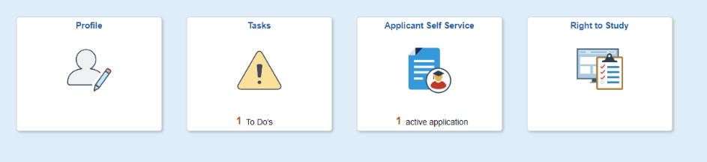
- Click on the Right to Study tile

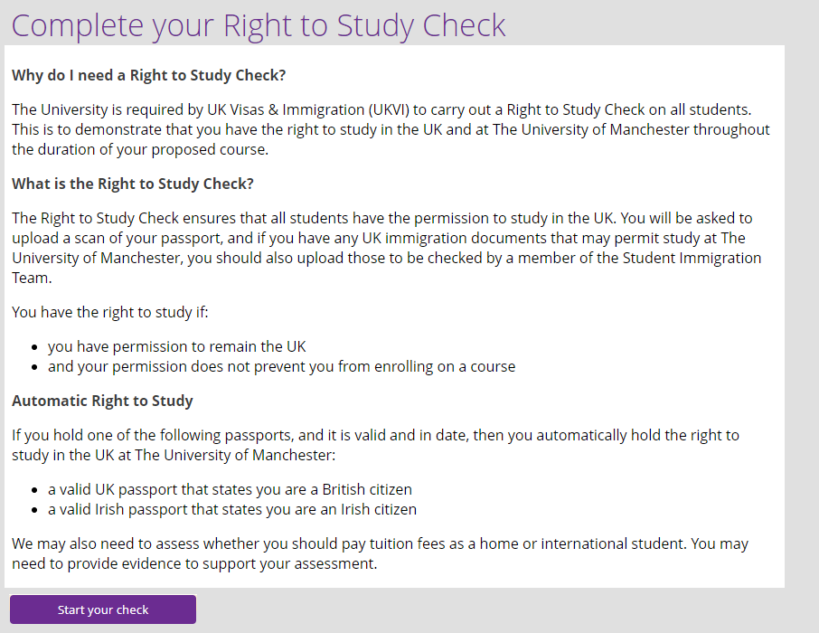
- Click Start your check

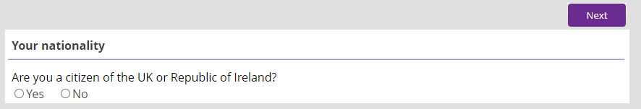
- Answer the questions as appropriate, clicking Next to move through the form

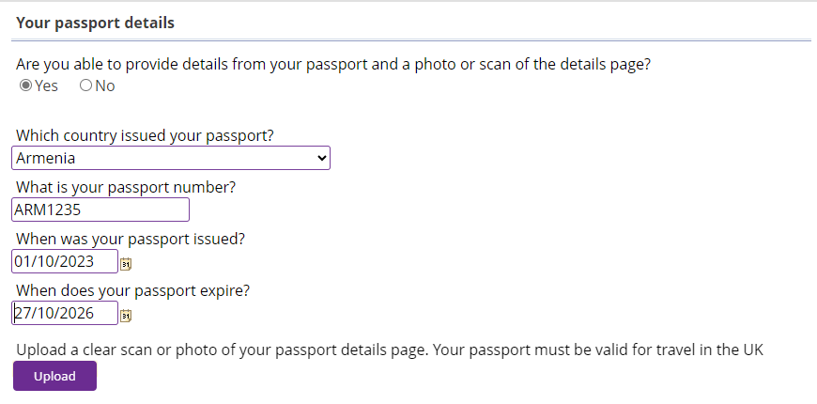
- If prompted, upload a copy of your passport/visa documentation as appropriate:

- Once you have answered all required questions the option to Submit will appear which completes the form.

