Directions to the TEACHING AND LEARNING SUPPORT Office (TLSO), John Owen’s Building

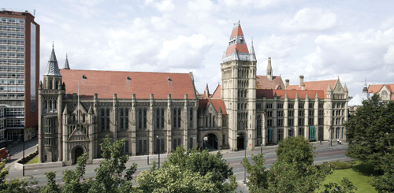

Enter here

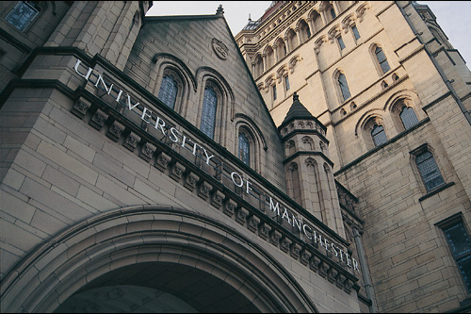

Go under the arch into the quadrangle and you will see this:

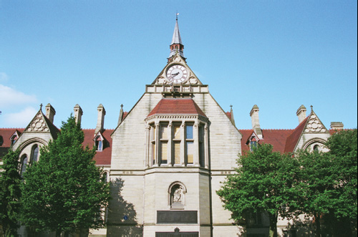

On both sides of the clock tower there are large doors. Enter the building through the doors on the LEFT (The doors on the right are swipe card entry only).

Inside the John Owen’s Building

1. Once inside, go up the stairs to your left.
2. At the top of the stairs turn right and continue climbing the next flight of stairs.
3. At the top of this flight of stairs you will see another much smaller staircase, opposite and to the right. Go up these.
4. At the very top of these, turn right and go through a door.
5. The TLSO office is the second door on the left, room number 2.010.
6. Ask for Kim or Kathy.

