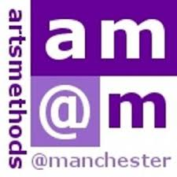


Artsmethods Methodology and Theory Programme 2026-2027
This programme of twenty workshops over two semesters provides postgraduates with both an introduction to a selected range of theories and research methods, as well as practice-based activities and applications of research methods to specific disciplines. Researchers have the opportunity to work with theories and methods critically and effectively and to integrate these practices into their doctoral research as well as networking with colleagues from various disciplines.
Bookings via the Training Catalogue. Participation is limited to 25 researchers.
All workshops are led by Dr Letizia Alterno.

SEMESTER I - Artsmethods Methodology and Theory Programme

28 September, 2026, 11.00-13.00: Theoretical Frameworks (C.1.18, Ellen Wilkinson)
05 October, 11:00-13:00: Textual Analysis (C.1.18, Ellen Wilkinson)
12 October, 11:00-13:00: Introduction to Post-colonial Theory (C.1.18, Ellen Wilkinson)
19 October, 11:00-13:00: Narrative as Research Method (C.1.18, Ellen Wilkinson)
09 November, 11:00-13:00: Using World Literature (C.1.18, Ellen Wilkinson)
16 November, 11.00-13.00: Thematic Analysis (C.1.18, Ellen Wilkinson)
23 November, 11.00-13.00: Researching Human Rights (A4, Sam Alex)
30 November, 11.00-13.00: Discourse Analysis (A4, Sam Alex)
07 December, 11.00-13.00: Discourse Analysis and Language (C.1.18, Ellen Wilkinson)
14 December, 11.00-13.00 Discourse Analysis - Terminology and Methods (C.1.18, Ellen Wilkinson)

