You have now booked on to your interview via the self-service booking system.

We advise that you allow 1 hour for the interview process, which includes:

- Measurements for uniform (15 minutes)
- Interview (approx. 30-45 minutes)

Please report for interview to Campus Support and Security Management Office, Ground Floor, AMBS Building. The entrance is very close to the door you used to enter the Precinct Control Room from Booth Street on the Assessment Day. But I have included details below.

This is a link to the interactive map https://www.manchester.ac.uk/about/maps/interactive-map/

AMBS is building number 29.

Parking is available in Car Park D Car Parking (The University of Manchester)
If you walk from the Car Park on Higher Cambridge Street, and between AMBS and the Hotel, turn right on to Booth Street West. You will walk past the buildings Service Entrance and we are the double glass doors before the stairwell (see picture below).

If you are struggling to find us, you can call me on 0161 275 7569.
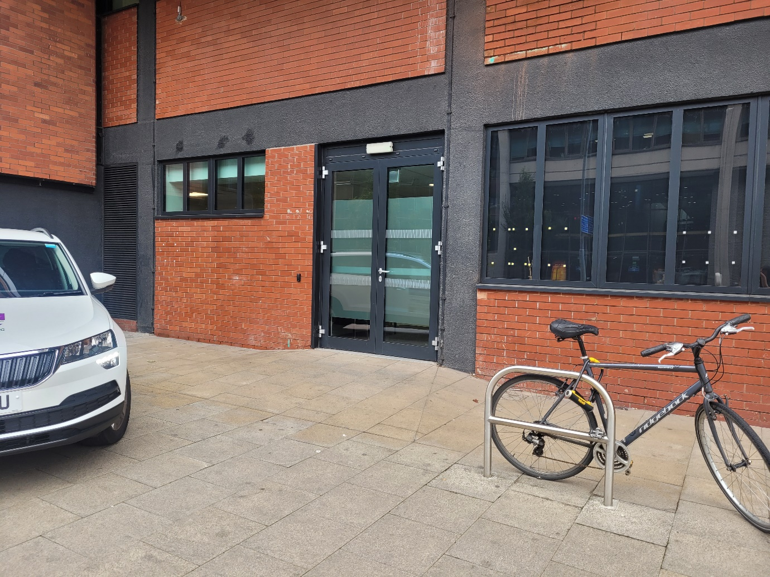

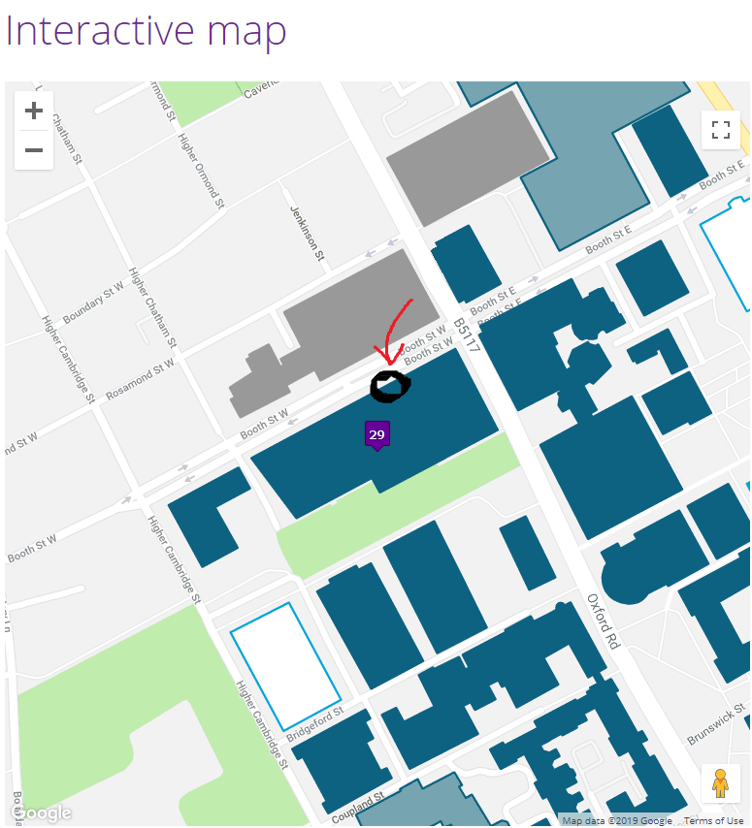

The main entrance to AMBS is opposite the hotel near the Car Park I have directed to you. We are NOT found through the main entrance, but on Booth Street West itself.
If you walk from the Car Park on Higher Cambridge Street, and between AMBS and the Hotel, turn right on to Booth Street West. You will walk passed the buildings Service Entrance and we are the double glass doors before the stairwell (see picture below).
If you are struggling to find us, you can call my mobile on 07773 354 374.

