UoM Template for Research Consent Form - Easy access
Any research project should be compliant with the Data Protection Act 2018 and UK GDPR.
You must have a legal basis defined in data protection law for each purpose you wish to use personal information. Whilst the use of the personal information for the research itself or additional information generated from it, is likely to rely on the public interest task legal basis (and for special category personal information also the research legal basis), this must be cited in the participant information sheet. Consent in terms of Data protection is not used and should not be cited on this form.
This is a sample consent form which aims to explain the activities that may still require consent, this is consent in the ethical sense and to satisfy the common law duty of confidence. NB: the information described in this template should be adapted, where necessary according to the needs of your participant.
We have provided guidance notes in red text and example images for you to consider, please ensure you replace these with your own text and/or images, amend the consent points as appropriate and delete consent points if they are not applicable to your project.
You must ensure that the statements you list here are also mentioned in your participant information sheet and data management plan.
If you are taking consent verbally, you will need to prepare a consent script, using the statements in this form as the basis. You should include an introduction, description of how the consent will work and each of the consent statements relevant to your study.
Please also delete this guidance section.
Please ensure you adjust the footer to the correct version number and date for your project.
If your study involves the NHS and you are submitting for HRA approval then please use the NHS specific Consent Form templates available at: Application Preparation & Guidance and not this template.

Title
Consent Form for Participants
Tell us if you want to take part by circling all that you agree with:


1. Do you know what the study is about? Yes  No


2. Have you asked any questions you wanted to ask? Yes No


3. Do you understand the answers you were given? Yes No


4. Do you know you can stop taking part at any time? Yes No


5. Is it Ok for us to take photos of your face or make videos of you? Yes No


6. Is it OK for us to use photos of your face or videos of you in books or reports? Yes No


7. Is it OK for us to use things you tell us [with your name/without your name] in books and reports? Yes No


8. Is it OK for people at the University of Manchester, or people who check the study, to look at what you say to help keep you safe? Yes No


9. Is it OK for us to share things you say in the study [with your name/without your name]/photos of your face or videos of you with researchers at other places? Yes No


10. Is it OK for researchers to ask you about taking part in other studies later? Yes No


11. Do you know that we may need to tell your parents/guardians/carer/GP something you said if we are worried about you? Yes No

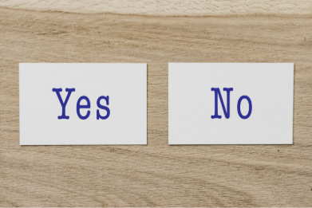
12. Do you want to take part in the study? Yes No

If you don’t want to take part, don’t sign your name!

If you do want to take part, you can write your name below

________________________ ________________________

Name of participant Signature Date

________________________ ________________________
Name of the person taking consent Signature Date

[Insert details of what will happen to the copies of consent form e.g. 1 copy for the participant, 1 copy for the research team (original)]

