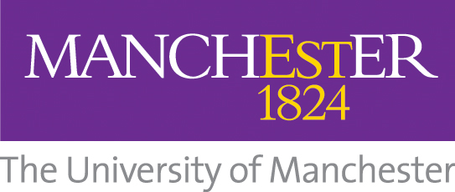 Alliance Manchester Business School (AMBS)
PGR Welcome September 2026
Date | Time | Session | Hosted by | Venue
Wednesday 23 September | 10.00- 10.45 | Tea and Coffee and Registration | AMBS and Doctoral Academy | 3.004 The Hive
Wednesday 23 September | 10.45 - 11.00 | Welcome from Head of School | Prof Ken McPhail | Room 4.010
Wednesday 23 September | 11.00- 11.30 | Welcome from the PGR Director | Prof Jamie Burton | Room 4.010
Wednesday 23 September | 11.30 - 12.30 | Meet your Division | Prof Hening Liu  A&F PGR Divisional Coordinator  Dr Gianluigi Giustiziero  IMP PGR Divisional Coordinator  Dr Ilma Chowdhury  MSM PGR Divisional Coordinator  Dr Kara Ng  PMO PGR Divisional Coordinator | Room 3.008 (A&F)  Room 3.013a (IMP)  Room 4.010 (MSM)  Room 3.015a (PMO)
Wednesday 23 September | 12.30- 1.30 | Lunch |  | 3.004 The Hive
Wednesday 23 September | 1.30 -2.30 | Research Training Programme (RTP) | Dr Pietro Frigenti | Room 3.049
Wednesday 23 September | 2.45 - 3.30 | Tour of AMBS Building and PGR Workspace | Darren Cunningham and Jo Slater | Meet at reception
Wednesday 23 September | 3.30 onwards | Meet your Student Representatives | School and Cohort Student Reps | Room 3.008
Monday 28 September | From 9.15 | MIOIR Induction (*MIOIR students will be contacted separately) | Prof Phil Shapira | Room 3.049

