How to export invoice details from the Power BI report to Excel

Open the Invoice details view.
Move your cursor to the top-right corner of the data table, just above the table, until the available icons appear.

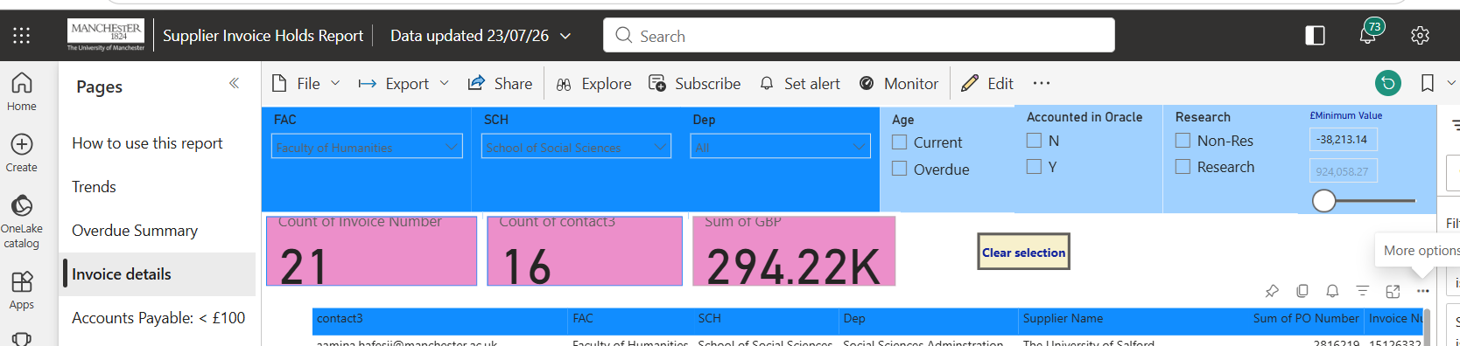

Select the three dots to open the more options menu.
Choose Export data from the menu.
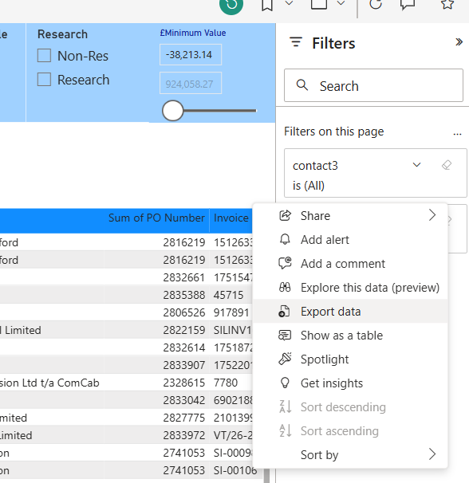

When prompted, select Export.
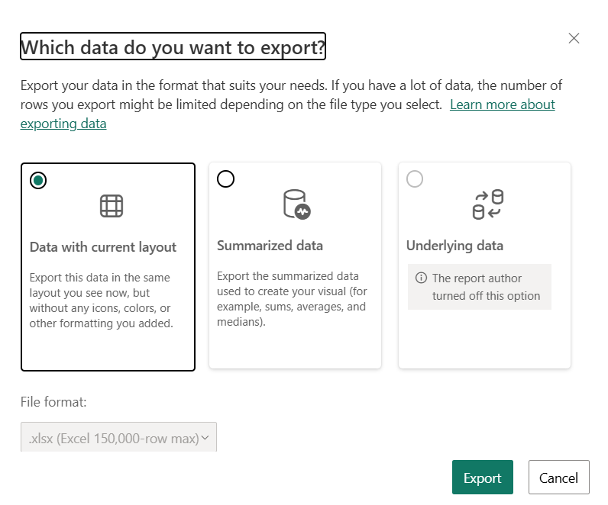
The Excel output will open on the Data sheet for you to review or select the exported information.
