Illuminating Knowledge: Exploring Arabic Scientific Manuscripts at the John Rylands Library’ Itroduction
‘Illuminating Knowledge: Exploring Arabic Scientific Manuscripts at the John Rylands Library’ is a result of the collaboration between academic and library staff at the University of Manchester, the John Rylands Library and Research Institute to explore a neglected episode in Islamic cultural history. We present the findings of our research on notable Islamic scientific manuscripts. We discuss the manuscripts, the texts they contain, the authors who composed them, their value in Islamic culture, and how they travelled across vast distances, far from their place of origin, to Manchester. These artefacts may tell us much, not only about the past, but about the present and future as well.

Pursuit of Knowledge (ṭalab al-ʿilm)
Muhammad, born in the sacred city of Mecca around 570 CE, rarely travelled outside the Arabian peninsula. His religion did, however. Soon after its founder’s death in 632 CE, Islam spread to many of the urban centres of classical antiquity in the Middle East, North Africa, Mesopotamia and Central Asia. Along with the familiar doctrines of God’s absolute unity and transcendence and rituals, including prayer, fasting, charity and pilgrimage, Islam was also distinctive for its emphasis on learning and knowledge in the service of faith. The Qur’an, God’s speech to the Prophet Muhammad and thence to mankind, places considerable emphasis on nature as a sign (āya) of God’s wisdom, knowledge, will and creative power. As time passed, the value of learning and the vital role it played in Muslim spiritual life contributed to the evolution of an elite class of scholars (ʿulamāʾ) who specialised in systematically producing and imparting knowledge. This systematic learning is called ʿilm in Arabic and normally translated into English as science. Early on, this science was made up of religious disciplines such as Arabic grammar and Qur’an commentary (tafsīr), but eventually came to include secular disciplines, such as medicine, astronomy, and mathematics.
From Greek to Arabic: the translation of classical works
Over centuries, secular scientific learning was gradually incorporated into the Islamic vision of science and religious learning institutions. This process began less than two centuries after the death of the Prophet Muhammad. Between 800 and 1000 CE, most non-historical, non-literary Greek texts in the Levant, Mesopotamia and Asia Minor were translated into Arabic in Baghdad, the capital of the Islamic empire ruled by the ʿAbbāsid dynasty (CE 750–1258), and the cultural and economic centre of the classical Islamic world. While none of the translators were Muslim, the translations were funded by Muslim and Christian elites of ʿAbbāsid society, including caliphs, viziers, courtiers and merchants.
Desire for Greek scientific learning among Muslim political, social and intellectual elites was fuelled by more than a thirst for scientific understanding or intellectual curiosity. These scientific texts also played a part in Muslim political manoeuvring against the ruling dynasty’s political rivals. They were indispensable to medieval Muslim-Christian religious debates. They provided scientific know-how that facilitated religious ritual and enhanced spiritual life and wellbeing. Lastly, they provided the ruling dynasty with the appearance of legitimacy and furnished a cosmic narrative about the ʿAbbāsid dynasty’s place in the history of Islam and humankind.
Leading scientists of the classical tradition whose works were translated into Arabic during the translation movement include Galen (d. 216 CE), Euclid (fl. 300 BCE), Archimedes (d. ca. 212 BCE), and Ptolemy (d. ca. 170 CE). These figures made revolutionary contributions in antiquity to medicine, mathematics and astronomy. Arabic translators devoted considerable effort to the translation of their writings.
Islamic innovations
By 1000 CE, the translation movement had wrapped up its activities, but from that time and for centuries thereafter, Islamic scientific activity continued apace, with innovative texts, composed originally in Arabic rather than Greek, multiplying in number and growing in sophistication. While in some ways, Muslim scientific authorities overshadowed or replaced Greek, the classics did not fade away altogether. Some of the original translations underwent changes at the hands of editors, such as Naṣīr al-Dīn al-Ṭūsī (d. 1274 CE), who revised numerous Greek mathematical and scientific texts, updating them so that they were in line with discoveries made by Muslim mathematicians and scientists. Islamic views on wellness, embodied in the tradition of prophetic medicine (al-ṭibb al-nabawī), was constructed around Greek humoral pathology. Above all, the connection between faith and scientific understanding was shared by Muslims and their Greek forebears. Ibn Rushd’s (d. 1198 CE) famous remark that ‘the one who studies the science of anatomy shall increase in faith in God’ is an echo of Galen, who likened his most famous book on human anatomy to the songs of the poets who ‘used to chant standing before the alters…and singing hymns of praise to the gods’ (Galen Book XVII).
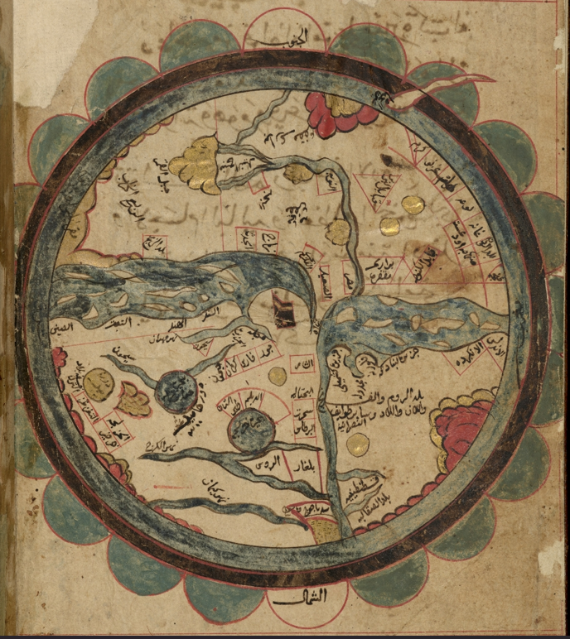
The Map of the World in a 16th-century copy of Qazwīnī’s geographic work, The Marvels of Regions (Arabic MS 668, f. 1)
The traffic of ideas: Islamic science in the wider world
Over the centuries Hellenistic learning spread far and wide. Muslim scientists often became scientific authorities outside the Islamic world, particularly in Europe where Arabic texts were translated into Latin and Hebrew. In its turn, Europe developed outstanding, innovative scientific traditions, particularly in the late medieval and early modern periods. Paracelsus (d. 1541 CE), the Swiss-born alchemist and physician, articulated a controversial and somewhat idiosyncratic approach to medicine, therapy and pharmacology. Writing in German when the language of science in Europe was still Latin, Paracelsus’ ideas were brought from Latin and thence into Arabic by Ṣāliḥ ibn Naṣr Allāh Ibn Sallūm (d. 1670 CE) of Aleppo. This traffic of ideas between scientists in the Islamic world and Western and Southern Europe would continue until the end of the eighteenth century.

Rising European dominance
The fifteenth to the nineteenth centuries brought tectonic shifts in global political and economic power dynamics. Europe’s relation to the rest of the world changed radically. Traditional dynastic powers in the Islamic world, especially the Ottomans and the Mughals, were gradually undermined by European economic and political expansion as the nation-states of Western Europe, above all Britain and France, expanded their search for new markets, sources of labour and raw material for industry. Growing European dominance was coupled with a new vision of science and the role it should play in human life. According to ancient and medieval conceptions, the purpose of science, or true understanding of reality, is to enrich human life through contemplation that deepens our knowledge about God, the natural order and ourselves. Europe’s new epistemic regime viewed science as a means for creating technologies that granted their possessor power and mastery over man and nature. In the colonial era, this mastery extended to the bodies and minds of colonised peoples. Britain was the greatest colonial power in modern history. Its political control and cultural influence, direct and indirect, over the peoples of the Indian subcontinent, for instance, lasted for centuries. In India, British merchants, scholars and military personnel acquired oriental manuscripts in vast numbers. Motives for collecting the manuscripts were diverse, ranging from the illicit to the noble. Motives aside, once the manuscripts were transported back to Europe and studied in universities by specialists, they yielded up knowledge about India and its Islamic cultural heritage and, through this process, were transformed into tools for dominating and having authority over the Indian subcontinent. Islamic manuscripts were prized cultural productions which carried considerable value to European collectors and scholars. Colonel George William Hamilton collected these and hundreds other such manuscripts while he served in the British Army in India. The codices he amassed were later acquired by Alexander Lindsay, the 25th Earl of Crawford, who added them to his vast library, the Bibliotheca Lindesiana. After his death, the Persian scholar Nathaniel Bland’s (1803–1865) oriental manuscripts were also bought by Alexander Lindsay. In 1901, his son, James Lindsay, sold over 3,000 manuscripts, East Asian books and papyri from the Crawford collection to Enriqueta Rylands, the widow of John Rylands, for the monumental sum of £155,000 (£12M circa 2026).

Islamic Medicine: Health and Faith
Like the western medical tradition, the origins of Islamic medicine can be traced to texts attributed to Hippocrates of Cos. While Hippocratic texts were undoubtedly vital to the historical evolution of the Islamic medical tradition, the framework of medical concepts, methods and boundaries for medical innovation was set out in the expansive oeuvre of Galen of Pergamum. In thousands of pages of writing, Galen single-mindedly pursued his vision of medicine which combined reason with medical experience, made anatomy and dissection central to medical learning, systematised humoral pathology and aetiology, and more closely incorporated pharmacology into the Hippocratic vision of therapy. Thanks to the tireless efforts of Ḥunayn ibn Isḥāq (d. 873 CE) and his collaborators, virtually the entire Galenic corpus was translated into Arabic. These texts would form the foundations for Islamic medicine until the nineteenth century and live on today in the Islamic tradition of Unani ṭibb.
The Greek physician Galen of Pergamum
Galen’s influence on Islamic intellectual culture was not limited to medicine. His vision also included the idea that, as the title of one of his most memorable books avers, the best physician is also a philosopher. One of Galen’s memorable forays into philosophy is his treatise On the Usefulness of the Parts of the Body (Arabic MS 780). Ostensibly a text on anatomy, Usefulness of the Parts represents a highly detailed teleological proof of the existence of a creator God. The book was well-known to Muslim theologians such as the great Abū Ḥāmid al-Ghazālī (d. 1111 CE) and the renowned medieval Jewish philosopher Moses Maimonides (d. 1204 CE).
Abū Bakr al-Rāzī.
Galen was highly respected by Muslim thinkers. This did not, however, stop them from heaping criticism on him where they felt it was justified. In a famous book entitled Doubts Concerning Galen, Abū Bakr al-Rāzī (d. ca. 925 CE) begins by acknowledging his intellectual debt but follows this up with hundreds of pages of detailed criticisms of Galen’s philosophy and medicine. Al-Rāzī was probably the greatest physician of medieval Islam. He was certainly one of the most prolific and dynamic. His works include the colossal Comprehensive Book of Medicine, a 23-volume medical commonplace book, and a brief medical self-help manual Book for the One Who is Not Attended by a Physician. (Arabic MS 552).
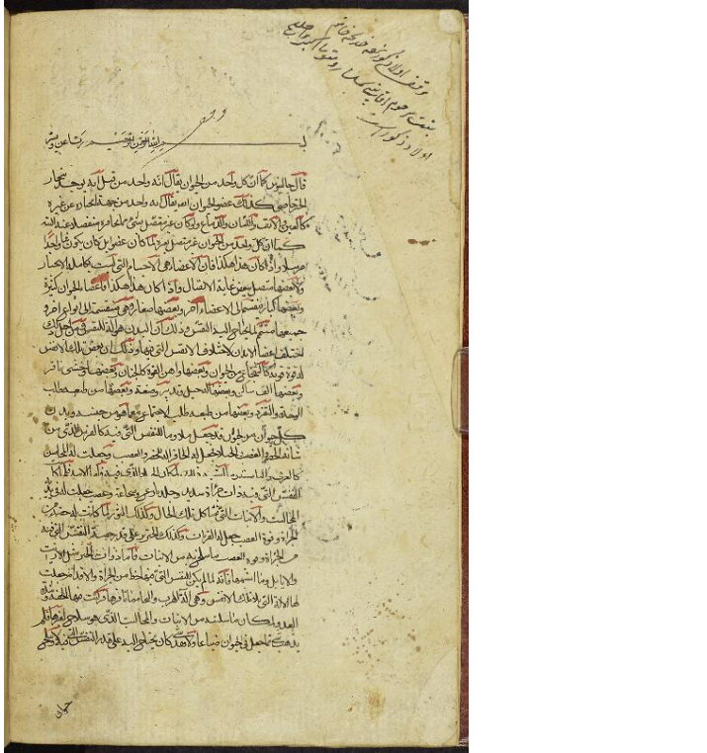
Galen’s On the Usefulness of the Parts of the Body (Arabic MS 780, f. 1b)
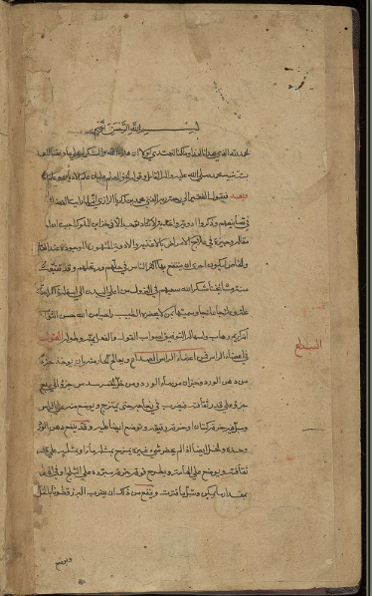
Book for the One Who is Not Attended by a Physician (Arabic MS 552, f. 1b)
Ibn Sīnā
No-one better embodied Galen’s maxim that the best physician is also a philosopher than Ibn Sīnā (d. 1037 CE), one of history’s great philosophers. He thought very little of al-Rāzī’s abilities as a philosopher, however. Al-Rāzī, Ibn Sīnā memorably quipped, outdid himself in ‘lancing abscesses and examining urine and faeces (wa-tajāwaza qadrahu fī baṭṭi l-jirāḥi wa-n-naẓari fī l-abwāli wa-l-birāzāt)’. Ibn Sīnā’s medical encyclopaedia, the Canon of Medicine (Arabic MSS 300-303), is probably the single most widely read medical text in history. Written in five books and the subject of numerous translations, commentaries and glosses, the Canon shaped medical discourse in the Islamic world until at least the seventeenth century.

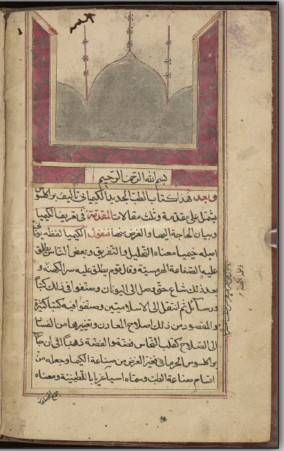
On the New Chemical Medicine, Arabic MS 424, folio 1b

Paracelsus
In Western Europe, Ibn Sīnā was known by his Latinised name ‘Avicenna’. The Canon of Medicine was read in European medical schools into the 1700s. But the traffic of medical ideas was not always one-way. As the centuries passed, European medicine made its way into the early modern Islamic world. Theophrastus Bombast von Hohenheim, better known as Paracelsus, was a pioneering but controversial Swiss physician and alchemist. He outlined a novel approach to medicine that traditional European physicians regarded as rivalling the orthodoxy of Galenic humoral pathology. Latin translations of summaries of Paracelsus’ ideas trickled into the Ottoman Empire in Arabic translation (Arabic MS 424). Thanks to the efforts of Ibn Sallūm, summaries of Paracelsus’ system of ‘chemical medicine’ in Latin by Oswald Crollius (d. 1609 CE) and Daniel Sennert (d. 1637 CE) became available to Muslim physicians in Arabic.

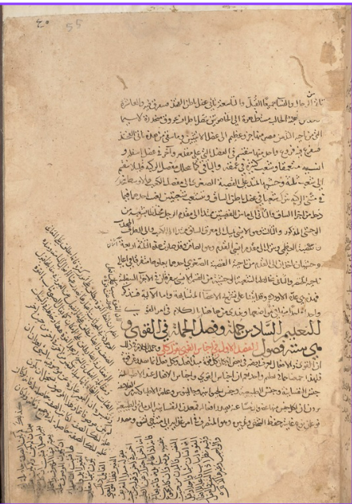
Ibn Sīnā’s The Canon of Medicine, Book I, Thesis 6 (Arabic MS 300, f. 55a)

Manuscripts discussed - Medicine
Kitāb Gālīnūs fī manāfiʿ al-aʿḍaʾ (كتاب جالينوس في منافع الأعضاء)
[Book on the Usefulness of the Parts of the Body]

A copy of the Arabic translation of On the Usefulness of the Parts of the Body by the renowned Greek physician Galen of Pergamum (129-216 CE) as translated into Arabic by Ḥunayn ibn Isḥāq, a very highly regarded translator of the ʿAbbāsid period. This copy was probably written in the late 17th century. Arabic MS 780

Kitāb Man lā yaḥḍuruhu al-ṭabīb (كتاب من لا يحضره الطبيب)
[Book for the One Who is Not Attended by a Physician]

A work on diseases and practical remedies. The Persian scholar Abū Bakar Muḥammad bin Zakarīyā al-Rāzī composed this work in the 10th century CE. There is no date given in this manuscript copy but it was probably written in the 17th century. Arabic MS 552

Kitāb al-Qānūn fī al-ṭibb (كتاب القانون في الطب)

[Canon of Medicine]
Medical encyclopedia composed by Avicenna (Ibn Sīnā) around 1025 CE.
The manuscript containing Book I was copied around 1750 CE. The other three volumes are from the 1860s presumably commissioned for Colonel Hamilton to compete the set. Arabic MS 300

Kitāb al-Ṭibb al-jadīd al-kīmīyaʾī (كتاب الطب الجديد الكيميائي)

[On the New Chemical Medicine]
A treatise on the general principles of therapeutics and alchemy. Translated from Latin by Ṣāliḥ Naṣr Allāh ibn Sallūm Ḥalabī (d. 1669). This copy was completed in Ṣafar 1205 AH (1790 CE) by Ibn Muḥammad Sāmi Alī. Arabic MS 424

Islamic Astronomy: Signs in the Heavens
Translations of Greek works
Euclid (fl. 4th century BCE) is best known for his famous treatise on geometry, the Elements. Less well-known were other pioneering texts including a treatise on spherical astronomy called the Phaenomena (Arabic MS 381, ff. 2a-28a). It is one of the earliest Greek geometric texts to deal with some fundamental problems related to the risings and settings of stars and arcs on the celestial sphere.
Like much early astronomy among the ancient Egyptians and Babylonians, Euclid’s Phaenomena is practical. It devotes much attention to how to calculate the length of daylight on a certain day and in a certain location. At around the same time as Euclid, however, Greek philosophers and scientists, including Plato (d. ca. 348 BCE) and Aristotle (d. 322 BCE), were interested in getting a grasp of the configuration and motion of the heavens as an integrated system of concentric spheres, with the moon, sun, planets and the stars embedded in orbs rotating round Earth at the centre of the cosmos.

Ptolemy of Alexandria
The impulse towards observation, mathematical sophistication, empirical accuracy and practical calculation reached their apotheosis in Ptolemy of Alexandria (d. ca. 170 CE), the greatest astronomer of antiquity. In his pioneering work the Almagest, Ptolemy introduced a number of novelties into mathematical astronomy that placed it on firm mathematical and empirical foundations. Ptolemy retained several basic assumptions about the configuration of the cosmos, including the fact that the cosmos as a whole is eternal and the celestial spheres each move in perfect circles at a steady speed in a single direction around the Earth which lies at its centre. Ptolemy also introduced innovations into the astronomical models that ensured predictions based on them more closely matched observation. According to some, however, these innovations had their drawbacks. Ptolemy’s critics accused him of introducing conceptual contradictions into his models of the cosmos.
Ibn al-Haytham
Like Galen, nearly all of Ptolemy’s writings were translated into Arabic during the era of translation. This included not only Ptolemy’s magnum opus the Almagest, but also his masterpiece on astrology the Tetrabiblos, and the Planetary Hypotheses. Ptolemy’s reception among Arabic-speaking astronomers closely resembled Galen’s. His work served as the starting point for all subsequent astronomical research. Islamic astronomers acknowledged Ptolemy’s merits but did not hold back from criticising him for what they regarded as blunders and errors. Of all Ptolemy’s critics, al-Ḥasan ibn al-Haytham (d. 1040 CE) was probably the most vocal. In Doubts Concerning Ptolemy, clearly modelled on al-Rāzī’s critique of Galen, Ibn al-Haytham criticises Ptolemy’s mistakes and failure to correctly balance the dual imperatives of theoretical and observational consistency in his models of the cosmos. Ibn al-Haytham argues that Ptolemy’s theoretical innovations, while generating better predictions, are inconsistent with the physical principles of uniform circular motion.
Naṣīr al-Dīn al-Ṭūsī
Addressing Ibn al-Haytham’s criticisms of Ptolemy’s system and finding ways to overcome them within the cosmological paradigm of ancient and late antique natural philosophy set the research agenda for Islamic astronomy for several centuries. Ibn al-Haytham died in Egypt, but the group of astronomers who carried on his legacy worked at an observatory hundreds of miles away, in a town in Northwest Iran called Maragha. The Maragha observatory is one of the most famous scientific institutions in Islamic history and hosted some of Islam’s greatest astronomers, Naṣīr al-Dīn al-Ṭūsī being by far the most prominent.
Al-Ṭūsī’s output includes well over 100 titles on astronomy, mathematics, philosophy and theology. His best-known book on astronomy is Memoir on the Science of Astronomy. But al-Ṭūsī was also famous as an editor or redactor of Greek scientific and mathematical texts. This includes the collection of various short texts on astronomy and mathematics which, in the Greek tradition, were conventionally called the Middle Books, the Kitāb al-Mutawassiṭāt in Arabic (Arabic MS 381). He also produced recensions of some of the great works of antiquity, including Euclid’s Elements and Ptolemy’s Almagest.
Al-Ṭūsī’s recension of the Almagest (Taḥrīr al-Majisṭī) attracted numerous commentaries and glosses. Niẓām al-Dīn al-Nīsābūrī’s (d. 1330 CE) is one well-known example. The commentary by ʿAbd al-ʿAlī al-Bīrjandī’s (d. ca. 1527) is another (Arabic MS 299). By the sixteenth century, astronomy was thoroughly embedded in Islamic institutions of religious learning. Nor was the connection between astronomy and religious experience difficult to find. The Qur’an speaks frequently of God’s signs in the ‘heavens and the earth’ for those who reflect. In the Almagest, Ptolemy says instruction in astronomy improves moral character and fosters divine love. ‘With regard to virtuous conduct in practical actions and character’, Ptolemy movingly remarks, astronomy ‘could make men see clearly; from the constancy, order, symmetry and calm which are associated with the divine, it makes its followers lovers of this divine beauty, accustoming them and reforming their natures…to a similar spiritual state. It is this love of the contemplation of the eternal and unchanging which we constantly strive to increase’ (Almagest, I.1).
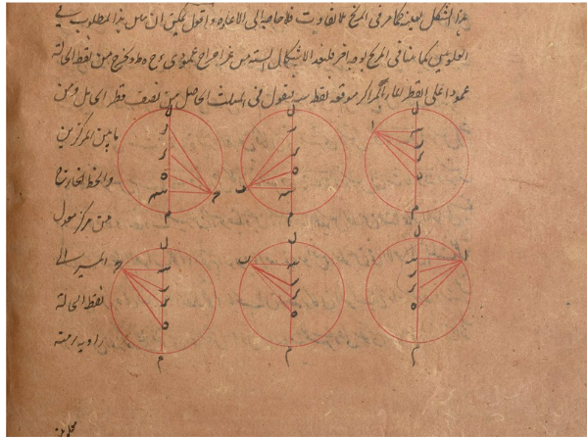
Commentary on the al-Ṭūsī’s Taḥrīr al-Majisṭī; Arabic MS 299, f. 366b
Some Muslims, however, had less flattering things to say about astronomy. Having thoroughly familiarised themselves with the discipline during their studies, some of the savvier Muslim theologians dismissed the planetary spheres as no more than heuristic mathematical devices for making calculations, but whose connection to reality was ‘more tenuous than a spider’s web’ (referring to Qur’an 29:41). Other theologians, by contrast, defended the mathematical models. They argued that such models provide a genuine account of the real nature and configuration of the cosmos. Al-Bīrjandī’s commentary on al-Ṭūsī’s recension of the Almagest illustrates how these tensions manifested in commentaries. Ptolemy’s indirect proof of the geocentric universe proceeds on the assumption that any correct configuration of the cosmos must align with experience and observation. And, as a matter of fact, Ptolemy shows all the models with the Earth displaced from the centre also entail astronomical phenomena that do not align with our basic experience of the heavens.
That Ptolemy’s proof of the correctness of the geocentric model assumes the infallibility of astronomical experience is keenly felt by al-Bīrjandī. At the end of his survey of Ptolemy’s proof in his commentary on al-Ṭūsī’s recension of the Almagest he says al-Ṭūsī rightly frames the whole discussion of Ptolemy’s proof as being based on how things appear to our senses (al-ḥiss), not on how the cosmos really is (al-ḥaqīqa).
Al-Bīrjandī says, in effect that, Ptolemy’s proofs of the geocentric universe do not refute the prospect that alternative geometric configurations of the cosmos would appear indistinguishable to our senses. As a matter of fact, the revolutionary heliocentric model of the cosmos was introduced to the Ottoman world about a century after Copernicus published On the Revolutions of the Heavenly Spheres. Some Ottoman astronomers were impressed by the proposal, but the suggestion that the Sun, not the Earth, is the centre of the universe did not have the radical impact on Islamic intellectual culture one might expect. Indeed, even as late as the nineteenth century, Muslim authors continued to write texts on astronomy and timekeeping, either unaware or untroubled by the emergence of a rival to the geocentric model that had dominated Islamic cosmology for so long.

Islamic Mathematics: Finitude to Infinity
Archimedes’ reception in the Islamic world
Greek mathematicians excelled at geometry. Pythagoras (d. ca. 495 BCE), one of the earliest and greatest of the early Greek mathematicians, was joined by legions of outstanding Greek mathematicians, including Euclid and, several hundred years later, Archimedes of Syracuse (d. 212 BCE). The texts of Euclid, Archimedes and many others were translated into Arabic during the translation movement. Some of Archimedes’ most famous mathematical results are presented in a short and fragmentary text entitled Measurement of the Circle, where he proves the area of a circle is equal to the area of a right-angle triangle whose height is equal to circle’s radius and whose length is equal to the circle’s circumference. Still more intriguing is that in the same treatise Pythagoras offers an estimated numerical value of pi, namely, the value of the ratio of the circumference of any circle to its diameter. Interestingly, the Arabic title, Taksīr al-dāʾira, gives some idea of the method Archimedes used in the treatise (Arabic MS 381, ff. 120b-125a). As a technical term, the Arabic word taksīr can mean to measure, but lexically it means to break up or to segment something into parts. And Archimedes’ method of exhaustion for measuring the area of a circle in this treatise, which has its precursor in Euclid’s Elements, involves repeatedly breaking up the sides of polygons, one circumscribing the circle, another inscribed in it, into smaller and smaller lengths to get finer approximations of the circle’s true area.
Ibn al-Haytham
Archimedes’ Measurement of the Circle was one of the treatises included in the so-called Middle Books which were used in educational settings in Greek and Islamic late antiquity and in classical and post-classical Islam (after 1258 CE). Naṣīr al-Dīn al-Ṭūsī included this famous text by Archimedes in his recension of the Arabic Middle Books. Works translated from Greek into Arabic appearing in the Mutawassiṭāt also included On Spheres (Kitāb al-Ashkāl al-kurrīya) by Menalaus of Alexandria (d. ca. 140 CE) and On the Sphere and the Cylinder, another text by Archimedes. The version of al-Ṭūsī’s recension of the Mutawassiṭāt preserved at the Rylands also includes original works by prominent Muslim writers, including al-Ḥasan ibn al-Haytham.
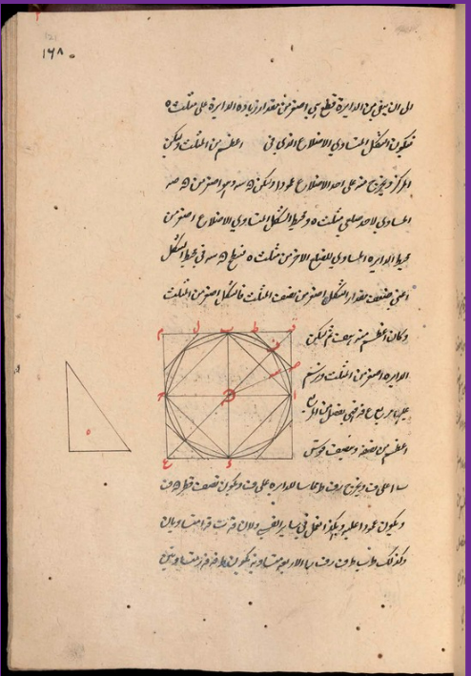
Archimedes’ Measurement of the Circle (Taksīr al-dā’ira); Arabic MS 381, folio 121a.
Ibn al-Haytham was not just the author of Doubts Concerning Ptolemy. He was perhaps more well known in his day for his work on optics and mathematics. The John Rylands’ copy of the Arabic Middle Books includes his famous treatise On the Quadrature of the Circle (Fī tarbīʿ al-dāʾira) in which Ibn al-Haytham attempts to prove, in the face of scepticism from ‘many philosophers’, that it is possible to construct a square with the same area as a circle (Arabic MS 381, ff. 125b-130a). Mathematicians have since proved that no such procedure exists, but there were, nevertheless, mathematical reasons informing Ibn al-Haytham’s intuition. One was, of course, Archimedes’ Measurement of the Circle and Euclid’s Elements. Together these treatises showed that the area of a circle, a curved figure, could be thought of in terms of the area of a triangle, a rectilinear figure, and they also described a procedure for constructing such figures. The second is that in an earlier treatise Ibn al-Haytham himself had famously demonstrated that it is possible to find two crescent-shaped figures (called ‘lunes’) equal in area to the area of a triangle. If the areas of crescent-shaped figures could be equal to the area of a triangle, why not the simpler figure of a circle?
Mathematics and God
Greek mathematicians drew on the resources of ancient Egyptian and Babylonian mathematicians. Pythagoras, the most prominent early Greek mathematician, mixed mathematics with metaphysical speculation. Pythagoras and Pythagoreans were known especially for the special attention they granted to geometry. They are on record as having claimed that, with each new theorem, geometry ‘sets up a platform to ascend by, and lifts the soul on high instead of allowing it to go down among sensible objects and so become subservient to the common needs of this mortal life’ (Heath 1921, 1:141).
Some Muslim philosophers adopted the Neoplatonic convention of identifying the divine Monad and principle of being, the One, with God. But they did not think God, the ultimate reality, is a number. Indeed, the great Muslim theologian Abū Ḥāmid al-Ghazālī appears to suggest that mathematical and religious truths are necessarily consistent; they cannot, that is, come into conflict, because they appear to concern different orders of reality.
Muslims like al-Ghazālī recognised that people cannot help but marvel at mathematics. It was widely recognised, too, that mathematical disciplines such as arithmetic and algebra were useful for and facilitated religious practice and adherence to God’s Law, the Sharīʿa. Indeed, one of the chief motives behind the development of algebraic methods in the Islamic world lay in the desire to facilitate religious practice. The word ‘algebra’ is derived from the title of the book Kitāb al-Jabr wa-l-muqābala (The Book of Restoring and Balancing) by Muḥammad ibn Mūsā al-Khwārizmī (d. ca. 850 CE). The impulse to write the book, which is one of the first books on algebra in history, comes from not only intellectual curiosity and desire for mathematical discovery, but the need to solve complex problems in Islamic inheritance law. Al-Khwārizmī devoted around half of this book to providing mathematical tools to facilitate conformity with the Sacred Law. The motive to facilitate calculation also lay behind the development of arithmetic tools for simplifying multiplication and division of large numbers and decimals. Several numeral systems for counting and measuring existed in classical Islam. Probably the most common was sexagesimal or base-60 numeral system, which was used by astronomers. Another system was the decimal or base-ten system of numbers which originated in India, but was quickly appropriated in the Islamic world. Numerous treatises on decimal numbers and fractions (kusūr aʿshārīya) were written over centuries, beginning with Abū l-Ḥasan al-Uqlīdisī (fl. ca. 950 CE). The topic appears not to have lost its urgency, for the John Rylands library contains an original booklet written in 1855 on decimal fractions, dedicated to Major (later Colonel) George William Hamilton (Arabic MS 430). The author’s motives for writing the book may have to do with familiarising Muslims with the numeral conventions of the British who fully embraced the decimal system after the seventeenth century. Strangely, the author appears unaware that Muslim mathematicians had long ago set out the principles of decimal fractions and elaborated the notation.
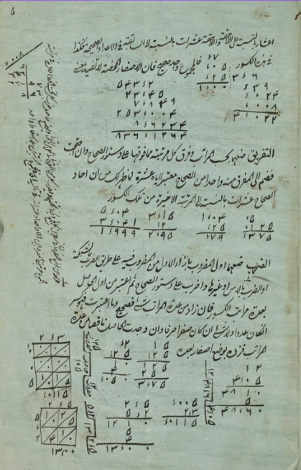
Decimal fractions by Bir Khurdārm Jīlā; Arabic MS 430, f. 5a

Manuscripts discussed- Astronomy and mathematics
Kitāb al-Mutawassiṭāt (كتاب المتوسطات)
[Middle Books]

Compendium of short texts on astronomy and mathematics. It was edited by Naṣīr al-Dīn al-Ṭūsī (d. 1274 CE). Among others, it contains recensions of Euclid’s Phenomena (folios 2a-28a) and Archimedes’ Measurement of the Circle (Taksīr al-dāʾira; folios 120b-125a), and the famous treatise On the Quadrature of the Circle (Fī Tarbīʿ al-dāʾira; folios 125b-130a) composed by the 11th century Abū ʿAlī al-Ḥasan ibn al-Haytham (Alhazen). This copy was produced in the late 18th century.
Arabic MS 381
Sharḥ Taḥrīr al-Majisṭī (شرح تحرير المجسطي)
[Commentary on the al-Ṭūsī’s Taḥrīr al-Majisṭī]

Lemmatic commentary on selected passages from Naṣīr al-Dīn al-Ṭūsī’s (d. 1274 CE) recension of Ptolemy’s Almagest by ʿAbd al-ʿAlī ibn Muḥammad ibn Ḥusayn al-Bīrjandī (16th century). This manuscript was probably copied around the mid-18th century.
Arabic MS 299Arabic MS 299
Al-Kusūr al-aʿshārīya (الكسور الاعشارية)

[Decimal fractions]
A modern short treatise on decimal fractions written in 1855 CE by Barkhūrdār Jīlā, who dedicated it to Major (later Colonel) George William Hamilton. This copy appears to be an autograph, that is, written by the author himself.
Arabic MS 430
References and Further Reading
Berggren, J. (2007). Episodes in the Mathematics of Medieval Islam.
Brentjes, S. (2022). Routledge Handbook on the Sciences in Islamicate Societies: Practices from the 2nd/8th to the 13th/19th Centuries (ed.)
Gutas, D. (1998). Greek Thought, Arabic Culture: The Graeco-Arabic Translation Movement in Baghdad and Early ‘Abbāsid Society (2nd–4th/8th–10th Centuries).
Heath, T. (1921). A History of Greek Mathematics.
Ismail, M. (2016). ‘Algebra in Islamic Mathematics’. In: Encyclopaedia of the History of Science, Technology, and Medicine in Non-Western Cultures, H. Selin (ed.), 207–211.
Morrison, R. (2007). Islam and Science: The Intellectual Career of Niẓām al-Dīn al-Nīsābūrī.
Perho, I. (1995). The Prophet’s Medicine: A Creation of Muslim Traditionalist Scholars.
Pormann P.E., Savage-Smith, E. (2007). Medieval Islamic Medicine.
Pormann, P.E. (ed.). (2010). Islamic Medical and Scientific Tradition. 4 vols.
Rashed R. and Morelon R (1996). Encyclopedia of the History of Arabic Science (ed.)
Sabra, A.I. (1994). ‘The Appropriation and Subsequent Naturalization of Greek Science in Medieval Islam: A Preliminary Statement’. In: Optics, Astronomy and Logic: Studies in Arabic Science and Philosophy, A.I. Sabra (ed.), no. 1 [223–243].
Said, E. (1979). Orientalism.
Saliba, G. (2007). Islamic Science and the Making of the European Renaissance.
Siraisi, N. (1987). Avicenna in Renaissance Italy: The Canon and Medical Teaching in Italian Universities after 1500.
Stolz, D. (2018). The Lighthouse and the Observatory: Islam, Science, and Empire in Late Ottoman Egypt.

Arabic Manuscripts in Manchester Digital Collections

Scan the QR code and explore some of our digitised Arabic manuscripts including mushafs (written copies of the Qurʾan) accompanied with detailed descriptions. This collection will be gradually expanded.

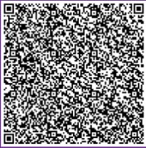
Arabic Manuscripts in Library Digital Collections
Scan the QR code and discover many more of our digitised Arabic manuscripts from religious codices to poetry, science, law, and history.

Anyone can join the Rylands and access the collections for free. To find out more visit:
https://www.library.manchester.ac.uk/rylands/special-collections/using-the-reading-rooms/john-rylands-library/
Researched and compiled by Dr Kamran Karimullah, Lecturer in Islamic Thought at The University of Manchester and Dr Zsófi Buda, Curator of Global Manuscripts at The John Rylands Library. Part of the MACFEST Festival
July 2026

