

Doctoral Academy Updates

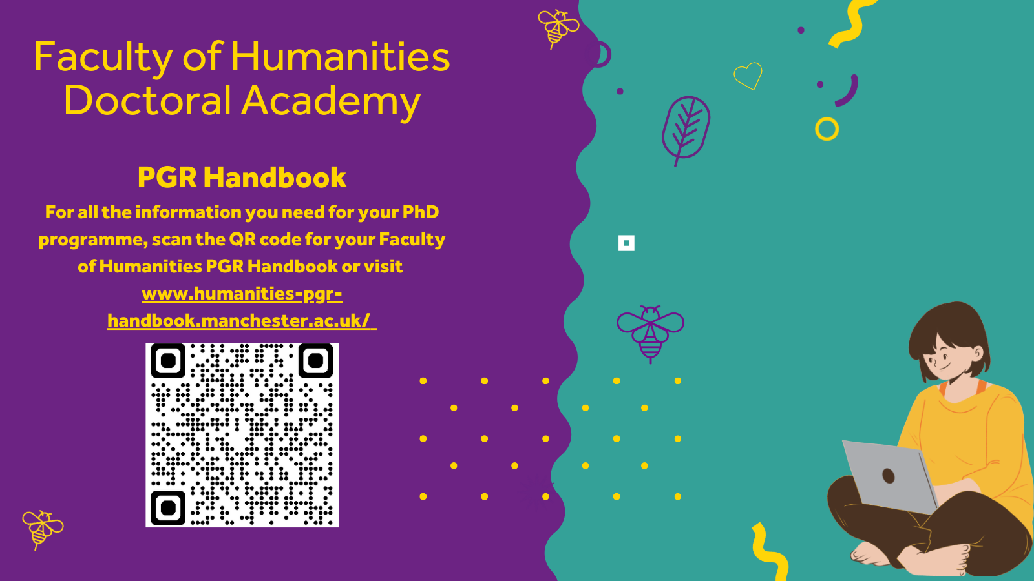

In the June edition of the DA newsletter, you will find a round up of our AMBS and SEED Conferences, details of the Mental Health team's Summer programme, a reminder of how the Student Services Centre can support you and links to the upcoming workshops from the Library.

The Doctoral Academy will be here to support you over the Summer period and you can find details of other support services, and when they will be available over the Summer, here.

If you're graduating next month, make sure you have all the information you need (see below) and many congratulations - you made it!

As always, if you would like to feature anything in the newsletter, please let us know.

The Doctoral Academy Team

Follow us on Bluesky: https://bsky.app/profile/uom-humsdocacad.bsky.social
Join us on LinkedIn: The University of Manchester Faculty of Humanities Doctoral Academy | Groups | LinkedIn
DA Spotify Podcast

Meet the Team: Monique James

  Hi, I’m Monique, PGR Services Manager in the Faculty of Humanities Doctoral Academy.
  I have worked at the University for several years, with much of my experience focused on postgraduate research. Most recently, I spent three years in the Faculty of Science and Engineering as PGR Operations Officer, where I supported progression and welfare activity across the PGR lifecycle.
  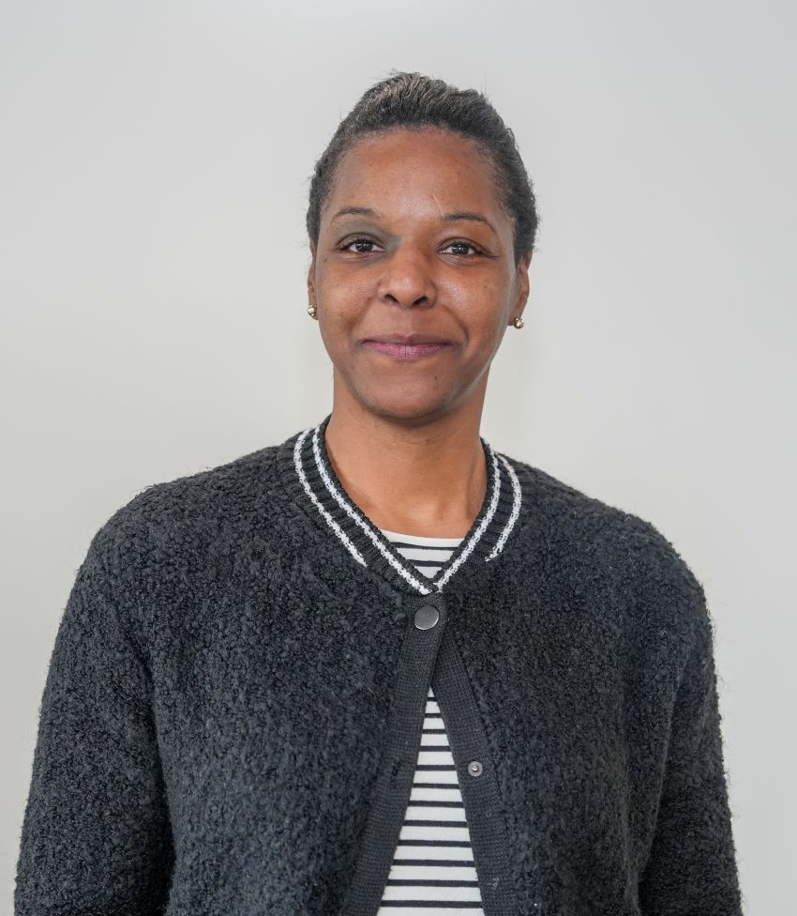

As PGR Services Manager, I contribute to strategic planning and discussions aimed at supporting innovation, strengthening engagement, and delivering meaningful improvements for our PGR community. I work closely with the Associate Dean for Postgraduate Research, Dr Admos Chimhowu, and the School Postgraduate Directors to help drive these priorities.

What I value most is working collaboratively with colleagues to create a shared sense of direction, build strong relationships, and make a positive and lasting contribution to the postgraduate research experience.

Outside of work, I enjoy travelling, being creative at home, and spending time on projects that give me the chance to relax and try something new.

Monique

Manchester Doctoral College Awards Winners!

  Congratulations!
  The Manchester Doctoral College (MDC) have announced their 2026 winners.
  The awards celebrate the outstanding achievements of postgraduate research students (PGRs) and their supervisors. The nominations received reflect the exceptional work, dedication, and innovation from our PGR community.
  

Huge congratulations to our winners in Humanities:

Shashank Nitundil (Geography, SEED)
Best Contribution to Internationalisation
Sunil Thaker (Education, SEED)
Best Contribution to Society – Local Community (individual or team)
Tetyana Solovey (Sociology, SOSS)
Best Contribution to Society – Research Impact (individual or team)
Grace Dutt (EAC, SALC)
Best Outstanding Output
David Gadd (Criminology, SOSS)
Supervisor of the Year

SEED PGR Conference 2026

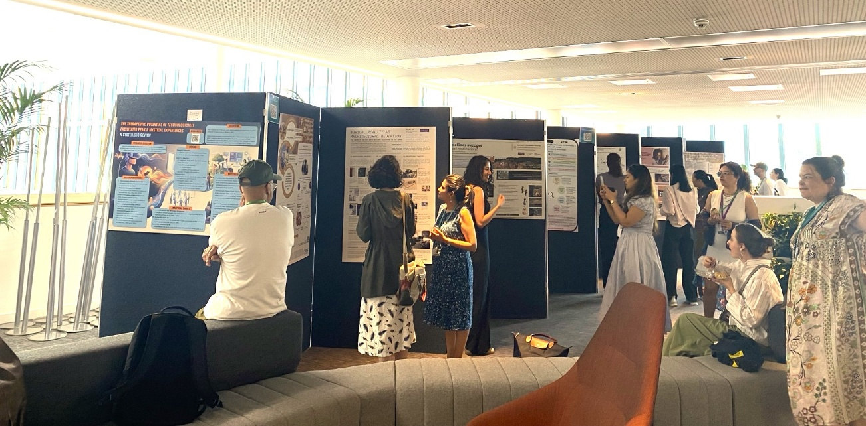

The 2026 SEED conference took place at the end of May with the theme World in Flux: Weaving Interdisciplinary Responses to Global Challenges.

The event explored the reality of confronting global crises that continually evolve, revealing new and shifting dimensions with every attempt to address them. These challenges are not discrete problems to be solved in isolation, but interconnected expressions of geopolitical, economic, technological, and environmental forces in constant interaction.

It was a fantastic chance to hear more about the range of research that the SEED PGR community is producing. The variety of posters and presentations was brilliant, and everyone’s enthusiasm to engage with presenters was wonderful to see.

Saska Petrova set the conference off to a great start with her keynote speech, and the Social Responsibility Panel certainly gave lots of our PGRs some exciting ideas for weaving positive impact into the fabric of our research projects.

  A huge Thank You...
  to Chair Hannah and all the committee members for their hard work and tireless energy over the past few months, as well as to all the academic chairs, panellists, speakers and presenters that joined us on the day.
  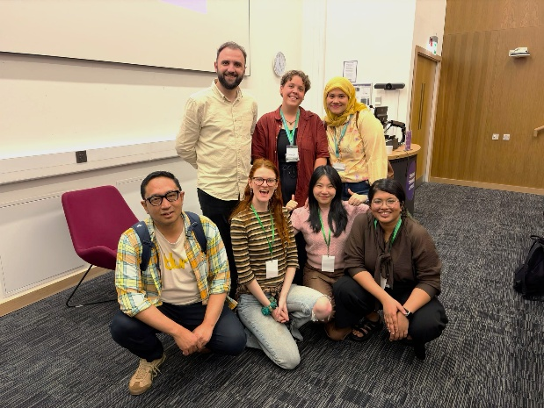

AMBS PGR Conference 2026

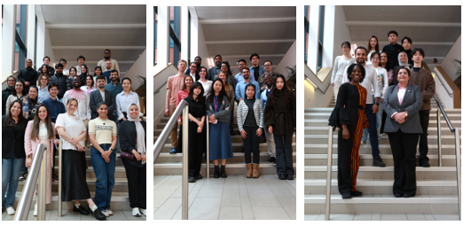

The 2026 AMBS PGR Conference took place early this month with a jam packed schedule. First, second and third years presented their work alongside a keynote speech from our own Dr Ning Gu, divisional talks and a session on early career research from Dr Kara Ng.

Many congratulations to winners Shaokai, Jiaming, Soliman and Fatma (Best Abstracts) and Yuran, Weifeng, Yan, Alkis, Xiangyu, Dzaki, Linyi and Qi (Best Papers)!

Your School Representatives

Following the announcement of the appointment of our new School Representatives, this month we hear from two of them, Lily (School of Arts, Languages and Cultures) and Rashmi (School of Environment, Education and Development).

  Lily Fell (SALC)
  My name is Lily, I am a first-year postgraduate researcher supervised between English Literature and Archaeology.
  My work examines representations of wetlands in Victorian literary and scientific texts, with a specific focus on moorland environments and peat bogs.
  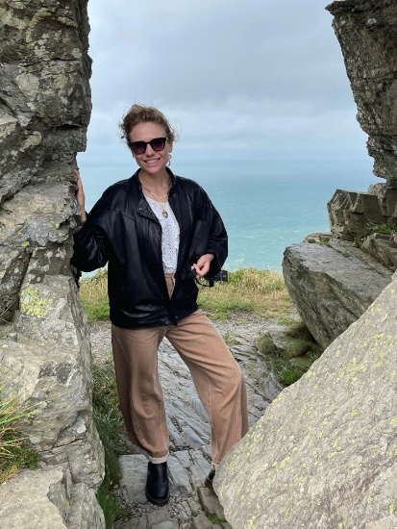

I’m really excited to work as the PGR rep for SALC. I took on this role partly because I previously held a similar position at another university, which I found both enjoyable and rewarding. The experience gave me the opportunity to support and engage with fellow students and I am now looking forward to working closely with fellow PGRs and staff across SALC. Next academic year (26/27), I will be holding some in-person drop-in sessions, providing opportunities for you to share feedback and discuss any queries or concerns you may have. You are also always welcome to reach out via email.

Outside of my research, I enjoy hiking in the Peak District and am currently training to become a moorland navigator, which means most of my weekends are spent outside! Having recently moved to the North West, I’m also enjoying exploring the city of Manchester, with its amazing galleries and museums and its fantastic food culture.

  Rashmi Kundu (SEED)
  Hi everyone, I'm Rashmi. I joined the University last September to start a PhD in SEED, and my research is about air pollution in India, though it ends up being as much about cities and housing as about the air itself.
  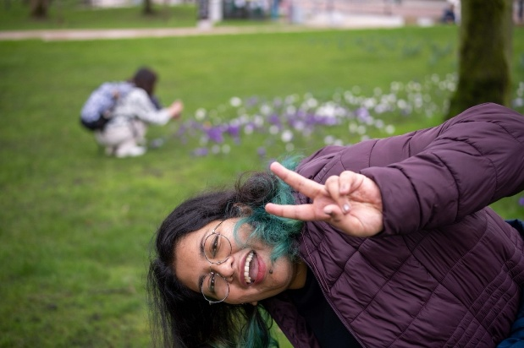

The short version is that I'm trying to work out whether clean air gets paid for. India has spent years trying to bring its pollution down, and I want to know whether any of that effort shows up in the places people choose to live and the prices they pay for them.
What pulls me in, beyond the data, is the question of why good policies so often fail to do what they were meant to. Someone designs a sensible rule, and somewhere between the page and reality, it loses its way, and I find that gap genuinely interesting to sit with.
I also do my best thinking away from a desk. Being from a tropical country, I'm forever chasing the sun, so on a good day you might find me snoozing under a tree with a book over my face.
As your SEED rep, my job is to make sure PhD researchers in the school have a say in the things that shape our time here, from supervision to training to the ordinary business of getting through a doctorate. Mostly I want to be easy to talk to. If something is going wrong, tell me and I'll carry it to the people who can do something about it. And if something is working, that's worth knowing too. Do say hello if we cross paths.

Graduation July 2026

  Class of 2026 - Get Ready for Graduation!
  Your graduation ceremony is the final milestone on your Manchester PhD journey and a chance to look back and celebrate all that you've achieved throughout your time here.
  Key Dates and Deadlines
  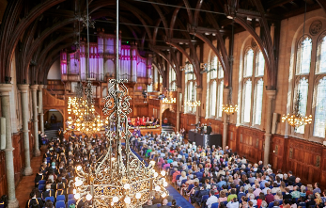

Summer ceremonies will take place in Whitworth Hall from Monday, 13 July to Monday, 27 July 2026. View the schedule of ceremonies and find out more.

You can also find details here on getting ready for graduation along with what will happen on day and FAQs.

Counselling and Mental Health Summer Programme

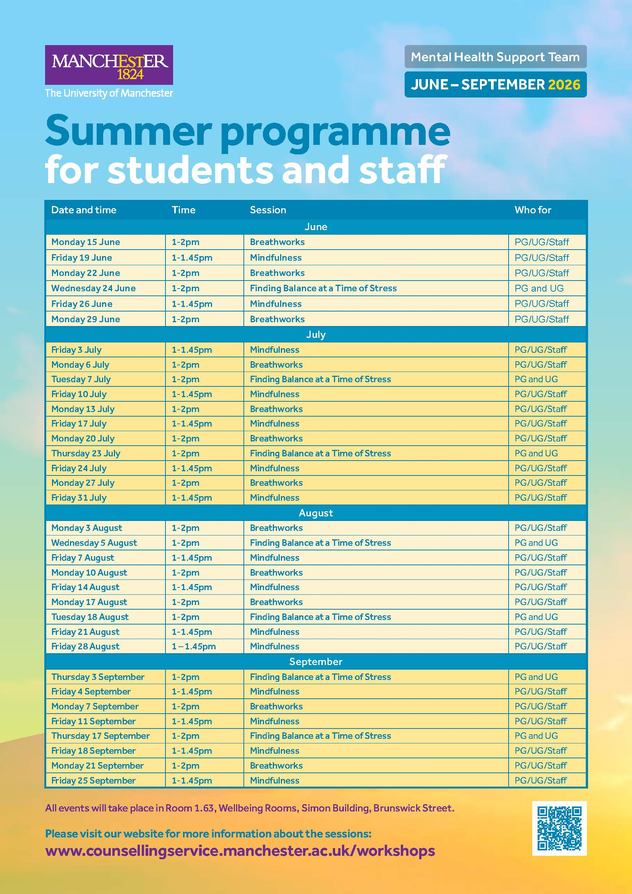

The Mental Health Support Team have now released their Summer programme.

Please see above for the full schedule and visit their website (or scan the QR code) for all the details and to book your place.

Mental Health Support Team: New Website and Self-referral form Launch

The Mental Health Support Team have now launched a new website and self-referral form. The new website will provide the same information as before, but in a clearer format to make it easier for students and staff to navigate.

They are also introducing a new self-referral form to make it easier for students to access the service. There will be a link to the new form with clear instructions on how to fill it in available on the new home page. Following student feedback, the new system will allow a longer time window for self-referral, including overnight, and means students will not need to call the service themselves and repeat their story to different staff.

The new self-referral form will be available on the new website during the following times:
- Open from Monday at 9:00 a.m. until Wednesday at 5:00 p.m. (so open overnight Mondays and Tuesdays)
- Closed on Thursdays and Fridays while the team carry out triage and allocate appointments.

For further details, please visit their webpage.

Student Services Centre Support

A reminder of what colleagues in the Student Services Centre can support you with:

Official letters
The DA Support Hub does not produce central/official letters, such as Confirmation of Registration or bank letters. If you need to request an official letter or document, please contact the SSC via their online Student Enquiry Form, or telephone (0161 275 5000) for urgent or emergency requests, where you will need to provide evidence explaining why the request is urgent.

Transcripts and Certificates

Any email enquiries relating to official documents, including transcripts or certificates, should be sent directly to the Student Administration Team (ssc@manchester.ac.uk).

Updates from the Library

Library Training and Support for PGRs
The Library's researcher training programme continues this Spring with a series of workshops aimed to support researchers at all stages of their research career and our online guides, which can be accessed any time.

Upcoming Workshops
Shut up and write (on campus):
Tuesday 7 July 2026, 14:00 - 16:00
Wednesday 12 August 2026, 14:00 - 16:00
Tuesday 1 September 2026, 14:00 - 16:00

Shut up and write (online):
Thursday 23 July 2026, 10:00 - 12:00
Thursday 20 August 2026, 14:00 - 16:00

Sharing research with confidence: developing your public speaking skills (on campus)
Wednesday 29 July 2026, 14:00 - 15:30

MRE Writing Retreat
Friday 17 July 2026, 09:00 - 17:00

Reference management with EndNote desktop for researchers (on campus)
Tuesday 28 July 2026, 10:00 - 11:30

University News
Researcher Development
Counselling Services
Research IT
PGR News

The University Of Manchester, Faculty of Humanities, Doctoral Academy
Contact Us | Tel: +44 (0) 161 306 6000 | Web: www.manchester.ac.uk
Registered Office: The University of Manchester, Oxford Rd, Manchester, M13 9PL. Royal Charter Number: RC000797

To opt out of future communications click here

