

‘CDT/DTP’ program administration set up in Campus Solutions

Research Degrees and Researcher development / Student System Office
June 2023
- How to use this guide 2
- CDT Programme set up scenarios 3
- SCENARIO 1 and 2: Guidance on managing a cohort of students with a standard programme set up 4
b. Split ownership with the Campus Solutions Virtual Organisation** 5
- SCENARIO 3: Students registered on both a 4 year PhD programme and a PGDip for the full 4 years 6
- SCENARIO 4: Student with a 6, 9 or 12 month taught PGDip/PGCert in their 1st year of study and transfer to PhD 8
- SCENARIO 5: Collaborative programme where the student is registered at another institution on a research program and is registered at University of Manchester as a Visiting Research Student 14
- SCENARIO 6: Students are on a collaborative programme with another institution and are registered at University of Manchester on a PGDip/PGCert (normally for 6, 9 or12 months). They then move onto a 3.5, 3.3 or 3 year PhD program her 6 months, 9 months or 12 months submission pending (the period of the PhD program must not be longer than 4 years). Students are not awarded the PGDip/PGCert at the end of the program 17
- Awards 18
- Reporting 19
- Fees 19
- eProg 19
Appendix 1 – Glossary of terms 20
Appendix 2 - How to add a Virtual Organisation (VO) 21

How to use this guide
  - This guide is for PGR administrators who have responsibility for a programme where students are funded through a Centre for Doctoral training (CDT), Doctoral Training Partnership (DTP) or Doctoral Training Centre (DTC). For the purpose of this guide all these arrangements will be referred to as ‘CDT’. The cohort of students are normally registered either within one Faculty/School or students register in different Schools but belong to a CDT cohort. Further information can be found at the following link: http://www.manchester.ac.uk/study/postgraduate-research/why-manchester/doctoral-college/doctoral- training/

  - A group of CDT students (cohort) registered on a programme of study will be administered through one of the scenarios listed below and PGR administrators should have an understanding of the specific requirements of the programme structure they administer before they start to use this guide. Local guidance should be sought on how a specific programme is managed before consulting this guide.

  - The following guidance is for PGR administrators who are managing the administration of a CDT as either the main Doctoral Academy contact for the programme or as the secondary PGR administrator who has one or more of the CDT students in their own Doctoral Academy.

  - For further guidance on how your programme will be administered please contact your Faculty Doctoral Academy.

  - PGR Administrators will require PGR Admin access in Campus Solutions and eProg to be able to make the changes/updates detailed in this guidance. See Appendix 1 for details on the PGR Administrators roles required for maintaining CDT student records.

  - A glossary of terms can be found in Appendix 1 of this document.

CDT Programme set up scenarios

The structure of a CDT programme is normally determined by the funder and should fall into one of the following scenarios.

SCENARIO 1: Students are registered at Manchester on a 3 year PhD programme with 12 months submission pending period or 3.5 year PhD program with 6 months submission pending. There is no taught element as part of the programme.

SCENARIO 2: Students are registered at Manchester on a 4 year PhD programme (including a taught element) with no submission pending period.

SCENARIO 3: Students are registered at Manchester on a 4 year PhD (or EngD) and a PGDip for all 4 years with no submission pending period and are awarded both the PhD and the PGDip at the end of the 4 years (this mainly applies to the EngD). The PGDip is undertaken through separate assessment to the research project.

SCENARIO 4: Students are registered at Manchester on a PGDip/PGCert (normally for 6, 9 or 12 months) to cover the taught element of the programme. They then move onto a 3.5, 3.3 or 3 year PhD programme respectively. They are then entitled to apply for either 6 months, 9 months or 12 months submission pending (the period of the PhD programme plus writing up must not exceed 4 years). Students are not awarded the PGDip/PGCert at the end of the programme but can be awarded as an exit award). NB. The set up process for programmes that include a standalone period of taught units must be approved by the MDC committee, the Research Council and must be set up on Campus Solutions as per the instructions set out in this guide.

SCENARIO 5: Students are on a 3 or 4 year collaborative programme with another institution and are formally registered at the external institution. They will also be registered from the beginning of their collaborative programme as a visiting Research student at the University of Manchester.

SCENARIO 6: Students are on a collaborative programme with another institution and are registered at University of Manchester on a PGDip/PGCert (normally for 6, 9 or12 months). They then move onto a 3.5, 3.3 or 3 year PhD program with 6 months, 9 months or 12 months submission pending (the period of the PhD programme must not exceed 4 years). Students are not awarded the PGDip/PGCert at the end of the programme.

SCENARIO 1 and 2: Guidance on managing a cohort of students with a standard programme set up

SCENARIO 1: Students are registered at Manchester on a 3 year PhD programme with 12 months submission pending period or 3.5 year PhD program with 6 months submission pending.
SCENARIO 2: Students are registered at Manchester on a 4 year PhD programme (including a taught element) with no submission pending period.

  - For both scenario 1 and 2 where the cohort of students are registered solely in one Faculty/School
    - Students on a CDT programme where the cohort of students are registered solely in one Doctoral Academy and which fall into Scenario 1 or 2 should be set up as a standard PhD programme specific programme/plan code for the cohort.
Students are administered through the standard PGR process of the Faculty/School the only difference being that the plan has a split ownership between the Faculty/School and the Virtual Organisation (VO)**.
    - Students in scenario 1 can apply for Submission pending but those students in scenario 2 cannot as they are registered on a 4 year programme.

    - Create a prog/plan in Campus Solutions

      - Create the Campus Solutions Programme/Plan and apply ownership to the host organisation ie: the Faculty/ School which has overall responsibility for the administration of the CDT
The Campus Solutions programme and plan must be created for the School/Faculty which has overall responsibility for the CDT program. Details on how to set up a program/plan in Campus Solutions can be found at the following link: Academic Program/Plan Table.
      - Split ownership with the Campus Solutions Virtual Organisation (see appendix 2)
When creating the program/plan in Campus Solutions, for each program/plan one Faculty/School (organisation) will need to be set up as the primary ‘owner’. This can be a School, Faculty, or business unit, but is normally the School/Faculty to which the administrator of the programme belongs.
The ownership of the plan must then be split between the Faculty/School ‘owner’ and the relevant Virtual Organisation (VO).
Details on how to split the ownership of a program/plan can be found in Appendix 2 of this guide.
NB: It is very important that it is only the ownership of the plan which has split ownership between the relevant school and virtual organisation. The programme must not have split ownership with a virtual organisation as the ownership of the programme dictates the flow of finance.

  - Scenario 1 or 2 where the cohort of students register in 2 or more School/Faculties

    - Create a prog/plan in Campus Solutions

      - Create the Campus Solutions Program/plan and apply ownership to the host organisation ie: the Faculty/ School which has overall responsibility for the administration of the CDT
The Campus Solutions programme/plan must be created for the School/Faculty which has overall responsibility for the CDT programme. Details on how to set up a programme/plan in Campus Solutions can be found at the following link: Academic Program/Plan Table

Split ownership with the Campus Solutions Virtual Organisation
When creating the programme/plan in Campus Solutions, for each program/plan one Faculty/School (organisation) will need to be set up as the primary ‘owner’. This can be a school, Faculty, or business unit, but is normally the School/Faculty to which the administrator of the programme belongs.
The ownership of the plan must then be split between the Faculty/School ‘owner’ and the Virtual Organisation (VO).
Details on how to split the ownership of a program/plan can be found in Appendix 2 of this guide.

NB: It is very important that it is only the ownership of the plan which has split ownership between the relevant school and virtual organisation. The programme must not have split ownership with a virtual organisation as the ownership of the program programme es the flow of finance.

    - Create a mirrored program/plan for each Faculty/School (organisation) which is hosting one of the students within the programme cohort

      - Create a mirrored programme/plan
For each School/Faculty which has a student on the CDT programme, a ‘mirrored’ programme/plan must be created in that School/Faculty where the student will be registered (i.e. not the ‘host’ School/Faculty). A ‘mirrored’ program/plan will be created in the same way that a program/plan is set up in Campus Solutions by using the Academic Program/plan set up guidance: Academic Program/Plan Table.

      - Split ownership with the Campus Solutions Virtual Organisation**
For each mirrored program/plan one Faculty/School (organisation) will need to be set up as the primary ‘owner’. This can be a school, Faculty, or business unit, but is normally the School/Faculty to which the administrator of the programme belongs. The plan ownership must then be split between the owning School/Faculty/Business unit and the appropriate Virtual Organisation**.

      - The only students registered on the School/Faculty mirrored program/plan should be students who are on the specific CDT programme; there should not be any students on this programme/plan who are on standard programmes run within the school. This will allow administrators to identify all students who are registered as a CDT student.

    - Check the PGR administrator who has overall responsibility for the CDT has the correct role access for the programme/plan in Campus Solutions (ie: the PGR administrator should have PGDR access assigned to the Virtual organisation for that interdisciplinary programme as well as PGDR access for their own Faculty/School organisation)

      - A PGR administrator who manages a whole cohort of interdisciplinary students must have PGDR access to both the Faculty/School organisation the interdisciplinary programme belongs to and the virtual organisation (VO)** in Campus Solutions.
      - PGR Directors for the interdisciplinary programme will need to have PGDR Director access to the virtual organisation if they wish to view all the student records on the interdisciplinary program programme. If PGR Directors need to be able to view all students who are in their own School they will need to be assigned PGDR Director access for that school.
      - Administrators who require access to the relevant Virtual Organisation need to contact the SSO helpdesk who can set them up with access: cs.records@manchester.ac.uk

SCENARIO 3: Students registered on both a 4 year PhD programme and a PGDip for the full 4 years
- Students must be registered on both the PhD programme and the PGDip from the same start of the program.
- Where the PGDip is awarded at the end of the 4 years the Programme will need to be retrospectively completed in Campus Solutions. The programme will remain active throughout the students programmme.
- Students are not allowed to apply for submission pending as they are on a 4 year program.

  - SCENARIO 3 where the cohort of students is held solely in one School/Faculty

    - Create a prog/plan for the PGDip/PGCert part of the programme (the taught element)

      - Create the Campus Solutions Program/plan for the taught programme owned by the ‘host’ organisation
The Campus Solutions programme/plan must be ‘owned’ by the School/Faculty which has overall responsibility for the CDT programme. Details on how to set up a programme/plan in Campus Solutions can be found at the following link Academic Program/Plan Table.
      - Split ownership with the Campus Solutions Virtual Organisation
When creating the programme/plan in Campus Solutions, for each programme/plan one Faculty/School (organisation) will need to be set up as the primary ‘owner’. This can be a school, Faculty, or business unit, but is normally the School/Faculty to which the administrator of the programme belongs.
The ownership of the plan will then be split between the ‘owner’ and the Virtual Organisation (VO). Details on how to split the ownership of a programme/plan can be found in Appendix 2 of this guide.
      - The PGDip/PGCert part of the programme should be set up with the ‘expected length of study’ field, (in the HESA tab of the programme in the plan table), having the full length of the entire program (i.e. 4yr programme )

    - Create a prog/plan for the research element of the program

      - Create the Campus Solutions Programme/plan for the PhD programme
The Campus Solutions programme/plan must be ‘owned’ by the School/Faculty which has overall responsibility for the CDT programme. Details on how to set up a programme/plan in Campus Solutions can be found at the following link: Academic Program/Plan Table.
      - Split ownership with the Campus Solutions Virtual Organisation
When creating the programme/plan in Campus Solutions, for each programme/plan one Faculty/School (organisation) will need to be set up as the primary ‘owner’. This can be a school, Faculty, or business unit, but is normally the School/Faculty to which the administrator of the programme belongs.
The ownership of the plan will then be split between the ‘owner’ and the Virtual Organisation (VO). Details on how to split the ownership of a programme/plan can be found in Appendix 2 of this guide.

    - The student must register on both the taught element and research element of the programme.

  - Scenario 3 where the cohort of students is managed in more than one School/Faculty

    - Create a mirrored program/plan for each Faculty/School (organisation) which is hosting one of the students within the programme cohort

      - Create the Campus Solutions Programme/plan for the taught programme owned by the ‘host’ organisation
The Campus Solutions programme/plan must be ‘owned’ by the School/Faculty which has overall

responsibility for the CDT programme. Details on how to set up a programme/plan in Campus Solutions can be found at the following link: Academic Program/Plan Table.
      - Split ownership with the Campus Solutions Virtual Organisation
When creating the programme/plan in Campus Solutions, for each programme/plan one Faculty/School (organisation) will need to be set up as the primary ‘owner’. This can be a school, Faculty, or business unit, but is normally the School/Faculty to which the administrator of the programme belongs.
The ownership of the plan will then be split between the ‘owner’ and the Virtual Organisation (VO). Details on how to split the ownership of a programme/plan can be found in Appendix 2 of this guide.
      - The PGDip/PGCert part of the programme should be set up with the ‘expected length of study’ field, (in the HESA tab of the program programme in plan table), having the full length of the entire programme (i.e. 4yr programme)

    - Create a prog/plan for the research element of the programme

      - Create the Campus Solutions Program/plan for the PhD programme
The Campus Solutions programme/plan must be ‘owned’ by the School/Faculty which has overall responsibility for the CDT programme. Details on how to set up a programme/plan in Campus Solutions can be found at the following link: Academic Program/Plan Table.
      - Split ownership with the Campus Solutions Virtual Organisation
When creating the programme/plan in Campus Solutions, for each programme/plan one Faculty/School (organisation) will need to be set up as the primary ‘owner’. This can be a school, Faculty, or business unit, but is normally the School/Faculty to which the administrator of the programme belongs.

    - Check the PGR administrator who has overall responsibility for the CDT has the correct role access for the programme/plan in Campus Solutions (ie: the PGR administrator should have PGDR access assigned to the Virtual organisation for that interdisciplinary programme as well as PGDR access for their own Faculty/School organisation)

      - A PGR administrator who manages a whole cohort of interdisciplinary students must have PGDR access to both the Faculty/School organisation the interdisciplinary programme belongs to and the virtual organisation (VO)** in Campus Solutions.
      - PGR Directors for the interdisciplinary programme will need to have PGDR Director access to the virtual organisation if they wish to view all the student records on the interdisciplinary program programme. If PGR Directors need to be able to view all students who are in their own School they will also need to be assigned PGDR Director access for that school.
      - Administrators who require access to the relevant Virtual Organisation need to contact the SSO helpdesk who can set them up with access: cs.records@manchester.ac.uk

SCENARIO 4: Student with a 6, 9 or 12 month taught PGDip/PGCert in their 1st year of study and transfer to PhD

- Students are registered on a PGDip/PGCert in their 1st year, discontinued in Campus Solutions after the appropriate period and then registered on a PhD programme after 6, 9 or 12 months.
- Students apply as a standard PGDR student, usually for a 4 year programme, and are then moved onto the CDT PGDip programme code in Campus Solutions prior to registration.
- Where there is standalone taught component in the first 6, 9 or 12 months, the programme should be set up in such a way that the students end the PGDip/PGCert program programme to commence the PhD program. This will then enable the student to be registered on the research component for the necessary length of time on the PhD and will then permit them to apply for a further submission pending period if required.
- Students may be registered on the taught element of the programme at either Faculty or School level.
- The student will apply for a 4 year research programme. Before registration the student is moved onto a PGDip programme specific to the CDT. The student is unaware of this change and considers themselves on a 4 year PhD programme (however, if the student uses eProg for the taught element the name of the taught programme will appear in their profile page).

  - Set up the PGDip/PGCert programme/plan in Campus Solutions
    - Create the Campus Solutions Program/plan for the taught programme
The Campus Solutions programme/plan must be created in the School/Faculty which has overall responsibility for the CDT programme. Details on how to set up a programme/plan in Campus Solutions can be found at the following link: Academic Program/Plan Table.
      - Set up the taught version of the programme so it is called a PGDip/PGCert.
      - Leave the academic level rule and calendar as PGDT and leave the career as PGDR. The course aim should be D00.
      - Flag the programme as ‘non-award bearing’ where appropriate.¹ Normally the taught element of the programme returned to HESA as award bearing.
      - The PGDip/PGCert part of the programme should be set up with the ‘expected length of study’ field, (in the HESA tab of the programme in the plan table), having the full length of the entire program (i.e. 4yr programme)

    - Split ownership with the Campus Solutions Virtual Organisation
When creating the programme/plan in Campus Solutions, for each programme/plan one Faculty/School (organisation) will need to be set up as the primary ‘owner’. This can be a school, Faculty, or business unit, but is normally the School/Faculty to which the administrator of the programme belongs.
The ownership of the plan must then be split between the Faculty/School ‘owner’ and the Virtual Organisation (VO).
Details on how to split the ownership of a plan can be found in Appendix 2 of this guide.

  - Create a prog/plan for the research element of the programme.

    - Create the Campus Solutions Programme/plan for the PhD programme in the ‘Host’ Faculty/School The Campus Solutions programme/plan must be created in the School/Faculty which has overall responsibility for the CDT programme. Details on how to set up a programme/plan in Campus Solutions can be found at the following link: Academic Program/Plan Table.
The programme should be set up with the ‘expected length of study’ field, (in the HESA tab of the programme in the plan table), having the full length of the entire program.
    - Split ownership with the Campus Solutions Virtual Organisation

¹ PGDip/PGCerts are returned as PGR to HESA unless they are awarded in which case they are returned as PGT

When creating the programme/plan in Campus Solutions, for each programme/plan one Faculty/School (organisation) will need to be set up as the primary ‘owner’. This can be a school, Faculty, or business unit, but is normally the School/Faculty to which the administrator of the programme belongs.
The ownership of the plan must then be split between the Faculty/School ‘owner’ and the Virtual Organisation (VO).
Details on how to split the ownership of a programme/plan can be found in Appendix 2 of this guide.

  - Create a mirrored programme/plan in Campus Solutions
    - For each School/Faculty outside of the host School/Faculty which has a student on the CDT programme, a ‘mirrored’ program/plan must be created in that School/Faculty where the student will be registered (i.e. not the ‘host’ School/Faculty). A ‘mirrored’ programme/plan will be created in the same way that a programme/plan is set up in Campus Solutions by using the Academic Programme/plan set up guidance: Academic Program/Plan Table.
    - Split ownership with the Campus Solutions Virtual Organisation**
For each programme/plan one Faculty/School (organisation) will need to be set up as the primary ‘owner’. This can be a school, Faculty, or business unit, but is normally the School/Faculty to which the administrator of the programme belongs. The plan ownership must then be split between the owning School/Faculty/Business unit and the appropriate Virtual Organisation**.

The only students registered on the School/Faculty mirrored programme/plan should be students who are on the specific CDT programme; there should not be any students on this programme/plan who are on standard programmes run within the school. This will allow administrators to identify all students who are registered as a CDT student.

  - Check the PGR administrator who has overall responsibility for the CDT has
the correct role access for the programme/plan in Campus Solutions (ie: the PGR administrator should have PGDR access assigned to the Virtual organisation for that interdisciplinary programme as well as PGDR access for their own organisation)
    - A PGR administrator who manages a whole cohort of interdisciplinary students must have PGDR access to both the organisation the interdisciplinary programme belongs to and the virtual organisation (VO)** in Campus Solutions.
    - PGR Directors for the interdisciplinary programme will need to have PGDR Director access to the virtual organisation if they wish to view all the student records on the interdisciplinary programme. If PGR Directors need to be able to view all students who are in their own School they will also need to be assigned PGDR Director access for that school.
    - Administrators who require access to the relevant Virtual Organisation need to contact the SSO helpdesk who can set them up with access: cs.records@manchester.ac.uk

When the student has completed the taught element of the programme (after either 6, 9 or 12 months) move the student from the taught programme to a research programme in Campus Solutions.
If the student is moving from the PGDip/PGCert section of the programme based in Manchester to the Research section of the programme in Manchester, following successful completion of their taught component they would have a Discontinuation row added in the CS taught programme and they then register on to the relevant research section of the research programme (or mirrored programme where appropriate). PGR administrators should make the following updates to the student record in Campus Solutions when moving the student into their research part of the programme.

    - For students who discontinue the PGDip/PGCert and move to the PhD at 6 or 9 months

      - Discontinue the PGDip/PGCert PGDR programme in Campus Solutions using DISC/PRGC (Discontinuation/Program Programme in Student Program/Plan.
Navigation: Records and Enrollment > Career and Programme Information > Student Program/Plan


The discontinuation process is covered in the How to Discontinue a Student who is changing programmes and not carrying credits guide.

      - Create a NEW PGR record with an incremented career number in Student Program/Plan
attaching the student to the PGR research programme.

This process known as ‘Quick Admitting an Existing Student’ is covered in the How to Discontinue a Student who is changing a programme and not carrying credits guide.

      - Student’s discontinuing on one of the 6 or 9 month taught programmes will already be term activated for the current academic term for the PGDR career.

Navigation: Records and Enrollment > Student Term Information > Term Activate a Student

To ensure that the term activation is referencing the correct programme of study/career number, you will need to manually update the career number within the current term activation by overtyping the previous career number with the NEW incremented career number.

Term activations are applicable for a 12 month period. Students can only be term activated once for each academic career within an academic term. Where a student is on a 6 or 9 month PGDip/PGCert the admit term should not be altered.

        - Update the students ‘Start Date of Programme’ ONLY in registration details data by adding a new row in the ‘Registration Details’ screen. (NB: If you don’t do this the student could appear in the incorrect eprog cohort or in the incorrect cohort for the submissions/completions reports in the data cube)

Navigation: Records and Enrollment > Career and Programme Information > Registration Details
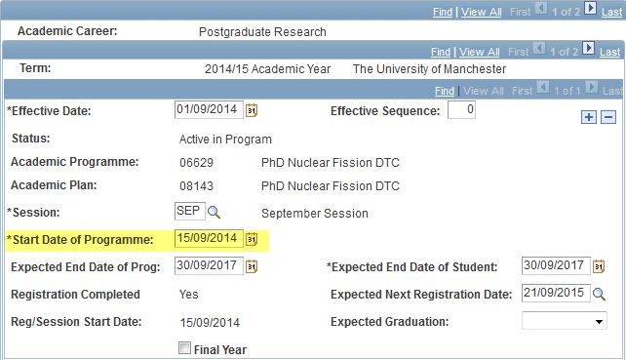

        - ‘Session’ remains unchanged.

        - Amend ‘Start Date of Program’ to;

          - 1st April for 6 month programs.

          - 1st July for 9 month programs.

        - ‘Expected End Date of Prog’ remains unchanged (check this date to ensure it states the correct date).

        - ‘Expected End date of Student’ remains unchanged (check this date to ensure it states the correct date).

        - ‘Expected Next Registration Date’ remains unchanged.

- Students will not need to re-register until their registration session anniversary is met (i.e. September).

- Contact the fees team to manually correct the fee (the fee should not be re-calculated). Contact: tuitionfees@manchester.ac.uk
Fees for the student will need to be re-calculated where a student takes a 6-9 month PGDip/PGCert as follows:
  - The student pays a full 12 month fee at the start of the program
  - After 6 or 9 months the fee is removed and a new 12 month fee amount is applied for the research element
  - The Faculty/School where the PGDip/PGCert is held can claim back the 6 or 9 month fee
  - The final registration for a 6/9 month PGDip/PGCert will require an amended fee amount
  - PGR Administrators should contact the fees team to ensure the correct fee is attached to the account:tuition.fees@manchester.ac.uk

    - For students who discontinue the PGDip/PGCert and move to the PhD at 12 months

Discontinue the PGDip/PGCert PGDR programme in Campus Solutions using DISC/PRGC (Discontinuation/Program Programme in Student Program/Plan.

Navigation: Records and Enrollment > Career and Programme Information > Student Program/Plan

The discontinuation process is covered in this guidance How to Discontinue a Student who is changing programme and not carrying credits.

      - Create a NEW PGR record with an incremented career number in Student Program/Plan
attaching the student to the PGR program.
- Admit term increments (for example if student was 1141 for the PGDR taught element, they would be 1151 for the PGDR research element).

This process known as ‘Quick Admitting an Existing Student’ is covered in this guidance: Missing Student Data

      - Student’s discontinuing on one of the 12 months CDT PGR taught programs, will need to be manually term activated for the new academic term against the new PGDR career numbered programme created in step 2 in Term Activate a Student.

Navigation: Records and Enrollment > Student Term Information > Term Activate a Student

- This term activation should be correctly against the newly incremented career number by default as this should be the only active PGDR record.

The manual term activation process is covered in this guidance: Term Activate a Student.

      - Student’s registration details data remains unchanged.

      - Student re-registers as normal.

      - Contact the fees team to manually correct the fee (the fee should not be re-calculated). tuitionfees@manchester.ac.uk

    - Academic programme set up for the research element

The screen shot below shows the set up for the research element. For the taught section of the programme, the same set up is used but with a PGDT academic level rule.

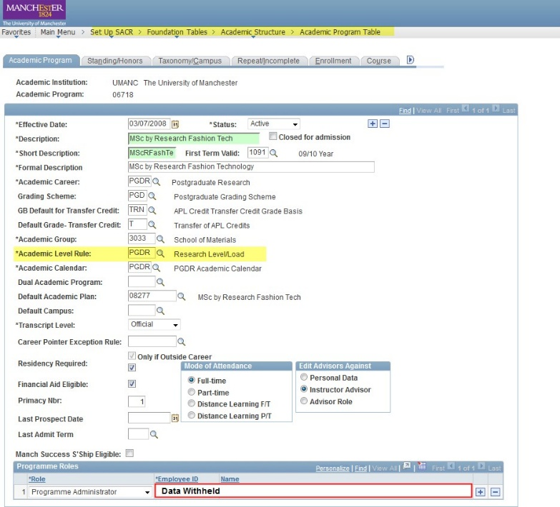

SCENARIO 5: Collaborative programme where the student is registered at another institution on a research programme and is registered at University of Manchester as a Visiting Research Student
NB: administrators should refer to the Visiting Research Student policy for further guidance on how to administer Visiting Research Students

- Those students primarily registered at a collaborating institution should be registered at Manchester as a Visiting Research Student for the duration of the program. This will be the only way to provide them with a library card and the appropriate access to facilities.

- The PGR should be manually added to Campus Solutions using the guidance set out in the Non-Standard applications and File Parser chapter of the Centrally Managed Processes guide. Please note that this is a change in process compared to the Quick Admit guidance which is no longer in use.

  - Create a Visiting Research Student programme/plan for the CDT cohort primarily registered at the other institution.
Details on how to set up a programme/plan in Campus Solutions can be found at the following link: Academic Program/Plan Table.
The student will remain on this programme/plan unless they decide to move between institutions.

  - Moving a student from another institution to Manchester while on a collaborative program
If the student is moving from the research section of the programme based in another institution to the Research section of the programme in Manchester the student would be moved from the Visiting Research Student program at UoM to a programme for the appropriate research program/plan at UoM.

The following steps will need to be completed if the CDT programme/plan has not already been created in Campus Solutions.

  - Where the cohort of students is held solely in one School and the student transfers from another institution to Manchester

    - Create a prog/plan

      - Create a programme/plan in the host organisation ie: the Faculty/ School which has overall responsibility for the administration of the CDT
The Campus Solutions programme and plan for the programme is created in the School/Faculty which has overall responsibility for the CDT. Details on how to set up a programme/plan in Campus Solutions can be found at the following link: Academic Program/Plan Table.
      - Split ownership with the Campus Solutions Virtual Organisation (see appendix 1)
For each programme/plan one Faculty/School (organisation) will need to be set up as the primary ‘owner’. This can be a school, Faculty, or business unit, but is normally the School/Faculty to which the administrator of the programme belongs.
Details on how to split the ownership of a plan can be found in section xx of this guide.

    - Move the student from the Visiting Research Student (VRS) programme and move them to the CDT program programme in Campus Solutions.

      - Administrators should ‘discontinue’ the VRS programme in Campus Solutions
      - Add the student to the PhD programme with an incremented Career Number.
      - Term activate the student on the research programme
      - Admit the student onto the research programme
      - Update the registration details screen with the new start/end dates

  - Scenario 5 where the cohort of students are registered in 2 or more different School/Faculties and the student transfers from another institution to Manchester (see appendix x):

    - Create a prog/plan in the host organisation ie: the Faculty/ School which has overall responsibility for the administration of the CDT

      - Create the Campus Solutions Programme/plan
The Campus Solutions programme/plan must be created in the School/Faculty which has overall responsibility for the CDT programme. Details on how to set up a programme/plan in Campus Solutions can be found at the following link: Academic Program/Plan Table.
      - Split ownership with the Campus Solutions Virtual Organisation
When creating the programme/plan in Campus Solutions, for each programme/plan one Faculty/School (organisation) will need to be set up as the primary ‘owner’. This can be a school, Faculty, or business unit, but is normally the School/Faculty to which the administrator of the programme belongs.
The ownership of the plan must then be split between the ‘owner’ and the Virtual Organisation (VO). Details on how to split the ownership of a programme/plan can be found in Appendix 2 of this guide.

    - Create a mirrored programme/plan

      - Create a mirrored programme/plan for each Faculty/School (organisation) which is hosting one of the students within the programme cohort
For each School/Faculty which has a student on the CDT programme, a ‘mirrored’ programme/plan must be created in that School/Faculty where the student will be registered (i.e. not the ‘host’ School/Faculty). A ‘mirrored’ programme/plan will be created in the same way that a programme/plan is set up in Campus Solutions by using the Academic Programme/plan set up guidance: Academic Program/Plan Table.
      - Split ownership with the Campus Solutions Virtual Organisation**
For each programme/plan one Faculty/School (organisation) will need to be set up as the primary ‘owner’. This can be a school, Faculty, or business unit, but is normally the School/Faculty to which the administrator of the programme belongs. The plan ownership must then be split between the owning School/Faculty/Business unit and the appropriate Virtual Organisation**.

The only students registered on the School/Faculty mirrored programme/plan should be students who are on the specific interdisciplinary/CDT programme; there should not be any students on this programme/plan who are on standard programmes run within the school. This will allow administrators to identify all students who are registered as a CDT student.

    - Check the PGR administrator who has overall responsibility for the DTC/DTP/CDT has the correct role access for the programme/plan in Campus Solutions (ie: the PGR administrator should have PGDR access assigned to the Virtual organisation for that interdisciplinary programme as well as PGDR access for their own organisation)
      - A PGR administrator who manages a whole cohort of interdisciplinary students must have PGDR access to both the organisation the interdisciplinary programme and plan belongs to and the virtual organisation (VO)** in Campus Solutions.
      - PGR Directors for the interdisciplinary programme will need to have PGDR Director access to the virtual organisation if they wish to view all the student records on the interdisciplinary programme. If PGR Directors need to be able to view all students who are in their own School they will also need to be assigned PGDR Director access for that schools.
      - Administrators who require access to the relevant Virtual Organisation need to contact the SSO helpdesk who can set them up with access: cs.records@manchester.ac.uk

    - Move the student from the Visiting Research Student programme to the research CDT programme in Campus Solutions.

      - Add the student to the appropriate PhD programme with an incremented Career Number.
      - Term activate the student on the research programme
      - Admit the student onto the research programme
      - Update the registration details screen with the new start/end dates

  - Where a student moves from a research programme of study at Manchester to a research programme at a collaborative institution.

    - Add a ‘Discontinuation/transfer to another institution (TRFR)’ row to the student’s programme stack in Campus Solutions.
    - The other institution would then have to add the new programme in the same career and not carry any credits.
    - The student would be admitted onto a University of Manchester research program/plan as a Visiting Research Student (as per section 6.1 of this guide)

SCENARIO 6: Students are on a collaborative programme with another institution and are registered at University of Manchester on a PGDip/PGCert (normally for 6, 9 or12 months). They then move onto a 3.5, 3.3 or 3 year PhD programme with either 6 months, 9 months or 12 months submission pending (the period of the PhD programme must not exceed 4 years). Students are not awarded the PGDip/PGCert at the end of the programme.

Students admitted to the University under this scenario would follow the set up for SCENARIO 4. The main difference with this scenario is that the student may move from one institution to the other collaborative institution during their programme.
The following guidance refers to when a student changes institution.

  - A student moving from the taught section of a programme based in another institution to the research section of a programme
A student registered at another institution on a collaborative programme will be registered at the University of Manchester as a Visiting Research Student.
If the student is moving from the taught section of the programme based in another institution to the Research section of the programme at Manchester the student would be moved from the Visiting Research Student programm at UoM to the appropriate research programme/plan at UoM.
Administrators should ‘discontinue’ the VRS programme in Campus Solutions.
To report on students transferring to/ from the University include a row; ‘Discontinuation/transfer to another institution (TRFR)’ row to the student’s programme stack
Campus Solutions
    - Add the student to the PhD programme with an incremented Career Number.
    - Term activate the student on the research programme
    - Admit the student onto the research programme
    - Update the registration details screen with the new start/end dates

  - A student moving from the taught section of the programme in Manchester to the Research section of the programme at another institution

    - Following successful completion of their taught component they would have a ‘Discontinuation/transfer to another institution (TRFR)’ row applied to their programme stack.
    - The other institution would then have to add the new programme in the same career and not carry any credits.
    - The student would be admitted onto a University of Manchester research programme /plan as a Visiting Research Student
    - The HESA student identifier (HUSID) should be collected from the partner institution. This should be recorded in CS in: Campus Community>personal information (student)>identification (student)>external system ID.
    - The ‘term activate a student page’ will need to be checked to ensure that the student is showing on the correct ‘year of student on programme’. If for example a student started the taught section of the programme in Sep09 in a collaborating institution and then transferred to Manchester in Sep10, they would need to show that their ‘year of student on program’ was ‘2’.
    - If the student is to be awarded a PGDip/PGCert at the end of the programme then the programme should be completed in Campus Solutions and awarded at the end of the 4yr programme

Awards

The programmes can be set up with the early exit awards, (in its plan pages). Details on how to add awards to the prog/plan set up can be found at: Academic Program/Plan Table.
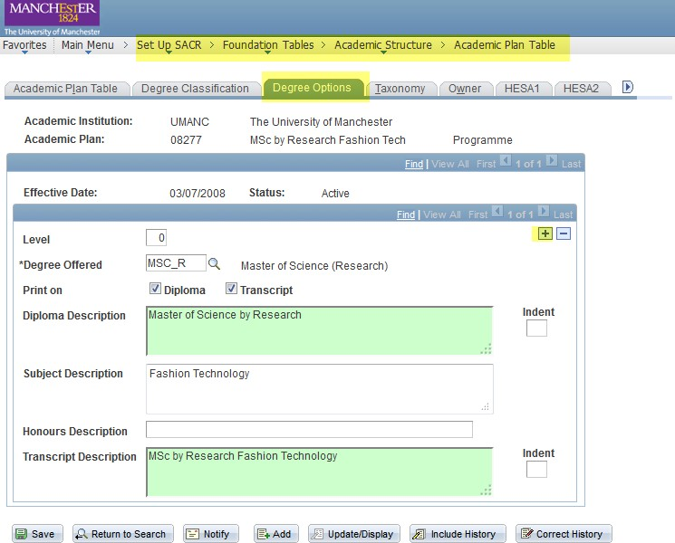

- The Research version of the programme can be set up in the same way with all the relevant early exit awards.
- Awards will only need to be set up for the Manchester versions of the programmes. Where students are registered at another institution they will not be receiving an award from Manchester and will be registered here as a Visiting Research Student.
- If a student is on the taught section of the programme and leaves with an early exit award, this should be dated within 12 months.
- Students on collaborative programmes will still need to be completed in CS or they will stay as active students. This can be done by adding a completion row as detailed this guidance: Postgraduate Research (PGDR) Administration. Students will receive the award from the institution where they are registered on the PhD
- If the student exits with the PGDip/PGCert change the name of the associated plan to PGDip/PGCert and change the COURSEAIM from D00 to M41.

Reporting

Students registered as Visiting Research students on a collaborative programme should not appear on PSO returns to HESA etc.
The programme codes can be given to the PSO who will be able to use these to exclude any students from returns.
Programme cohorts with a taught element will only be included in internal completion/submission reports from the start of the research section of their program.
PGR Administrators should untick the ‘HESA Reportable’ box when setting up a programme/plan for a Visiting Research Student programme/plan code in Campus Solutions.

Fees

Students who are primarily registered at collaborative institutions and registered at Manchester as Visiting Research Students should incur no fee when registering with the University of Manchester.

The SSC can set the programs with a zero fee. Administrators should contact the fees team.

eProg

- eProg can support the administration of CDT students through the setting up of VO’s and will allow access to staff who have the correct access to view the VO in Campus Solutions.
- When a VO is set up in CS the eProg technical team must be notified so that the VO is also created within eProg. The PGR administrator can then create a pathway for a specific cohort of CDT students using the VO as the owning organisation (please see appendix 2 for details on how to add a VO and request access).
- All members of staff who have PGDR access in Campus Solutions to the VO will then automatically have access to view the students in eProg for that particular cohort of students.
- Administrators can use eProg for managing either the taught or research element of a student’s program. This is a decision made locally in Faculties/Schools.
- Changes made in Campus Solutions will integrate to eProg Mon – Fri normally overnight. Users should
be aware that changes made to Campus Solutions may take up to 72 hours to appear in eProg.

Appendix 1 – Glossary of terms

**Virtual organisation:
When creating an academic plan in Campus Solutions, the plan must have a specified ‘ownership’ which is normally the School (organisation) where the student will be registered. For example, a plan held in School of Social Sciences will have the ‘owning’ organisation in Campus Solutions as ‘School of Social Science’. A CDT programme/plan should have a ‘shared’ ownership in Campus Solutions to be able to identify a cohort of students who are registered on a CDT programme. The ‘ownership’ should be split between the School that they will be registered in and a Virtual Organisation (VO). A VO does not have a physical location, but allows administrators to identify CDT programs and specific cohorts of students in Campus Solutions and eProg.
eProg will also pick up on the VO in terms of allowing staff access to records that they should be allowed to view.
Details on how to select ownership for a programme/plan in Campus Solutions is detailed in the Academic programs and plans guidance: Academic Program/Plan Table.

- The ownership of the Campus Solutions plan (not the programme as the programme defines the flow of finances) should be split between the relevant Virtual Organisation and the owning School/Faculty/Business organisation.
- For new CDT programmes which require a new VO, administrators should contact the CS helpdesk (cs.records@manchester.ac.uk) to add new virtual organisations prior to splitting ownership in Campus Solutions. The eProg technical team will also need to be contacted to create the VO in eProg.
NB: it is important that the ownership is split on the plan and not the programme in order to ensure that finances are allocated correct.
PGR Administrators will need to request access to a VO through the normal route of requesting access (i.e. the Student Systems Office Connect form).

- Interdisciplinary program:
‘Interdisciplinary program’ refers to programmes of study where a cohort of students register in different Schools at the University of Manchester or at University of Manchester and another institution.
Examples of interdisciplinary programs are Centres for Doctoral Training (CDT’s), Doctoral Training Centres (DTC’s) and Doctoral Training Partnerships (DTP’s).

- Centre for Doctoral Training (CDT): A format for managing UK Research Council’s funding for postgraduate research studentships

- Cohort: A group of students admitted onto one programme at the same entry point.

- PGR Administrator (CDT and School): for each scenario there may be a number of administrators involved with the management of a CDT/DTC student. The PGR Administrator (CDT) has overall ownership of the CDT/DTC programme and will normally be located in the ‘host’ School/Faculty. Some administrators are solely responsible for CDT/DTC programmes. PGR Administrators located in a Faculty/School where the CDT student is placed as part of their programme will not usually manage a large cohort of CDT students and will only administer the process for a small number of CDT students. They will need to liaise with the PGR Administrator (CDT) to ensure that the CDT student is managed correctly.

Appendix 2 - How to add a Virtual Organisation (VO)

To split the ownership of an academic plan with a Virtual Organisation (VO) administrators can refer to the guidance in Academic Programmes and Plans: Academic Program/Plan Table.
Users should refer to section 21, Creating an academic programme.
The Virtual Organisation code should be used to split the ownership between the School and the Virtual Organisation (VO).

Users can search for the CDT (note that all CDTs have been configured with a prefix of ‘V’ in the Academic Organisation ID, and a prefix of ‘VO’ in the Description) to select the VO.

NB: To create a new Virtual Organisation (VO) you will need to contact the SSO with details of the name of the new programme organisation. If you create a new Virtual Organisation in Campus Solutions it will not automatically feed into eProg. Therefore you will need to raise a new ARS for the eProg technical team to manual create the new VO to be used in eProg.
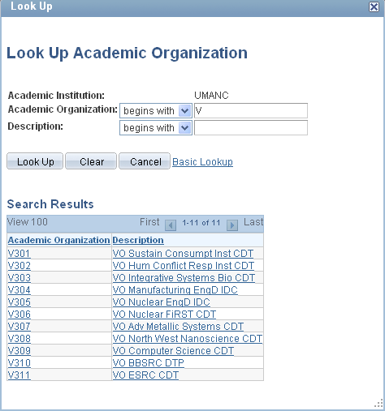

For programme/plans which have already been created in Campus Solutions, administrators should use the following guidance:

For each Academic Plan:

Navigate to Set Up SACR > Foundation Tables > Academic Structure > Academic Plan Table

Search for the Academic Plan you wish to update, having selected the ‘Correct History’ checkbox in the search page (alternatively you can select the ‘Correct History’ button when in the component)

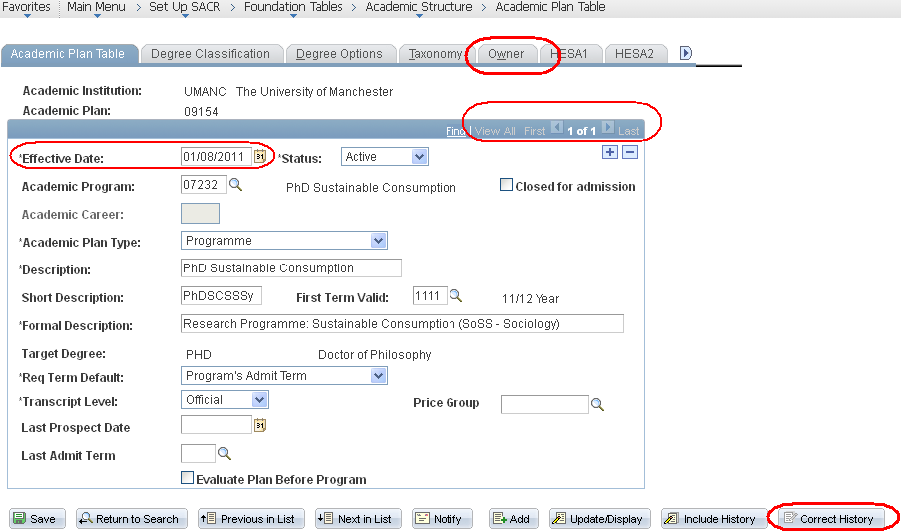

If the Effective Date of the current record is prior to the date at which the split ownership should appear (or prior to 01/09/2005), you will need to Add a new row using the button. Enter the Effective Date that the split ownership should be applicable from.

If the Effective Date of the current record is appropriate for reflecting the split ownership, or indeed if the current record is the ONLY row of data present for the relevant Academic Plan (identifiable by looking at ), go directly to update the owner data under the Owner tab.

Navigate to the Owner tab
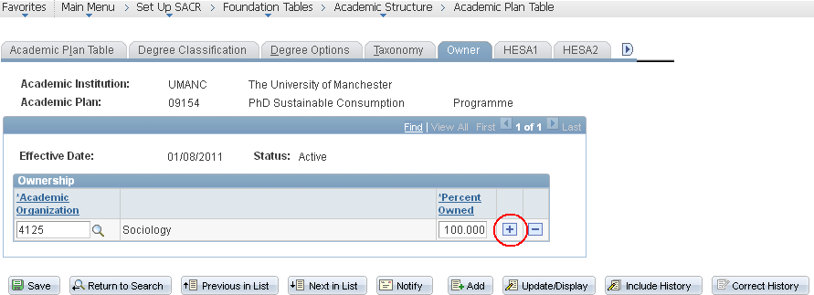

Use the button to add a new row under Ownership

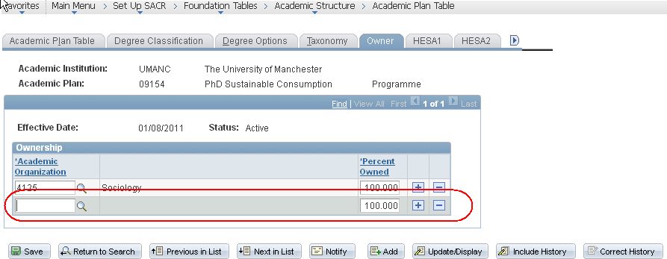

Use the against the new row to search for the relevant CDT (note that all CDTs have been configured with a prefix of ‘V’ in the Academic Organisation ID, and a prefix of ‘VO’ in the Description)

Select the relevant CDT organisation from the list, and then amend the associated Percentage Owned values (50:50 or as appropriate for multiple split ownerships)
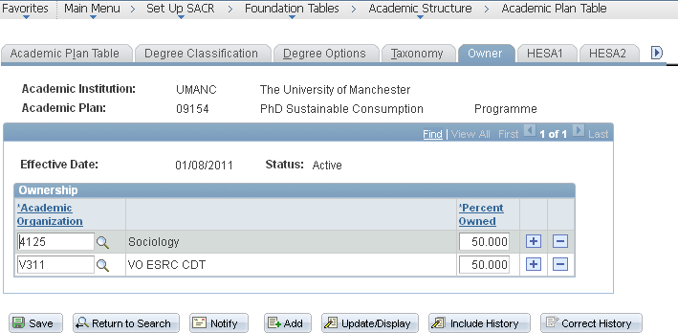

OR, for multiple School ownership for example

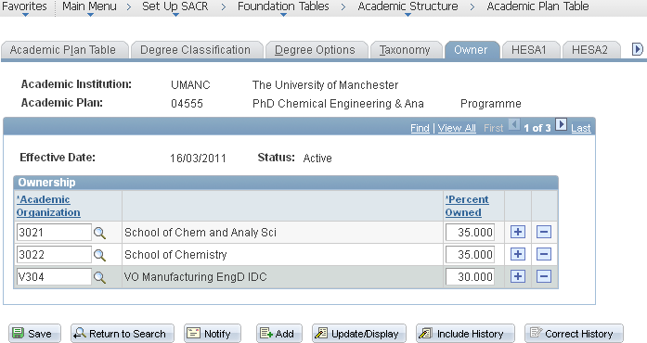

CLICK ON SAVE

Note: If you need to update previous rows of data against an Academic Plan, navigate to all the relevant rows for update using , and carry out the same process.

You can find additional information regards managing the Academic Programme and Plan data in CS on the Student Systems Records and Data sharepoint.

