Ellen Lewis, PhD
Ethos of Engagement Consulting
linkedin.com/in/ellendlewis

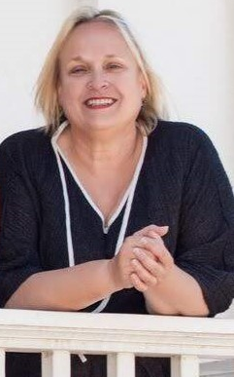
Bio:
Ellen Lewis, MA, PhD, is a global consultant working in the United Kingdom and Portugal, specialising in inclusive systemic thinking, organisational development, academia, and evaluation. She works across public, private, and community sectors, with a strong focus on addressing complex problems through systemic approaches grounded in gender equality, biodiversity, and inclusion. She is currently on the board of the International Evaluation Academy, a global movement of volunteers committed to evaluation policy influence, professionalism, and transformative impact.

Ellen is co-author of ‘Inclusive Systemic Evaluation’ (2018, UN Women) and ‘Inclusive Systemic Thinking (2024, Elgar Encyclopedia of Interdisciplinarity and Transdisciplinarity, Ch. 56). Ellen co-directs Ethos of Engagement Consulting PTY alongside Dr. Anne Stephens (Australia).
Her practice centres on Inclusive Systemic Thinking (IST), a flexible methodology that uses the GEMs framework—Gender (non-binary), Environments (ecological and human-made), and Marginalised voices (human and non-human)—to explore complexity, structure problems, evaluate systems, and inform policy while foregrounding power, diversity, and inclusion.
Ellen teaches and consults internationally in English and Spanish, with particular emphasis on curriculum design and capacity/capability building. She currently teaches systems thinking at the University of Exeter.

