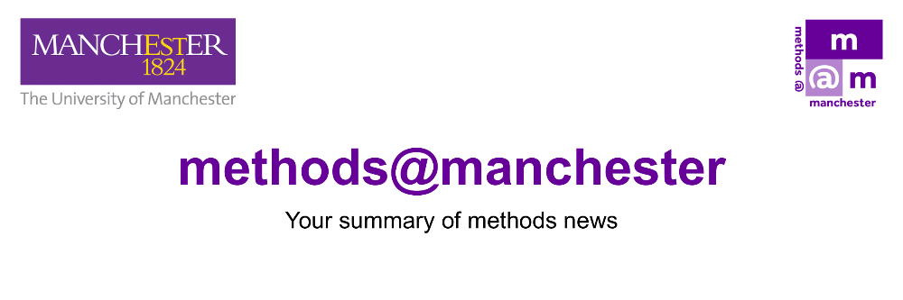

June 2026

Hello
Welcome to the June edition of Methods News.
Methods News is the regular newsletter from methods@manchester, providing a summary of our events and activities.
This month we celebrate the success of the Methods Fair and also provide you with a last opportunity to purchase a place on one of the courses at our annual Summer School.
The next Methods News will be the last one for this academic year, so if you have a methods-related event or activity that you would like us to include, please send us brief details by Wednesday 8 July to be included.
Emma
Prof. Emma Banister (Director of methods@manchester)
Connect With Us

methods@manchester Events and Activities

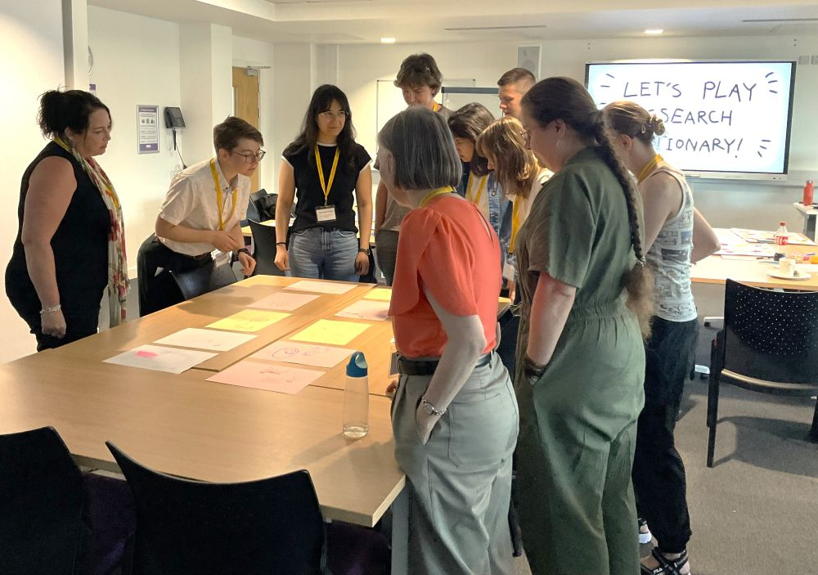

Methods Fair 2026
Thank you to everyone who contributed to and or attended this year’s Methods Fair.
Our annual Methods Fair provides an excellent opportunity for researchers to come together, connect and gather feedback on projects and innovative research methods.
One of the highlights was a workshop sessions by ‘Draw your Research’ - a bi-weekly, cross-university, informal group of academics interested in exploring what drawing can bring to our research practice. You can find out more about their sessions here.
If you weren’t able to attend this year’s Methods Fair, please do read some reflections in our featured blog post.

Summer School 2026

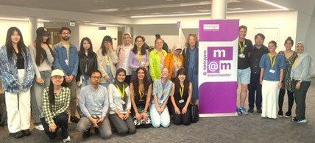

Summer School 2026
The Methods@Manchester Summer School provides a fantastic opportunity to expand your methods knowledge and research skills, with a range of courses focused on software training, qualitative and quantitative analysis, data collection techniques and much more.
The School will take place Monday 6 July to Friday 10 July. The programme includes two social events, and along with the shared breaks and lunches this means it provides a unique opportunity to meet researchers across the Summer School as a whole.
The 2026 Summer School includes the following courses:
- Using NVivo for Qualitative and Mixed-Methods Analysis
- Digital Methods
- Qualitative Interviewing: Developing Confidence in Approach and Analysis
- Creative Approaches to Qualitative Research

We offer reduced rates for doctoral students and those working within the voluntary, charity and community sector but remember to book your place by 15 June.
For all the details about the Summer School, click the button below or email us at methods@manchester.ac.uk
Find out more!

artsmethods@manchester
Are you a University of Manchester PGR with an interest in arts and humanities? artsmethods@manchester is an academic programme of talks, workshops, training and events which explore approaches to arts research methods and their dissemination.
The final workshop of the academic year will be:
8 June 2026, 11am - 1pm
Sociology of Work Theory (A4, Samuel Alexander Building)
Workshops can be booked via the Training Calendar.
About artsmethods

Methods North West

Methods North West brings together the collective strength, depth, and breadth of methodological expertise across the North West Social Science Doctoral Training Partnership (NWSSDTP) consisting of the Universities of Manchester, Liverpool, Lancaster, Keele, and Lancashire.

PGR Social Media Network Event
Friday 5 June, Oddfellows Hall, The University of Manchester in June 2026
This event will provide a space for PGR’s and ECR’s who are using social media/online methods to network and share their research. It will be of interest to those who use qualitative, quantitative, computational, and mixed methods, as well as more besides, and will allow those working in this area to meet and present their research to fellow PGRs.
Details and sign up

Lost and Found in Translation Series
The Lost & Found in Translation (L&FIT) Network is a collaboration of PGRs/ECRs based in all five Methods North West Institutes. The network explores the ethics & methodologies of qualitative and interview-based research carried out in and across different languages.
The final event in the series is the L&FIT Conference and will be held on 10 June, The University of Manchester.
Researchers from the north-west area and beyond are invited to present papers on their projects, all of which concern diverse formats of cross-language research. The conference also focuses on the future of cross-language innovation, the where and the why of how scholarly findings may be lost, or found in translation: what are the borders of (inter-disciplinary) approaches to translation, transcription and multi-language mediation? Why are the challenges of cross-language research on constant flux? Where do we go from here?
Submit your Abstract!

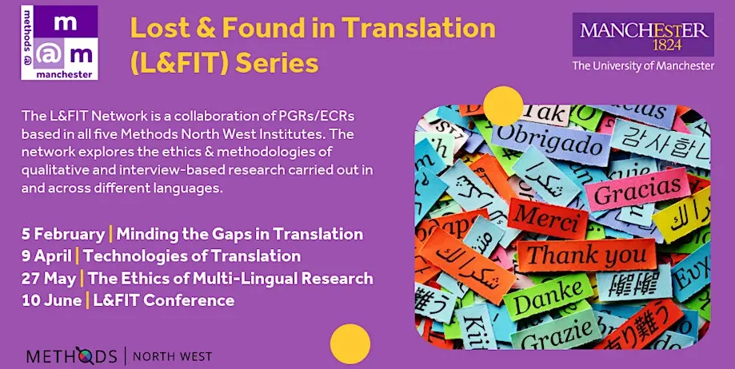

National Centre for Research Methods

The National Centre for Research Methods delivers training and resources at core and advanced levels, covering quantitative, qualitative, digital, creative, visual, mixed and multimodal methods.
Upcoming online events include:
How to write your Methodology Chapter - Online, with Dr Patrick Brindle
1 June
This online workshop aims to give participants a range of practical approaches they can adopt when writing about methodology in the social sciences, with a particular focus on writing a PhD methodology chapter. Using a range of exercises throughout, the course focuses on 20 or so writing strategies and thought experiments designed to provide more clarity and power to the often-difficult challenge of writing about methods.
AI for Survey Researchers – A three-workshop series (online), with Dr Paulo Serôdio
8 June, 22 June and 6 July
Across three standalone half-day sessions, participants build a working understanding of the AI stack: from how models generate text and where inference happens, through prompt engineering, retrieval-augmented generation, and API-based workflows, to the rapidly maturing ecosystem of agentic platforms, harness engineering, and autonomous research infrastructure.
To register for the above courses, and for details of the NCRM full programme of events, please see here.
Upcoming NCRM Events

Subscribe to Methods News

If someone has forwarded you this edition of Methods News, please do sign up to receive it directly.
Subscribe

  
  

methods@manchester | The University of Manchester | Methods North West
Contact Us | Tel: +44 (0) 161 306 2859 Web: https://www.methods.manchester.ac.uk
Registered Office: The University of Manchester, Oxford Rd, Manchester, M13 9PL
Royal Charter Number: RC000797

