Geoffrey Jefferson Brain Research Centre

Annual report

2025/2026

Foreword from our Directors
A warm welcome to our fourth annual report on the Geoffrey Jefferson Brain Research Centre (the ‘Jeff’).
It is hard to believe that it is 5 years since we launched the centre. Our ambition in doing so was to create a clear identity (‘brand’) for translational neuroscience research across Manchester and build capacity and innovation in this important area to improve the lives of patients with neurological disease.
Reflecting on progress since our online launch (we were of course in the midst of the COVID-19 pandemic) there is no question we have achieved our first aim – the Jeff now being firmly established as a leading centre bridging the outstanding discovery science at the University with top level clinical practice across the various NHS Trusts in Greater Manchester with neuroscience activity.
We have had another exceptional year in obtaining Fellowships for our next generation of researchers, with multiple successes across different themes in the Jeff. Some of this success stemmed directly from pump-priming support we provided, highlighting the critical importance of having unrestricted funds which we can allocate to exciting new areas of research and our brightest minds.
Building capacity starts at the earliest stages of the research journey and we are delighted that Manchester led on a successful bid for a new 4-year BHF PhD programme CHAIN (Connecting HeArts and mINds). This prestigious £7.1M programme brings together the Universities of Manchester, Bristol and Liverpool to train a future generation of scientists to tackle a key research area: the bidirectional link between brain and heart diseases. This builds on the Alzheimer’s Society VIDA (Vascular and Immune contributors to DementiA) Doctoral Training Centre led by Manchester that started in 2024.
Looking forward to the next year we are excited about playing a major role in The University of Manchester’s major fundraising campaign ‘Challenge Accepted’ and in building new partnerships with the many outstanding research centres and Institutes in Manchester and beyond. Our focus is on making sure our research has as much impact as possible and we are excited to be hosting our second showcase event this November, where we can share our successes with donors, funders and key stakeholders.
Stuart Allan and Andrew King
Directors of the Geoffrey Jefferson Brain Research Centre

Centre highlights from 2025/6

Themes
Extension of support across Manchester Centre for Clinical Neurosciences, increased engagement of clinical academics

Publications
102 new publications arising from the centre
Researchers
7 of our early and mid-career researchers were awarded prestigious externally funded fellowships
Grant income
Over £9 million new grant income from applications and projects associated with the centre
Fundraising
More than £12,000 raised through patient driven fundraising, to fund research activity
Philanthropy
New Challenge Accepted philanthropy campaign launched by The University of Manchester with brain health as a focus area

A century of neuroscience in Manchester
In 1926, Sir Geoffrey Jefferson was appointed to the Manchester Royal Infirmary, where a small but dedicated neurological department was established for him. At the time, specialist neurological services were rare, and this appointment marked a significant step towards the development of structured neurology and neurosurgery in Manchester. From this base, Jefferson began developing new approaches to the treatment of head injuries, spinal conditions, and neurological disease, helping to raise the city’s national and international profile in the emerging field of neurosurgery.
As Jefferson’s clinical and academic reputation grew, so did institutional recognition of neurosurgery as a distinct discipline. In 1939, The University of Manchester created a personal chair of neurosurgery for Jefferson, the first such position in Britain. This appointment formally established neurosurgery as an academic specialty and reflected Manchester’s leadership in integrating surgical practice with teaching and research. During the same period, Jefferson played a key role in planning neurosurgical services nationally, particularly through his work to establish and coordinate specialist centres during the Second World War.
The clinical infrastructure he had advocated for was finally realised in 1950, with the opening of a fully equipped neurosurgical unit at the Manchester Royal Infirmary. This unit provided dedicated operating theatres, wards, and specialist facilities, embedding neurosurgery as a core component of hospital care in the city. The opening took place just a year before Jefferson’s retirement, serving as a capstone to his career in Manchester and a lasting foundation for future generations of clinicians and researchers.
Innovation continued with the installation of the world’s first commercial CT scanner at the MRI in 1972. This development transformed brain imaging and diagnosis, reinforcing Manchester’s international standing in neuroscience.
Today, our centre builds on Jefferson’s belief that advances in brain science are strongest when clinicians, researchers, and trainees work closely together and when new knowledge is translated thoughtfully into patient care.

A century of neuroscience continued…

Timeline:
1926: The beginning
The modern history of neuroscience in Manchester began in 1926, with the appointment of Sir Geoffrey Jefferson to the Manchester Royal Infirmary. His work established one of the first dedicated neurology services in the city, laying the foundations for specialist neurological care.
1920s and 1930s: Building a national reputation
Jefferson helped establish Manchester as a leading centre for neurosurgery in the UK. Working alongside contemporaries such as Norman Dott and Hugh Cairns, he shaped a generation of clinical practice and training.
1950: A permanent home for neurosurgery
A fully equipped neurosurgical unit opened at the MRI in 1950, shortly before Jefferson’s retirement. This marked the formal establishment of neurosurgery as a core clinical service in Manchester.
1972: A World first
Innovation continued with the installation of the world’s first commercial CT scanner at the MRI in 1972. This development transformed brain imaging and diagnosis, reinforcing Manchester’s international standing in neuroscience.
2021 - Looking forward
The opening of our centre in 2021 marked a new chapter. Bringing together The University of Manchester, the Northern Care Alliance NHS Foundation Trust, we are continuing a century long commitment to advancing research and care in neurological diseases.

Inflammation-related protein changes could help predict cognitive impairment after a stroke

This work highlights exactly what the Jeff was set up to do: combining patients, clinicians, and scientists from major neuroscience groups to deliver research that can translate to improve outcomes for patients.

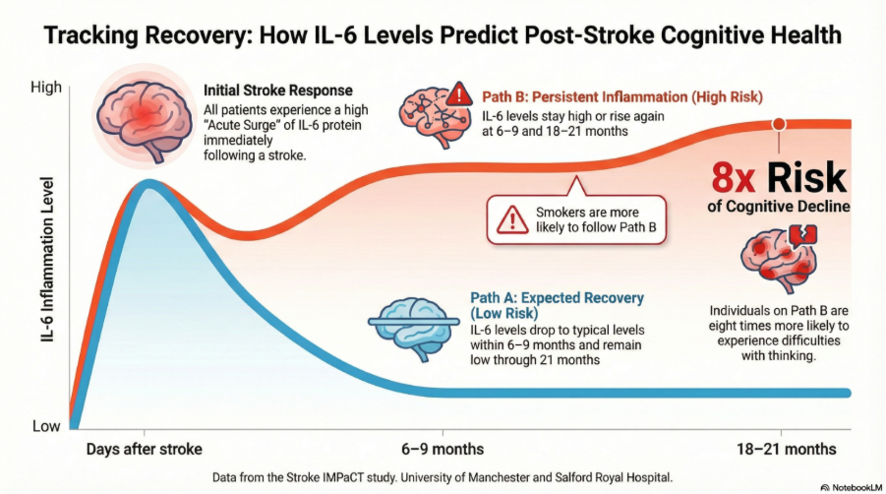

Our researchers have identified a potential way to predict which patients are most at risk of developing cognitive impairment after a stroke, with important implications for follow-up care and prevention. The study showed that changes over time in the inflammatory protein interleukin-6 (IL-6) are strongly associated with later problems in memory and thinking, particularly among people who smoke.
The team followed patients treated for an ischaemic stroke at Salford Royal Hospital, part of Northern Care Alliance NHS Foundation Trust. They measured levels of IL-6 in the days after stroke and again at both 6-9 and 18-21 months. Participants also completed detailed tests of memory and thinking.
IL-6 levels increased soon after stroke and, in most people, fell back to typical levels within 6-9 months. But in some patients, levels stayed high or rose again. These individuals were about eight times more likely to develop difficulties with thinking ability.
This is an incredibly exciting discovery, especially given Manchester’s expertise in inflammation in stroke and history of clinical trials using anti-inflammatory drugs. If future studies confirm IL-6 is indeed the cause of cognitive decline, we might one day use medications that block it to protect brain health.
Originally funded by the Leducq Foundation, the study has been extended with the generous support of Louis & Amy Wong.

Read more: https://alz-journals.onlinelibrary.wiley.com/doi/full/10.1002/alz.71261

Developing novel techniques of measuring inflammation in brain tumours: USPIO enhanced MRI Imaging

This study also demonstrates the key strength of the Jeff in bringing together diverse groups, including from the University: MR imaging research, neuroimmunology, and analytical chemistry - and the NHS: surgeons, radiologists and patients - to form an interdisciplinary group.
Led by Drs Daniel Lewis and David Coope, this study is the first of its kind in the UK, using clinically relevant imaging and tissue tools to study the inflammatory microenvironment in brain tumours.
The study has successfully recruited its first 18 patients including the first ever application of this imaging technique in patients with skull base tumours and transforming glioma.
This work was originally funded by the European Association of Neurosurgical Societies, the Dowager Countess Eleanor Peel Trust and a Medical Research Council PhD studentship. The study group has also received dedicated funding from the Skull Base Foundation to look at a special tissue analysis technique for detecting and mapping iron released from these nanoparticles in the tumours.
The group hope to develop a clinically applicable imaging tool that can not only measure the amount of inflammation within any given tumour before treatment, but also crucially be used to guide inflammation targeting therapies against these challenging conditions.
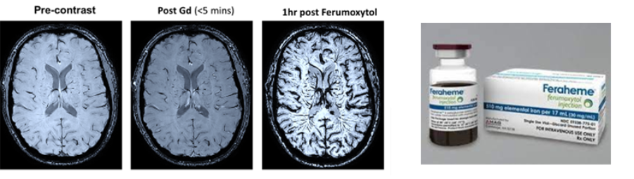
MRI images from an early patient scanned at Salford Royal using Ferumoxytol (Feraheme). The new technique allows much more detailed visualisation of the brain blood vessels than conventional contrast agents currently used in the clinic.
Possible use of this new technique is now being explored in Multiple Sclerosis and Parkinson's Disease.

Investigating access to epilepsy care across Greater Manchester
Researchers within our epilepsy theme have been hard at work investigating access to epilepsy care.
The team studied 1,609 adults attending Manchester Centre for Clinical Neurosciences, one of the largest neurology centres in the country, between 2020 and 2024, and found that people from Asian, Black and Mixed backgrounds were underrepresented in the clinic compared to census data.
In Greater Manchester:
- Asian people make up 13.6% of the population, but only 6.4% of the clinic attendees
- Black people make up 4% of the population, but only 1.4% of the clinic attendees
- Mixed-race people make up 3% of the population, but only 1.% of the clinic attendees
The team noted that disparities in access to treatment was one of the main issues, as people from ethnic minorities had similar outcomes to the white population once they were receiving specialist care.
The majority of the patients attending the clinic came from the most deprived areas, demonstrating that epilepsy disproportionately affects socioeconomically deprived populations – and most patients from ethnic minority backgrounds lived in more deprived areas, indicating that deprivation and ethnicity were closed linked in this cohort.
A larger programme of work also led by consultant neurologist Dr Rajiv Mohanraj has collated a dataset of more than 125,000 patients with neurological diagnoses, including headache, seizure, movement disorders, neuromuscular disorders, and functional disorders. This is the largest dataset of its kind in existence, and will aid epidemiological study into each disease and better understanding of health inequalities.
Read more: https://www.epilepsy.org.uk/news/people-from-ethnic-minorities-lack-access-to-epilepsy-care-study

Supporting our research community

Connecting people, expertise, and activity across disease areas

We are working to strengthen connections across disease-focused communities in Manchester. We have brought together the brain tumour research and clinical community to map activity, understand where expertise sits, and support better alignment across teams.
We invited clinicians and researchers from across Manchester for a brain tumour thinktank event, to gain a clearer picture of brain tumour research activity across the city.
Professor Petra Hamerlik, our brain tumour theme lead, set out the ambition to ensure researchers and clinicians are visible, better connected and supported to work together.
The day focused on sharing expertise and identifying where collaboration could make the greatest difference. Short lightning talks highlighted strengths across neuro-oncology, imaging, immunology, engineering and data science, and helped lay the foundations for collaborative pilot projects with near-term potential.
Building on the momentum from the meeting, a small pump-priming funding call was launched to support innovative pilot projects focused on brain tumour biology, detection, monitoring and treatment. Projects will be supported using funds raised directly by patients and carers of those with brain tumours.

Dementia network revival
Building on the success of the brain tumour theme activities, we are now planning future meetings for the dementia research community to provide the same shared view of people, expertise and ongoing work. Planning is underway to relaunch Dementia@Manchester, an interdisciplinary network originally established by Professor Nigel Hooper to connect dementia researchers across The University of Manchester.
The renewed dementia consortium led by Dr Roy Ng will bring together researchers from across disciplines, strengthening collaboration and supporting translational dementia research across Greater Manchester.

Support for tissue and sample collection
This year we invested in tissue provision by funding staff time, training and the laboratory processes needed to collect patient samples across our clinical studies.
We contributed funding to a team of research support workers embedded in clinical delivery teams at Salford Royal Hospital, where they contribute to studies by assisting with tissue collection, sample processing and biobanking activity.
This spending underpinned safe sample handling and close coordination between clinical, pathology and laboratory teams, ensuring tissue and liquid biopsy samples are collected consistently, which will strengthen existing and future trials utilising patient tissue.
Read more about how the team contribute to bridging the gap between clinical tissue provision and laboratory research: https://gjbrainresearch.org/2026/03/09/healthcare-science-week/

Opening doors to research careers: widening participation summer research internships

Last summer, researchers in our stroke and inflammation themes delivered an undergraduate internship programme, hosting four students for a 3.5 week paid placement funded by the Division of Neuroscience, Alzheimer’s Research UK North West Network, and a generous donation to the Jeff.
Building on a successful pilot, the programme was designed to improve access to neuroscience research for underrepresented groups by providing early, supported exposure to laboratory research. Interns received structured introductions to laboratory working, core techniques, and research careers before undertaking supervised mini-projects alongside PhD students and postdoctoral researchers.
Evaluation at the end of the programme showed clear benefits: all participants reported improved laboratory skills, increased confidence, and a better understanding of research career pathways.
The Jeff is now looking forward to supporting and expanding this initiative in coming years, encouraging more young people into research careers.
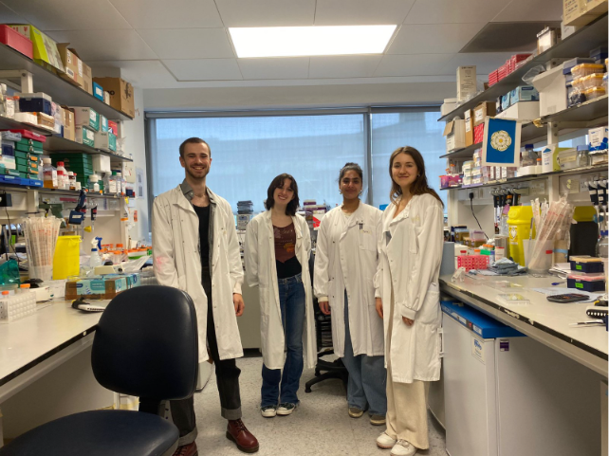

In the pipeline...

New partnerships and collaborations

Manchester Rare Conditions Centre
We’re excited to join forces with the Manchester Rare Conditions Centre, which aims to improve the lives of people living with rare conditions. Over the next year we will work to bring our research communities together, through workshops to highlight research strengths and synergies, and collaborative funding calls to support early-stage projects. We hope that closer collaboration will help build critical mass and create clearer pathways from early ideas to competitive funding in areas where coordinated working is essential.

Read more about the MRCC on their website: https://www.mrcc.org.uk/

British Heart Foundation Chain Consortium PhD programme
Alongside the University of Liverpool and University of Bristol, The University of Manchester has established the British Heart Foundation (BHF) CHAIN Consortium PhD programme (Connecting Hearts And mINds) which will train the next generation of cardiovascular scientists, investigating the mechanisms linking cardiovascular and brain diseases.
Dr Gina Galli from The University of Manchester will lead this innovative programme, which is supported by a £7.1m investment from the participating institutions and the BHF. The programme will train 40 of the UK’s most promising scientists to move beyond disciplinary boundaries and adopt integrated approaches to heart–brain health.
The students will work on ambitious cross-disciplinary projects spanning discovery bioscience, engineering, data science, imaging, epidemiology and behavioural science. We look forward to welcoming them in our relevant themes within the Jeff.

Fellowship awards in 2025/26
It has been another highly successful year for our early and mid-career researchers, with external fellowship funding enabling them to establish their portfolios and build their own research groups.

Cell surface glycocalyx control of immune cell recruitment and pathology in the inflamed brain
Doug Dyer, Wellcome Trust career development award
Doug has been awarded 8 years of funding to support his research into immune cell recruitment following brain injury, using stroke as a model condition.
Despite their central role in inflammation, chemokines have not yet been successfully targeted in clinical treatments due to gaps in understanding how they function. This project will identify mechanisms that drive harmful brain inflammation to inform future therapies.
By improving understanding of how immune cell trafficking is regulated in the inflamed brain, this research has the potential to support the development of new approaches to treat stroke and other neurological conditions linked to inflammation.

Central underpinnings of obesity-related hypertension
Claire Feetham, BHF Centre of Excellence transition fellowship
Claire has been awarded a BHF Manchester CRE transition fellow position to begin work on how the brain controls cardiovascular regulation and what happens when this system becomes dysfunctional. This work focuses on understanding how specific brain pathways link hormonal signals released from fat tissue to high blood pressure.
This research will improve our understanding of brain mechanisms regulating blood pressure and identify novel treatments for hypertension in individuals with obesity, addressing a critical unmet clinical need.
Quantifying glymphatic dysfunction as a key link between vascular dysfunction and neuroinflammation in cerebral small vessel disease
Will Morrey, BHF Centre of Excellence transition fellowship
Will has been developing MRI methods to quantify neurofluid circulation and brain waste clearance. His research will focus on applying these approaches alongside computational modelling to elucidate how neurofluid dysfunction contributes to brain inflammation in rodent models of small vessel disease. He will also translate these methods for use in humans, helping to bridge the gap between preclinical and clinical research. The project integrates expertise in preclinical and clinical imaging, computational modelling, and neuroinflammation.
Does menopause enhance Alzheimer’s disease risk by exacerbating vascular dysfunction?
Kira Shaw, Wellcome Trust career development award
Kira will lead an 8 year programme uncovering why women, who represent around 65% of dementia patients, are disproportionately affected by Alzheimer’s disease.
The research will investigate how falling oestrogen during the menopause transition alters blood flow, oxygenation and vascular function in the brain, and how these changes interact with major risk factors, including APOE4 genotype and ageing.
Using advanced in vivo two-photon microscopy to simultaneously record activity from neurons and blood vessels (see image on right), the project will reveal how these vascular and neural changes emerge in real time during the menopause transition.
The project will also explore when treatments are most effective across menopause stages, testing both the timing of hormone replacement therapy (HRT) and new approaches that target key vasodilatory pathways, aiming to find better ways to protect the female brain during this critical transition period.

Regulation of cell volume shapes inflammatory and immune responses
Jack Green, BHF Centre of Excellence transition fellowship
Jack has been awarded a BHF CRE transition fellowship to develop his independent research programme on how mechanical forces influence unwanted inflammation.
Inflammation is a major contributor to heart and brain diseases, including stroke, yet current anti-inflammatory treatments are often ineffective or non-selective. This project investigates a newly recognised way that immune cells detect danger by sensing changes in their volume driven by changes in the cellular environment.
During injury or disease, tissues often swell, forcing immune cells to rapidly change volume. Jack’s research has shown that these physical changes act as powerful warning signals that can drive harmful inflammation.
This project will explore how immune cells detect and respond to cell swelling, and how this process influences inflammatory signals in the brain following intracerebral haemorrhage (a severe form of stroke). By combining advanced imaging, genetic models, and molecular profiling, the research will reveal how disturbances in cell volume shape damaging immune responses in diseased tissue.

Spotlight on philanthropic impact: the Freddy Carboni Neuro-oncology Research Fellowship

A generous donation from the Carboni family in memory of their late son Freddy has provided research fellow Claire O’Leary with the opportunity to expand her portfolio of glioblastoma research.

Freddy was our middle son. Always single minded, he rejected a place at university, deciding instead to go straight into the workplace after leaving school. By the age of 24 he had bought his own flat and was loving his job as a finance systems analyst at a London law firm.
But a year later double vision and headaches led to an MRI and biopsy investigations which resulted in the devastating news that he had a life-limiting brain tumour – a rare form of anaplastic astrocytoma with piloid characteristics. He died just five years later. Before he did, he decided to leave most of his money to charity and to donate his brain for medical research. His courageous decisions led us to initiate the Freddy Carboni Neuro-oncology Research Fellowship.
The impactful research that Claire and the Manchester Brain Bank are undertaking offers the potential for a better future for those with brain tumours.
This is Freddy’s legacy. He was an exceptional young man who showed maturity and vision by wanting his brain to be used for medical research. Together with his two brothers, we are proud to support the work that he began.
Words by Anna and Marius Carboni

Evaluation of responses in glioblastoma patients enrolled in the POBIG and PORTRAIT clinical trials
Claire O’Leary, Freddy Carboni neuro-oncology research fellow
In collaboration with Prof Fede Roncaroli, Dr Gerben Borst and Dr Andrew Robinson, Claire will investigate systemic immune responses in glioblastoma patients enrolled in the POBIG and PORTRAIT clinical trials through longitudinal blood and matched tumour sampling.
Using serial samples collected via a CRUK sample collection award, the study will assess how preoperative radiotherapy or tumour-treating fields (TTFields) can affect immune responses before surgery, during postoperative treatment and throughout follow-up. Examining immune modulation caused by radiotherapy or TTFields in an unperturbed pre-surgical setting will address a critical gap in understanding treatment-driven immune effects in glioblastoma.
Leveraging richly annotated clinical, imaging and molecular data, the project will generate mechanistic insights into radiotherapy and TTFields, identify clinically relevant immune pathways, inform optimal timing of combination strategies such as immunotherapy and guide the development of innovative future treatments.

Harnessing postoperative blood-brain barrier permeability for targeted nanotherapies against aggressive brain tumours
Tom Kisby, CRUK career development fellowship
Dr Tom Kisby, our theme lead for nanotechnology, has been awarded a prestigious CRUK career development fellowship to continue his work on nanomedicines for aggressive brain tumours. This work focuses on understanding how the brain changes following tumour surgery to inform the development of better treatments enabled by nanoparticles.
This approach has the potential to develop novel therapies that integrate with the current standard of care and improve outcomes for patients with glioma, a cancer with an urgent unmet clinical need. The project brings together a highly collaborative team across the centre, including clinical neurosurgeons, and experts in brain tumours and imaging.
“I am incredibly grateful for the support from the Jeff, both through its highly collaborative network with clinical neurosurgery colleagues, which makes a project like this possible, and through the Jeff’s brain tumour pump priming award which helped shape the early development of these ideas” – Tom Kisby.
In 2024, the Jeff awarded Tom funding to support his research into enhancing TTFields in glioblastoma treatment. That funding originated from another family donation as part of Laura Nuttall’s legacy, and its impact is clear today, with Tom going on to secure prestigious external funding to continue his important work.

From charitable investment to major national funding: building an NF2 research programme

Over the past 5 years, the Jeff has built a collaborative programme of research into neurofibromatosis type 2 (NF2), leveraging a strategic partnership with CureNF2 Foundation (formerly NF2 BioSolutions UK) whose funding provided the foundation for a new integrated approach to NF2 research in Manchester.
Funding for 2 PhD studentships initiated a new partnership between academics at the University and neurosurgeons at Salford, enabling the team to invest in the training of early-career researchers and explore fundamental questions around NF2 tumour biology and inflammation. Building expertise in this area has attracted external funding for a further 4 PhD students, with further investment by Cure NF2 Foundation to maintain momentum.
Now, with 7 published papers evidencing a strong track record of collaboration and delivering essential research, the team has been awarded an MRC project grant worth over £700k to continue to expand the NF2 research programme:
This pathway, converting charitable partnership support into nationally competitive Research Council funding, highlights the Jeff’s role as a facilitator of novel, collaborative research. We have translated early investment into sustainable momentum for NF2 research, and look forward to the next discoveries in this story.
Read more here about the team’s plans for the new funding https://gjbrainresearch.org/2025/07/18/new-funding-for-nf2-research/

University of Manchester launches Challenge Accepted campaign
In November 2025 the University launched its first major global fundraising and volunteering campaign. The campaign will mobilise more than £500,000 global alumni, supporters, staff and students with a target of raising £400M to drive transformative change.
‘Challenge Accepted’ will focus on 4 core priorities: student inclusion and success; research with purpose; innovation and enterprise; and culture and community - accelerating the University's ambitious Manchester 2035 strategy.

Brain health as a growing priority area
Brain health, cancer and health inequalities are key priorities for philanthropic support into Research with Purpose. Research across the Jeff integrates all 3 areas and we are excited to get behind this campaign and drive research and development in this space.
Support for brain health research is also firmly embedded in the UK’s national health strategy with the recently published NHS 10-year plan focussing on 3 shifts - from hospital to community, analogue to digital, and sickness to prevention - with dementia and mental health being early priority areas.
Find out more about Challenge Accepted and get in touch with the Philanthropy Team:
manchester.ac.uk/give/
Supporters@manchester.ac.uk

Research with Purpose: How alumni are supporting the Jeff through Challenge Accepted
In December 2025 the University launched an appeal which reached over 100,000 alumni, focused on supporting our brain tumour theme lead Professor Petra Hamerlik’s neuro-oncology research group - accelerating progress in the detection, treatment and prevention of brain cancer. The campaign raised an incredible £146,000 from 629 donors. The appeal featured Nicola Nuttall whose daughter, the late Laura Nuttall, was a Manchester graduate and passionate advocate for brain cancer research. Her powerful message drove strong engagement and support for life-changing brain cancer research.
Read more about the brain cancer campaign: https://donate.manchester.ac.uk/p/researchappeal25/

Powering brain research breakthroughs through fundraising
Each year we are inspired and deeply moved by the generosity of our patients, staff and patient families who fundraise in support of our work. This year we have raised over £12,000 in patient fundraising, which will go directly towards funding new research.

“Thankfully, I was born in Manchester, home to incredible research centres like the Geoffrey Jefferson Brain Research Centre. The centre has been fundamental in providing research, support, and care for me over the last two years.” – Conor Flood
In March 2023, at the age of just 28, Conor Flood received a life changing diagnosis.
He was diagnosed with a sinonasal undifferentiated carcinoma, a rare and aggressive form of cancer.
Over the next 25 months Conor underwent multiple investigations, two major operations, 13 weeks of daily radiotherapy and 10 cycles of chemotherapy.
Due to the rarity of his cancer, much of Conor’s treatment was based on discovery science and experimental medicine, requiring collaboration and research with colleagues across multiple expert fields with the Jeff.
Despite extensive treatment Conor wanted to give back to the centre. Conor and his wife Elle took on the Manchester 10k in May 25 and raised a phenomenal £8,800.
The impact of fundraising
Together with previous patient fundraising, the money raised by Connor and Elle allowed us to open a brain tumour funding call.
This call is open to researchers across the Jeff and is seeking innovative projects to advance the understanding of brain tumour biology, detection, monitoring or treatment.

Prof Jackie Carter left The University of Manchester after a 41 year career in education.
Jackie worked at The University of Manchester for almost 30 years, and taught Laura Nuttall, who sadly died from her glioblastoma not long after graduating from university. Her son Huw was also diagnosed with a brain tumour at just 31.
In memory of Laura and support of her wonderful son, Jackie asked for contributions towards the Jeff as a leaving gift, raising over £1,800 to date.

In loving memory of June Doherty
In March 2025 the Doherty family lost their mum, June, to glioblastoma. The family wanted to thank the neuro-oncology team, specifically the Jeff for our initiatives to improve outcomes for glioblastoma patients.
The family felt that the best way to honour their mum, who always cared about others, would be to support a cause that would help patients in similar situations to her. They therefore requested charity donations in lieu of flowers and raised over £2,500 for the Jeff in donations.
This year, around the anniversary of June’s passing, her colleagues at Barclays also wanted to honour their beloved colleague and raised £750 through a charity bake sale. Barclays have kindly agreed to match fund this.
This brings the total to £4,000 raised in memory of June, which will go directly towards supporting research on glioblastoma.

Involving patients and the public in our research
Our dedicated stroke PCPIE group brings our researchers together with people with lived experience of stroke. This ensures our research is focused on the problems important to the people it affects, and that their voices have a meaningful impact on how we do our work.

“I had a stroke in 2014 and have been interested and involved with research projects ever since.
The Jeff PCPIE group has gathered together a regular panel of local people with an interest in stroke, whether survivors, carers or health professionals. Together we’ve been given the opportunity to discuss topics on stroke treatment and recovery, related medical subjects and research. We’ve also learned about and contributed to the planning of research projects at various stages of their development.
The projects have been really varied (and often surprising), the input of people with real experience and opinions on stroke and stroke care is important in shaping better outcomes for researchers. For anyone wanting to improve the lives of stroke survivors, whether through lived experience or research, I’d highly recommend the group.
We’ve had the opportunity to give honest feedback based on our genuine experiences, helping researchers think differently about what matters most after stroke.”
Stephen Taylor, PCPIE contributor

The impact for researchers

Consultant stroke physician and honorary senior clinical lecturer Amit Kishore has been working with our PCPIE group to help with a recent grant application.
“My work on stroke-associated pneumonia, including the OPTIMA SAP programme, has been shaped by close collaboration with the Jeff PCPIE group, building directly on discussions with stroke survivors and carers. Their input has been central to ensuring that our research questions, outcomes and study design focus on what matters most to people affected by stroke, including accurate diagnosis, preventable complications and the real-world impact of infection on recovery.
Feedback from the group has strengthened this Stroke Association lectureship application, refined our approach across multiple work packages, and ensured that patient and public involvement is embedded as a core part of the programme, enhancing the relevance, rigour and patient-centred focus of my research.” – Amit Kishore.

Thank you from the core team

The Jeff would not be what it is without the excellent researchers, clinicians, patients, volunteers, and public contributors who are committed to improving brain health in Greater Manchester and beyond.
We would also like to thank all of our generous fundraisers and donors, and grant and charity funders and partners, whose support has been fundamental to our progress as a translational research centre.

