

Doctoral Academy Updates



In this DA newsletter you will find the next instalment of 'Meet the Doctoral Academy Team', where we meet our Admissions and Recruitment Team, reminders for your Annual Review and the Key Travel process, along with updates from your Library and Researcher Development Team.
We also want to highlight the upcoming 3 Minute Thesis final on 11 June. This is a fantastic opportunity to come and hear from our PGRs about their research in a lightning three minutes! The link to register can be found in the article.
As always, if you would like to feature anything in the newsletter, please let us know.
The Doctoral Academy Team
Follow us on Bluesky: https://bsky.app/profile/uom-humsdocacad.bsky.social
Join us on LinkedIn: The University of Manchester Faculty of Humanities Doctoral Academy | Groups | LinkedIn
DA Spotify Podcast

Meet the Doctoral Academy Team

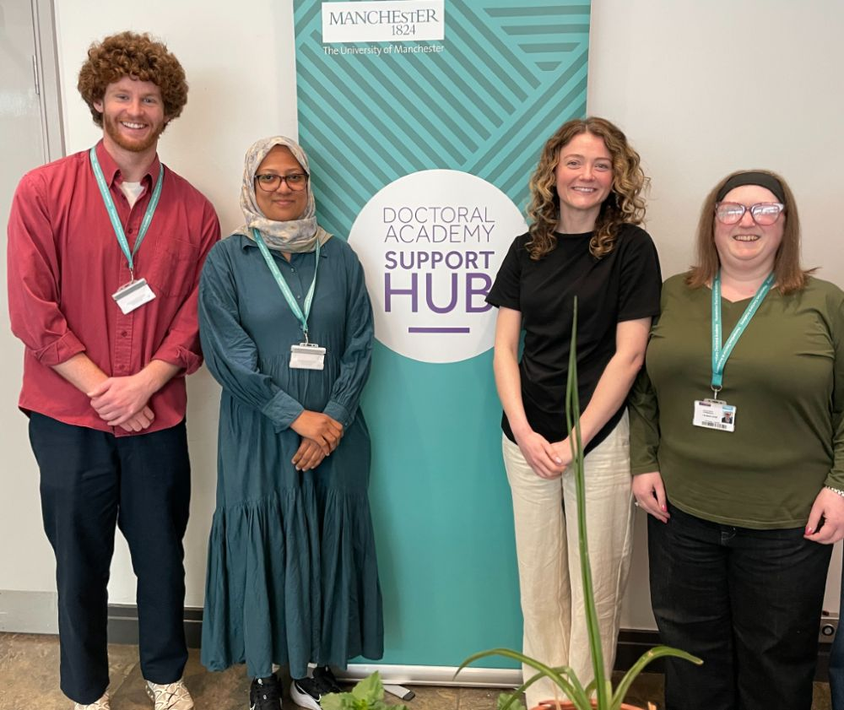

Hi all, I'm Charles Rhodes and I lead the DA's Recruitment and Admissions team. The team manage all PGR applications for the Humanities Faculty, using their knowledge and experience to assess applications, resolve candidate queries and issue CAS. We also manage a variety of funding schemes both internal and external, advertising opportunities and helping recruit the best quality candidates.
There is an array of information about our work on the Recruitment and Admissions Staffnet pages, or you can email us via HUMS.doctoralacademy.admissions@manchester.ac.uk if you have questions.
We aim to provide the best possible support for applicants on their journey to becoming Manchester students. While our focus is applicants and all the pre-enrolment admin, you will see us on the DA Hub and we are always happy to help our students in any way we can!
Charles, Paul, Eliza, Romy, Rachel, Zahra and Mark

Annual Reviews

Preparing for your Annual Review
We are now approaching the period where many of you will be having your Annual Review. This is a key milestone in your studies each year, while also being a supportive framework to guide you through your PGR journey.
Your School (through your PGR Director, Divisional/Discipline Coordinator, and/or Supervisory Team) may now have shared with you information about preparing for your Review. Your PGR Handbook will provide guidance also in addition to any other specific details your School may provide. If you haven’t already done so, please start discussions with your supervisory teams with regard to planning for and organising a date for your Review.
In addition, we appreciate that some of you may have a different timeline for your studies (e.g. if you have previously interrupted your studies or joined the programme outside of September) and so your Review may take place outside of this period. If you are in any doubt when your Review is due, please check the Progression page of your eProg record where this is shown.
If you have any questions not answered by either the Handbook, your supervisors or School colleagues, please do get in touch with the Doctoral Academy ‘Progression & Welfare’ team.

PGR of the Year

  Huge Congratulations
  to Freddie Jones, PGR in Education, School of Environment, Education and Development, who has been awarded the President's Distinguished Award for PGR of the Year in Humanities!
  

The award is given to an outstanding postgraduate researcher who has excelled in some significant manner, for example after the presentation of a thesis, or has had a major research achievement during a PGR programme.
Freddie's nominator says 'Freddie is an exceptional postgraduate researcher whose impact extends far beyond his doctoral research. Freddie combines outstanding scholarship with values-driven leadership, using his lived experience to advance inclusive, ethical research and teaching practice. His PhD work on the experiences of non-speaking neurodivergent young people is already shaping research, policy, and practice.

A highly regarded teacher, researcher, and advocate, Freddie is a role model for inclusive academic practice. His generosity, integrity, and commitment to equity are changing culture and creating lasting impact at Manchester and beyond.'
A hugely deserved achievement - well done Freddie!

PGR Parent and Carer Event

As part of Carers Week 2026, the Parents, Carers and Guardians Network invite you to a special flagship event:
Building Carer-Friendly Universities: Advancing Inclusive Support for Parents and Carers across the North West
🗓 Tuesday 9 June 2026
⏰ 11:00 – 15:00
📍 Alliance Manchester Business School (AMBS)
This event will bring together colleagues, sector leaders, and partner institutions from across the North West to explore how we can strengthen support for parents and carers within our universities.
Professor Duncan Ivison will open the event, followed by a panel discussion focused on institutional commitment, shared learning, and practical action.
✨ Expect:
Inspiring leadership perspectives
Cross-institutional dialogue
Opportunities to connect and share experiences
A collective push towards more inclusive, carer-friendly environments
This is an important moment for our community, and we would love for you to be part of it.
More details and registration information will be shared soon; for now, please save the date!

Researcher Development



The Researcher Development Team have a great programme of workshops for PGRs coming up this June:
08/06/2026
Editing and Proofreading your Thesis for PGRs in HUMS

09/06/2026
Maintaining Momentum: Project, Time and Self-Management

16/06/2026
1 Day NViVO Course

16/06/2026
Preparing for Viva in Humanities

17/06/2026
Overcoming Imposter Feelings and Building Self Confidence

17/06/2026
Career Hacks: Career options beyond academia

17/06/2026
Creating a winning job application (Research Staff and PGRs)

18/06/2026
Writing a Literature Review in Humanities

23/06/2026
Basic Introduction to Statistics in Research

23/06/2026
Planning and Writing your Thesis

24/06/2026
Your doctoral thesis as a research output

  3 Minute Thesis Final!
  3MT develops academic, presentation, and research communication skills and supports the development to effectively explain research in language appropriate to a non-specialist audience.
  

Postgraduate Researchers from across the University are invited to present a compelling spoken presentation on their research topic and its significance in just three minutes only using one static PowerPoint slide.

The finalists will be presenting on 11 June 2026 (2pm - 4.30pm) in Room SLG.12, Samuel Alexander Building so please do some along to listen and support! Register here to confirm your attendance.

Key Travel - A Reminder

Key Travel is a specialised procurement system The University of Manchester uses to make academic transportation and lodging arrangements much more efficient and easy to arrange. As a doctoral PGR with scope for conferences and fieldwork, we ask that you please register with Key Travel by following the instructions in your handbook.
Just a reminder that if you submit a booking request in Key Travel, the approver can only action during normal working hours. If the request is submitted at the weekend, evening, public holiday or University closure period, the itinerary may time out before it can be approved. Therefore, please ensure that requests are submitted at a suitable time.

Updates from the Library

Library Training and Support for PGRs
The Library researcher training programme continues this Spring with a series of workshops aimed to support researchers at all stages of their research career and our online guides, which can be accessed any time.
Their Specialist Library Support service provides expert guidance in areas such as copyright, referencing tools and software, advanced searching, systematic reviews and business data.
For further information see My Research Essentials and our Specialist Library Support via the Library website.
China National Knowledge Infrastructure (CNKI) E-Books service
The Library’s CNKI E-Books service, offers 9,300+ high-quality titles from China’s leading scholarly publishers. With full-text access and downloadable volumes across Art, Language & Literature, History, Geography, and Philosophy.
Moreover, as one of only two UK libraries with full access to all 10 subject collections of the China Academic Journals via CNKI, the Library offer access to over 8650 journals worldwide anytime, anywhere. These essential resource for teaching, research, and China related studies. See the Library News page for details.

University News

Researcher Development
Counselling Services
Research IT
PGR News

The University Of Manchester, Faculty of Humanities, Doctoral Academy
Contact Us | Tel: +44 (0) 161 306 6000 | Web: www.manchester.ac.uk
Registered Office: The University of Manchester, Oxford Rd, Manchester, M13 9PL. Royal Charter Number: RC000797

To opt out of future communications click here

