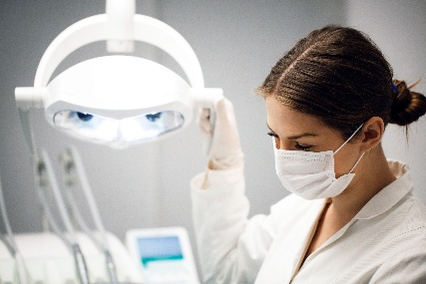



MAP Medicine and Dentistry Strand Resources – 2026
Please note: The information on this web page is for students on the Medicine or Dentistry strands of the Manchester Access Programme (MAP) 2026. For the most up to date information regarding Medicine and Dentistry admissions at the University of Manchester, please visit https://www.bmh.manchester.ac.uk/study/medicine/apply/ or https://www.bmh.manchester.ac.uk/study/dentistry/apply/

Useful Resources and Links
- Welcome to the MAP Medicine Strand 2026 e-Learning Module
- https://share.articulate.com/OrcOc-7cNkoEdTVcvexUA#/

- Welcome to the MAP Dentistry Strand 2026 e-Learning Module
- https://share.articulate.com/kw-OGgUseBJnTuoHfS36C

Recording of the MAP Medicine and Dentistry Admissions Webinar held on Mon 11th May 2026 - https://youtu.be/0oh6MNfU4qI

UCAT Resources
Recording of the MAP UCAT Webinar held on Weds 20th May - https://youtu.be/FViA_fP1wtw
- UCAT Website - https://www.ucat.ac.uk/
- UCAT Practice - https://www.ucat.ac.uk/prepare/practice-tests/
- UCAT Test Key Dates - https://www.ucat.ac.uk/about-ucat/ucat-test-dates/
- UCAT Bursary - https://www.ucat.ac.uk/register/bursary-scheme/

MAP Medicine and Dentistry MMI Preparation Day – Sat 13th June, 10am – 5pm (on campus) – Thanks to everyone who attended. The workshop powerpoint presentations are available here.

MAP Public Health and Biosciences Webinar – You can watch the recording here https://www.youtube.com/watch?v=mvRKHgNuGq4

MAP Personal Statement Feedback - Medicine, Dentistry, Veterinary Science and Oxbridge.
- Weds 19th August
- Thurs 20th August
Get one to one feedback on your personal statement from a UoM staff member or ambassador! Your feedback appointment will last approximately 20-25 mins and feedback will be given online via a Zoom meeting. You need to have a good draft of your personal statement ready to share.
Please provide your availability on this form by Friday 7th August at 10am.
The feedback session will only last approximately 20-25 minutes, but you need to be available for the full hour – please select on the form all the dates and times you are available. We will confirm which session you have been allocated and send you the Zoom link week commencing 10th August. Please note these sessions are only for students who have the October UCAS deadline.

These web page will continue to be updated during your time on MAP with resources from Medicine and Dentistry events. Please keep checking the MAP Newsletter for updates. If you have any queries, please email map@manchester.ac.uk

