How to activate your MAP LinkedIn Learning account
Step 1. You should have received an email from LinkedIn Learning from the address messages-noreply@linkedin.com.
The email will look like the screenshot below and tell you to activate your account. Click on that button and follow the instructions.

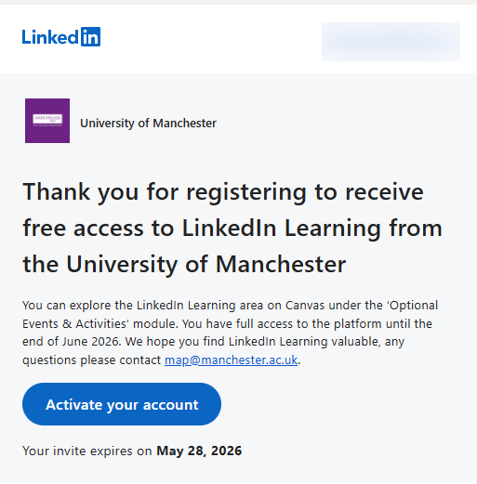
Step 2. You have the choice of signing in with LinkedIn (if you already have an account) or creating a new LinkedIn Learning account.
Choose one and follow the instructions.
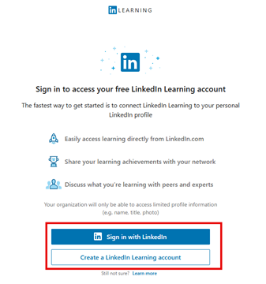
If you’re struggling to find the first activation email:
Step 1: If you’re struggling to find the email, please check your Social tab (Gmail) or your junk mail as it could have landed in there.
If you still cannot see the activation email in your inbox then you can access LinkedIn Learning directly by going to https://www.linkedin.com/learning/ and clicking on Sign in:

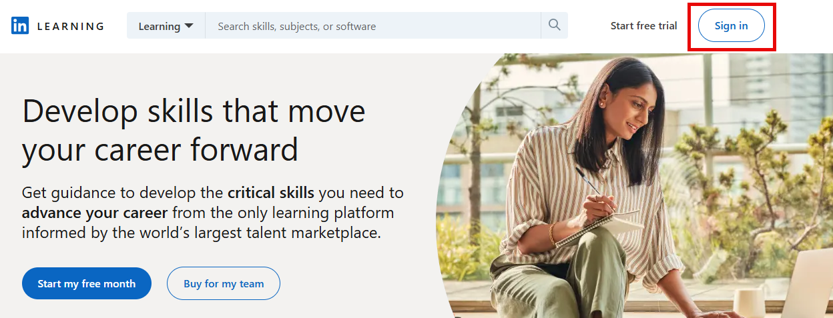

Step 2: You will be prompted to enter the email address your account was set up with and select continue:
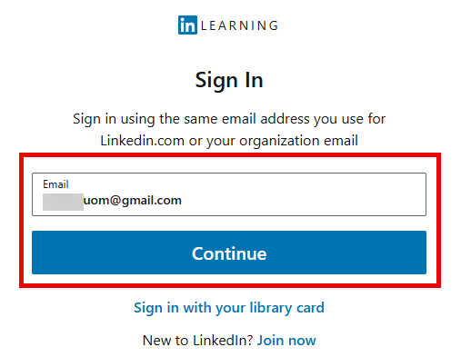

Step 3: You will get a notification email sent to that inbox:
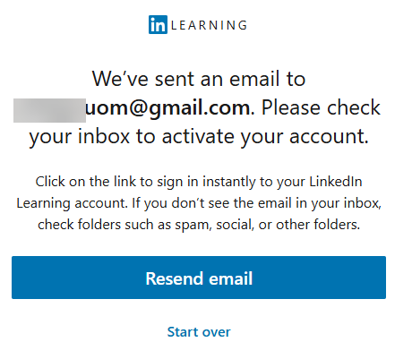
Please check all folders if you’re struggling to find the activation email again – it could be sitting under the social tab (this example is G-mail).

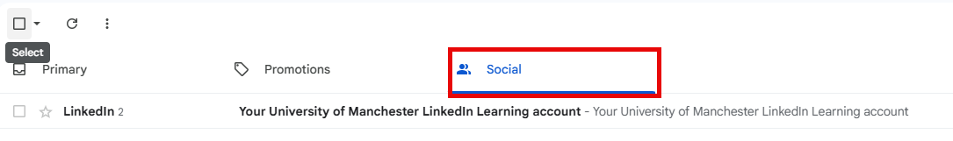

Step 4: Click on Accept your invite and follow the instructions:
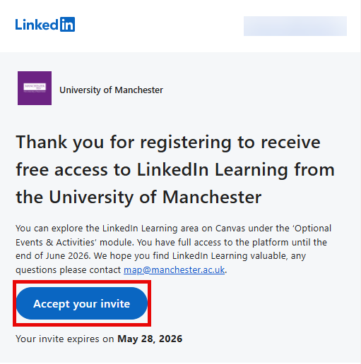

Step 5: You have the choice of signing in with LinkedIn (if you already have an account) or creating a new LinkedIn Learning account. Choose one and follow the instructions.

