

Doctoral Academy Updates



In this DA newsletter you will find the next instalment of 'Meet the Doctoral Academy Team', a reminder to nominate a fellow PGR or supervisor for the MDC Excellence Awards and information on how to take part in the methods@manchester Summer School. You will also find our regular updates from the Library and the Researcher Development Team on their PGR workshops programmes.
As always, if you would like to feature anything in the newsletter, please let us know.
The Doctoral Academy Team
Follow us on Bluesky: https://bsky.app/profile/uom-humsdocacad.bsky.social
Join us on LinkedIn: The University of Manchester Faculty of Humanities Doctoral Academy | Groups | LinkedIn
DA Spotify Podcast

Meet the Doctoral Academy Team



This month’s “Meet the Doctoral Academy Team” feature comes from the Professional Doctorate & Non-Standard Programmes Team
Hello, I’m Debbie Kubiena, PGR Coordinator for the Programmes Team in the Doctoral Academy. I have line-management/oversight responsibility for the Professional Doctorates and non-standard PGR programmes, which sit within the Programmes Team managed by Carole Arrowsmith.
The Professional Doctorates Team encompasses Liam, Christopher, Lou and Farzana, with Scott providing temporary cover during Farzana’s absence. Liam administers the Doctorate in Counselling Psychology (DCounsPsych), while the rest of the team support the Doctorate in Educational and Child Psychology (DECP). Both programmes are managed on a cradle-to-grave basis, from admissions through to examination and completion.
Our wider specialist provision is supported by Sandra, who administers the Centre for Doctoral Training (CDT) programmes, dual-award programmes with the University of Melbourne, visiting research students, and PhD Theology/Missiology programmes delivered with our validated partners — Cliff College, Nazarene Theological College, and Luther King House.
Alongside programme oversight, we have primary responsibility for pre-screening ethics applications and DASS coordination for SEED and SoSS (with Lynne in the Progression & Welfare Team supporting AMBS and SALC). We also undertake DBS checks for research programmes across all schools, and oversee Fieldwork, Study Away and Change in Location during Submission Pending applications via My Placement.
We work in alignment with the Progression and Welfare Team to ensure consistent support for PGRs where processes and regulations align.
Our team is here to support you at every stage of your doctoral journey.
With best wishes,
Carole, Debbie, Sandra, Christopher, Liam, Lou and Farzana

Dean's Award

The Faculty of Humanities Dean’s Prize is a new award created to recognise truly outstanding doctoral achievement within our PGR community.
This prize celebrates those who demonstrate both academic excellence and timely completion, and reflects the Faculty’s commitment to supporting and acknowledging exceptional research performance.
Each recipient of the Dean’s Prize will receive a £2,000 prize, a formal congratulatory letter from the Dean of the Faculty and a commemorative shield.
For full details, including eligibility criteria, visit your handbook.

Methods@manchester Summer School

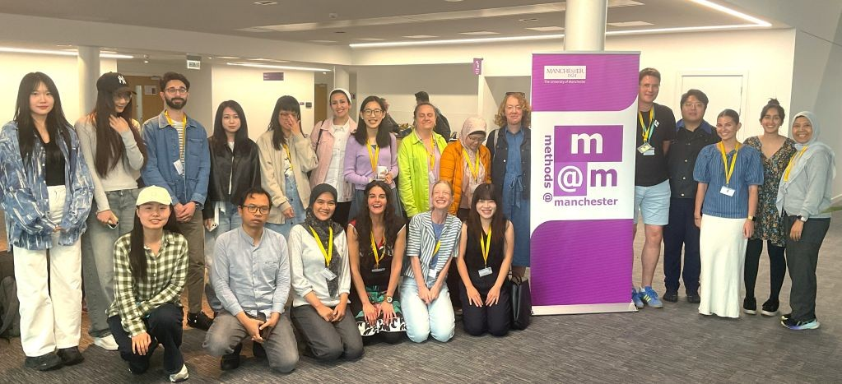

The Methods@Manchester Summer School offers a great opportunity to develop your methods knowledge and research skills while meeting new people across disciplines.
It takes place from Monday 6 July to Friday 10 July and includes the following courses:
- AI Driven Analytics
- Using NVivo for Qualitative and Mixed-Methods Analysis
- Digital Methods
- Qualitative Interviewing: Developing Confidence in Approach and Analysis
- Longitudinal Data Analysis
- Introduction to Social Network Analysis
- Mixed Methods in Social Network Analysis
- Regression Models Using Bayesian Estimation
- Discourse Analysis for Qualitative Research in the Arts and Humanities

Reduced rates are available for PGRs and there is also an Exceptional Circumstances Bursary (deadline for applying: 3 May).

Details on all the above courses and how to book can be found here.

Manchester Doctoral College Excellence Awards

A reminder that the deadline for nominations for the 2026 Manchester Doctoral College (MDC) Excellence Awards is 1 May 2026.
These annual Awards recognise and celebrate the achievements of our postgraduate researchers and postgraduate research supervisors. Awards will be given in the following categories:
- Best Outstanding Research Contribution
- Best Contribution to PGR Environment
- Best Contribution to Society - Local Community
- Best Contribution to Society - Research Impact
- Best Contribution to Internationalisation
- Supervisor of the Year

The call for nominations has been circulated, but you can also find all the details, including nomination forms, here.
If you have any questions about the awards and nomination process, please get in touch.

Researcher Development



The Researcher Development Team have a great programme of workshops for PGRs coming up this May:
07/05/2026
Preparing for Annual Review for Humanities PGRs
12/05/2026
Foundations in Leadership for PGRs
12/05/2026
Research Independence - Fellowship grant applications
12/05/2026
An introduction to qualitative data collection
13/05/2026
How to communicate your research to an online audience
19/05/2026
Planning Life Beyond your Doctorate
20/05/2026
Maintaining Momentum: Project, Time and Self-Management
21/05/2026
Your doctoral thesis as a research output

DSN Photography Competition

  DSN Photography Competition: In Focus – Now Open for Entries
  As part of Disability Pride Month (July 2026), the Disabled Staff Network invites disabled staff, PGRs, and carers to take part in our In Focus photography competition.
  

This is your chance to share your story through up to three images that reflect your experiences — daily realities, moments of pride, hidden challenges, community, or anything meaningful to you. No photography experience is needed, and any device can be used.
Top entries will be showcased during our June celebrations, with prizes of £50, £20 and £10 sponsored by NADSN.
How to Enter:
- Capture a photo (up to 3) that responds to theme 'In Focus'
- Upload your entry here including a brief description on how your submission reflects the theme

For further support, please contact the DSN co-chairs via dsn@manchester.ac.uk

Updates from the Library

Upcoming Workshops from the Library:

Introduction to Research Data Management part one: Starting your research journey (online)
Wednesday 29 April 2026, 11:00 - 12:00

Introduction to FAIR data principles (online)
Wednesday 29 April 2026, 14:00 - 16:00

Introduction to Research Data Stewards: A key role in modern research (online)
Tuesday 5 May 2026, 14:00 - 15:00

Communicating your research differently (on campus)
Wed 6 May 2026, 10:00 - 11:30

Shut up and write (online)
Monday 11 May 2026, 14:00 - 16:00

Research Data Conversations with Phil Reed, Research Community & Training Manager at the eScience Lab (on campus)
Tuesday 12 May 2026, 12:00 - 13:30

MRE Writing Retreat (on campus)
Friday 15 May 2026, 09:00 - 17:00

To highlight one new workshop above, Communicating your research differently - this workshop explores the ways we can communicate our research to different audiences and the benefits this can have in developing our understanding of our own research. You will have the opportunity to reflect on the forms of research communication that have or haven't worked for you, as well as the consideration of impact and appropriateness of research output formats for different audiences.
Just a reminder that the Library have a dedicated website for PGR support here. This is designed to bring together library support for postgraduate researchers in one clear, accessible place. The new page provides an overview of Library services, resources and training to help you during your doctoral journey.

University News
Researcher Development
Counselling Services
Research IT
PGR News

